Machine Conditioner- 910 Data Logger
(Suitable for Monitoring Machinery Vibration caused by imbalance, Misalignment & Gear Faults)
5 functions in one
Vibration, Laser tachometer, Infrared Temperature, Current Clamp & Noise
Features
❖ Vibration Measurement all three Parameters
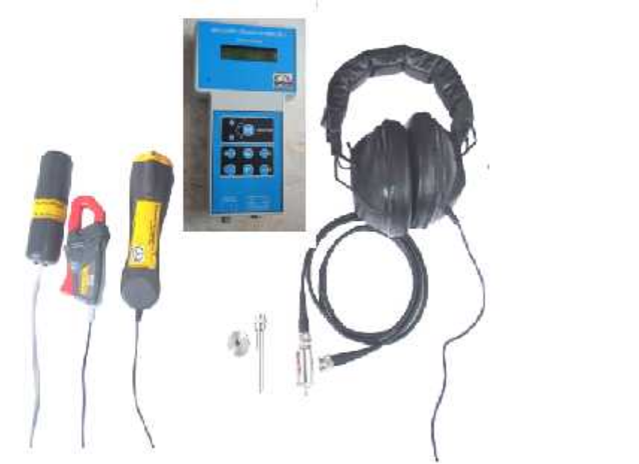
(Velocity, Acceleration & Displacement)
❖ Laser Tachometer measurement
❖ Infrared Temperature measurement
❖ Current Clamp measurement
❖ Electronic Stethoscope (Noise) (Locate the sound source quickly and accurately in a generally noisy environment
with headset)
❖ Microcontroller based
❖ 1250 points Data logger
❖ RS232 /USB computer interface
❖ Data transmission software
❖ Battery Low Indication
❖ Back light LC Display
❖ Small size & Light weight
❖ Auto Power off
Technical Specifications

• Vibration Velocity:0.1 – 199.9mm/s True RMS  Accuracy: ± 2% + 0.1 mm/s | Accuracy: ± 2%
• Acceleration:0.1 – 199.9 m/s² Peak  Accuracy: ± 2% + 0.1 m/s² | Clamp jaw size: 16mm dia.
• Displacement:1.0 – 2800 µm Peak – Peak  Accuracy: ± 5% | • Electronic Stethoscope (Noise)Test
Resolution: 0.1 mm/s | Head set: Stereo type
Frequency response: 10HZ – 1KHZ | Contact tip: 220mm Stainless Steel rod
• Laser Tachometer measuring Range:10 – 30000 rpm | • Power: Rechargeable Battery
Resolution:1 rpm | • Display: 2 x 16 line back light dot matrix LCD
Accuracy: ± (1 rev. + 0.1% of reading) | • Operating Temp. Range: 0 - 55ºC
• Infrared Temperature Range:0 - 550°C | • Sealed Membrane key pad
Resolution:1°C | • Input Connectors: BNC & MIC
Accuracy: ± 2% of reading or 2ºC | • Casing: ABS
Field of View: D/S = Approx. 8:1 ratio | • Size: 200x100x40 mm
• Current Clamp measuring range:1 – 200 Amps | • Weight: 600gms (Approximately)
Resolution:1Amp
Standard Supply:
1) Machine Conditioner 910 with Protective Pouch,
2) Vibration Transducer (Accelerometer), Magnetic Base, Low Noise Cable with connectors (1.5 Mtrs),
3) Head Phone & Contact Tip, 4) Laser Tachometer Probe with Reflecting Tapes (3 Strips), 5) Infrared Temperature Probe,
6) Current Clamp Probe,7) Charger, 8) Manual, 9) Test & Calibration Report with Warranty/Guarantee Certificate &
10) Carry Bag, 11) RS232 to USB Convertor & Cable.

Technical Data are subject to change without Prior Notice.
 | PREDICTIVE MEASURING EQUIPMENTS  Plot No 146, Phase 1, Mytrinagar, Madinaguda, Hyderabad – 500049  Mobile: +91-90593 40351, eMail: info@pmequipments.com, www.pmequipments.com

