VIBRATION METER VIB-30Plus
(Suitable for Monitoring Machine Vibration caused by imbalance, Misalignment and Gear Faults)

Cable with Connectors

Magnetic Base
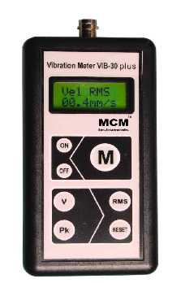

Vibration Sensor

Hand held probe

Features

❖ Measuring Vibration Velocity & Acceleration
❖ True RMS measurement & Peak
❖ Sealed Membrane key pad
❖ Micro Controller based
❖ Back Light Display
❖ Auto Off
❖ Battery Low Indication
❖ Pocket size and Light weight

Vibration Meter VIB-30Plus is Micro controller based and has been designed as simple diagnostic tool for preventive maintenance. The instrument and the monitoring techniques are based on the recommendations of ISO standard.
Need based maintenance is the latest trend of industry with which maintenance costs are low and life machinery is most optimum. Condition monitoring is basic need for maintenance.
The above useful measurement is possible with VIB-30Plus. Velocity mode allows a user to perform basic
vibration analysis.
Technical Data
➢  ➢  ➢  ➢ | Velocity Measuring Range: Resolution:  Accuracy:  Frequency response : | 0.1 – 199.9 mm/s True RMS & 282 mm/s PEAK  0.1mm/s  ± (2% + 0.1mm/s)  10HZ - 1KHZ
➢ | Temperature Range | 0-55˚C
➢ | Power Supply: | 9V - 6 F22
➢ | Display: | 2 x 8 Dot Matrix LCD Large Characters with back light
➢ | Casing | ABS
➢ | Auto Off: | Yes
➢ | Battery Low Indication: | Yes
➢ | Weight: | 200gms
➢ Size 135x70x25mm

Standard Supply
1) Vibration Tester VIB-30Plus with Protective Pouch, 2) Vibration Transducer (Accelerometer) - Magnetic Base -
Hand Held Probe Rod - Low Noise Cable with Connectors (1.5 Mtrs), 3) Manual with Warranty/Guarantee Certificate, 4) 9V Battery (Alkaline), 5) Test & Calibration Report & 6) Carry Case.

Technical Data are subject to change without Prior Notice.

 | PREDICTIVE MEASURING EQUIPMENTS  Plot No 146, Phase 1, Mytrinagar, Madinaguda, Hyderabad – 500049  Mobile: +91-90593 40351, eMail: info@pmequipments.com, www.pmequipments.com

