Longer ORF PDB search and results

Mirte Ciz Marieke Kuijpers

02/03/2022

The code in this document is made to be useful with either the long or the short ORF, but in the set-up below the sequence to use is set to the long ORF.

# Set-up  
library("bio3d")  
library("ggplot2")  
library("ggrepel")  
library("msa")  
library("bio3d.view")  
  
# Load sequence of POI  
seqL <- read.fasta("long.ORF.fa")  
seqS <- read.fasta("short.ORF.fa")  
  
#Choose which sequence to use  
seq <- seqL

After set up the blast search can be completed and the summary statistics of this search can be plotted.

# Blast search  
blast <- blast.pdb(seq, database = "pdb")

## Searching ... please wait (updates every 5 seconds) RID = 1ZJ94FWD01R   
## ..................................................................................................................................................................................................................................................................................................................  
## Reporting 148 hits

# Plot summary statistics of results  
hits <- plot(blast)

## * Possible cutoff values: 70 -2   
## Yielding Nhits: 3 148   
##   
## * Chosen cutoff value of: 70   
## Yielding Nhits: 3

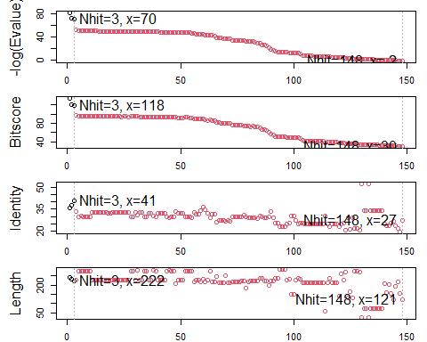

# Print the IDs of the hits above the threshold  
hit.IDs <- hits$pdb.id  
hit.IDs

## [1] "7BMH_A" "5AWZ_A" "6GYH_A"

There are 3 hits that pass the statistical threshold, namely: 7BMH_A, 5AWZ_A, 6GYH_A. More information can be found on these by interrogating the blast results.

# Show the hit table for the top hits which pass the threshold  
head(blast$hit.tbl, n = length(hit.IDs))

## queryid subjectids identity alignmentlength mismatches gapopens q.start  
## 1 Query_540941 7BMH_A 35.685 241 149 3 42  
## 2 Query_540941 5AWZ_A 37.662 231 115 5 39  
## 3 Query_540941 6GYH_A 40.541 222 122 4 46  
## q.end s.start s.end evalue bitscore positives mlog.evalue pdb.id acc  
## 1 276 51 291 6.05e-36 133 51.45 81.09301 7BMH_A 7BMH_A  
## 2 258 16 228 6.87e-32 120 49.78 71.75556 5AWZ_A 5AWZ_A  
## 3 266 14 226 2.73e-31 118 55.86 70.37584 6GYH_A 6GYH_A

We can also download these PDB files, annotate them for more information and align them with our sequence to get an overview of sequence alignment.

# Download related PDB files  
files <- get.pdb(hits$pdb.id, path="pdbs", split=TRUE, gzip=TRUE)

## | | | 0% | |======================= | 33% | |=============================================== | 67% | |======================================================================| 100%

# Align related PDBs  
pdbs <- pdbaln(files, fit = TRUE, exefile="msa")

## Reading PDB files:  
## pdbs/split_chain/7BMH_A.pdb  
## pdbs/split_chain/5AWZ_A.pdb  
## pdbs/split_chain/6GYH_A.pdb  
## PDB has ALT records, taking A only, rm.alt=TRUE  
## . PDB has ALT records, taking A only, rm.alt=TRUE  
## . PDB has ALT records, taking A only, rm.alt=TRUE  
## .  
##   
## Extracting sequences  
##   
## pdb/seq: 1 name: pdbs/split_chain/7BMH_A.pdb   
## PDB has ALT records, taking A only, rm.alt=TRUE  
## pdb/seq: 2 name: pdbs/split_chain/5AWZ_A.pdb   
## PDB has ALT records, taking A only, rm.alt=TRUE  
## pdb/seq: 3 name: pdbs/split_chain/6GYH_A.pdb   
## PDB has ALT records, taking A only, rm.alt=TRUE

# Vector containing PDB codes for figure axis  
ids <- basename.pdb(pdbs$id)  
  
# Annotate hits for more information on the hits  
anno <- pdb.annotate(ids)  
  
# Find the organisms these PDB hits come from  
unique(anno$source)

## [1] "Leptosphaeria maculans" "Acetabularia acetabulum"   
## [3] "Coccomyxa subellipsoidea C-169"

# View more information on the hits  
anno

## structureId chainId macromoleculeType chainLength experimentalTechnique  
## 7BMH_A 7BMH A Protein 324 X-ray  
## 5AWZ_A 5AWZ A Protein 244 X-ray  
## 6GYH_A 6GYH A Protein 236 X-ray  
## resolution scopDomain pfam  
## 7BMH_A 2.20 <NA> Bacteriorhodopsin-like protein (Bac_rhodopsin)  
## 5AWZ_A 1.57 <NA> Bacteriorhodopsin-like protein (Bac_rhodopsin)  
## 6GYH_A 2.00 <NA> Bacteriorhodopsin-like protein (Bac_rhodopsin)  
## ligandId  
## 7BMH_A LFA (22),OLA (3)  
## 5AWZ_A RET,OLB,D12 (2),D10 (3),OCT (2),C14  
## 6GYH_A RET,CLR,OLB (4)  
## ligandName  
## 7BMH_A EICOSANE (22),OLEIC ACID (3)  
## 5AWZ_A RETINAL,(2S)-2,3-dihydroxypropyl (9Z)-octadec-9-enoate,DODECANE (2),DECANE (3),N-OCTANE (2),TETRADECANE  
## 6GYH_A RETINAL,CHOLESTEROL,(2S)-2,3-dihydroxypropyl (9Z)-octadec-9-enoate (4)  
## source  
## 7BMH_A Leptosphaeria maculans  
## 5AWZ_A Acetabularia acetabulum  
## 6GYH_A Coccomyxa subellipsoidea C-169  
## structureTitle  
## 7BMH_A Crystal structure of a light-driven proton pump LR (Mac) from Leptosphaeria maculans  
## 5AWZ_A Crystal Structure of the Cell-Free Synthesized Membrane Protein, Acetabularia Rhodopsin I, at 1.57 angstrom  
## 6GYH_A Crystal structure of the light-driven proton pump Coccomyxa subellipsoidea Rhodopsin CsR  
## citation rObserved  
## 7BMH_A Zabelskii, D., et al. Commun Biol (2021) 0.23840  
## 5AWZ_A Furuse, M., et al. Acta Crystallogr D Biol Crystallogr (2015) 0.17760  
## 6GYH_A Fudim, R., et al. Sci Signal (2019) 0.19398  
## rFree rWork spaceGroup  
## 7BMH_A 0.28470 0.23610 P 21 21 21  
## 5AWZ_A 0.19410 0.17690 C 1 2 1  
## 6GYH_A 0.22493 0.19231 H 3

# Draw schematic alignment  
plot(pdbs, labels=ids)

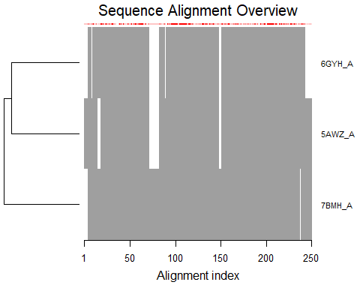

We can also plot the three structures we have found as follows:

# Set up  
library(bio3d.view)  
library(rgl)  
  
# Plot  
#view.pdbs(pdbs)

The View.pdbs() function brings up an interactive viewer, which cannot be directly viewed in the markdown document, so instead two screen-shots of this have been inserted.

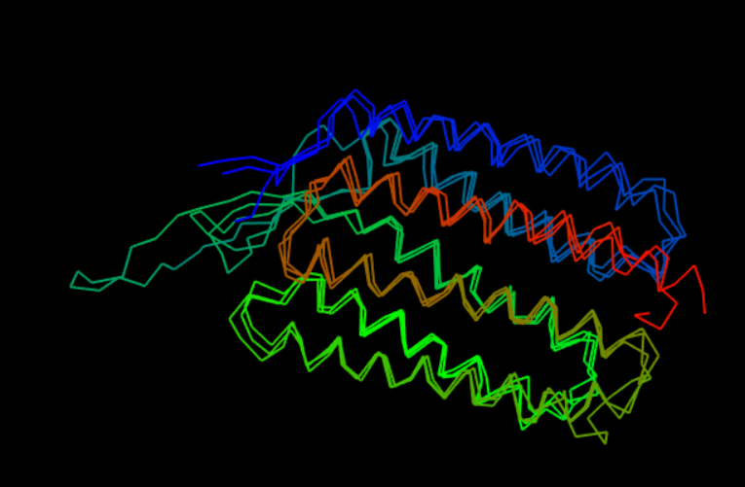

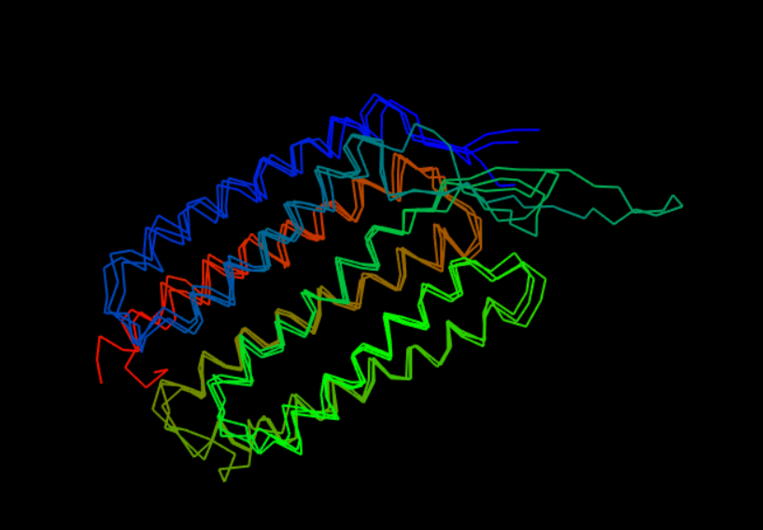

With more proteins it could be interesting to plot variability, or even do PCA using the amino acid position data, but with only three proteins this is not useful.

# Session Information

sessionInfo()

## R version 4.1.2 (2021-11-01)  
## Platform: x86_64-w64-mingw32/x64 (64-bit)  
## Running under: Windows 10 x64 (build 22000)  
##   
## Matrix products: default  
##   
## locale:  
## [1] LC_COLLATE=English_United Kingdom.1252   
## [2] LC_CTYPE=English_United Kingdom.1252   
## [3] LC_MONETARY=English_United Kingdom.1252  
## [4] LC_NUMERIC=C   
## [5] LC_TIME=English_United Kingdom.1252   
##   
## attached base packages:  
## [1] stats4 stats graphics grDevices utils datasets methods   
## [8] base   
##   
## other attached packages:  
## [1] rgl_0.108.3 bio3d.view_0.1.0.9000 msa_1.26.0   
## [4] Biostrings_2.62.0 GenomeInfoDb_1.30.1 XVector_0.34.0   
## [7] IRanges_2.28.0 S4Vectors_0.32.3 BiocGenerics_0.40.0   
## [10] ggrepel_0.9.1 ggplot2_3.3.5 bio3d_2.4-3.9000   
##   
## loaded via a namespace (and not attached):  
## [1] tidyselect_1.1.2 xfun_0.29 purrr_0.3.4   
## [4] colorspace_2.0-2 vctrs_0.3.8 generics_0.1.2   
## [7] htmltools_0.5.2 yaml_2.2.2 utf8_1.2.2   
## [10] rlang_1.0.1 pillar_1.7.0 glue_1.6.1   
## [13] withr_2.4.3 GenomeInfoDbData_1.2.7 lifecycle_1.0.1   
## [16] stringr_1.4.0 zlibbioc_1.40.0 munsell_0.5.0   
## [19] gtable_0.3.0 htmlwidgets_1.5.4 evaluate_0.15   
## [22] knitr_1.37 extrafont_0.17 fastmap_1.1.0   
## [25] curl_4.3.2 parallel_4.1.2 fansi_1.0.2   
## [28] Rttf2pt1_1.3.10 highr_0.9 Rcpp_1.0.8   
## [31] scales_1.1.1 jsonlite_1.8.0 digest_0.6.29   
## [34] stringi_1.7.6 dplyr_1.0.8 grid_4.1.2   
## [37] cli_3.2.0 tools_4.1.2 bitops_1.0-7   
## [40] magrittr_2.0.2 RCurl_1.98-1.6 tibble_3.1.6   
## [43] extrafontdb_1.0 crayon_1.5.0 pkgconfig_2.0.3   
## [46] ellipsis_0.3.2 httr_1.4.2 rmarkdown_2.11   
## [49] rstudioapi_0.13 R6_2.5.1 compiler_4.1.2