Do negative expressives impose contextual constraints in a second language? A bilingual replication and extension
Expressive and derogatory terms are often analysed as conveying information about an attitude holder (typically the speaker) over and above any descriptive content. On influential views, this expressive contribution is characteristically (1) attitudinal and agent-oriented and (2) do not impose strong contextual felicity constraints beyond securing reference. However, recent experimental work challenges this picture: negative expressives show reduced acceptability in neutral contexts relative to supporting contexts, suggesting that felicitous use can depend on what is presupposed or supported by the discourse situation (see Domaneschi, Cepollaro & Stojanovic, 2025 and Cepollaro, Domaneschi & Stojanovic, 2021).
We propose a bilingual replication and extension of vignette-based acceptability study on negative expressives (e.g., predicative utterances of the form X is P, where P is a negative expressive, such as jerk/stronzo; Cepollaro et al., 2021; Domaneschi et al., 2025). Participants will be tested either in their first language (L1) or second language (L2), allowing us to assess whether the contextual constraint profile of negative expressives is stable under the affective distance typically associated with L2 processing (e.g., Dewaele, 2008; Ferré et al., 2018; Imbault et al., 2022; Thoma, 2023).
The present work addresses three questions:
- Do bilinguals replicate the contextual constraint asymmetry for negative expressives (neutral < supporting; target-oriented > agent-oriented)?
- Does language nativeness (L1 vs. L2) modulate these effects? Do they attenuate, preserve, or reorganize these constraints, consistent with the possibility that affective impact contributes to felicity judgments?
- Are L1/L2 effects uniform across derogatory categories, or do negative expressives (e.g., jerk) and ordinary insults (e.g., rude) differ due to their social-indexical and conventionalized derogatory content?
By testing context, valence, word type, and language nativeness within a single paradigm, the study provides a simple empirical route to adjudicating between “universally agent-oriented” assumptions and accounts on which felicity and acceptability depend on interaction between attitude attribution, contextual support, and affective impact. A growing body of work highlights that bilinguals process emotions differently across their languages, with attenuated affective responding occurring in the L2 (), therefore, work assessing the impacts of valence should be replicated in a bilingual context in order to highlight whether this is a universal process, or whether it is moderated by language use.

Procedure
Each participant will read short written vignettes instantiating key contextual configurations (including neutral and supporting contexts, as well as contrasts that make the attitude holder salient: target-oriented vs agent-oriented variants), followed by a target utterance attributed to a fictional speaker. Participants will rate the acceptability of the utterance (primary DV). This procedure will follow the procedure of Domaneschi et al. (2025), as highlighted in Figure 1.
Figure 1
Overview of Procedure
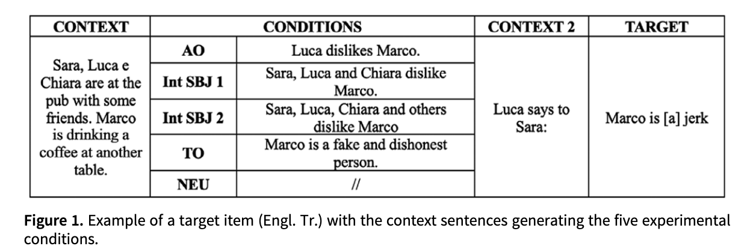
Note. Reprinted (or adapted) from “Literally ‘a jerk’: An experimental investigation of expressives in predicative position,” by F. Domaneschi, B. Cepollaro, & I. Stojanovic, 2025, Language and Cognition, 17, Article e13. https://doi.org/10.1017/langcog.2024.38

Analysis plan
Acceptability ratings will be analysed with mixed-effects regression including fixed effects of Context Condition, Testing Language (L1 vs L2), and their interaction, with random effects for participants and items. Primary confirmatory tests are (i) the Neutral vs Supporting contrast, (ii) the Target-oriented vs Agent-oriented contrast (if included), and (iii) interactions with Testing Language.

Expected contribution
The study provides a direct bilingual replication of experimentally established contextual constraints on negative expressives found by Domaneschi, Cepollaro and Stojanovic (2025). By testing whether the constraint profile is stable across L1 and L2, it offers evidence relevant to debates about whether acceptability patterns for expressives reflect primarily semantic/pragmatic licensing conditions, affective impact, or an interaction between the two. The results speak directly to STAL-2026 themes concerning derogatory language across languages and the conditions under which expressive evaluations are felicitous.
References
Cepollaro, B., Domaneschi, F., & Stojanovic, I. (2021). When is it ok to call someone a jerk? An experimental investigation of expressives. Synthese, 198(10), 9273-9292.
Dewaele, J.M. (2008). The emotional weight of I love you in multilinguals’ languages. Journal of Pragmatics, 40, 1753–1780.
Domaneschi, F., Cepollaro, B., & Stojanovic, I. (2025). Literally ‘a jerk’: an experimental investigation of expressives in predicative position. Language and Cognition, 17, Article e13.
Ferré, P., Anglada-Tort, M., & Guasch, M. (2018). Processing of emotional words in bilinguals: Testing the effects of word concreteness, task type and language status. Second Language Research, 34, 371-394.
Imbault, C., Titone, D., Warriner, A. B., & Kuperman, V. (2021). How are words felt in a second language: Norms for 2,628 English words for valence and arousal by L2 speakers. Bilingualism: Language and Cognition, 24(2), 281-292.
Thoma, D. (2024). Language-dependent emotions in heritage and second language bilinguals: When physiological reactions deviate from feelings. International Journal of Bilingualism, 28(3), 374-389.

