# CE6003 Labs – Instructions

* The labs for this module are intended to be run using Jupyter Notebooks on Colab.
* The programming language we will use is Python 3.
* Content for the labs is stored in Github at <https://github.com/EmdaloTechnologies/CE6003>
* This is a publicly accessible repo and you do not need a Github account to access it.

## Starting Colab

To start the labs, you will need a Google Account. Create one if you haven’t already got one.

Go to <https://colab.research.google.com/notebooks/welcome.ipynb> and sign into your Google Account.

## Opening one of the labs

Select “File->Open Notebook” (or press CTRL+O) to open a Notebook.

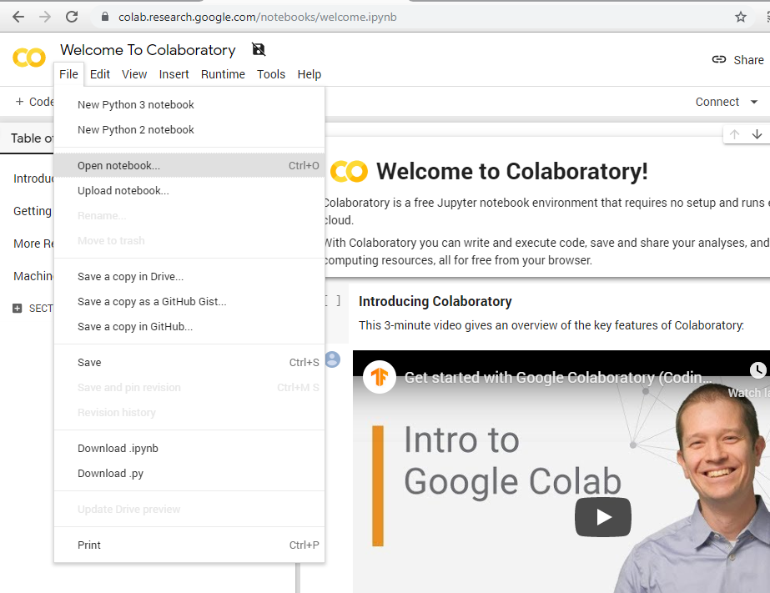

In the dialog box, select the “GitHub” tab and enter EmdaloTechnologies as the user (all one word, no spaces). Select EmdaloTechnologies/CE6003 as the Repository, as master as the Branch.

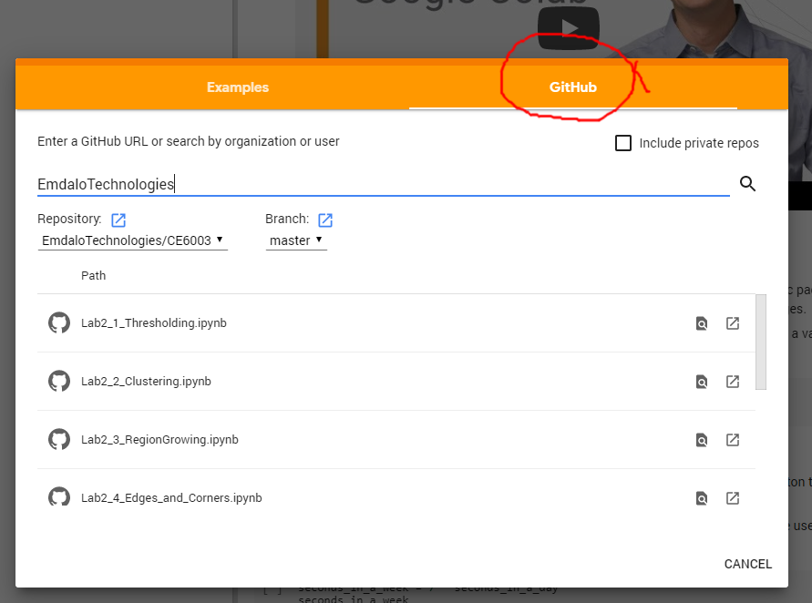

The various labs can be opened by clicking on the appropriate Jupyter Notebook file (*.ipynb).

Most of the labs need to populate the Colab environment with various images and assets. This is done through using a git clone, which is at the top of Jupyter Notebooks.

When running the cell with the git clone command in it, you may get a warning

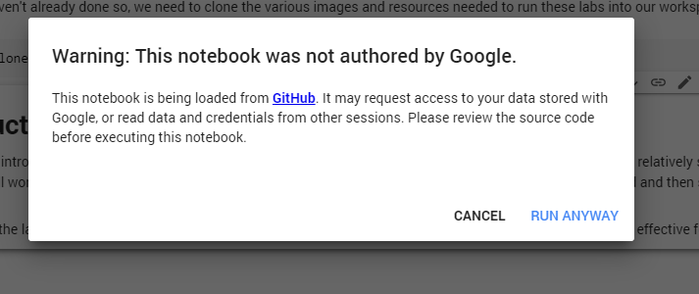

This is normal and expected. Click **RUN ANYWAY**. If this is the first-time cloning into your Colab environment, you will see messages like …

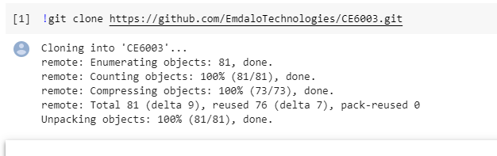

If you have already cloned, you may see the following error message if you run this cell – this can safely be ignored.

