Exercise 1:

Gather clients requirements is important and often been done before designing. This is because requirements must be implemented in your project, otherwise your work maybe terminated.

List out all your clients’ requirements at the left side, explain what you intend to do to implement each requirement at the right side. The first requirement has done for you as an example.

Client: Vincent Cicconi – Refugee Supporter

|  |  |
| --- | --- |
| Requirements | Implementation |
| #1 client is an environmental friendly company. Colours like green, earthy, and natural are encouraged. | Use mainly green, earthy natural colours on the pages. For example, use green #a6bf33 as the background color for footer, and navigation bar. |
| Heading 1, Heading 3 Titles | Times New Roman, Sans Serif, Bold |
| Paragraphs | Normal, black #000000 |
| Navigation Bar | Top of the page |
| Banner | Top of all pages and centered |
| Footer bar | Copyright, bold h6, green slightly darker |
| Social Media Links | At bottom of footer of all pages |
| Background colour must be neutral | Orange background |
| Mouse hovering | Grey background |
| Click on bottom of page | Black background for Home Page |

Exercise 2:

After designing the storyboard, the next step is to convert the design to template. Use the following storyboard as an example, complete converting all designs to HTML. The first few rows have been already done for you as an example.

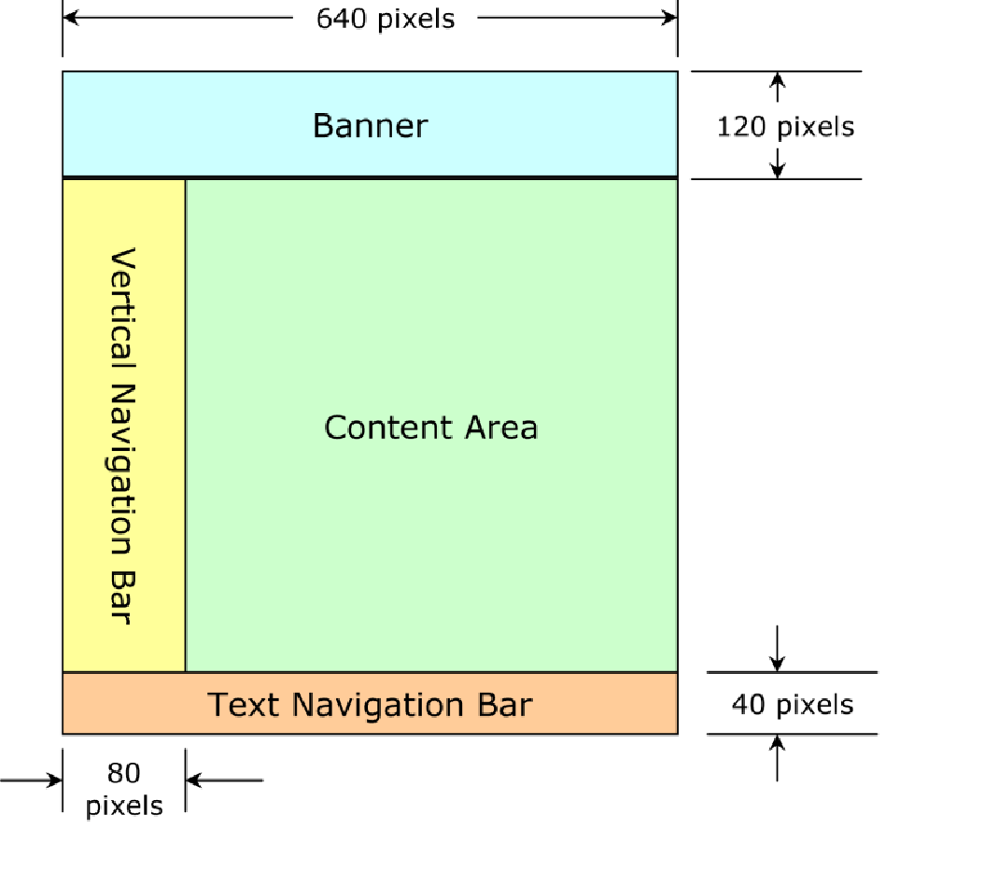

|  |  |
| --- | --- |
| HTML Template: | |
| Document type, Head  Body | <!DOCTYPE html>  <html lang="en">  <head>  <meta charset="utf-8">  <title>……………….</title>  <link rel="stylesheet" href="folder/stylesheet.css">  </head>  <body> |
| Banner | <header> |
|  |  |
|  |  |
|  |  |
|  |  |
|  |  |