Name: Huynh Phuc Nguyen Nguyen

ID: 32442890

Visualization GitHub link:

<https://mcnguyen963.github.io/fit3179_assignment_2/>

Why?

The visualization helps Australia individuals and organizations that care about the weather data. One of the specific audients is farmers who are not professional understand how related temperature, rainfall, and altitude vary across different parts of Australia as well as the trends of climax change in Australia to help the audient in their farming. Based on the past data in the past, the audience can use it to model climate change or predict future weather patterns

What?

This visualization displays climate data across various weather stations in Australia. The data includes the location of which data is recorded, how height from the sea level it is, temperature record for each date from 2017-2023 and rainfall record for each date from 2017-2023

The dataset is sourced from meteorological records collected at 298 stations across Australia, offering a comprehensive look at the country’s diverse climate zones.

Who?

The visualization is designed with the average Australian in mind, making it intuitive and accessible. It’s meant for general users who might have limited knowledge of meteorology but are interested in understanding local weather conditions. For instance, a farmer in Victoria could easily use this visualization to plan for the planting season based on rainfall data, while a resident of Sydney could track temperature trends to better understand upcoming weather patterns. By focusing on climate data relevant to different areas of Australia, the visualization caters to a broad audience, from everyday citizens to professionals in climate-sensitive industries.

How?

Story telling type: magazine to focus on more about analysis of the data to help the audience to understand the patten, predicting the future weather.

I use map (Location, colour) to and colour to showing the weather station location and height.

Sankey diagram (Length, text) to show the relationship between temperature, rain, and height.

Finally I use heat map(location, colour) to show the recent temperature record and radial (size, colour, text)to show the recent rainfall record.

**Five Design sheets:** [**https://drive.google.com/drive/folders/1RQbotlb9wvewCDANlk2DOCS4ISixPU3f?usp=sharing**](https://drive.google.com/drive/folders/1RQbotlb9wvewCDANlk2DOCS4ISixPU3f?usp=sharing)

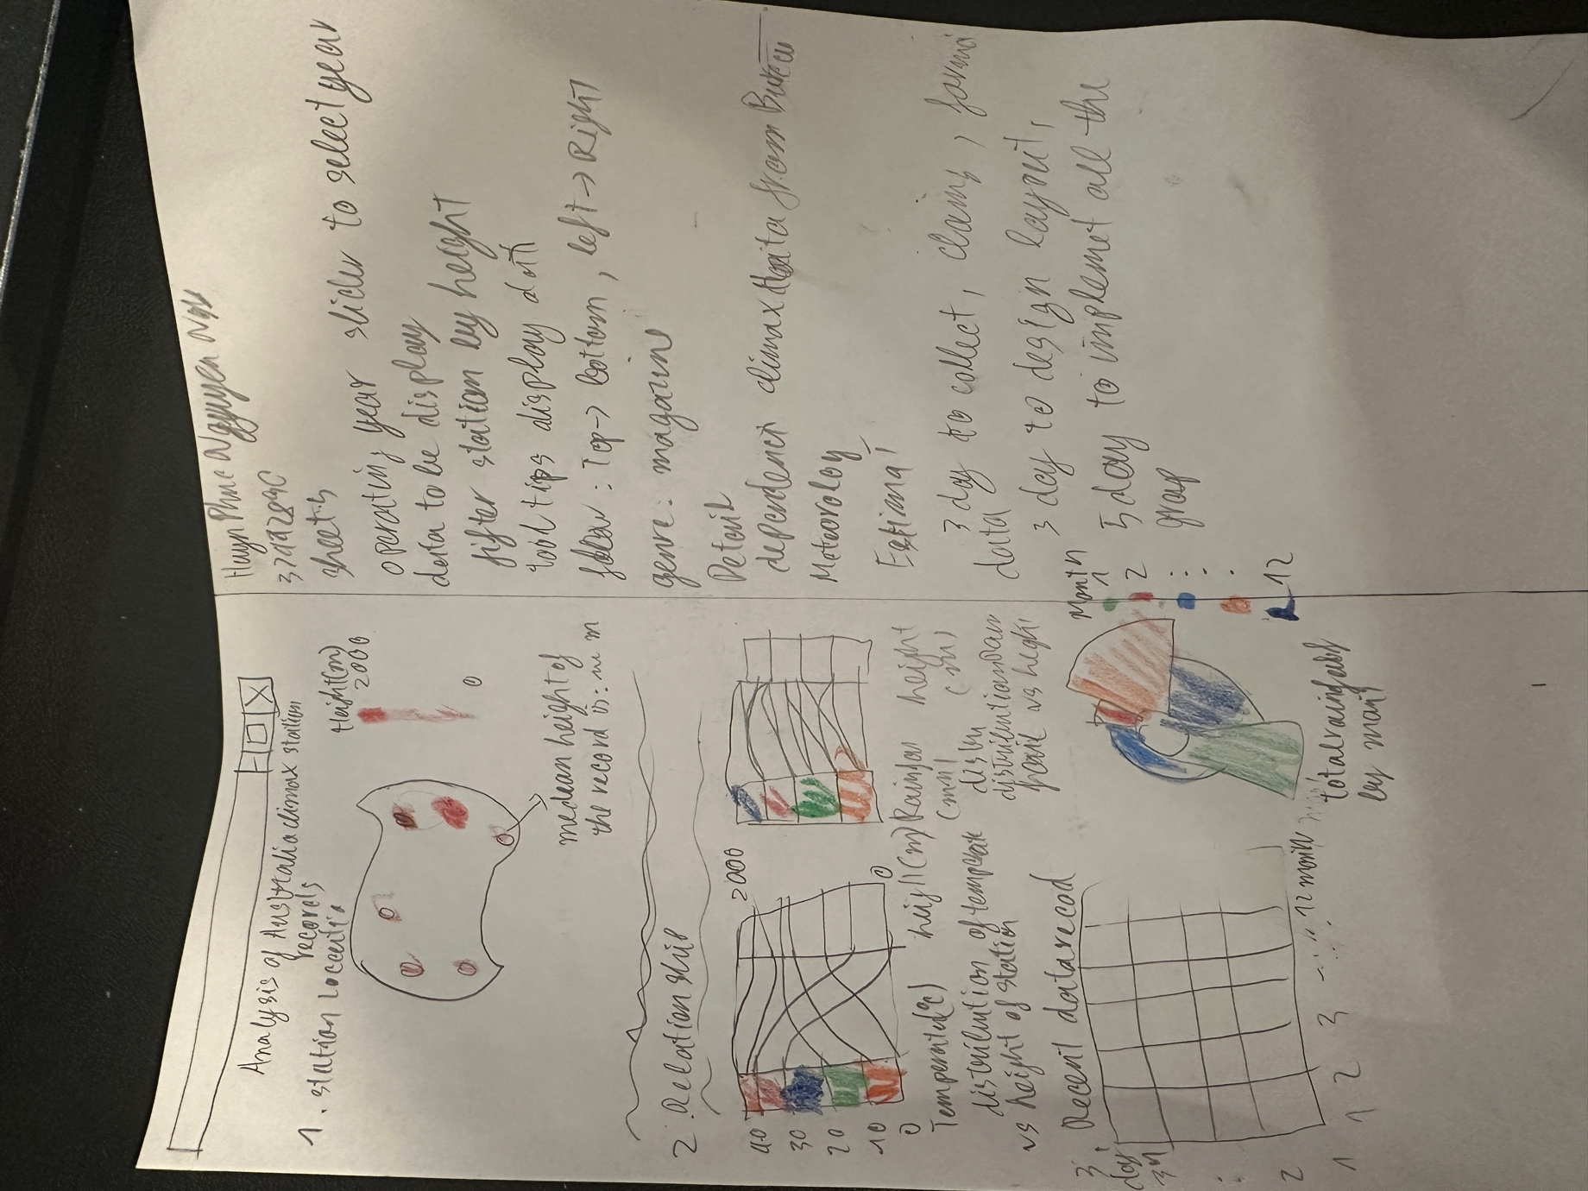

**Acknowledgement:**

I used Vega for Sankey diagram. Based on the based graph from  
<https://stackoverflow.com/questions/66387154/sankey-diagram-alluvial-diagram-in-vega-lite>