





Introduction……………………………………………………1

Marking Test 1 Document……………………………….5

Marking Test 2 Document……………………………….6

Marking Test 3 Document……………………………….7

Marking Test 1 Appendix…………………………………8

Marking Test 2 Appendix…………………………………10

Marking Test 3 Appendix…………………………………11



This document provides the resources required for the portfolio for Project 1.

I decided to start this project the way I have been taught using the practices learnt in software engineering.

I use a git repository for my personal portfolio

<https://github.com/mcnorth/Crozzle-Project>

I started with a use case:



With this I was able to create an object model.





I had to write a few algorithms for the harder solutions but most of it I was able to write on my own.

**Algorithm for cell placement in grid.**

Get the object in RowData

Get the x and y coordinates of the object

Get the name and split into chars

Get each char of the name

Get the starting row and starting column cords.

Get the first letter

Add to grid

Move along +1 every letter of the name

**Algorithm for score**

Get the object in row data

Get the x, y cords.

Step through each letter cords.

Get obj in column data

Get x, y cords

Step through each letter cords

Condition: does the xy cords of each letter match.

Get value of the cell add to list

**Algorithm calculate score**

Step through letter list

Get a letter

Step through points list

Condition: does the first letter match the second letter.

Grab value of second letter

Assign a variable int

Add value to variable.



Marking test 1 is the valid crozzle. I used this for the cell placement on the grid. Iwas also able to calculate the score from this.

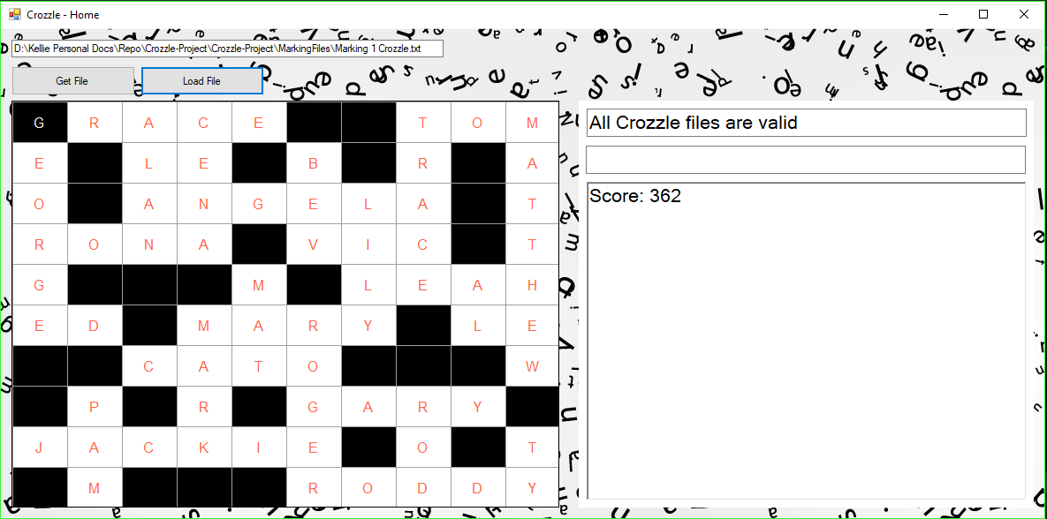

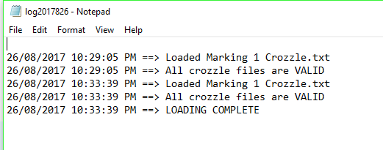





This test has invalid configuration and wordlist files. I used it for error logs. Because the files are invalid the crozzle grid will not load.

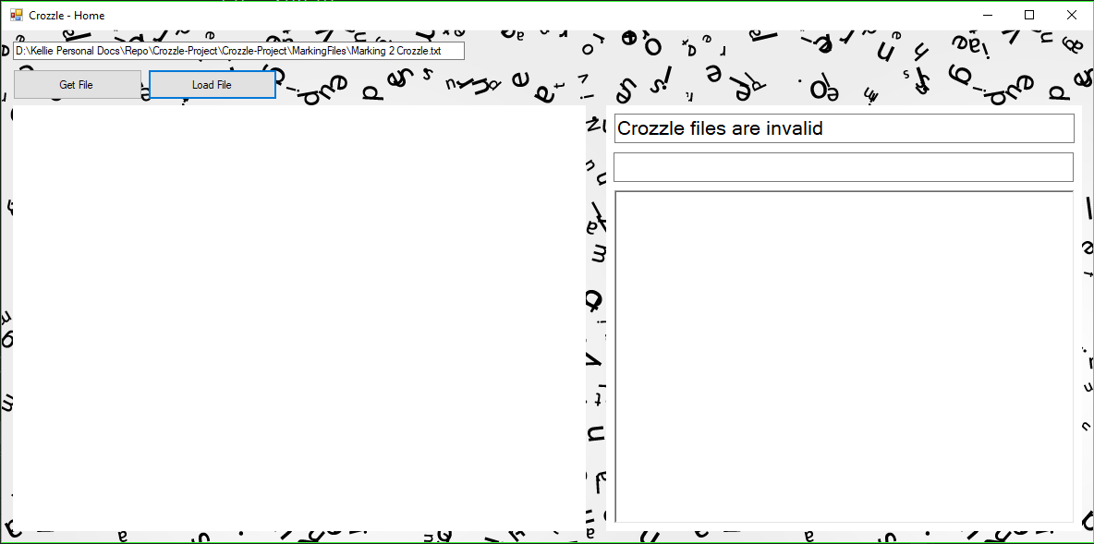

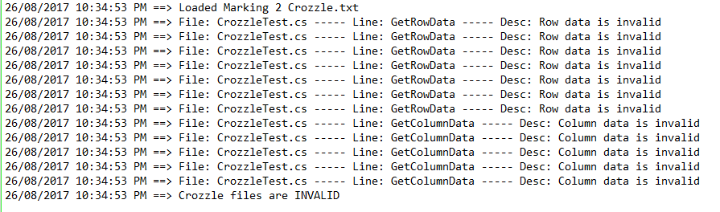



This test has invalid crozzle test file. I used it for error logs. Because the files are invalid the crozzle grid will not load.

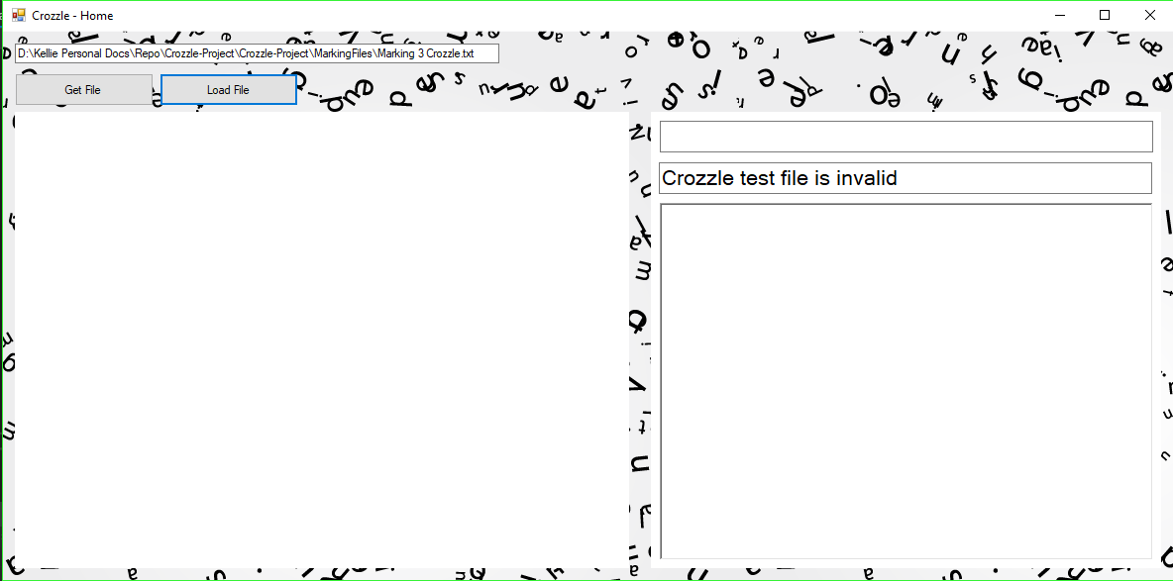







**Marking 1 Crozzle.txt**

// File dependencies.

// Configuraton file.

CONFIGURATION_FILE=".\Marking 1 Configuration.txt"

// Word list file.

WORDLIST_FILE=".\Marking 1 Wordlist.txt"

// Crozzle Size.

// The number of rows and columns.

ROWS=10 // This crozzle will have 10 rows.

COLUMNS=10

// Word Data.

// The horizontal rows containing words.

ROW=3,ANGELA,3

ROW=7,CATO,3

ROW=6,ED,1

ROW=8,GARY,6

ROW=1,GRACE,1

ROW=9,JACKIE,1

ROW=2,LE,3

ROW=6,LE,9

ROW=5,LEAH,7

ROW=6,MARY,4

ROW=10,RODDY,6

ROW=4,RONA,1

ROW=1,TOM,8

ROW=4,VIC,6

// The vertical rows containing words.

COLUMN=9,AL,5

COLUMN=3,ALAN,1

COLUMN=6,BEV,2

COLUMN=4,CENA,1

COLUMN=1,GEORGE,1

COLUMN=7,LILY,3

COLUMN=4,MARK,6

COLUMN=5,MAT,5

COLUMN=10,MATTHEW,1

COLUMN=2,PAM,8

COLUMN=6,ROGER,6

COLUMN=8,ROD,8

COLUMN=8,TRACE,1

COLUMN=10,TY,9



**Marking 1 Configuration.txt**

// Log File Configurations.

// The default log file name.

LOGFILE_NAME="log.txt" // log file

// Word List Configurations.

// Limits on the size of the word list.

MINIMUM_NUMBER_OF_UNIQUE_WORDS=10

MAXIMUM_NUMBER_OF_UNIQUE_WORDS=1000

// Crozzle Output Configurations.

INVALID_CROZZLE_SCORE="INVALID CROZZLE"

UPPERCASE=true

STYLE="<style> table, td { border: 1px solid black; border-collapse: collapse; } td { width:24px; height:18px; text-align: center; } </style>"

BGCOLOUR_EMPTY_TD=#777777

BGCOLOUR_NON_EMPTY_TD=#ffffff

// Crozzle Configurations.

// Limits on the size of the crozzle grid.

MINIMUM_NUMBER_OF_ROWS=8

MAXIMUM_NUMBER_OF_ROWS=80

MINIMUM_NUMBER_OF_COLUMNS=10

MAXIMUM_NUMBER_OF_COLUMNS=100

// Limits on the number of horizontal words and

// vertical words in a crozzle.

MINIMUM_HORIZONTAL_WORDS=1

MAXIMUM_HORIZONTAL_WORDS=100

MINIMUM_VERTICAL_WORDS=1

MAXIMUM_VERTICAL_WORDS=100

// Limits on the number of

// intersecting vertical words for each horizontal word, and

// intersecting horizontal words for each vertical word.

MINIMUM_INTERSECTIONS_IN_HORIZONTAL_WORDS=1

MAXIMUM_INTERSECTIONS_IN_HORIZONTAL_WORDS=100

MINIMUM_INTERSECTIONS_IN_VERTICAL_WORDS=1

MAXIMUM_INTERSECTIONS_IN_VERTICAL_WORDS=100

// Limits on duplicate words in the crozzle.

MINIMUM_NUMBER_OF_THE_SAME_WORD=1

MAXIMUM_NUMBER_OF_THE_SAME_WORD=2

// Limits on the number of valid word groups.

MINIMUM_NUMBER_OF_GROUPS=1

MAXIMUM_NUMBER_OF_GROUPS=1

// Scoring Configurations

// The number of points per word within the crozzle.



POINTS_PER_WORD=10

// Points per letter that is at the intersection of

// a horizontal and vertical word within the crozzle.

INTERSECTING_POINTS_PER_LETTER="A=1,B=2,C=2,D=2,E=1,F=4,G=4,H=4,I=1,J=8,K=8,L=8,M=8,N=8,O=1,P=16,Q=16,R=16,S=16,T=16,U=1,V=32,W=32,X=64,Y=64,Z=128"

// Points per letter that is not at the intersection of

// a horizontal and vertical word within the crozzle.

NON_INTERSECTING_POINTS_PER_LETTER="A=0,B=0,C=0,D=0,E=0,F=0,G=0,H=0,I=0,J=0,K=0,L=0,M=0,N=0,O=0,P=0,Q=0,R=0,S=0,T=0,U=0,V=0,W=0,X=0,Y=0,Z=0"

**Marking 1 Wordlist.txt**

AL,ALAN,ANGELA,BETTY,BEV,BILL,BRENDA,CATO,CENA,ED,FRED,GARY,GEORGE,GRACE,HARRY,JACKIE,JESSICA,JILL,JOHN,LARRY,LE,LEAH,LILY,MARK,MARY,MAT,MATTHEW,OSCAR,PAM,ROBERT,ROGER,ROD,RODDY,RONA,TOM,TRACE,TY,VIC,WENDY,WALTER





**Marking 2 Crozzle.txt**

// File dependencies.

// Configuraton file.

CONFIGURATION_FILE=".\Marking 2 Configuration.txt"

// Word list file.

WORDLIST_FILE=".\Marking 2 Wordlist.txt"

// Crozzle Size.

// The number of rows and columns.

ROWS=10 // This crozzle will have 10 rows.

COLUMNS=10

// Word Data.

// The horizontal rows containing words.

=3,ANGELA,3 // error 1

ROW=,CATO,3 // error 2

ROW=2,$#@$#@,3 // error 3

ROW=5,LEAH,XYZ // error 4

ROW=6,,1 // error 5

ROW=8,GARY, // error 6

ROW=12,GRACE,1 // error 7

ROW=ABC,LE,9 // error 8

ROW=1,TOM,8

ROW=4,RONA,1

ROW=4,VIC,6

ROW=6,MARY,4

ROW=9,JACKIE,1



ROW=10,RODDY,6

// The vertical rows containing words.

=3,ALAN,123 // error 9

COLUMN=,CENA,1 // error 10

COLUMN=5,???,5 // error 11

COLUMN=7.5,LILY,3 // error 12

COLUMN=9,AL,9.5 // error 13

COLUMN=1,GEORGE,1

COLUMN=2,PAM,8

COLUMN=4,MARK,6

COLUMN=6,BEV,2

COLUMN=6,ROGER,6

COLUMN=8,TRACE,1

COLUMN=8,ROD,8

COLUMN=10,MATTHEW,1

COLUMN=10,TY,9

**Marking 2 Configuration.txt**

// Log File Configurations.

// The default log file name.

LOGFILE_NAME="log.txt" // log file

// Word List Configurations.

// Limits on the size of the word list.

MINIMUM_NUMBER_OF_UNIQUE_WORDS=abc // error 1: abc

MAXIMUM_NUMBER_OF_UNIQUE_WORDS=1000

// Crozzle Output Configurations.

INVALID_CROZZLE_SCORE="INVALID CROZZLE"

UPPERCASE=TRUE // error 2: TRUE

STYLE="<style> table, td { border: 1px solid black; border-collapse: collapse; } td { width:24px; height:18px; text-align: center; } </style>"

BGCOLOUR_EMPTY_TD=#7777777 // error 3: 7 digits

BGCOLOUR_NON_EMPTY_TD=#fffffff // error 4: 7 digits

// Crozzle Configurations.

// Limits on the size of the crozzle grid.

MAXIMUM_NUMBER_OF_ROWS=8 // error 5: MINIMUM_NUMBER_OF_ROWS missing

MAXIMUM_NUMBER_OF_ROWS=80 // error 6: duplicate AXIMUM_NUMBER_OF_ROWS

MINIMUM_NUMBER_OF_COLUMNS=10

MAXIMUM_NUMBER_OF_COLUMNS=100

// Limits on the number of horizontal words and

// vertical words in a crozzle.

MINIMUM_HORIZONTAL_WORDS=1

MAXIMUM_HORIZONTAL_WORDS=100

MINIMUM_VERTICAL_WORDS=1

MAXIMUM_VERTICAL_WORDS=100

// Limits on the number of



// intersecting vertical words for each horizontal word, and

// intersecting horizontal words for each vertical word.

MINIMUM_INTERSECTIONS_IN_HORIZONTAL_WORDS=1

MAXIMUM_INTERSECTIONS_IN_HORIZONTAL_WORDS=100

MINIMUM_INTERSECTIONS_IN_VERTICAL_WORDS=1

MAXIMUM_INTERSECTIONS_IN_VERTICAL_WORDS=100

// Limits on duplicate words in the crozzle.

MINIMUM_NUMBER_OF_THE_SAME_WORD=1

MAXIMUM_NUMBER_OF_THE_SAME_WORD=2

// Limits on the number of valid word groups.

// MINIMUM_NUMBER_OF_GROUPS=1 // error 7: keyword missing

MAXIMUM_NUMBER_OF_GROUPS=3

// Scoring Configurations

// The number of points per word within the crozzle.

POINTS_PER_WORD=10

POINTS_PER_WORD=123 // error 8: duplicate POINTS_PER_WORD

// Points per letter that is at the intersection of

// a horizontal and vertical word within the crozzle.

INTERSECTING_POINTS_PER_LETTER="A=1,B=2,C=2,D=2,E=1,F=4,G=4,H=4,I=1,J=8,K=8,L=8,M=8,N=8,O=1,P=16,Q=16,R=16,S=16,T=16,U=1,V=32,W=32,X=64,Y=64,Z=128"

// Points per letter that is not at the intersection of

// a horizontal and vertical word within the crozzle.

NON_INTERSECTING_POINTS_PER_LETTER="B=0,C=0,D=0,E=0,F=0,G=0,H=0,I=0,J=0,K=0,L=0,M=0,N=0,O=0,P=0,Q=0,R=0,S=0,T=0,U=0,V=0,W=0,X=0,Y=0,Z=0,@=0"

// errors 9 & 10: A missing, @ invalid

**Marking 2 Wordlist.txt**

AL,ALAN,ANGELA,BETTY,BEV,BILL,BRENDA,CATO,CENA,ED,FRED,GARY,GEORGE,GRACE,HARRY,JACKIE,JESSICA,JILL,JOHN,LARRY,LE,LEAH,LILY,MARK,MARY,MAT,MATTHEW,OSCAR,PAM,ROBERT,ROGER,ROD,RODDY,RONA,TOM,TRACE,TY,WENDY,VIC.,WALTER,"WILMA",WADE,O'NEIL,WALT,123,,WAYNE,WALDO,WAYNE,WILL,????,WILLOW,PRENTICE-HALL,WESLEY,JAMES COOK,WANETA,HUNGRY

JACKS,QWILSONQ,WILSON



**Marking 3 Crozzle.txt**

// File dependencies.

// Configuraton file.

CONFIGURATION_FILE=".\Marking 3 Configuration.txt"

// Word list file.

WORDLIST_FILE=".\Marking 3 Wordlist.txt"

// Crozzle Size.

// The number of rows and columns.

ROWS=10 // This crozzle will have 10 rows.

COLUMNS=10

// Word Data.

// The horizontal rows containing words.

ROW=1,GRACE,1

ROW=2,LE,3

ROW=3,ANGELA,3

ROW=4,RONA,1

ROW=4,VIC,6

ROW=5,LE,7

ROW=6,ED,1

ROW=6,MARY,4

ROW=6,LE,9

ROW=7,CATO,3

ROW=7,LEW,8

ROW=9,JACK,1

ROW=9,LE,7

ROW=10,FREDDY,5

// The vertical rows containing words.

COLUMN=1,GEORGE,1

COLUMN=2,MAT,8

COLUMN=3,ALAN,1

COLUMN=4,CENA,1

COLUMN=4,MARK,6

COLUMN=5,MAT,5

COLUMN=6,BEV,2

COLUMN=6,ROD,6

COLUMN=7,LILY,3

COLUMN=7,LE,9

COLUMN=8,TRACE,1

COLUMN=8,ED,9

COLUMN=9,LEO,6

COLUMN=10,MATTHEW,1

COLUMN=10,TY,9



**Marking 3 Configuration.txt**

// Log File Configurations.

// The default log file name.

LOGFILE_NAME="log.txt" // log file

// Word List Configurations.

// Limits on the size of the word list.

MINIMUM_NUMBER_OF_UNIQUE_WORDS=10

MAXIMUM_NUMBER_OF_UNIQUE_WORDS=1000

// Crozzle Output Configurations.

INVALID_CROZZLE_SCORE="INVALID CROZZLE"

UPPERCASE=true

STYLE="<style> table, td { border: 1px solid black; border-collapse: collapse; } td { width:24px; height:18px; text-align: center; } </style>"

BGCOLOUR_EMPTY_TD=#777777

BGCOLOUR_NON_EMPTY_TD=#ffffff

// Crozzle Configurations.

// Limits on the size of the crozzle grid.

MINIMUM_NUMBER_OF_ROWS=8

MAXIMUM_NUMBER_OF_ROWS=80

MINIMUM_NUMBER_OF_COLUMNS=10

MAXIMUM_NUMBER_OF_COLUMNS=100

// Limits on the number of horizontal words and

// vertical words in a crozzle.

MINIMUM_HORIZONTAL_WORDS=1

MAXIMUM_HORIZONTAL_WORDS=10

MINIMUM_VERTICAL_WORDS=1

MAXIMUM_VERTICAL_WORDS=100

// Limits on the number of

// intersecting vertical words for each horizontal word, and

// intersecting horizontal words for each vertical word.

MINIMUM_INTERSECTIONS_IN_HORIZONTAL_WORDS=1

MAXIMUM_INTERSECTIONS_IN_HORIZONTAL_WORDS=4

MINIMUM_INTERSECTIONS_IN_VERTICAL_WORDS=1

MAXIMUM_INTERSECTIONS_IN_VERTICAL_WORDS=4

// Limits on duplicate words in the crozzle.

MINIMUM_NUMBER_OF_THE_SAME_WORD=1

MAXIMUM_NUMBER_OF_THE_SAME_WORD=3

// Limits on the number of valid word groups.

MINIMUM_NUMBER_OF_GROUPS=2

MAXIMUM_NUMBER_OF_GROUPS=2

// Scoring Configurations

// The number of points per word within the crozzle.



POINTS_PER_WORD=10

// Points per letter that is at the intersection of

// a horizontal and vertical word within the crozzle.

INTERSECTING_POINTS_PER_LETTER="A=1,B=2,C=2,D=2,E=1,F=4,G=4,H=4,I=1,J=8,K=8,L=8,M=8,N=8,O=1,P=16,Q=16,R=16,S=16,T=16,U=1,V=32,W=32,X=64,Y=64,Z=128"

// Points per letter that is not at the intersection of

// a horizontal and vertical word within the crozzle.

NON_INTERSECTING_POINTS_PER_LETTER="A=0,B=0,C=0,D=0,E=0,F=0,G=0,H=0,I=0,J=0,K=0,L=0,M=0,N=0,O=0,P=0,Q=0,R=0,S=0,T=0,U=0,V=0,W=0,X=0,Y=0,Z=0"

**Marking 3 Wordlist.txt**

AL,ALAN,ANGELA,BETTY,BEV,BEVERLY,BILL,BILLY,BRADLEY,BRAD,BRENDA,CATO,CENA,ED,EDWARD,FRED,FREDDY,GARY,GEORGE,GRACE,HARRY,JACK,JACKIE,JESS,JESSICA,JILL,JOHN,LARRY,LEO,LEW,LE,LEAH,LILY,MARK,MARY,MAT,MATTHEW,OSCAR,PAM,PAMELA,ROB,ROBERT,ROGER,ROD,RODDY,RONA,TOM,TOMMY,TRACE,TY,TYLER,VIC,VICTORIA,WENDY,WALTER