Volume

1

MCN Technologies Inc

Onyx Virtual Studio

Onyx Virtual Studio

User Guide

ONYX VIrtual studio SOftware components

Onyx Virtual Studio User Guide

© MCN Technologies Inc

45401 Research Avenue

Fremont, CA 94539

Phone 510.943.4469 • Fax 408.854.8214

Table of Contents

About the tool 2

Audio and Video Formats 2

Overview 3

Installation 4

User Account Control Permissions 4

Copyright warning 5

Specify Installation Folder 6

Confirm Installation 7

User Account Control Permissions 8

Successful completion of installation 9

Using the application 10

Configuring the application 11

Launching the application 15

Configuring the OGRE rendering engine 15

Camera Control 16

Stream Control 17

Anchor Control 17

Miscellaneous Control Keys 17

Application Use Cases 18

Making Technology Tutorials 18

Creating HTTP Live Video Channel 19

Platform Requirements 20

System Requirements for Windows Desktop 20

About the tool

Onyx Virtual Studio is a software tool that can be used to mix video streams in real-time and send over the internet for viewing. The incoming streams can come from various sources. This includes network streams such as from Skype, IP Cameras and local streams such as mp4 and wmv files or local cameras. Onyx provides 3D mixing environment where the streams are positioned in a pre-created 3D scene. The viewport for the stream being broadcast can be changed dynamically using camera like control. This gives a virtual studio environment where focus can be changed to different objects quickly with smooth panning and zooming.

# Audio and Video Formats

Onyx supports WMV and MP4 container format with H.264 and AAC compression formats. The mixed video is broadcast over Internet using HTTP Live streaming form and can be stored locally as MP4 files. The output streams can be VGA (640x480) resolution @16fps when using software only solution. The output streams can be up to 1920x1080p @30fps when using Onyx HW Accelerator.

Section

1

Overview

Onyx Virtual Studio is a suite of software tools that help author and publish video content over Internet. The windows desktop version of the software consists of four software tools. After installation of the software, these tools appear under the group “Onyx Virtual Studio” in windows “Start Menu”.

O

Nyx Virtual Studio program is a 3D graphics based rendering and compositing engine. The other tools of the suite help to configure the engine, format the composited video and publish over the Internet. These operations are described in the following sections of this document. The main module of Onyx Virtual Studio gives the facility of mixing multiple video streams along with 3D background by positioning each stream at the desired location in the 3D scene.

Video Compositing

(Configure)

Video Mixing

(Onyx Virtual Studio)

Capture And Format

(OvsCapture)

Upload the content

(Publish)

The “Configure” tool allows mapping of the streams to display elements in the 3D scene. The streams can come form any offline or online content such as wmv, mp4 files or online sources such as rtsp camera or skype video call. The mixing tool (Onyx Virtual Studio) can be controlled through keyboard to play/pause any stream, changing the view to zoom up/down and set the orientation of captured view. The “OvsCapture” tool can be used to capture and format the mixed video. The “Publish” tool can be used to upload the content to Amazon S3 for distribution over Internet.

Installation

Installation of Onyx application follows windows standard setup procedure.

t

he screen shots in the this section shows the typical setup configuration on a Windows 7 Home Premium. Other windows operating systems may show the similar steps. The application is expected to work on windows XP or latter versions of Microsoft Windows operating systems.

After installation a program group is created under windows “Start Menu” as shown below.

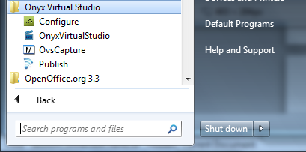

Download the installation files from the web link supplied to you in to a folder.

Launch the setup application by double clicking Setup.Exe.

# User Account Control Permissions

This application is not certified by Microsoft yet. The Windows pops up a dialog box requesting permission to install the application. Select “Yes” to continue the installation.

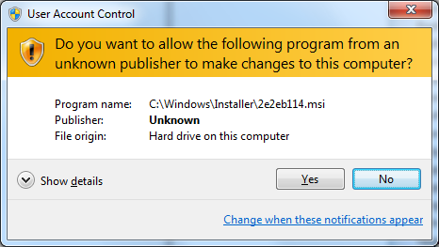

# Copyright warning

The installer issues a copyright warning that needs to be accepted to continue with installation steps.

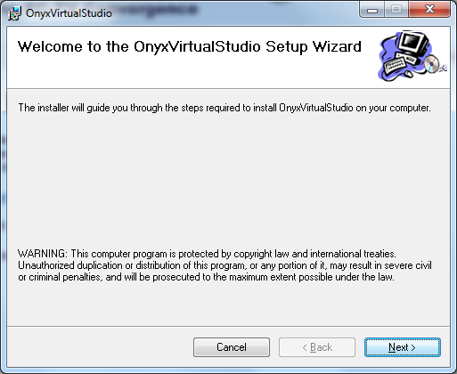

# Specify Installation Folder

The installer prompts for the installation folder. You may accept the default or specify a folder to install the application binaries. You can also specify whether installation is restricted to single user (by selecting “Just me”) or all the users (by selecting “Everyone”).

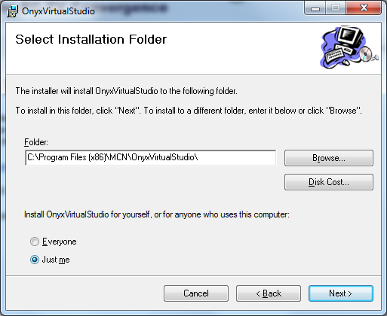

# Confirm Installation

The installer prompts for the confirmation of continuing with the installation.

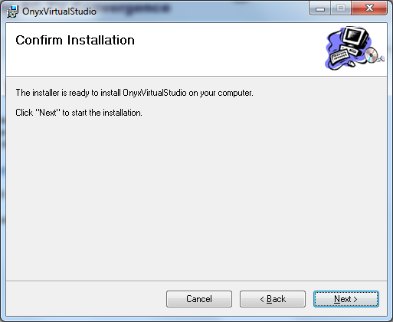

# User Account Control Permissions

The Windows pops up a dialog box requesting permission to install the application. Select “Yes” to continue the installation.

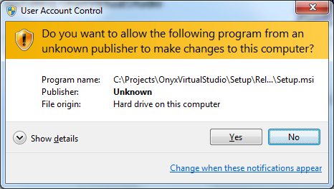

# Successful completion of installation

After successful installation the following screen will be shown.

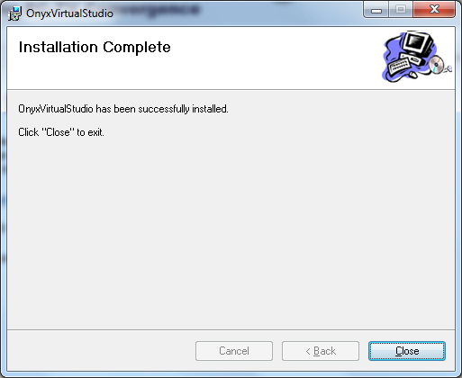

Section

2

Using the application

t

he application can be launched from the windows start menu as shown in the following screenshot. Use the “Onyx Virtual Studio / Configure” tool to configure the input and output streams used for a streaming session.

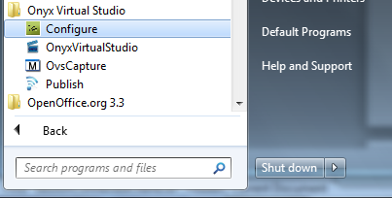

# Configuring the application

Onyx needs to be configured to indicate incoming and outgoing streams. The configuration UI is shown below. The configuration application needs to be launched and configure the system, before launching the onyx virtual studio.

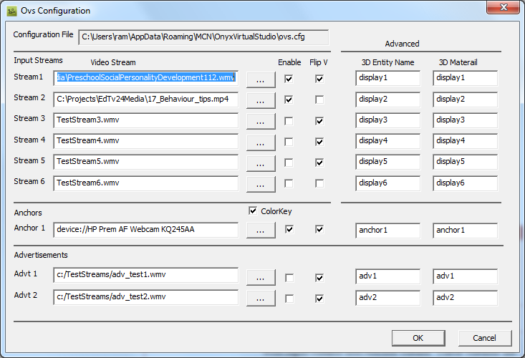

There are four categories of video input streams as shown in the dialog box named as “Input streams”, “Anchors” and “Advertisements”.

Stream Section

|  |  |
| --- | --- |
| Format | Description |
| Input Streams | Up to six streams can be selected for composition. The stream location can be selected by clicking button labeled “ …” which pops up a dialog box shown below. Check the enable option to use it in a session. For WMV streams and MJPEG camera feeds check “Flip Vertical” box. |
| Anchors | Choose this option select stream that can be positioned interactively in the 3D scene. |
| Advertisements | Specify up to two streams that can be composited along with input streams and Anchor stream. These streams are overlaid at the bottom of the view. |

Advanced options will allow mapping of video displays to different 3D objects (specified by entity name and material name pair).

The input stream can originated from any of the sources that include

* Local File : WMV or MP4 container with H264 and AAC
* Camera : MJPEG Camera that support VGA resolution
* RTSP : RTSP Server with H.264
* Skype : Skype video participant (Future Release)
* SIP : SIP Video Phone (Future Release)

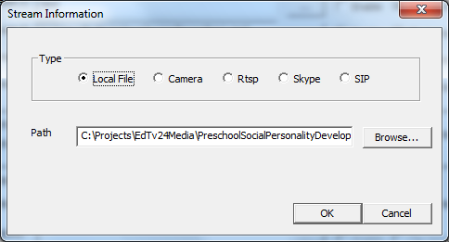

A local file can indicated either by directly entering in to the edit control or selecting through browse button.

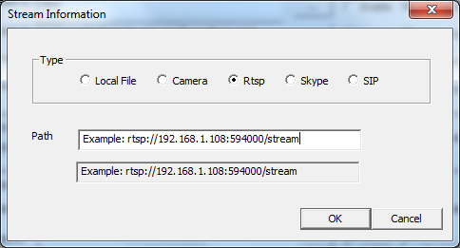

An rtsp file can indicated as shown in the dialogbox above.

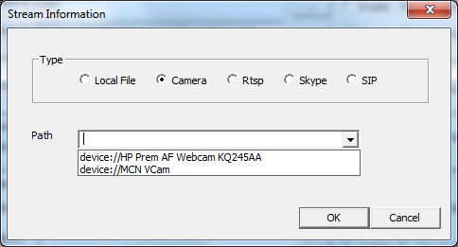

The camera source can be selected using a combo box as shown above.

# Launching the application

The application can be launched from the windows start menu as shown in the following screenshot. Select the “Onyx Virtual Studio” program form the menu.

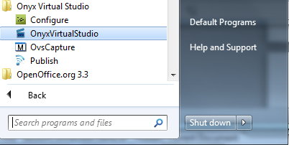

# Configuring the OGRE rendering engine

When the application is launched first time, a dialog box pops and prompts for the OGRE rendering engine options. Select ‘Direct3D9 Rendering subsystem’ from the ‘Rendering subsystem’ combo box options. Leave the remaining parameters to the defaults.

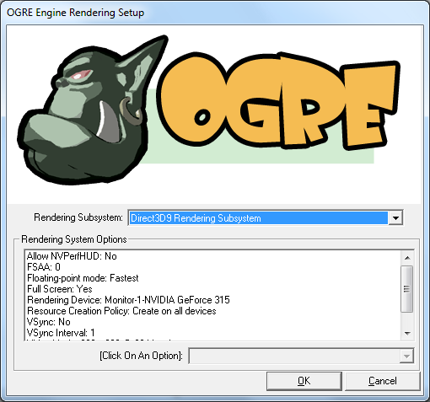

# Camera Control

The content of the capture window being broadcast or stored to a file is controlled by the hidden entity called camera. The position and orientation of the camera specifies the section of the composited 3D scene. The camera (capture window) can be repositioned using the following commands

|  |  |
| --- | --- |
| Key | Function |
| Up Arrow | Move the camera in to the scene (zooming up) |
| LeftShift + UpArrow | Move the camera in to the scene at faster speed |
| Down Arrow | Move the camera away from the scene (zooming down) |
| LeftShift+ DownArrow | Move the camera away from the scene at faster speed |
| Left Arrow | Move the camera to left |
| LeftShift + LeftArrow | Move the camera to left at faster speed |
| Right Arrow | Move the camera to right |
| LeftShift + RightArrow | Move the camera to right at faster speed |
| PageUp | Move the camera upwards |
| LeftShift + PageUp | Move the camera upwards at faster speed |
| Page Down | Move the camera downwards |
| LeftShift + PageDown | Move the camera downwards at faster speed |
| Mouse MoveLeft | Rotate camera on vertical Y axis (Yaw) |
| Mouse MoveRight | Rotate camera on vertical Y axis (Yaw) |
| Mouse MoveUp | Rotate camera one vertical X axis (Pitch) |
| Mouse MoveDown | Rotate camera one vertical X axis (Pitch) |
| 1 to 8 | Orient the camera to show the specified stream |
| 0 | Orient the camera to default position |
| 9 | Orient the camera to show the Anchor |
| Q | Save the camera position for stream with focus |
| LeftShift + Q | Reset the camera position of default stream |

# Stream Control

Input or output streams can be controlled using the following keys.

|  |  |
| --- | --- |
| Key | Function |
| P | Toggle play/pause state of the stream. |
| O | Restart the stream |

# Anchor Control

Anchor object can be repositioned used following keys.

|  |  |
| --- | --- |
| Key | Function |
| J | Toggle between visible and hide state. |
| U | Move the anchor object away from the camera |
| M | Move the anchor object towards camera(depth) |
| H | Move the anchor object left |
| K | Move the anchor object right |
| I | Move the anchor object up |
| N | Move the anchor object down |
| Y | Scale up the anchor object |
| B | Scale down the anchor object |
| T | Rotate clockwise. |
| G | Rotate anti-clockwise. |
| F | Change focus to other anchor object. |
| X | Lock/Unlock the anchor object relative to the camera |

# Miscellaneous Control Keys

|  |  |
| --- | --- |
| Key | Function |
| L | Choose different background |
| V | Toggle advertisement panel visibility |
| Esc | Exit application. |

Section

3

Application Use Cases

t

he application can be launched from the windows start menu as shown in the following screenshot. The application can be controlled using keys listed below.

# Making Technology Tutorials

Onyx allows creation of video tutorials that can incorporate the following features compared to the traditional web tutorials.

* Facilitate active engagement of the student participant. The session may involve one or more students that represent the target audience along with the teacher using local of networked camera feeds (such as Skype).
* Integrate several instructional media such as film material, PowerPoint presentations and pre-recorded lab sessions related to the course easily.
* Make the student feel as though he is in a traditional classroom environment.

Following are the suggested guidelines to prepare a and present a tutorial using Onyx. For illustration, we select a programming course using Matlab.

* Choose a 3D scene suitable for the session
* Capture Matlab sample tutorials in to an mp4 file.
* Convert your PowerPoint slides (related to theory) in to a wmv file. You can choose ‘save as’ option and select wmv format in Microsoft PowerPoint.
* Connect two camera feeds i.e. one for the teacher and one for the student.
* Configure camera feed with the teacher as an Anchor stream and enable Chroma key.
* Configure Onyx to capture audio from ‘Stereo Mix’ recording interface.
* Specify capture filename in ovs.cfg.
* Configure Onyx for live broadcasting using Amazon S3 service. (Refer Onyx User Manual Vol 3.)

Use the camera commands to control the presentation view. For example while explaining theoretical concepts camera may focus on PowerPoint presentation and the teacher. While presenting the lab session camera may focus on the corresponding stream.

# Creating HTTP Live Video Channel

Onyx can be used to create a live streaming channel with the content that interests different interest groups, but cannot afford a dedicated TV Channel. Onyx provides very cost effective distribution system for live content over the Internet. Future version of Onyx is provided as a cloud service and can be used on demand and does not require dedicated platforms.

Following is a use case scenario for creation of live channel:

* Choose a 3D scene suitable for the session
* Setup Onyx to receive remote streams corresponding to the participants..
* Connect local camera feeds corresponding to the local participants.
* Configure local camera feed as an Anchor stream and enable Chroma key.
* Configure Onyx to capture audio from ‘Stereo Mix’ recording interface.
* Specify capture filename in ovs.cfg.
* Configure Onyx for live broadcasting using Amazon S3 service. (Refer Onyx User Manual Vol 3.)

Use the camera commands to control the presentation view. Change the stream layout on the fly to present TV like viewing.

Section

4

Platform Requirements

O

nyx uses cross platform 3D rendering engine for compositing streaming frame work based on DirectShow on windows and Gstreamer on Linux. It currently uses codec compression libraries that work well on Intel platforms. Future version also will be available as a service in the Cloud (Amazon EC2). Onyx also ingrates with Skype for supporting remote video feeds which is currently under certification process. Future versions of Onyx also support video feeds from SIP phones. For broadcasting the streams over Internet using S3, user needs to obtain Onyx Virtual Studio distributed by Amazon (currently under approval process).

# System Requirements for Windows Desktop

* Graphic card that supports D3D9 or OpenGL 3.0
* Soundcard with support for ‘Stereo Mix’
* Intel processor i5 2.4 GHz or above is recommended.
* Microsoft Windows 7
* Optional Onyx HW Adaptor for 1080p resolution support