Volume

2

MCN Technologies Inc

Onyx Virtual Studio Software Tools

OVS Capture

User Guide

ONYX VIrtual studio SOftware components

OVS Capture User Guide

© MCN Technologies Inc

45401 Research Avenue

Fremont, CA 94539

Phone 510.943.4469 • Fax 408.854.8214

Table of Contents

About the tool 1

Audio and Video Formats 1

Installation 1

Using the application 2

Launching the application 2

System Tray Icon 2

Popup Menu 3

Configure Capture 3

Start Capture 4

Capture Status 5

Pause Capture 5

Resume Capture 5

Sop Capture 6

Playing the captured stream 6

Section

1

About the tool

OVSCapture is a tool used to capture the video output by Onyx Virtual Studio and mic input in a continuous mode and create an mp4 file, HTTP Live streaming file. This tool can also be used to capture the activity on the desktop such as operation sequence of a software application. The captured file can be used as training material for the students that try to learn the software application. This desktop capture is intended to create video streams that can be imported to Onyx Virtual Studio.

# Audio and Video Formats

The tool captures the desktop at full resolution and converts in to H.264 video and AAC audio streams and saves in MP4 container format. The capture frame rate depends on the power of the CPU available on the system.

Installation

This tool is installed as part of Onyx Virtual Studio installation.

Section

2

Using the application

t

he application can be launched from the windows start menu as shown in the following screenshot. The application runs the background and installs a system tray icon to control the application.

# Launching the application

The application can be launched form start menu as shown below.

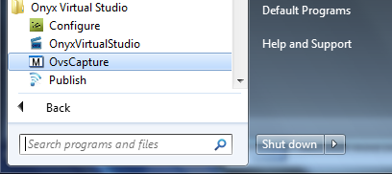

# System Tray Icon

After launching the application an icon will be shown as follows in the right side of the windows task bar. If the icon does not appear, use show hidden icons option to make it appear on the task bar.

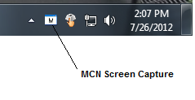

# Popup Menu

Right click on the icon to bring the popup menu.

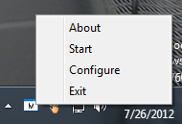

# Configure Capture

Selecting “Configure” menu item from popup menu brings the following dialog box. Select the name of the file to save the captured data.

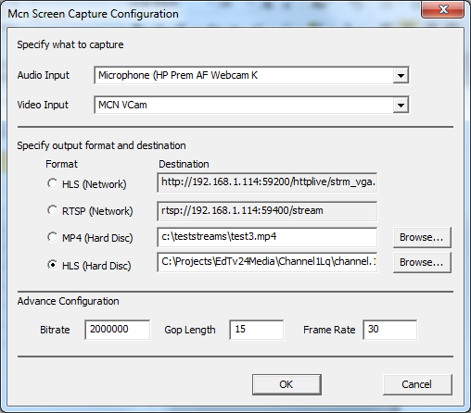

Click the “Audio Input” drop down list button to see the available audio input devices. Select the input device to record audio or select “Do not capture audio” option to ignore audio capture.

Click the “Video Input” drop down list button and select the desktop to lab sessions. Select “MCN VCam” for creating compressed stream of Onyx Virtual Studio generated video.

Select output file format of mp4 or HLS and specify the file. You can also select the rtsp server option and the stream will be sent over the network to an rtsp client. The address displayed in the box can be used by rtsp client to connect to this server.

Select the video bitrate and GOP Length. The suggested range for bitrate is from 512000 to 4000000. The suggest GOP Length is 15 to 300.

# Start Capture

Right click on the icon to bring the popup menu.

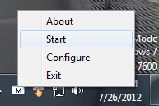

# Capture Status

Move the mouse over the McnScreenCap icon and the size of the video captured will be shown. The status is displayed only for mp4 format.

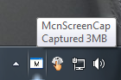

# Pause Capture

Right click on the icon to bring the popup menu and select pause option with left mouse button. The capture will be paused.

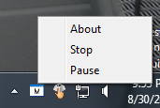

# Resume Capture

Right click on the icon to bring the popup menu and select resume option with left mouse button. The capture will be resumed.

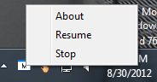

# Sop Capture

Right click on the icon to bring the popup menu and select stop option with left mouse button. The capture will be stopped.



# Playing the captured stream

Use an MP4 player such as VLC, QuickTime-Pro or windows media player to play the stream.