Volume

3

MCN Technologies Inc

Onyx Virtual Studio Software Tools

EdTV Sample Application

ONYX VIrtual studio SOftware components

EdTV24 Sample Application

© MCN Technologies Inc

45401 Research Avenue

Fremont, CA 94539

Phone 510.943.4469 • Fax 408.854.8214

Table of Contents

About the tool 1

Supported devices 1

Infrastructure 1

Using the application 2

Launching the application 2

Application Framework 6

Customization of the application 8

Setup of the application on Http Server 8

Populate the channel information 8

Populate the archives information 9

Publishing the Channel 11

Section

1

About the tool

EdTV24 is a sample web application that shows the typical steps for hosting content produced by the Onyx Virtual Studio on internet. EdTV24 shows how to host both online and offline content either on Internet or a LAN.

# Supported devices

The content distributed by EdTV24 can be accessed through iPhone/iPad, Android, Chrome browsers on PC and safari on Mac (needs testing).

# Infrastructure

EdTV24 requires Http server with php support and mysql database.

Section

2

Using the application

O

nce the application is hosted on a server, it can be used to navigate the streaming content and play it. This shows the UI of the application and the following sections describe the framework and steps required for hosting the application.

# Launching the application

On the client device’s browser such as safari on iPhone or Google Chrome on PC (connected to Internet) enter the website [*www.edtv24.com*](http://www.edtv24.com).

The webpage shows a list of channels. By selecting a channel, it gives brief description of the channel and allows the user to enter the channel. Once the channel is selected it launches an external link that will be streaming live or offline video using HTTP Live streaming protocol.

EdTV24 is hypothetically presenting a live streaming site that has video channels for all categories of students ranging from preschool to undergrads.

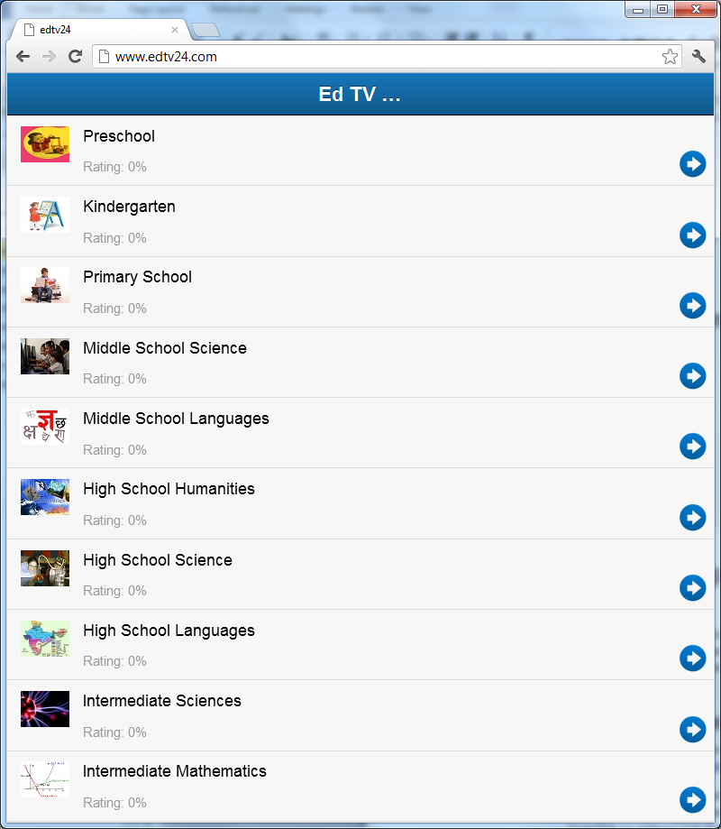

The above home page of edtv24 shows all the hosted video channels that can be accessed over Internet. User can select a channel and see the description of the page and enter the channel. (Only the channel “Preschool” is active for testing)

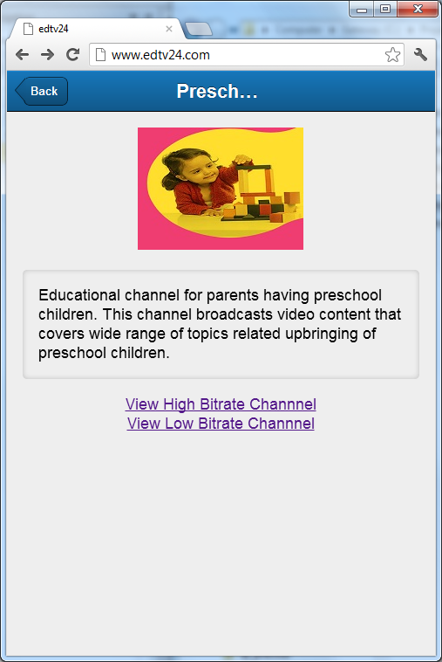

Once the “View Channel” is selected, the browser is given a video streaming link that contains offline or live content served from the same Http server or a different streaming server.

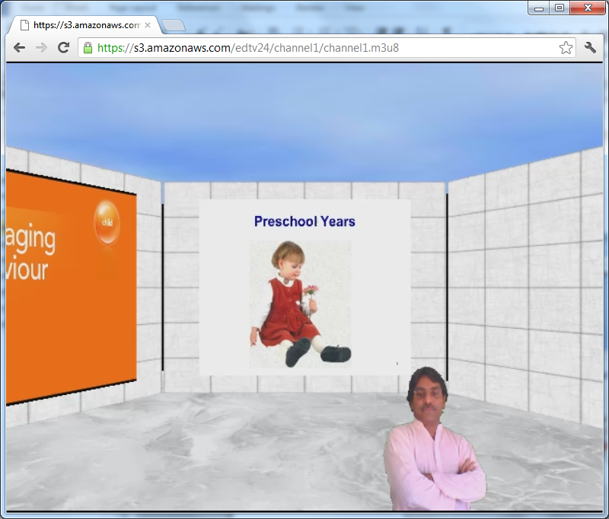

The Http Live Streaming player which is a browser plugin accesses the content from the streaming server and plays it. Player works in two modes namely live streaming and offline content. Apple devices support both the modes. Chrome supports only offlline streaming.

Section

3

Application Framework

The web application uses database driven web service on the server and on the client it uses Sencha Java script library

Streaming Server

MySQL

PHP

Web Browser

HTTP Server

HLS Player Plugin

EdTV24

Web Service

Sencha Js Ext Lib

Video

Channel Database

Video Content

Following is the brief description of the framework components:

* EdTV24 Web Service: The PHP file edtv24.php hosted on the web server enables a web service. It supplies the information of hosted video channels, retrieved from the database to the client using the JSONP data format.
* Sencha Js Ext Library: The client side application uses open source java script library available at the following site. This library provides uniform interface across desktop and smartphone devices and makes it easy to wrap web application as a native application and make it available through app store. <http://www.sencha.com/products/touch/download/>
* Video Channel Database: The information related to video channel is maintained in a MySQL data base.
* HLS Player: An HTTP Live streaming player is embedded in Chrome player and natively available on iPhone and iPad.
* Streaming Server : HTTP Server hosting live or offline video content generated/formatted using Onyx Virtual Studio. Amazon S3 or equivalent server can be used for the server. For offline content, it is a regular HTTP server. For live content, the server should support REST API as documented in the following link.

<http://docs.amazonwebservices.com/AmazonS3/latest/API/APIRest.html>

Onyx Virtual Studio can be configured either to output the HLS content directly to the streaming server or it can be saved on the hard disc and then uploaded manually.

# Customization of the application

In this section, we present the customization of the application, while hosting your own web application.

1. Application title: In the file “\app\view\MainNav.js” change the EdTV24 to the name of your choice.
2. Web API Server: In the file “\app\model\Archive.js” and “edtv24\app\model\Channel.js” change the host addresses “www.edtv24.com” to your hosting server.
3. Create a MySQL Data base with a name of your choice. Import the SQL file edtv24.sql that creates two tables namely channels and archives. Populate the tables with channel information as explained below.
4. Change $username, $password, $database in channels.php and archives.php

# Setup of the application on Http Server

1. Extract the file in app.zip to your http server www folder.
2. Rename app.html to index.html

# Populate the channel information

The following table describes fields of the channel table. The number of channels entered in this table appears in the home page of the web application. When use selects a channel, the information that includes image specified in poster page, synopsis and current program appears. It also creates two buttons and associates stream links specified in the fields named as urllq and urlhq. It also creates a button named archives to fetch archives list from the database.

|  |  |
| --- | --- |
| Column Name | Description |
| id | Unique channel id with the format chnxxx. This id is used in archives table to indicate category. |
| title | Title of the channel up to 255 characters |
| synopsis | Name of the channel |
| thumbnail | A jpeg image. Recommended size 54x40 |
| poster | A Jpeg image. Recommended size 190x140 |
| urlhq | Location of the high quality stream.  Example http://192.168.1.114/media/channel1hq/channel1.m3u8 |
| urllq | Location of the high quality stream.  Example http://192.168.1.114/media/channel1lq/channel1.m3u8 |
| program | Name of the current program in the channel. |
| rating | Popularity rating based on user feedback. |

# Populate the archives information

The following table describes fields of the archive table. This table contains video archives of all the channels. The table is queries usually based on channel_id to retrieve the archives associated with a channel. When an archive is selected, the details of the archive is shown similar to details of channels/current program.

|  |  |
| --- | --- |
| Column Name | Description |
| id | Unique archive id number. |
| channel_id | Channel id where this archive was played. |
| title | Title of the channel up to 255 characters |
| synopsis | Name of the video |
| thumbnail | A jpeg image. Recommended size 54x40 |
| poster | A Jpeg image. Recommended size 190x140 |
| urlhq | Location of the high quality stream.  Example http://192.168.1.114/media/channel1hq/channel1.m3u8 |
| urllq | Location of the high quality stream.  Example http://192.168.1.114/media/channel1lq/channel1.m3u8 |
| rating | Popularity rating based on user feedback. |

Section

3

Publishing the Channel

This section describes the tool used for publishing the video stream created using Onyx Virtual Studio.

Launch the OvsPublish tool from windows startup menu.

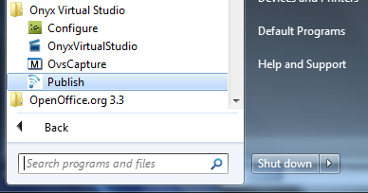

Use the dialog box shown below to upload the video stream to Amazon S3 for making the channel available over Internet.

* Obtain the Access ID and Security from Amazon AWS management console for your account and fill in the dialog box.
* Select the folder by clicking the “Browse” button in the dialog box.
* Specify bucket name that created using Amazon management console.
* Specify the folder where video stream is uploaded in the “Video Channel” edit control.
* Click the “Start Upload” button.

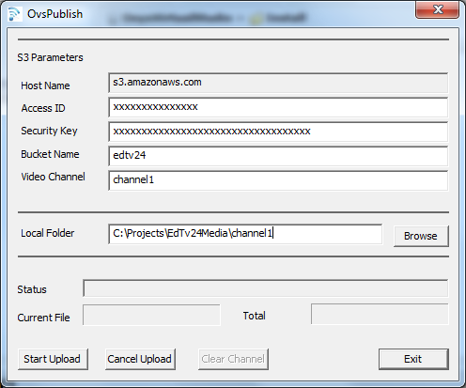

The folder location can be used in the channel description in the database to create the link in the webpage generated as described in the previous sections.