**How To Reset Your Forgotten Windows 10 User Account Password**

This article shows howto reset user's password if it is forgotten.

Brief Steps:

* + Make a bootable USB with Windows 10 Installation Media
  + (On locked PC/Notebook) Boot with USB, enter DOS command window
  + Replace "Utilmam.exe" with "cmd.exe"
  + Remove USB and reboot.
  + Click the assistance icon to bring up DOS command window
  + Enter this DOS command: net user "user_name" new_password
  + Exit DOS windows, login Windows using the new_password
  + Remember to restore back the Utilman.exe program in step #3.

Details:

1. **Make a bootable USB (or CD)**
   * Visit https://www.microsoft.com/en-us/software-download/windows10 or search for "Create Windows 10 installation media"

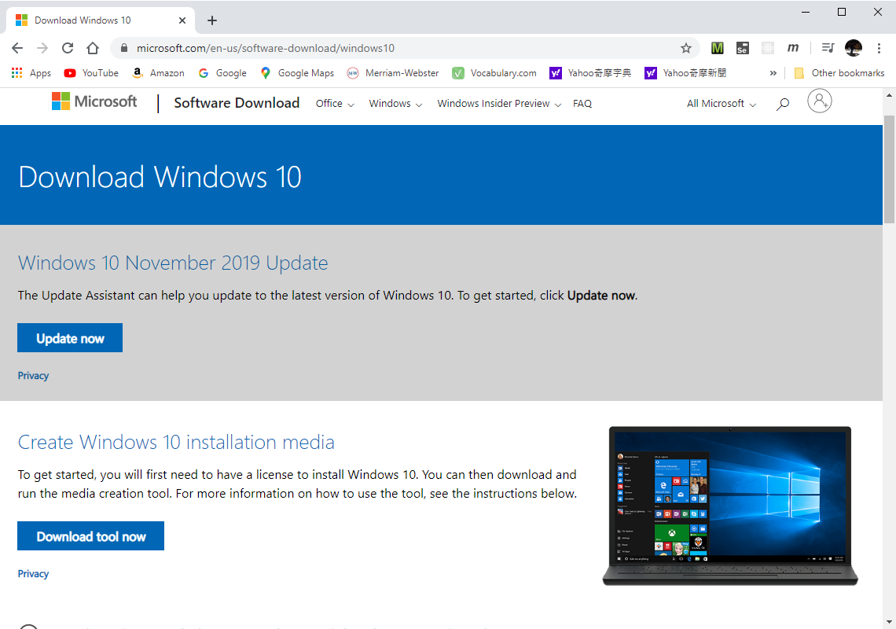

* + Download the file MediaCreationTool1909.exe, double click, when the screen "Applicable notices and license terms" shows up, click "Accept"

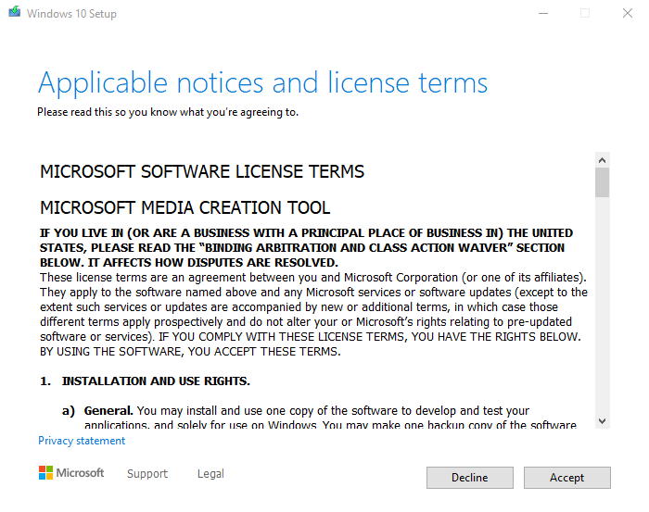

* + Select “Create installation media (USB flash drive, DVD, or ISO file) for another PC”, then click “Next”

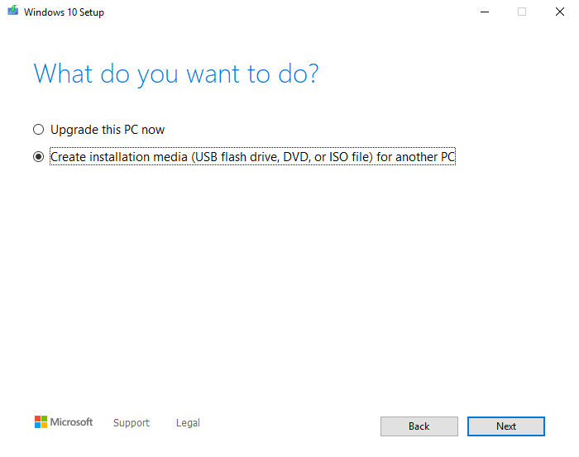

* + In the window “Select language, architecture, and edition, review the options that meets the target system (the notebook or PC that is locked by the forgotten password), then click “Next”

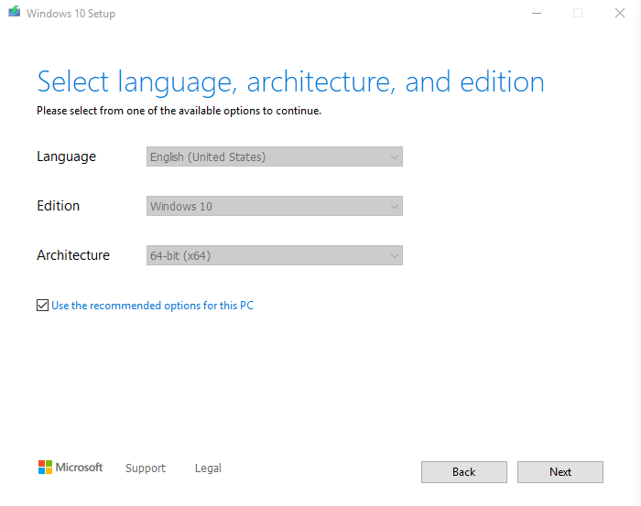

* + In the window “Choose which media to use” Select “USB flash drive” (or ISO file) then click “Next”

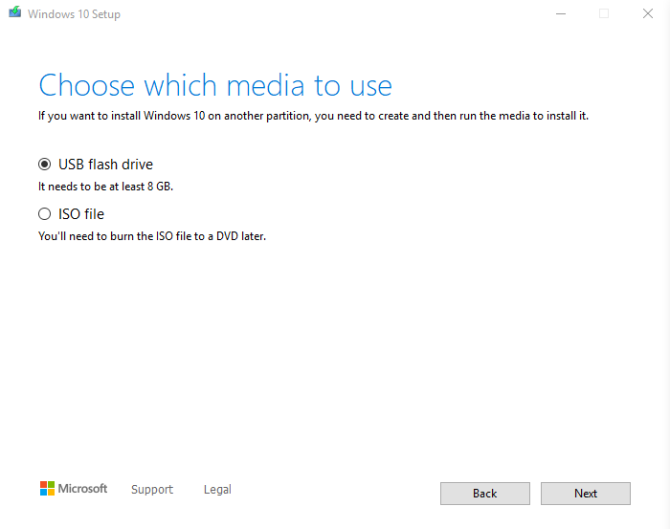

* + The program will then start to download and write the Windows 10 installation program to USB flash drive.

1. **(On locked PC/Notebook) Boot with USB, enter DOS command window**
   * (For Dell machine) After pressing the power button, wait till seeing the Dell logo, press “F12” to enter BIOS setup. Select boot from USB

(Option: UEFI: 1100, Partition 1)

* + When seeing Windows Setup screen, press “Next”
  + Click “Repair your computer”
  + Select “Troubleshoot”, and then select “Command Prompt”. This will bring up DOS command prompt (with the prompt showing “X:\Sources>”

1. **Repalce "Utilmam.exe" with "cmd.exe"**

DOS> cd c:\windows\system32

DOS> rename Utilman.exe Utilman_bak.exe

DOS> copy cmd.exe Utilman.exe

1. **Remove USB and reboot.**
2. **Click the “Ease of access” icon to bring up DOS command window**

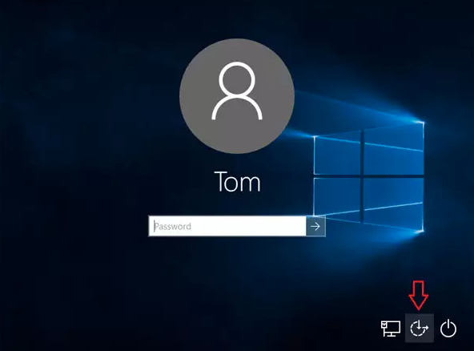

1. **Enter this DOS command: net user "user_name" new_password**

DOS> net user “user name” new_password

* + For example, to set new password “12345” for user “John Doe” :

DOS> net user “John Doe” 12345

* + If we want to grant this user the administrator privilege, we can:

DOS> net localgroup administrators “John Doe” /add

1. **Exit DOS windows, login Windows using the newly assigned password**
2. **Restore back the Utilman.exe program in step #3.**