MOBIUS Release Notes - December 2025

Contents

LOCATE Local Release Notes 2
Item View & Metadata Enhancements 2
Search and Discovery Enhancements 2
User Tools and Personalization 5
Requesting & Access Improvements 7
Visual & UI Enhancements 8
Additional Integrations 8
Defect Fixes 8
LOCATE OpenRS Release Notes 9

Below is a categorized summary of all features included in the Dec 2025 release to MOBIUS customers for Local and OpenRS LOCATE, introducing a wide range of enhancements across metadata display, search capabilities, and personalization tools.
- Full release scope on Connect
- Mobius Customer MOBIUS_Dec2025Deployments.xlsx

LOCATE Local Release Notes

Item View & Metadata Enhancements
- Move RTAC Configuration Option
Configuration to reposition RTAC table at the bottom of the page with a jump-to CALL TO ACTION. It also includes breaking out subjects into LC subjects and other subjects.
- Detail View Updates
Metadata on the detail page is reorganized with new fields and layout improvements. All FOLIO instance note types are visible, unless marked staff only. Please keep in mind that notes in the MARC record only appear if mapped to the FOLIO instance record.
- Holdings Notes Display
Public “Holding Notes” from FOLIO holdings records are now visible in Locate to improve metadata transparency.
- Enhanced Holdings Data Display & UI Redesign
Holdings-level metadata is now grouped above the RTAC table which has been visually improved for better scanability.
- Custom Alternative Title Type
Alternative titles can now be displayed directly under the title on the detail page using a custom “Alternate Graphical Representation” title type through configuration. All other alternative titles will be displayed further down the page under the titles section. The chosen configured title (Usually 880s which are linked to a 245) will now map to ‘Alternate Graphical Representation’ in alternative title types. This will also be displayed on the search results page and dashboard pages. It should only be displayed when the alternative title is present, and a new feature flag LC_ALTERNATIVE_TITLE is enabled. These values are also searchable through both keyword and title searches.
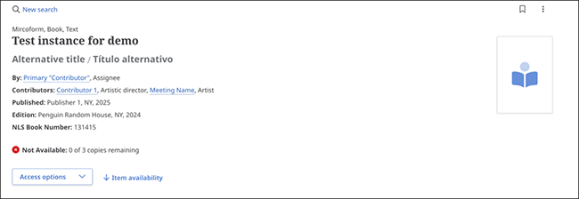

Search and Discovery Enhancements
- Subject Browse Experience
Users can browse subject headings linked to catalog records, enriched with authority metadata and persistent links. Note that this functionality is still in Beta at this time.
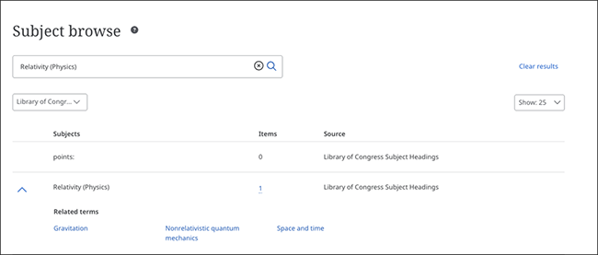
- New Facets
Users can now use “Contributor,” “Organization,” and “Genre/Form” facets to narrow their search results.
  - Contributor facet: Instance level Contributor field with type Personal Name
  - Organization facet: Instance level Contributor field with type Corporate Name
  - Genre/Form facet: based on the Subject Heading Genre/Form subtype
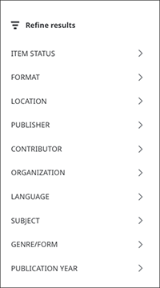
- Facet Search Capability
Users can search within facet values to quickly locate relevant filters, even when facets contain hundreds of options.
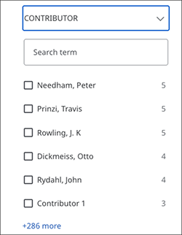
- Date Facet and Sort Improvements
Locate now uses controlled date fields from FOLIO for more accurate publication year filtering and sorting.
- Context-Sensitive Help
Inline help messages are now available across keyword, browse, and advanced search views.
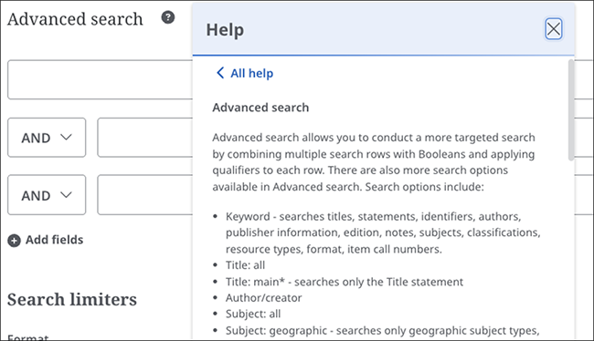
- New Subject Type and Source Logic
Subject metadata is now differentiated by source and type, with Genre/form subjects displayed separately and linked to secondary searches.
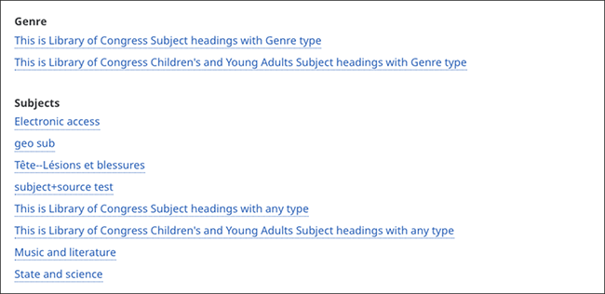
- Place of Publication and Subject: Geographic Search Filters
A new advanced search option allows filtering by Place of Publication, Series and Subject: Geographic search filters.
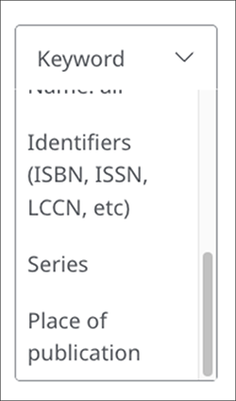
- Advanced Search Expansion
Additional filters for Title: Main and Name: Personal are now available through configuration, improving precision for researchers.

User Tools and Personalization
- Search History and Recently Viewed Records
Users can view and manage their search history and recently viewed items, with support for saving and re-executing queries.
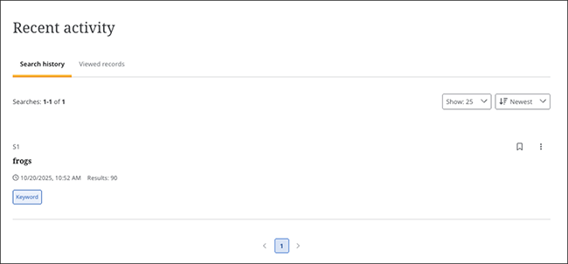
- Session Management for Guest and Authenticated Users
Saved items and history persist across browser tabs for guests and are retained permanently for authenticated users. A 20-hour inactivity timeout is enforced.
- Save Records to Favorites
Users can save records for later use, with sorting, printing, and citation options. Guest saves are session-based; authenticated saves persist.
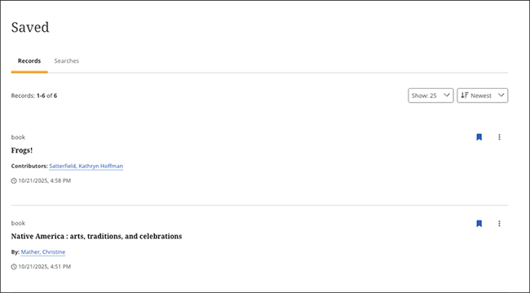
- Email Metadata to Patron
Users can email record metadata directly from Locate using a modal dialog, with support for multiple recipients.
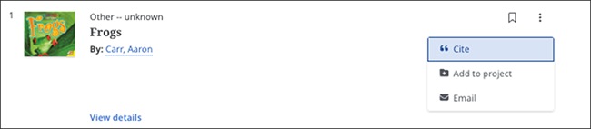
- Citations
Users can create citations from records in APA, Chicago, or MLA citation styles
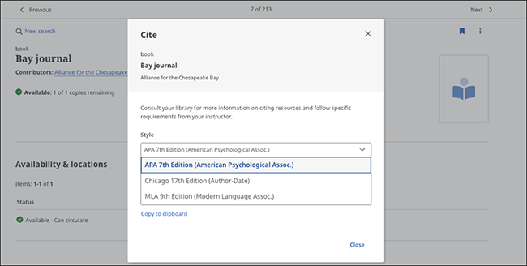
- Projects Dashboard and Folder Organization
Authenticated users can organize saved items and searches into folders, annotate them, and share with collaborators.
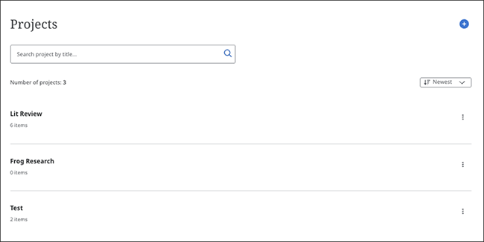

Requesting & Access Improvements
- Dynamic Pickup Locations
Pickup locations are now dynamically exposed based on patron group and item-level request settings, improving accuracy.
- Requesting for Holdings Without Items
Locate now supports placing holds on records with holdings but no items, a common scenario for serials and special collections.
- Request Workflow Enhancements
Library, location, and volume info will now display for specific copy requesting
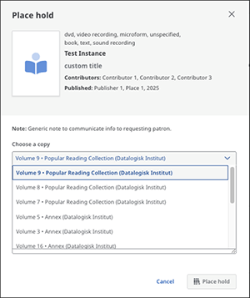

Visual & UI Enhancements
- Default Cover Image by Format
Cover images which reflect the source type of a record, can now be configured, if desired, helping users visually identify item formats. Icons must be selected from a predefined library.
- No Results Messaging Update
Improved messaging guides users when searches return no results, with suggestions and a CALL TO ACTION to clear filters.


Additional Integrations
- Librarian Chat Service Integration
Libraries can configure a chat service link on every Locate page, allowing patrons to contact librarians directly.
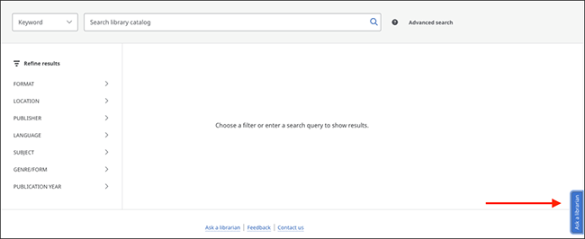

Defect Fixes
- Fixed errors in call number browse.
- Resolved issue with renewing items that have fees.
- Corrected sorting behavior by publication year.
- Fixed record printing issue.
- Due date display corrected.
- Special character search and indexing issues resolved.
- Suppressed records no longer appear in search results or through direct links.
- Bib record visibility and enum/chron display issues addressed.

LOCATE OpenRS Release Notes

- Originally deployed with local Locate, the Contents/Summary section is now available in OpenRS Locate.
- Originally deployed with local Locate, the Organization and Contributor facet is now available in OpenRS Locate.
- OpenRS Locate now supports a pickup library selector and corresponding selected pickup locations for patrons placing picking up items at a consortial library other than their own.
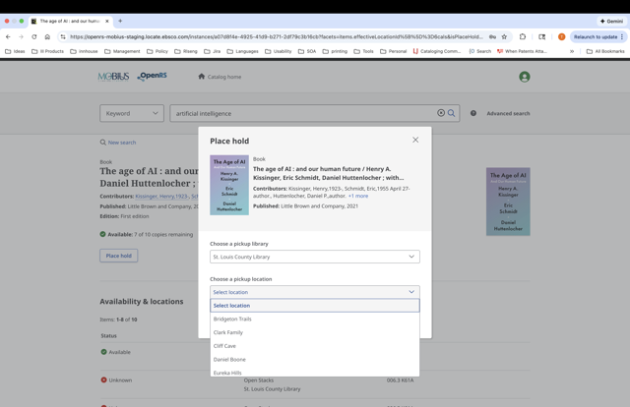

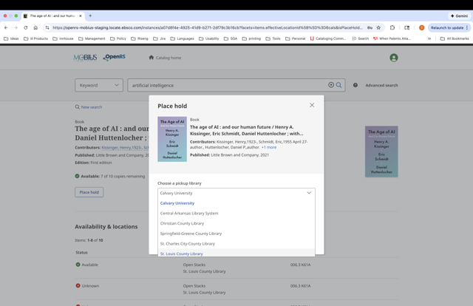

- OpenRS Locate now provides a way to filter search results by one or more member library holdings.
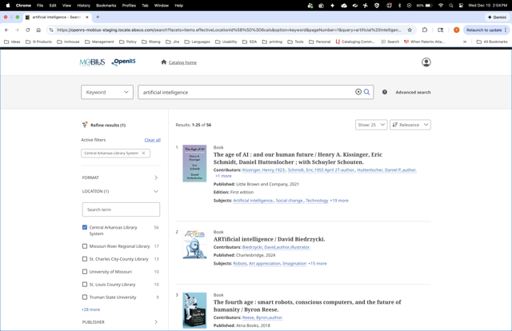
- Display of the number of holds, due dates and volume statements for each item in the detailed holdings display.
- Multiple search enhancements to improve search for titles with diacritics, special characters and length of titles
- Improved user messages for error or failure cases
- Consistent application of the “unavailable” status

