Charlotte’s Healing Hands, LMT
Client Information

Personal Information:
Name: _________________________________ Date of First Visit: _____________

Address: _____________________________City/State/Zip: ____________________

Home Phone: ___________ Work Phone: ____________E-Mail: ________________

Date of Birth: __________ Sex (Circle one): M F Referred by: ________________

Emergency Contact: ________________________ Phone: _____________________

Previous Bodywork/Exercise Information
Have you had professional massage therapy or bodywork before?
Yes ⁭ No ⁭ If yes, where and what type?___________________________________

How often do you receive massage therapy? _________________________________

Do you exercise regularly? Yes ⁭ No ⁭ Type? ___________How Often:__________

Do you stretch regularly? Yes ⁭ No ⁭ Type? ___________How often? _________

Stress Level
What is your current stress level? (Circle one number) Low 1 2 3 4 5 High

Do you feel that your stress is Positive ⁭ Negative ⁭ Both ⁭?

Do you feel anxious Often ⁭ Sometimes ⁭ Seldom ⁭? Explain?
_____________________________________________________________________

Do you feel depressed Often ⁭ Sometimes ⁭ Seldom ⁭? Explain?
_____________________________________________________________________

How many hours do you sleep on average? _____

Do you wake up feeling Rested ⁭ Tired ⁭ Other ⁭? Explain?
_____________________________________________________________________

Specific Complaints or Pain Issues
What complaint or pain brought you to the clinic? ____________________________
_____________________________________________________________________

Where is the pain located in your body? ____________________________________

When did the pain begin? ________________________________________________

How did the pain begin? _________________________________________________

What activities or actions aggravate or give rise to the pain? ____________________
_____________________________________________________________________

Is your pain chronic or sporadic? ________If sporadic, how often, and when does your pain occur? _______________________________________________________

What activities or body positions relieve your pain? ___________________________
_____________________________________________________________________

Is the pain or discomfort Dull ⁭ Sharp ⁭ Achy ⁭ Other ⁭ Explain? _____________________________________________________________________

Does the pain prevent you from falling asleep or wake you from sleeping?
Yes ⁭ No ⁭

Are there activities you cannot perform due to your pain? Yes ⁭ No⁭ Explain? _____________________________________________________________________

What would you like to achieve in your massage session? ______________________
_____________________________________________________________________

Medical History
Are you currently under the care of a physician or other health care professional?
Yes ⁭ No ⁭ If yes, for what condition? _________________________________

Name of health care professional? _____________________City ________________
Phone ___________________

Are you taking pain relief medication? Yes ⁭ No ⁭ If yes, please indicate the type(s) of medication you are currently taking and for how long? ________________
_____________________________________________________________________

Do you have allergies? Yes ⁭ No ⁭ If yes, please list allergens. ____________
_____________________________________________________________________

Please indicate (including year) if you have had any broken bones, serious physical trauma, surgeries, hospitalizations, childhood accidents, tailbone injuries, or head injuries. ______________________________________________________________
_____________________________________________________________________
_____________________________________________________________________
_____________________________________________________________________
_____________________________________________________________________
_____________________________________________________________________
_____________________________________________________________________

Circle the areas on the models below which identify your area(s) of current, acute, or chronic pain. Rate them by number; #1 = the greatest discomfort or pain.
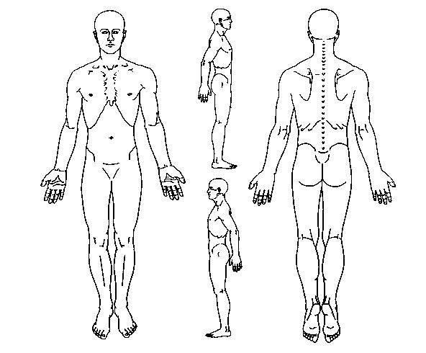
I understand that massage therapy services are in no way a substitute for examination, diagnosis or treatment by physician. I understand that individuals providing massage therapy services are not qualified to diagnose, prescribe or treat any physical or mental illness and are not qualified to perform spinal or skeletal adjustments. I acknowledge that any information I receive from individuals performing massage therapy services is educational in nature and is to be used at my own discretion. I have stated all medical conditions of which I am aware and will update my practitioner of any changes in my health status. I agree to communicate with my practitioner any time I feel my wellbeing is being compromised. If at any time I feel uncomfortable for any reason, I will ask the therapist to cease the massage and the therapist will end the session. The massage techniques that may be applied include myofascial release, trigger point release, soft tissue manipulation, hydrotherapy, hot/cold therapy, Swedish massage techniques and energy work.

Client signature: __________________________________________Date:_________

Therapist Signature: _______________________________________Date:_________

