NCL student Journal, 2018, 0-0, Publication Date: 06 June 2018

Category, DOI: xxxx/nclsj/xxxx

[Software Repository](https://github.com/dinikayame/biodynamo/tree/v1.0.0)

Software DOI: [10.5281/zenodo.1308730](https://doi.org/10.5281/zenodo.1308730)

A computational model of neuronal migration and layer formation in the human retina

Dinika Paramalingam1, Roman Bauer2, Marcus Kaiser3

1School of Computing, Newcastle University, NE4 5TG UK

2Institute of Neuroscience, Newcastle University, NE2 4HH UK

3School of Computing, Newcastle University, NE4 5TG UK

Corresponding author: Dinika Paramalingam (Email: [d.d.paramalingam2@newcastle.ac.uk](mailto:d.d.paramalingam2@newcastle.ac.uk))

ABSTRACT

Understanding the development of the human retina is essential for scientist to better understand how certain diseases develop, for example and how drug therapies could aid treatments. At the moment, most computational models of the retina were done in a different species or of a specific disease or stimulus such as oxygen levels. In this paper, we developed a model based on an external substance to show how the various retinal cells migrate and form the layers of the retina using BioDynaMo. The model has been simplified to the 5 main cell types - ganglion cells, amacrine cells, bipolar cells, horizontal cells and photoreceptors (rods and cones). Differentiation of cells occurs by having biology modules, a feature in BioDynaMo, for each cell type to define its characteristics and migration criteria to its final resting position. Migration occurs based on an external substance excreted in the environment to form the retinal layers. The overall retinal layer thickness in the model is measured and compared against known experimental data to see if it can reproduce the characteristics of human retinal development. Although the model developed is a simplification of human retinal development, it does support my hypothesis that the model is able to reproduce the characteristics of cellular migration and layer formation. Recommendations for further studies have also been made to further develop the complexity of the retina.

Index Terms BioDynaMo, Computational Model, Retinal Development

# 1 INTRODUCTION

Computational models on the eye such as the retina has been limited in comparison to other research topics on the eye such as cortical visual processing which focuses on how neurons in the brain responses to visual images(1). Though there has been retinal models being developed before, it has been less intensive as compared to other parts of the eye(2). Hence, reviewed that it is essential for “further modelling work” as well as collaborations with theoretical/ experimental studies when it comes to the retina.

Many developmental disorders can affect how our retina grows. Finding a solution to pinpoint how and where the defects are and how it can affect our sight is crucial for patients, scientists and medical practitioners. Traditional experimental methods that scientists use are in vivo and in vitro. Both approaches require a lot of time and are costly. On top of that, in vivo techniques will require a whole, living organism such as an animal as the test subject. In the UK, “animal research is carried out only where no practicable alternative exists and under controls which keep suffering to a minimum”(3)*.* Though it is kept to a bare minimum, there is always room for improvements to reduce the number of animals used for testing.

In silico simulations provide an attractive solution to such challenges. Replacing live tests with computational models, for example, can provide more flexibility when modifying or manipulating a system. This provides scientists with a better way to understand and predict any developmental defects in the retina on top of experiments which have been done before.

For the models to be created, suitable softwares are needed for scientist to use. An example of such software that is used in developmental neuroscience is Cx3D. Along those lines, the software BioDynaMo, which is inspired by Cx3D, constitutes a general software framework for the simulation of biological dynamics. It is written in C++ to allow high performance computing and parallelism without the overheads that Java has such as using a virtual machine (4).

The project aim is to create a computational model of the biological dynamics, generating the basic architecture of the human retina in a biologically plausible way using BioDynaMo. The main focus will be on the development of the five major retinal layers outer nuclear layer (ONL), outer plexiform layer (OPL), inner nuclear layer (INL), inner plexiform layer (IPL) and ganglion cell layer (GCL) (Figure 1).

Figure 1. Diagram of the retinal layers in the human eye. The four cellular layers are the outer retina (i.e. retinal pigment epithelium and photoreceptors (rods (R) and cones (C)) layer), inner retina (i.e. bipolar (B), horizontal (H), amacrine (A) and muller glial cell (M) and ganglion cell (G) layers) (2).

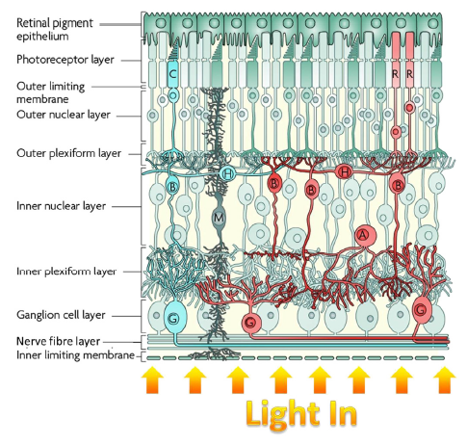

The overall retinal thickness from the computational model will be measured and tested against results collected in literature using Optical Coherence Tomography (OCT) (Figure 2). The hypothesis is that computational model can reproduce the characteristics of human retinal development, while the null hypothesis is that it will not be able to. In this project, the focus will be on retinal thickness measurements as a way to evaluate the model.

Figure 2. OCT scan of the human central retina (5)

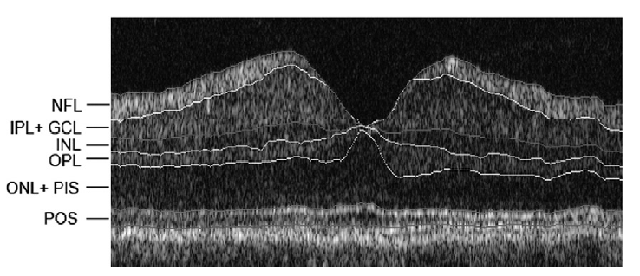

# 2 RESEARCH METHODS AND MATERIALS

## 2.1 Parameters for each cell type and overall retinal thickness range

The parameters used for each cell type and overall retinal thickness range are taken from the values obtained from literature. The following table shows the diameters used for each cell type in the model:

Table 1. Parameters used for each cell type in retinal model.

|  |  |
| --- | --- |
| **Cell Type** | **Diameter (in μm)** |
| **Ganglion Cell** | 11 |
| **Amacrine Cell** | 9 |
| **Bipolar Cell** | 9 |
| **Horizontal Cell** | 8 |
| **Cone Cell** | 2 |
| **Rod Cell** | 2 |

The decision to set the cell parameters as seen in Table 1 was an estimate of values from the various literature read. The ganglion cell diameter on average in a study showed that on average it will be around 10 - 11μm within 0° to 15°, which is the central retina, including the macula (6). Cell diameters for amacrine cell, bipolar and horizontal cell came from Kolb et al.‘s study (7,8). The cell diameters for these were estimated based on the diagrams from the study and excluded the dendrites (i.e. only considering the perikarya of the cell to capture the cell diameter). Amacrine cell diameter in the model was estimated roughly to have a diameter of 9μm. On the midget cone bipolar cell, fmB size within the 4.5mm (15°) region was taken into account for this project which estimated to approximately 9μm. H1 horizontal cell sizes were approximately 8μm with a dendritic field of 25μm within 2.5mm (8.3°) region. Cell sizes for cones and rods are rounded up to 2μm (9,10).

Table 2. Range of retinal thickness measurements taken by OCT for the adult human retina.

|  |  |  |
| --- | --- | --- |
| **Literature** | **Retinal thickness range (in μm)** | **Retinal thickness mean (in μm)** |
| **Chan et al. (2006) Foveal 500μm radius** | 192 ~ 232 | 212 |
| **Bagci et al. (2008) Automated segmentation thickness of IPL + GCL, INL, OPL, ONL+ PIS** | 147 ~ 267 | 207 |
| **Bagci et al. (2008) Manual segmentation thickness of IPL + GCL, INL, OPL, ONL+ PIS** | 143 ~ 269 | 206 |

The baseline for modelling uses the thickness range that is the largest using Bagci et al. (5) manual segmentation thickness. The maximum bounds for the model was 250μm and the measurements from the model will be tested against this range to conclude if it produces an accurate reading.

## 2.2 Model Simulation and Visualisation

Each retinal cell type was modelled as an individual BaseBiology module in BioDynaMo. The functions and behaviour of each cell type was programmed here.

An external substance was then added to the model to aid cell migration. A stopping criteria was set to each cell type to form the layers of the retina. Table 4 shows the stopping criteria for each cell type based on the level of concentration for the external substance in the environment.

Table 4. Migration stopping criteria for each cell type set in the final model developed. The stopping criteria is set in the BaseBiologyModule for each cell type as seen in the example earlier in this chapter *(highlighted in yellow)*. The results of how layer formation is in Figure 3.

|  |  |
| --- | --- |
| **Cell Type** | **Level of concentration to stop** |
| Ganglion Cell | < 0.0000025 |
| Amacrine Cell | < 0.0000002 |
| Bipolar Cell | < 0.000000045 |
| Horizontal Cell | < 0.000000037 |
| Photoreceptors (rod and cone) | < 0.000000002 |

The model was then visualised using a plugin, ParaView. ParaView is an open source application that aids visualisation of two- and three-dimensional data sets which have been incorporated into BioDynaMo. By simply adding a configuration file into the project, visualisation can be done.

A Glyph Filter will be used to differentiate cells. The filter generates a glyph (i.e. an arrow, cone, or sphere for example) at each point in the input dataset which can be orientated and scaled. The filter also provides colouring to aid visualisation of cell types which is useful when it comes to differentiating cell types.

Given the timeframe for this project, the model has been simplified to exclude dendritic process which occurs after cell migration. Therefore the spaces between each cell type is an estimate of where the cell’s final resting place is assuming the dendritic process has occurred.

Figure 3. Final model after adjusting scheduler settings, stopping criteria for each cell type, cell diameters. Model was generated using a random seed, 381. Model shows some gaps between cell types. This is to take into account that some cells have dendrites and in this project, dendrites are not modelled due to time constraints. *(From bottom up, photoreceptors - rod (blue), cone (dark blue), followed by, horizontal cells (light blue), bipolar cells (beige), amacrine cells (orange) and ganglion cells (red)).*

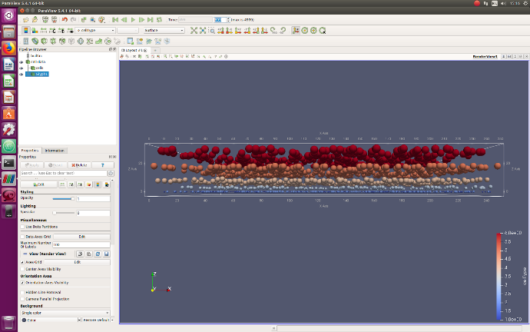

# 3 RESEARCH FINDINGS

## 3.1 Formation of Retinal layers

An example of how the retinal layers form is shown in Figure 28. The figure shows all cell types starting at the same position and slowly migrates to their final resting positions. A video link of how the cells migrate can be found in the appendices.

The cells have been differentiated from the beginning and generated randomly within the fixed x- and y-axis bounds. The cells then migrate along the z-axis based on the external substance concentration in its environment.

Figure 4. An example of cell migration. All cell types are differentiated from the beginning and start at the same position and migrate to its final resting position to form distinct layers in the retina model. (Model’s Random seed = 65)

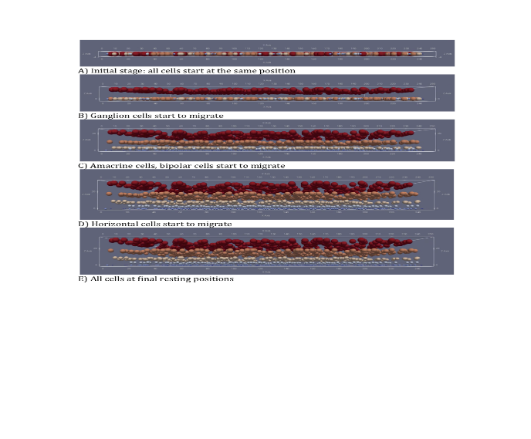

All cell types start at an initial position and the ganglion cells (Figure 4, B) are the first to migrate with the help of an external substance in the environment. As the concentration of the substance increases, other cells start their migration process. Once a certain level of concentration has reached, the individual cells will stop its migration process and lie in their final resting position (Figure 4, E).

## 3.2 Individual Results

Once the model has been generated 15 times, measurements are taken for the overall retinal thickness.

Measurements for each model were taken from the top of the highest cell (in red) to the base of the lowest cell (in blue and dark blue) as shown figure 5.

Figure 5. Measurements were taken from cells from the base to the last/highest cell from the top (white dotted lines) and calculated based on the scale as shown.

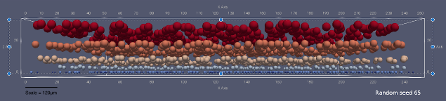

The results are in the table below (Table 3) and plotted as shown in Figure 6.

Table 3. Individual retinal model results. Thickness measurements are calculated based on the scale and are rounded to the nearest whole number.

|  |  |  |
| --- | --- | --- |
| **Random Seed** | **Thickness Measurement**  **(in μm)** | **Rounded values** |
| 65 | 203.88375 | 204 |
| 97 | 202.7187 | 203 |
| 121 | 202.7187 | 203 |
| 166 | 203.88375 | 204 |
| 198 | 205.0488 | 205 |
| 262 | 210.87405 | 211 |
| 331 | 203.88375 | 204 |
| 349 | 207.3789 | 207 |
| 381 | 206.21385 | 206 |
| 647 | 206.21385 | 206 |
| 704 | 205.0488 | 205 |
| 705 | 207.3789 | 207 |
| 709 | 208.54395 | 209 |
| 724 | 203.88375 | 204 |
| 856 | 206.21385 | 206 |

Figure 6. Bar graph of individual retinal thickness measurements from the model generated for each random seed. The thinnest value was 203μm (models 97 and 121) and the thickest retina was from model 262 with a thickness of 211μm.

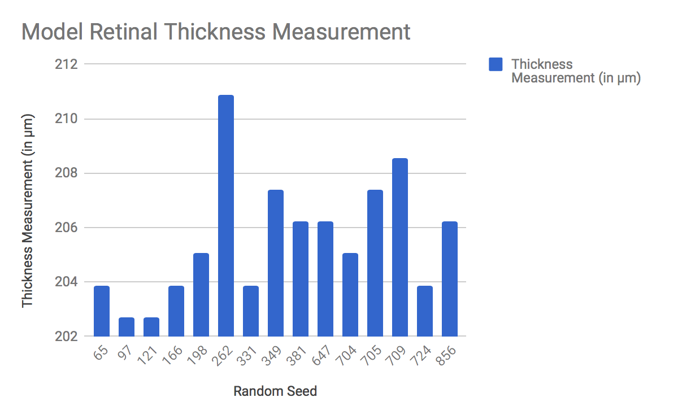

## 3.3 Comparison of results

Upon obtaining the individual model results, it is then compared against the mean thickness value from literature and the mean for the models was also calculated and plotted as seen in Figure 6 and a table of values in Table 4.

Figure 6. Comparison graph of individual results generated by the model against the mean from literature (206 μm, in red) and the computational model mean (207 μm, in orange).

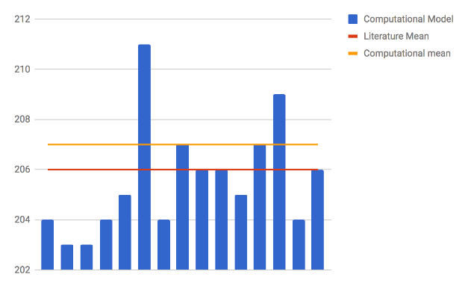

Table 4. Comparison table of thickness mean and range between known values in literature and those generated from the models.

|  |  |  |
| --- | --- | --- |
| **Data Source** | **Mean (in μm)** | **Thickness Range (in μm)** |
| **Literature** | 206 | 143 ~ 269 |
| **Computational Model** | 207  (Rounded to the nearest integer) | 203 ~ 211  (Rounded to the nearest integer) |

# 4 DISCUSSION

## 4.1 Graphical simulation of cell differentiation and layer formation

Generation of each cell type at the initial position has been consistent throughout the initialisation of all 15 models as visualised in ParaView (Figure 4). The layer formation has also been consistent with the ganglion cells (in red) migrating first, followed by the amacrine cells, bipolar cells and horizontal cells. The photoreceptors, rods and cones, remain at its initial position as to how it behaves based on literature (11).

## 4.2 Thickness measurements

Validation of the model with experimental data has been shown to be consistent for each random seed with a mean retinal thickness of 207 μm and standard deviation of +/- 4 μm across all 15 models (Table 3, 4). In comparison to the thickness values found in literature, the models do produce a value that is constant and has a mean thickness value off by 1 μm.

## 4.3 Repeatability and reproducibility of model

Based on the thickness values obtained and compared against the values from literature, the model does produce stable results despite being randomly generated across all 15 models. Therefore showing that the computational model is able to consistently reproduce the human retinal architecture in a similar fashion to show cell migration and layer formation.

# 5 CONCLUSION

The aim of this project was to create a computational model of the basic architecture of the human retina through knowledge of how the retina develops. The model was to show if it is possible for the computational model to reproduce such characteristics.

To accomplish this, a computational model of the five main retinal cell types were created to simulate cell migration and layer formation in the retina. The model is a simplified version of how the retina develops, with the use of an external substance to aid migration of cells to their final resting position. Differentiation of cells occurs at the beginning with each cell type defined in an individual BaseBiologyModule with its characteristics specified. As the level of concentration of the external substance increases over time, each cell type will have a stopping criterion to set their final resting positions and form distinct layers of the retina.

To test if the model is consistent in reproducing these characteristics, the retinal thickness is chosen as a way of quantifying the quality of the model. The overall retinal thickness in the model is measured and compared against known data in literature obtained by Stratus OCT.

It was demonstrated in this project that retinal structure can be recapitulated with simple growth rules in a biologically plausible way. The models produced had a mean thickness value of 207 μm (+/- 4). This falls within the range that is known in literature and does support that the model is able to provide consistency with each random seed. However, this project is a simplified model with factors such as the dendritic process that occurs after cell migration and the fact that in most layers there is an overlap of cell types, not taken into account. The data that the model is compared to is using OCT which, unlike immunostaining, it is non-invasive and data collected are mostly from adults. Therefore, the model developed is a representation of an adult retina development as opposed to how it develops at various stages from a fetus. The aim has been met, however, to fully depict how the retina develops from a fetus, for example, more studies are required.

# ACKNOWLEDGMENTS

# I would like to thank my supervisors, Roman Bauer and Marcus Kaiser, and Jean de Montigny for their patience and continuous feedback and guidance during the course of the project.

# REFERENCES

1. Heeger DJ, Simoncelli EP, Movshon JA. Computational models of cortical visual processing. Proc Natl Acad Sci USA. 1996 Jan 23;93(2):623–7.

2. Roberts PA, Gaffney EA, Luthert PJ, Foss AJE, Byrne HM. Mathematical and computational models of the retina in health, development and disease. Progress in Retinal and Eye Research. 2016 Jul 1;53:48–69.

3. Animal testing and research [Internet]. GOV.UK. [cited 2018 Jul 6]. Available from: https://www.gov.uk/guidance/research-and-testing-using-animals

4. Breitwieser L, Bauer R, Di Meglio A, Johard L, Kaiser M, Manca M, et al. The BioDynaMo Project: Creating a Platform for Large-Scale Reproducible Biological Simulations. 2016 Aug 17;

5. Bagci AM, Shahidi M, Ansari R, Blair M, Blair NP, Zelkha R. Thickness Profiles of Retinal Layers by Optical Coherence Tomography Image Segmentation. American Journal of Ophthalmology. 2008 Nov 1;146(5):679-687.e1.

6. Hebel R, Holländer H. Size and distribution of ganglion cells in the bovine retina. Vision Research. 1979 Jan 1;19(6):667–73.

7. Kolb H, Fernandez E, Schouten J, Ahnelt P, Linberg KA, Fisher SK. Are there three types of horizontal cell in the human retina? J Comp Neurol. 1994 May 15;343(3):370–86.

8. Kolb H, Linberg KA, Fisher SK. Neurons of the human retina: a Golgi study. J Comp Neurol. 1992 Apr 8;318(2):147–87.

9. Mustafi D, Engel AH, Palczewski K. Structure of cone photoreceptors. Prog Retin Eye Res. 2009 Jul;28(4):289–302.

10. Philips RM& R. » How big is a photoreceptor? [Internet]. [cited 2018 Jul 6]. Available from: http://book.bionumbers.org/how-big-is-a-photoreceptor/

11. Amini R, Rocha-Martins M, Norden C. Neuronal Migration and Lamination in the Vertebrate Retina. Front Neurosci [Internet]. 2018 Jan 9 [cited 2018 Jul 6];11. Available from: https://www.ncbi.nlm.nih.gov/pmc/articles/PMC5767219/

# APPENDICES

## 1. Layer formation video

A video of how the layers are developed is available [here](https://youtu.be/hirSbBPxpUU).

## 2. Final model code

The code is available on my [github](https://github.com/dinikayame/biodynamo.git) under the branch “retinal_project”.