NCL student Journal, YYYY, 0-0, Publication Date: DD Month YYYY

Category, DOI: xxxx/nclsj/xxxx

Software Repository <<add link to GitHub as a hyperlink>>

Software DOI: 10.5281/zenodo.xxxxxx

Journal Article Title

Author1, co-author2

1School of Computing, Newcastle University, NE4 5TG UK

2School of Computing, Newcastle University, NE4 5TG UK ssss

Corresponding author: First Author (Email: [xxx@newcastle.ac.uk](mailto:xxx@newcastle.ac.uk))

ABSTRACT

This section should include key words or phrases so that readers can easily find it. There should not be any repetitions in this section to ensure searchability is optimal.

Index Terms this can be key words or phrases in alphabetical order, separated by commas.

# 1 INTRODUCTION

Introduction to your project and why you are doing this.

# 2 RESEARCH METHODOLOGIES AND MATERIALS

What methods did you use to solve the problem or address your project? This also includes materials for background/ literature review on current projects/ technologies with similar topics.

Any in text citations should be in square brackets. E.g. [1], [2] or [3,4,5].

Figure titles should be labelled as either one of the followings: “tabl 1.”, “table 1”, “fig. 1” or “figure”. These should be placed above the table or figure. For captions, place them after the table and figure and start the caption with a * as follows: * this is a caption.

# 3 RESEARCH FINDINGS

Place your findings here. This can include any graphs or figures.

For any equations, try using MathType (<http://www.wiris.com/mathtype>).

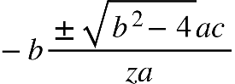

This works with Google Doc as well, simply add the plug in and it will be under “Add-ons”.

Figure 1.

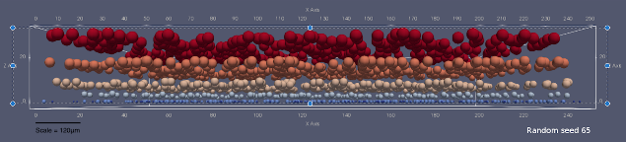

Add your description here.

Table 1.

|  |  |  |
| --- | --- | --- |
| **Data Source** | **Mean (in μm)** | **Thickness Range (in μm)** |
| **Literature** | 206 | 143 ~ 269 |
| **Computational Model** | 207  (Rounded to the nearest integer) | 203 ~ 211  (Rounded to the nearest integer) |

Add your description here.

# 4 DISCUSSION

Link back to your aims and objectives and how it has supported/ not supported your hypothesis

# 5 CONCLUSION

Conclude your project. This should be a paragraph long. Keep it short and precise.

# ACKNOWLEDGMENTS

Thank anyone you would like to for helping you with this project.

# REFERENCES

References should be in Vancouver/ AMA style as follows:

# APPENDICES

Or supplementary materials. Add any tables of results, code, and additional information for readers here. Else, you could upload it somewhere and add a link here.