**HOBO® U20L Water Level Logger Protocol**

**Logger**

* The logger should be encased in PVC to prevent damage from debris etc.
  + Slots or holes should be drilled to allow for adequate water entry
* The logger should not sit on the bottom
* The logger should be deployed in an area will remain wetted
* The logger should be easily removable
* Always attempt to deploy a barometric pressure logger for correction
  + This logger will be deployed in open air near the submerged loggers

Loggers can be deployed for long periods, however, plan on checking them frequently with new staff or until you’re comfortable. Sometimes cages are damaged. Sometimes loggers aren’t deployed accurately. Sometimes things aren’t saved. Things will go wrong! Pay close attention to data management and deployment. You don’t want to leave a dud in the water for 3 months, you don’t want to delete 3 months of data, and you don’t want to lose your logger!

**Site Data to collect at EVERY deployment/check**

1. Location
2. Logger Number
3. Date of Check
4. Time of Last Reading
5. Deploy Time
6. Time of First Reading
7. Logging Interval
8. Name of File
   1. Triple check file is saved before deploying
9. Depth at logger
   1. Depth to bottom
   2. Depth to Logger (bottom-offset)

**Launching a Device**

1. Open Hoboware Pro
2. Connect Device
   1. Connect reader with appropriate head attachment to computer
   2. Attach Logger to connector
   3. Press toggle on connector (light should be green)
3. Check Status
   1. Device>>Status
      1. If device is deployed stop Deployment
         1. Device>>Stop
      2. ALWAYS SAVE DATA PRIOR TO DEPOYMENT, DEPLOYMENTS ERASE DATA!!!!
         1. File>> Save Datafile
            1. Always use dates and locations in filenames
4. Launch Device
   1. Device>>Launch
      1. Check reading interval
      2. Record the time of first reading

**Readout**

1. Pull Logger
   1. Remove any biofilm from logger
2. Open Hoboware Pro
3. Connect Device
   1. Connect reader with appropriate head attachment to computer
   2. Attach Logger to connector
   3. Press toggle on connector (light should be green)
4. Check Status
   1. Device>>Status
      1. Device>>Stop
5. Readout Device
   1. Device>>Readout
   2. Look at data
6. ALWAYS SAVE DATA PRIOR TO DEPOYMENT, DEPLOYMENTS ERASE DATA!!!!
   1. File>> Save Datafile
7. Redeploy (see above)

**Working with Data**

1. Open Hoboware Pro
2. Open datafile
   1. File>>Open Datafile(s)
3. Select the file with the location/date that you’re interested in
   1. A Dialogue Box called “Plot Setup” will open
      1. 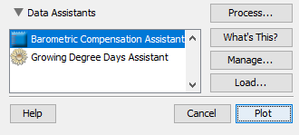Leave default settings, Double Click “Barometric Compensation Assistant” under “Data Assistants”
      2. Make sure “Freshwater” is selected
      3. Enter your reference water level
         1. Can be depth to logger, or elevation of water above sea-level
            1. This should be from the date of deployment and will change with each file that you process.
      4. Enter a Barometric Datafile
         1. This is where your baro logger comes in. Attach the datafile for the corresponding dates.
         2. If you did not deploy a baro logger, you can get this data from a nearby airport, weather station, or university
4. 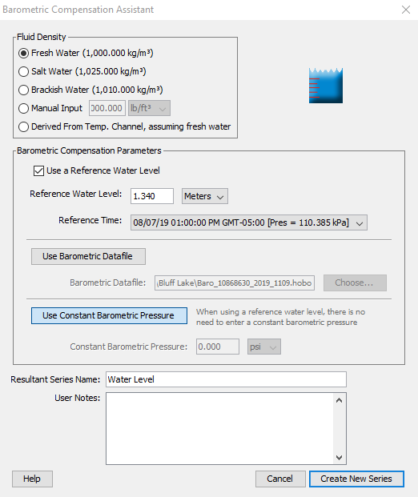Create new series>>Plot
   1. Check out your data! Does it make sense?

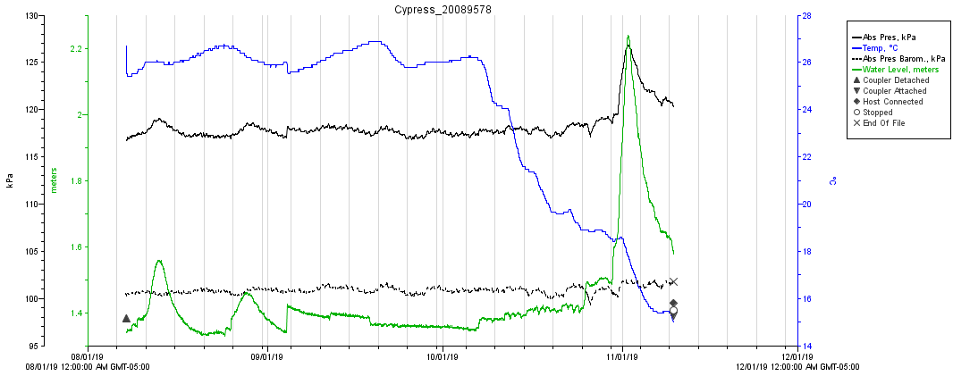

1. File>>Export Table Data or 
   1. Select data that you’re interested in and viola!