**Instantaneous Counts**

Route: Starting from the Upper Levee Access, the parking lot above the Bluff Lake Boardwalk, drive until you reach the Cypress Boardwalk pausing to take recordings of the boats, trailers, cars, or fishing individuals that you see (Reference figure below).

**Guidelines:**

General-

* Pull over or stop at access points as needed to record data. Do not attempt to drive and record data.
* If there are vehicles present near boardwalks, then park and walk onto the boardwalk until you can see the individuals. If they are fishing, record this on the datasheet.

Table 1.

* *Group Size*- This is the number of people fishing together. Ex) -three people in one boat, -two people fishing next to a single car.
* *Location*- This is the area where the anglers are fishing. If the angler is fishing from the bank record one of these sites: S1, S2, or S3. Reference the figure below. If the angler is in a boat write boat.
* *Methods*- Record how the angler is fishing. Ex) one/two/three poles, trotline, jugs, etc.
* *Vehicle-* If the angler(s) are on the bank fishing next to a vehicle(s) record that here.

Table 2.

* Keep a tally here of all the vehicles that you see on the route.

Table 3.

* Keep a tally of possible boat/water craft hauling vehicles at each access. If the vehicle has a boat or canoe trailer attached place the tally in the “Trailer” column. If the vehicle is a truck, or the vehicle (car/SUV) has racks for a kayak record the tally in the “Other” column.

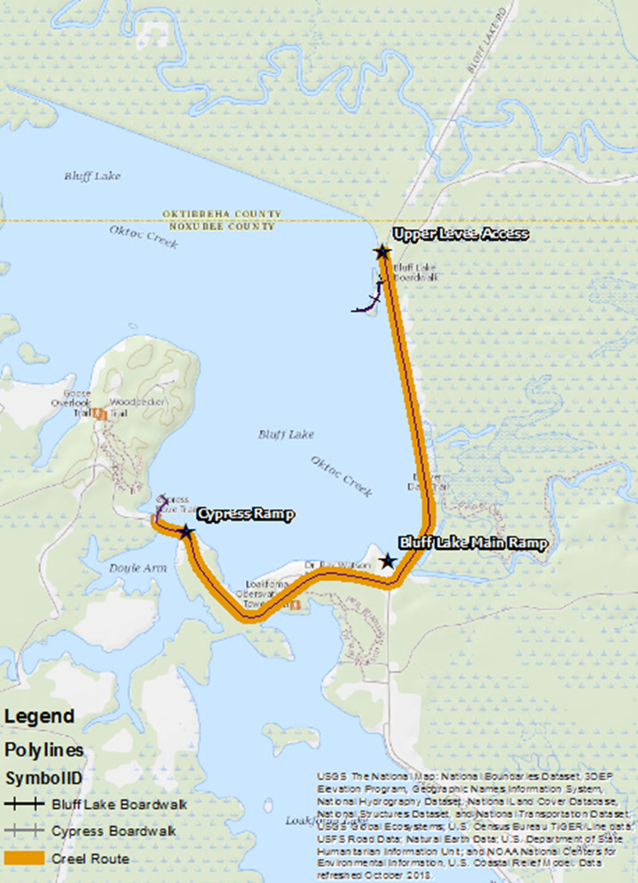

**Roving Creel**

* Sample Selection
  + Each month of the roving creel survey will be considered a block.
  + Within each block dates will be categorized as weekday, weekend, with any holidays classified as a weekend.
  + Survey dates will be chosen by randomly selecting seven sampling dates per time block, three weekdays and four weekends.
  + Each day will be separated into 3 different time categories “morning” from 6-10, “midday” 10-2, and “evening” 2-6. These times will shift later by one hour after daylight savings on March 10th, 2019.
  + During the sampling period each time category will receive equal probability of being sampled. The initial site and direction from which to begin will also be randomly selected.
* Conducting the Creel
  + The creel clerk will start at the selected site and then move either clockwise or counterclockwise around the lake.
  + In the initial circuit, the clerk will conduct an instantaneous count of all anglers. The number of anglers, the groups size, and the fishing method used will also be recorded. The clerk will also log all vehicles parked on the refuge.
  + Once the clerk finishes the initial circuit, they will reverse direction and begin conducting interviews. The creel clerk will complete the creel survey.
  + Any fish will be identified and measured to the nearest millimeter. Individuals of the same species will be combined, and a weight will be obtained to the nearest tenth of a kilogram.
* Calculating effort
  + Angler effort and catch per unit effort will be calculated from interviews and instantaneous counts based on protocols outlined by Pollock et al. (1997).
  + Estimates of catch will be calculated using the Ratio of Means where represents the incomplete catch for the jth angler and is length or the incomplete trip length for the jth angler.