**Protocol for Making Bathymetric Maps in GIS**

**Prep files-**

Bathymetric Data

1. See other protocols
2. You will also need waypoints for shallow areas

Elevation Data (MS)

1. Go to <https://www.maris.state.ms.us/HTML/DATA/Elevation.html> (LIDAR/DEM tab)
2. Find the coverage area that fits your site
3. 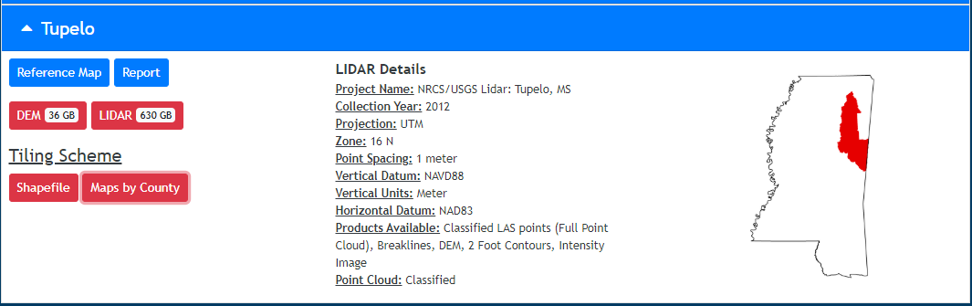Open a new tab looking at the “maps by county”
4. Click on LIDAR
5. Click on your county of interest
6. Match the .las file name with the tile names in the “maps by county” tab that you opened

KML of Water body

1. Sketch your waterbody in Google My Maps
2. Export as KML ***tip: Do not save the KML in a geodatabase.

**ArcMap**

1. Open ArcMap and enable 3D Analyst
2. 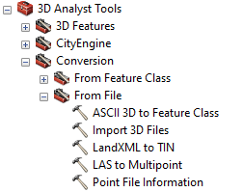Use the “LAS to Multipoint” tool to batch change your las files to points
3. 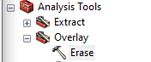Extract your waterbody from the new point layer with the KML you created
4. Plot the waypoints that you took while mapping and find the points that are the closest/overlapping.
5. Then correct your depth data using elevation data in the multipoint file (Excel, save as csv).
6. Add your transect data to the map.