2019-03-05 Meeting with Steve R.

Items:

1) Bluff Lake Update

Bathymetric mapping

* Surveys were completed on 2019-2-16 and 2019-3-2.
* Areas to the north could not be mapped because aquatic vegetation covers the sonar. This area could be potentially accessed by canoe or kayak and individual depths could be taken with a sounding weight.

Creel survey

* Angler interviews
  + Started March 1 with boat season-Two creel surveys have been completed. An excel sheet containing the results is attached.
    - 2019-03-01
      * Eleven individuals were interviewed in a four hour period from 2-6pm.
      * Five individuals were fishing exclusively for crappie, one for bass, and five were fishing for either crappie or bass. 10.54 kg of fish were harvested (0.21 kg/hr, 0.69 fish/hr).
    - 2019-03-03
      * Three individuals were interviewed in a four hour period from 6-10am.
      * Two individuals were fishing for crappie, and one for bass. Two crappie were harvested, but a weight was only obtained for a single 1kg white crappie (0.56 kg/hr, 1.09 fish/hr).
* Instantaneous counts
  + Instantaneous counts from the visitor’s center viewing deck were unsuccessful.
    - Bank anglers concentrate by the cypress boardwalk and cannot be seen. Smaller non-traditional boats are also launched from this ramp.
    - The not traditional boat anglers as well as the standard boat anglers fish the structure around the cypress trees and cannot be seen from the visitors center.
  + Conducted in a single driving pass starting from either the top of the levee or the cypress boardwalk. Bank anglers as well as boat anglers should be counted when possible.
  + Boat trailers, and trucks parked near ramps might be able to substitute for a lack of boat angle visibility.

Fish sampling

* Gillnets and trotlines will be set on the evening of March 14th and pulled on the morning of March 15th. Gillnets and trotlines will be marked with colored floats or balloons.
* Post signage at both ramps warning boaters about deployed nets and lines?

Interns?

2) Bluff Lake release for paddlefish passage

2) Madtoms

* Unlikely to be frecklebelly
* Slender

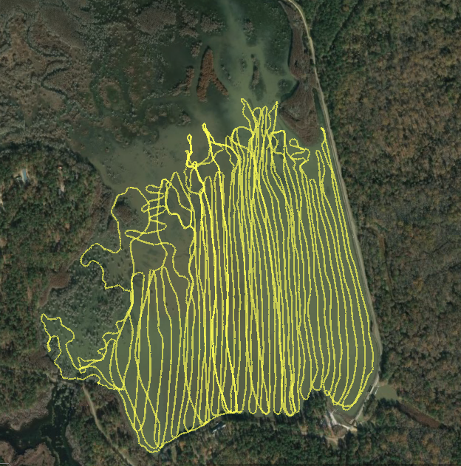

Tracks for areas mapped to develop bathymetric map. Depth values along the lines will be Kriged to estimate the depth surface for 30x30 meter resolution grid or finer.