Simulating Catch Data

# Overview

Simulated catch data was essential to calculating estimates of population abundance and trend using alternative estimators. It is because we could compare the estimates from simulated catch data to the underlying reference population, that we were able to evaluate estimator accuracy and precision. Therefore, simulating catch data was a key component of evaluating varying monitoring designs and their ability to achieve the fundamental objectives identified during the first population assessment program workshop (See Section ??).

The catchability and capture probability of particular gears are important elements of simulating catch data. Since these values are highly uncertain and in some case unknown, we simulate catch data over a range of plausible gear catchabilities.

### Objectives

The objectives of this analysis were to:

1. Simulate 10 years of bend sampling data (i.e. which bends are sampled during which years) for various monitoring designs,
2. Simulate 10 years of catch data for various sampling strategies using bends as the spatial scale,
3. Include information in the catch data that could be reasonably assessed by sampling crews in the field and is relevant to meeting fundamental or sub-objectives,
4. Allow gear catchability to vary over a wide range of values in order to evaluate its effect on monitoring design outcomes, and
5. Simulate several catch data tables per combination of reference population and monitoring design.

### Major Assumptions

1. All fish can be uniquely identified.
2. Fish ids are not lost or overlooked.
3. The sampling protocol is followed without exception.
4. Expected catch, $C$ can be approximated as $C=qfN$, a function of gear catchability, $q$, effort described as the time in minutes a gear is deployed, $f$, and the population size, $N$.
5. Gear deployments are independent of one another and do not interact.

Assumptions 1 and 2, while unlikely to be perfectly met, are reasonable assumptions for working with pallid sturgeon (ref) and are typical assumptions made when working with capture-recapture data (ref). For a well designed sampling protocol, assumption 3 is also a reasonable, although we recognized that it may not be perfectly met due to safety or other unforeseen issues.

Describing expected catch as in assumption 4: $C=qfN=pN$, where $p$ is the capture probability and $p=qf$, is also a commonly made assumption (ref). This equation is likely a good approximation for small effort values ($f$); however, it is clear that as effort increases without bound, capture probability ($p$) will become greater than 1 for fixed $q$. In other words, the model $C=qfN$ breaks down for large effort values, and therefore, we must be cautious drawing conclusions from outcomes that were generated from large effort values. To indirectly account for this we have flagged cases in our simulations where the capture probability is abnormally high.

To understand assumption 5, it is important to first describe the sampling relationship among years, occasions, deployments, and bends. In short, during each year a number of bends will be selected to be sampled. During a particular year, each selected bend will be sampled on several occasions. Occasions are short periods of time, say 24 hours, during which multiple deployments of a gear are used to sample the population throughout the bend. Using this terminology assumption 4 means both that there is a zero probability that the same fish will be caught by two separate deployments (within the same occasion), and that any particular deployment does not affect the probability that a fish is caught by any other deployment within the same sampling occasion. For some gear types these assumptions are very likely met, while with others there are some caveats that we examine in THE DISCUSSION/APPENDIX ??.

# Methods

### Monitoring Designs

For each of the simulated reference populations, various sampling decisions can be implemented to obtain simulated catch data. The choice of monitoring design determines the particular combination of decisions used in this process---system-level sampling design, within bend and year sampling design, gear selection, and measurements taken on individual fish are all prescribed by the monitoring design (Figure 1). Alternative sampling decisions of interest were identified during the PSPAP workshop at the 2017 MRNRC meeting, as well as during follow-up input from stakeholders and experts in the system. Simulated catch data have been generated from the range of the identified alternative sampling decisions, with the exception that some individual measurements have yet to be implemented and the spatially balanced system-level sampling design is still a work in progress.

For each combination of reference population and monitoring design, we simulated catch data (Figure 2) using two major steps:

1. For each year, select which bends to sample.
2. For each occasion, select which individual fish (of those located in the sampled bends) are caught.

### Bend Selection

All monitoring designs considered included sampling bends located within segments 2-4, 7-10, 13, and 14. The number of bends sampled within each segment was chosen to be consistent with past sampling procedures. In particular, we chose the number of sampled bends within segement to match those given in USACE's 2017 PSPAP Guiding Document Table A1 (CITATION) and reproduced in Table 1 below. The way selected bends were generated, however, varied and was determined by the choice of system-level sampling design laid out in the monitoring design. In particular, three alternative system-level sampling designs were considered: a random design, a fixed design, and a spatially balanced design (Stevens and Olsen 2004). Under the random sampling design bends within a segment were chosen each year uniformly at random, while under the fixed sampling design they were chosen uniformly at random for the first year and then fixed to be sampled each of the following 9 years. A combination of the fixed and random designs can also be implemented,and the spatially balanced design is in the works.

While monitoring designs can also differ in decisions made about within bend and year sampling design, gear selection, and measurement choices, none of these decisions affected which bends were selected for sampling each year. They did, however, affect the individual capture histories of the catch data.

### Individual Captures

Once the bends to be sampled were selected for each of the 10 years, 10 years of catch data can be simulated. Each year, catch was simulated spatially at the bend level and temporally at the sampling occasion level. We defined a sampling occasion as a short time period (e.g. 24 hours) within a year during which the given bend was sampled. The fixed number of sampling occasions per year per sampled bend was given as part of the monitoring design of interest. In particular, we simulated catch data for monitoring designs that included 1-4 sampling occasions per year for each sampled bend. Additionally, in order to thoroughly sample a bend during a sampling occasion, several gear deployments are used to capture fish. Currently simulations all utilize 8 gear deployments per sampling occasion; however, future analysis will include catch data simulated for a range of deployment numbers.

For a particular sampled bend during a particular year, each fish located in the given bend had a probability, $p_{occ}$, of being captured during occasion $occ$. This occasion level capture probability varied from bend to bend and occasion to occasion, as it was calculated from individualized deployment catchability and effort values. For each of the 8 deployments within occasion $occ$, an effort value $f$ was generated from a gear and basin specific gamma distribution, and a catchability value $q$ was generated from a gear specific distribution. Deployment specific capture probabilities, $p$, were calculated as $p=q⋅f$, and the 8 within occasion deployment capture probabilities were summed (and bounded at 1) to obtain occasion level $p_{occ}$. Therefore, if a fish was located in the given sampled bend during the given year, its capture was a Bernoulli trial with probability of success $p_{occ}$, resulting in total occasion level catch numbers for the particular bend being binomially distributed.

#### Effort Distributions

Distributions for deployment level effort ($f$) were generated using the PSPAP database. We defined effort as the time (in minutes) that a gear was set, dragged, or pulled for during a single deployment[1]. Since effort was calculated using the start and stop times, all PSPAP data without a start or stop time was excluded from this analysis. The relevant data entries were then merged with the gear data and a stop date column was added to take into account gears that were set over night. Effort was calculated in minutes as the difference between the stop time and the start time with any discrepancies in the set date and stop date taken into account by using the strptime function in R to link the start and stop times to their corresponding set and stop dates, respectively. Before generating the effort distributions, all entries resulting in negative effort values were removed.

Gamma distributions were fit to the cleaned up PSPAP effort data for standard gear types[2] by basin. The mean effort, standard deviation of the effort data, minimum effort, maximum effort, and median effort were also calculated for each gear by basin (Table 2). In general, gamma distributions provided a good fit to the effort data (e.g. Figure 3), but see Appendix ?? for more details.

#### Catchability Distributions

Gear specific catchability distributions were set up such that the log-odds of catchability ($q$) was normally distributed:

$$ln\left(\frac{q}{1−q}\right)∼N\left(μ,β_{0}\right),$$

where $μ=ln\frac{μ_{q}}{1−μ_{q}}$ and $μ_{q}$ is the expected catchability of the gear. Because deployment catchability values, or the probability of catching a single fish with one unit of effort, are a source of uncertainty we allowed the choices of $μ_{q}$ and $β_{0}$ to vary for among catch data simulations (CITE A TABLE OR SOMETHING THAT LISTS RANGES OF PARAMS).

#### Gear Selection and Size Selectivity

The choice of monitoring design also indicates which gears should be used in sampling. This is important as different gears will have different catch rates and associated costs of deployment. Currently, catch simulations include catch data from gill nets, trammel nets, otter trawls, trotlines, or a combination of these.

Additionally, gears may be size selective. In this case different gears will interact with the size distribution of the reference population to produce different catch data outcomes. Because gear selectivity is not precisely known, we are currently accounting for size selectivity by comparing the catch data results simulated under various selction curves. See Appendix ?? for details.

#### Individual Measurements

For a particular bend and year, a Bernoulli trial simulated whether or not an individual fish was captured during each occassion, producing a within year capture history for each fish. Fish that were never captured had their capture histories removed from the data. Fish that were captured had their individual attributes for the given year recorded from the reference population data. Specifically, whenever a fish is successfuly caught its fish id, location (bend), timing (occasion within year) of catch, gear used, and length are recorded.

We have primarily focused on measuring length, as it is vital to the metrics for sub-objective 2[3] as outlined in Section 4.1.1 of the 2016 AM plan. Additionally, we are currently working on including fish sex, origin (natural or hatchery), and age due to their importance to sub-objective metrics and to understanding effective populations size. Several other individual measurements were voiced to be of interest to stakeholders at the 2017 MRNRC PSPAP Workshop. These measurements may be considered as part of future analyses.

##### page break

# Figures

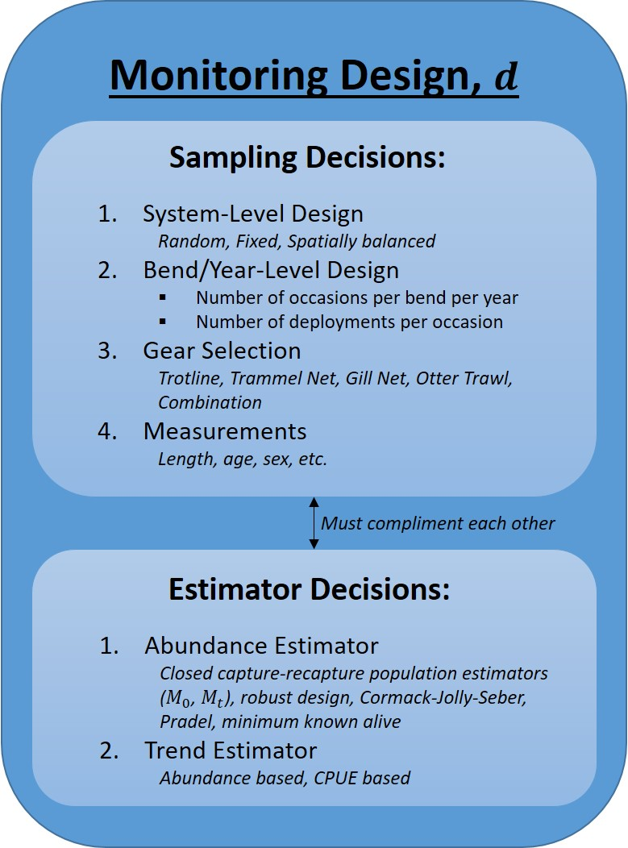

Figure 1.

##### page break

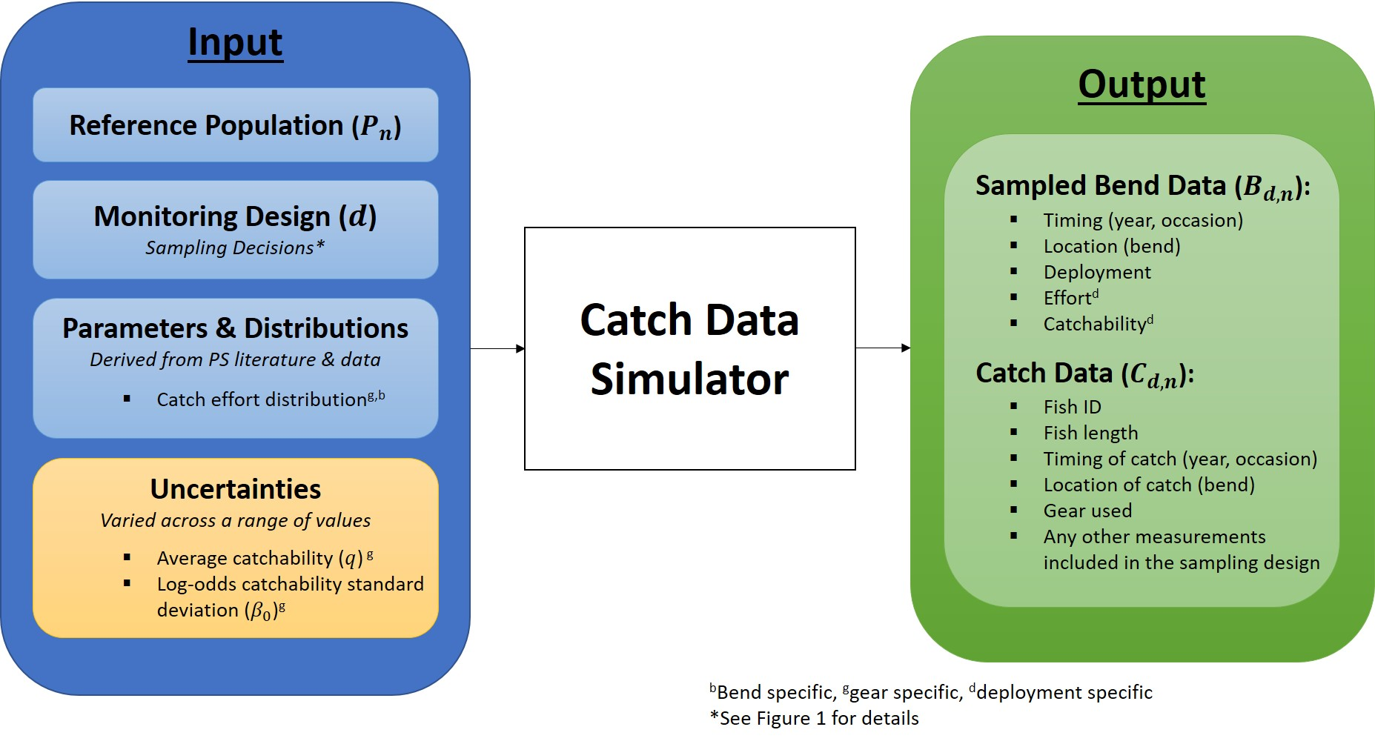

Figure 2.

##### page break

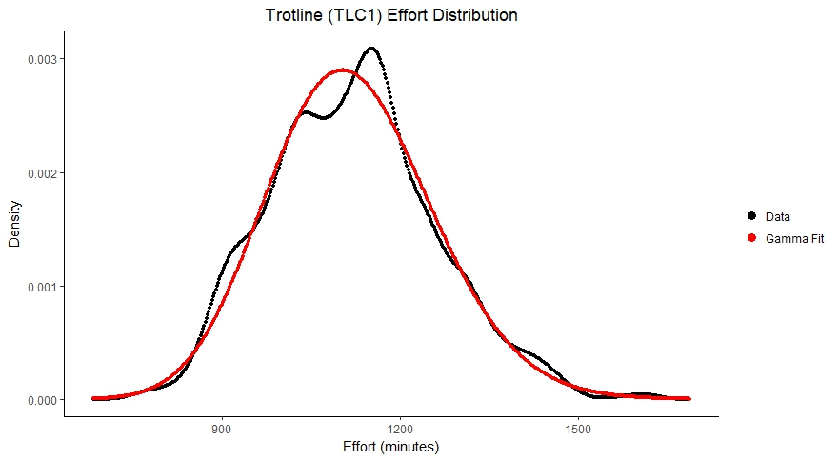

Figure 3.

##### page break

# Tables

Table 1. Number of Bends Sampled per Segment

|  |  |
| --- | --- |
| Segment | No. of Sampled Bends |
| 2 | 12 |
| 3 | 21 |
| 4 | 12 |
| 7 | 12 |
| 8 | 15 |
| 9 | 20 |
| 10 | 10 |
| 13 | 11 |
| 14 | 14 |

##### page break

Table 2. Summary of effort data by gear and basin, where effort is measured in minutes. The shape and rate columns are the results of fitting a gamma distribution to the data.

|  |  |  |  |  |  |  |  |  |  |  |
| --- | --- | --- | --- | --- | --- | --- | --- | --- | --- | --- |
| Basin | Gear | Gear ID | No. of Observations | Mean Effort | SD of Effort | Minimum Effort | Maximum Effort | Median Effort | Shape | Rate |
| LB | GN14 | 18 | 1523 | 1326 | 89 | 1002 | 1633 | 1333 | 224.493086 | 0.1692404 |
| LB | GN18 | 21 | 4698 | 1221 | 123 | 750 | 1695 | 1221 | 98.540664 | 0.0807099 |
| LB | GN41 | 18 | 1118 | 1327 | 91 | 969 | 1563 | 1340 | 210.667976 | 0.1587651 |
| LB | GN81 | 21 | 4094 | 1219 | 117 | 750 | 1678 | 1222 | 109.460899 | 0.0897863 |
| LB | MF | 41 | 7411 | 1278 | 126 | 729 | 2106 | 1288 | 103.412037 | 0.0808979 |
| LB | OT16 | 52 | 606 | 3 | 7 | 1 | 178 | 2 | 1.986635 | 0.7149057 |
| LB | TLC1 | 87 | 2164 | 1336 | 60 | 1067 | 1542 | 1341 | 500.663839 | 0.3746263 |
| LB | TLC2 | 87 | 5219 | 1206 | 109 | 859 | 1591 | 1210 | 122.773069 | 0.1017996 |
| LB | TN | 65 | 1072 | 4 | 3 | 1 | 69 | 3 | 2.568699 | 0.6765714 |
| UB | GN14 | 18 | 700 | 1130 | 183 | 310 | 1751 | 1151 | 29.735758 | 0.0263068 |
| UB | GN41 | 18 | 716 | 1134 | 183 | 295 | 1762 | 1138 | 30.634266 | 0.0270084 |
| UB | MF | 41 | 4281 | 1182 | 142 | 698 | 1708 | 1180 | 69.168422 | 0.0584990 |
| UB | OT16 | 52 | 9081 | 4 | 7 | 1 | 511 | 4 | 6.787978 | 1.6706862 |
| UB | TLC1 | 87 | 3616 | 1120 | 139 | 755 | 1615 | 1119 | 65.327401 | 0.0583306 |
| UB | TLC2 | 87 | 80 | 1025 | 150 | 694 | 1416 | 994 | 49.933263 | 0.0486958 |
| UB | TN | 65 | 10915 | 7 | 7 | 1 | 610 | 6 | 5.128287 | 0.7734619 |
| ##### pa | ge break |  |  |  |  |  |  |  |  |  |

# Code

Box 1. Function used to simulate which bends are sampled each year given a sampling strategy.

## function(sim_pop=NULL,  
## samp_type=NULL)  
## {  
## # this function determines which bends within segments are to be  
## # sampled each year with the number of bends sampled within a segment  
## # given by Table A1 in PSPAP_Vol_1.8.FEB 2017_Welker_Drobish_Williams.pdf  
##   
## # inputs  
## ## sim_pop: a simulated population using the reference_populations   
## ## function having components:  
## ## $out: a matrix of bend abundance data (rows=bends; cols=years)  
##   
## # outputs  
## ## a list of 2 elements:  
## ## $bendLong: a data.frame expanded from sim_pop$bendMeta to include one   
## ## observation per bend per year; new columns include:  
## ## $sampled: a column of 0's (not sampled) and 1's (sampled) that  
## ## tell if the given bend should be sampled in the given year  
## ## $s_abund and $r_abund: columns of segment-level and RPMA-level  
## ## abundances, respectively   
## ## $sampled: a matrix of 0's (not sampled) and 1's (sampled) where  
## ## each row is a bend and each column is a year  
##   
## # ERROR HANDLING  
## if(samp_type!="r" & samp_type!="f")  
## {return(print("samp_type needs to be one of two characters: \n  
## r, which randomly selects bends for each year of sampling or \n  
## f, which randomly selects a single set of bends and fixes them  
## to be sampled every year \n"))}  
##   
## # GET BEND INFORMATION  
## tmp<-sim_pop$bendMeta  
## tmp<-tmp[order(tmp$id),] #CRITICAL  
## bends_in_segs<-ddply(tmp, .(b_segment), summarize,   
## bend_num=length(bend_num),   
## start=min(id),   
## stop=max(id))  
## # SAMPLE NUMBERS IN TABLE A1 IN   
## # PSPAP_Vol_1.8.FEB 2017_Welker_Drobish_Williams.pdf  
## bends_in_segs$samp_num<-c(0, 12, 21, 12, 12, 15, 20, 10, 11, 14)  
##   
## # DETERMINE WHICH BENDS IN A SEGMENT TO SAMPLE  
## abund<-sim_pop$out  
## sampled<-matrix(0,nrow=nrow(abund), ncol=ncol(abund))  
## if(samp_type=="r")  
## {  
## for(j in 1:ncol(abund))  
## {  
## sample_bends<-NULL  
## for(k in 1:nrow(bends_in_segs))   
## {  
## sample_bends<-c(sample_bends,  
## sample(c(bends_in_segs$start[k]:bends_in_segs$stop[k]),   
## bends_in_segs$samp_num[k], replace=FALSE))  
## }  
## for(i in 1:nrow(abund))  
## {  
## sampled[i,j]<-ifelse(any(sample_bends==i), 1, 0)  
## }  
## }   
## }  
## if(samp_type=="f")  
## {  
## sample_bends<-NULL  
## for(k in 1:nrow(bends_in_segs))   
## {  
## sample_bends<-c(sample_bends,  
## sample(c(bends_in_segs$start[k]:bends_in_segs$stop[k]),   
## bends_in_segs$samp_num[k], replace=FALSE))  
## }  
## for(i in 1:nrow(abund))  
## {  
## sampled[i,]<-rep(ifelse(any(sample_bends==i), 1, 0),ncol(abund))  
## }  
## }   
##   
## # RETURN SAMPLES BENDS (MATRIX FORM)  
## return(sampled)  
## }

##### page break

Box 2. Function used to simulate the catch data given a sampling strategy. Note, this function calls the function "bend_samples", which is the function defined in Box 1.

## function(sim_pop=NULL,inputs,...)  
## {  
## samp_type=inputs$samp_type  
## gears=inputs$gears  
## catchability=inputs$catchability  
## B0_sd=inputs$B0_sd  
## deployments=inputs$deployments  
## effort=inputs$effort  
## occasions=inputs$occasions  
## gear_codes=gear_codes  
##   
##   
## # USE SIM_POP TO DEFINE VARIABLES  
## tmp<-sim_pop$bendMeta  
## tmp<-tmp[order(tmp$id),] #CRITICAL  
## b_abund<-sim_pop$out  
## individual_meta<-sim_pop$individual_meta  
## individual_meta<-individual_meta[order(individual_meta$fish_id),]  
## l<-sim_pop$l  
## BND<-sim_pop$BND  
## r_dat<-sim_pop$r_dat  
## inputs<-c(sim_pop$inputs,inputs)  
## sampled<-bend_samples(sim_pop=sim_pop,samp_type=samp_type)  
##   
## # LOG-ODDS CATCHABILITY BY GEAR  
## B0<- log(catchability/(1-catchability))  
##   
## # EFFORT AND CATCHABILITY DATA FOR SAMPLED BENDS  
## b_samp<-lapply(1:ncol(sampled),function(yr)  
## {   
## ## PULL OUT SAMPLED BENDS  
## samp_indx<-which(sampled[,yr]==1)  
## ## CREATE TABLE OF SAMPLED BENDS  
## tmp1<-tmp[samp_indx,]  
## tmp1<-tmp1[,c("b_segment","bend_num","id")]  
## ## ADD YEAR SAMPLED  
## tmp1$year<-yr  
##   
## ## FIND EFFORT AND CATCHABILITY FOR EACH GEAR, BEND,   
## ## OCCASION, & DEPLOYMENT  
## gear_dat<-lapply(gears,function(g,d=deployments,out=tmp1)  
## {  
## ### ADD GEAR TO TABLE  
## out$gear<-g  
## ### EXPAND TABLE FOR DEPLOYMENTS AND OCCASIONS  
## k<-which(gears==g)  
## out<-out[rep(seq_len(nrow(out)), each=d[k]*occasions),]  
## out$deployment<-rep(1:d[k],times=occasions*length(samp_indx))  
## out$occasion<-rep(1:occasions, each=8, times=length(samp_indx))  
##   
## ### ADD EFFORT  
## f<-sapply(samp_indx, function(x)  
## {  
## indx<-which(effort$gear==g &   
## effort$rpma==tmp$rpma[x])  
## #### ERROR HANDLING FOR GEARS THAT ARE NOT USED   
## #### IN A RPMA: NO EFFORT AND f=0  
## if(length(indx)==0)  
## {  
## f_reps<-rep(0,d[k]*occasions)  
## }  
## if(length(indx)>0)  
## {  
## f_reps<-rgamma(n=d[k]*occasions,  
## shape=effort$gamma_shape[indx],   
## rate=effort$gamma_rate[indx])  
## }  
## return(f_reps)  
## })  
## out$f<-c(f)  
##   
## ### ADD CATCHABILITY  
## out$q<-plogis(B0[k]+rnorm(n=d[k]*occasions*length(samp_indx),  
## mean=0,sd=B0_sd[k]))  
##   
## ### RETURN EXPANDED DATAFRAME (SINGLE GEAR)  
## return(out)  
## })  
##   
## ## COMBINE INTO A SINGLE DATAFRAME  
## gear_dat<-do.call(rbind, gear_dat)  
##   
## ## RETURN DATAFRAME (SINGLE YEAR)  
## return(gear_dat)  
## })  
##   
## # COMBINE INTO A SINGLE DATAFRAME  
## b_samp<-do.call(rbind, b_samp)   
##   
## # ADD INDIVIDUAL CPs  
## b_samp$p<-b_samp$q*b_samp$f  
##   
## # CREATE CAPTURE HISTORIES FOR EACH GEAR  
## # LONG TO RUN, OPTIMIZE CODE AT SOME POINT  
## ## RUN IN PARALLEL  
## library(parallel)  
## ### USE ALL CORES  
## numCores<-detectCores()  
## ### INITIATE CLUSTER  
## cl<-makeCluster(numCores)  
## ### MAKE PREVIOUS ITEMS AND FUNCTIONS AVAILABLE  
## clusterExport(cl, c("sampled", "individual_meta","l","BND","tmp",  
## "gears","occasions","b_samp"),  
## envir=environment())  
## ch<-parLapply(cl,1:ncol(sampled),function(yr)  
## {   
## ## PULL OUT SAMPLED BENDS  
## samp_indx<-which(sampled[,yr]==1)  
## bend_ch<-lapply(samp_indx, function(x)  
## {  
## indx<- which(BND[,yr]==x) ## LINK FOR MOVEMENT; ONLY GIVES LIVE FISH  
## if(length(indx)==0) {occ_ch<-NULL}  
## if(length(indx)>0)  
## {  
## ## CREATE TABLE OF SAMPLED BENDS  
## tmp1<-tmp[x,c("b_segment","bend_num","id")]  
## ## ADD YEAR SAMPLED  
## tmp1$year<-yr  
## ## EXPAND FOR INDIVIDUALS  
## tmp1<-merge(tmp1,data.frame(fish_id=indx),all=TRUE)  
## ## ADD INDIVIDUAL LENGTHS  
## tmp1$length<-l[tmp1$fish_id,yr]  
## ## EXPAND FOR GEARS  
## tmp1<-tmp1[rep(seq_len(nrow(tmp1)), each=length(gears)),]  
## tmp1$gear<-rep(gears, times=length(indx))  
## ## FIND CH FOR EACH OCCASION, GEAR, AND INDIVIDUAL  
## occ_ch<-lapply(1:occasions,function(occ,out=tmp1)  
## {   
## ### EXPAND DATAFRAME TO INCLUDE OCCASION  
## out$occasion<-occ  
## ### FIND OCCASION LEVEL CP FOR GIVEN BEND AND YEAR  
## dat<-subset(b_samp, year==yr & id==x & occasion==occ)  
## P<-aggregate(p~gear,dat,sum)  
## #P<-aggregate(pnot~gear,dat,prod)  
## #P$p<-1-P$pnot  
## ### CAP CPs AT 1  
## P$p<-ifelse(P$p>1,1,P$p)  
## ### CH  
## ch_reps<-matrix(rbinom(length(indx)*length(gears), size=1,  
## prob=rep(P$p,each=length(indx))),  
## nrow=length(indx),  
## ncol=length(gears))  
## out$ch<-c(t(ch_reps))  
## out<-subset(out,ch==1)  
## return(out)  
## })  
## occ_ch<-do.call(rbind,occ_ch)  
## }  
## return(occ_ch)  
## })  
## bend_ch<-do.call(rbind,bend_ch)  
## })  
## ### CLOSE CLUSTERS  
## stopCluster(cl)  
## ch<-do.call(rbind,ch)  
##   
## # PROCESS THE DATA  
## tmp1<-aggregate(length.rkm~b_segment, tmp,sum)  
## names(tmp1)[2]<-"seg_rkm"  
## tmp1<-tmp1[rep(seq_len(nrow(tmp1)),ncol(b_abund)),]  
## tmp1$year<-rep(1:ncol(b_abund), each=length(unique(tmp$b_segment)))  
## # SEGMENT ABUNDANCE BY YEAR  
## s_abund<-sapply(1:max(tmp$phi_indx), function(i)  
## {  
## r<-which(tmp$phi_indx==i)  
## if(length(r)==1) out<-b_abund[r,]  
## if(length(r)>1)  
## {  
## out<-colSums(b_abund[r,])   
## }  
## return(out)  
## })  
## tmp1<-tmp1[order(tmp1$b_segment,tmp1$year),]  
## tmp1$abundance<-c(s_abund)  
## # MEAN LENGTH BY SEGMENT & YEAR  
## s_length<-sapply(1:max(tmp$phi_indx), function(i)  
## {  
## r<-which(tmp$phi_indx==i) #find ids (bends) in segment  
## seg_i<-sapply(1:ncol(BND),function(yr)  
## {  
## z<-which(BND[,yr] %in% r) #find fish in these bends  
## if(length(z)==0) out<-NA  
## if(length(z)!=0) out<-mean(l[z,yr])  
## return(out)  
## })  
## return(seg_i)  
## })  
## tmp1<-tmp1[order(tmp1$b_segment,tmp1$year),]  
## tmp1$mean_length<-c(s_length)  
## # SEGMENT AGE-0s (THAT RECRUIT) BY YEAR  
## s_recruits<-aggregate(fish_id~yr_ini+b_segment,individual_meta, length, subset=yr_ini!=0)  
## colnames(s_recruits)[which(colnames(s_recruits)=="fish_id")]<-"age_0"  
## colnames(s_recruits)[which(colnames(s_recruits)=="yr_ini")]<-"year"  
## tmp1<-merge(tmp1,s_recruits,by=c("b_segment","year"), all.x=TRUE)  
## tmp1[is.na(tmp1$age_0),]$age_0<-0  
## # RECRUITMENT DATA BY YEAR  
## tmp1$rpma<-ifelse(tmp1$b_segment %in% c(1:4),2,4)  
## tmp1<-merge(tmp1,r_dat[,c("rpma", "year","r_year")],by=c("rpma","year"), all.x=TRUE)  
## #phi<-matrix(0,nrow=nrow(s_abund),ncol=ncol(s_abund))  
## #for(i in 1:(nrow(phi)-1))  
## # {  
## # phi[i,]<-s_abund[i+1,]/s_abund[i,]  
## # }  
## #phi[nrow(phi),]<-NA  
## #tmp1$phi<-c(phi)  
## #tmp1$density<-tmp1$abundance/tmp1$length.rkm  
## #tmp1<-tmp1[,c(1,3:6)]  
## tmp1<-tmp1[,which(names(tmp1)!="rpma")]  
## b_samp<-b_samp[,which(names(b_samp)!="p")]  
## ch<-ch[,which(names(ch)!="ch")]  
## inputs<-c(sim_pop$inputs, inputs)  
## return(list(true_vals=tmp1,   
## samp_dat=b_samp,   
## catch_dat=ch,  
## inputs=inputs))  
## }

1. This is a general measurement of effort that can be calculated for all gear types. However, we recognize that gear set time is more relavent to measuring effort for passive gears and we plan to further incorporate effort values based on distance or area metrics when considering active gears.
2. We use the term "standard gear" as defined in the USACE's 2017 Missouri River SOP for Fish Sampling and Data Collection (See green boxes of Appendix K) (CITATION).
3. 2016 AM Sub-objective 2 metric: "Population estimates for pallid sturgeon for all size and age classes, particularly for ages 2 to 3 to assess recent trends in recruitment; catch rates of all pallid sturgeon by size class (to maintain legacy data)." (CITATION)