# Figures

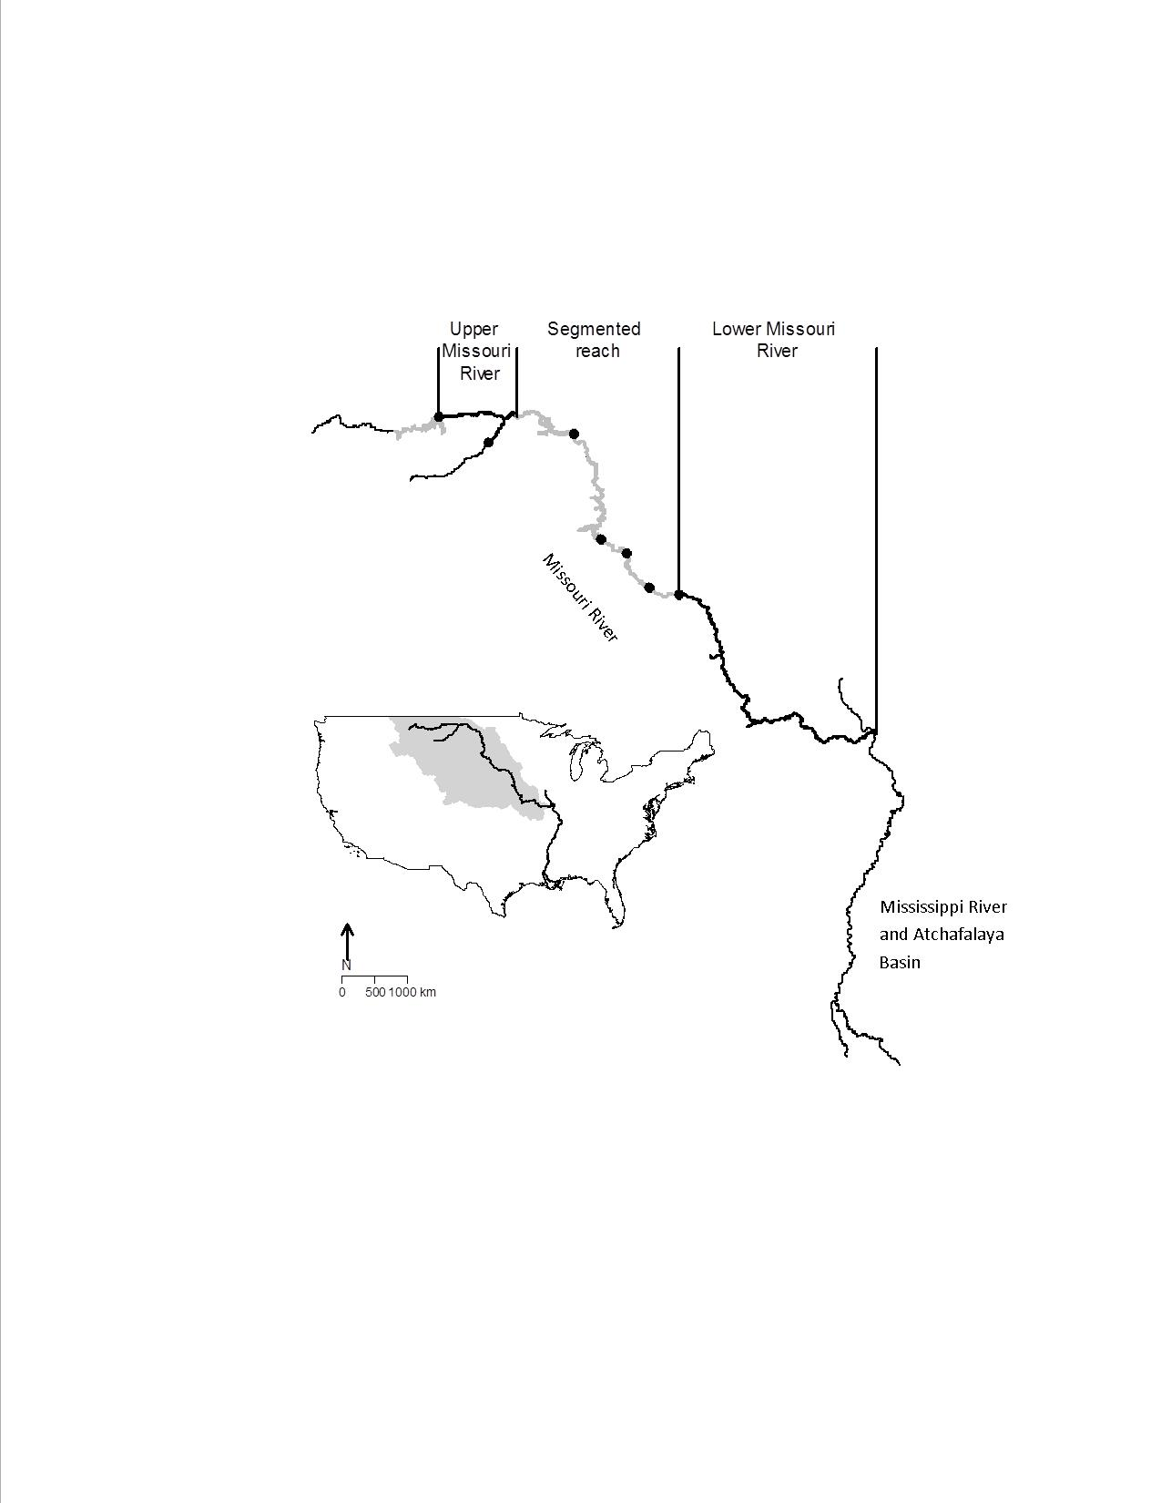

Figure 1. Missouri River drainage (denoted by grey area) and Mississippi River Pallid Sturgeon recovery areas described in this study. Black circles denote dams without fish passage. Black lines denote Missouri River segments used to delineate Pallid Sturgeon populations.