# Figures

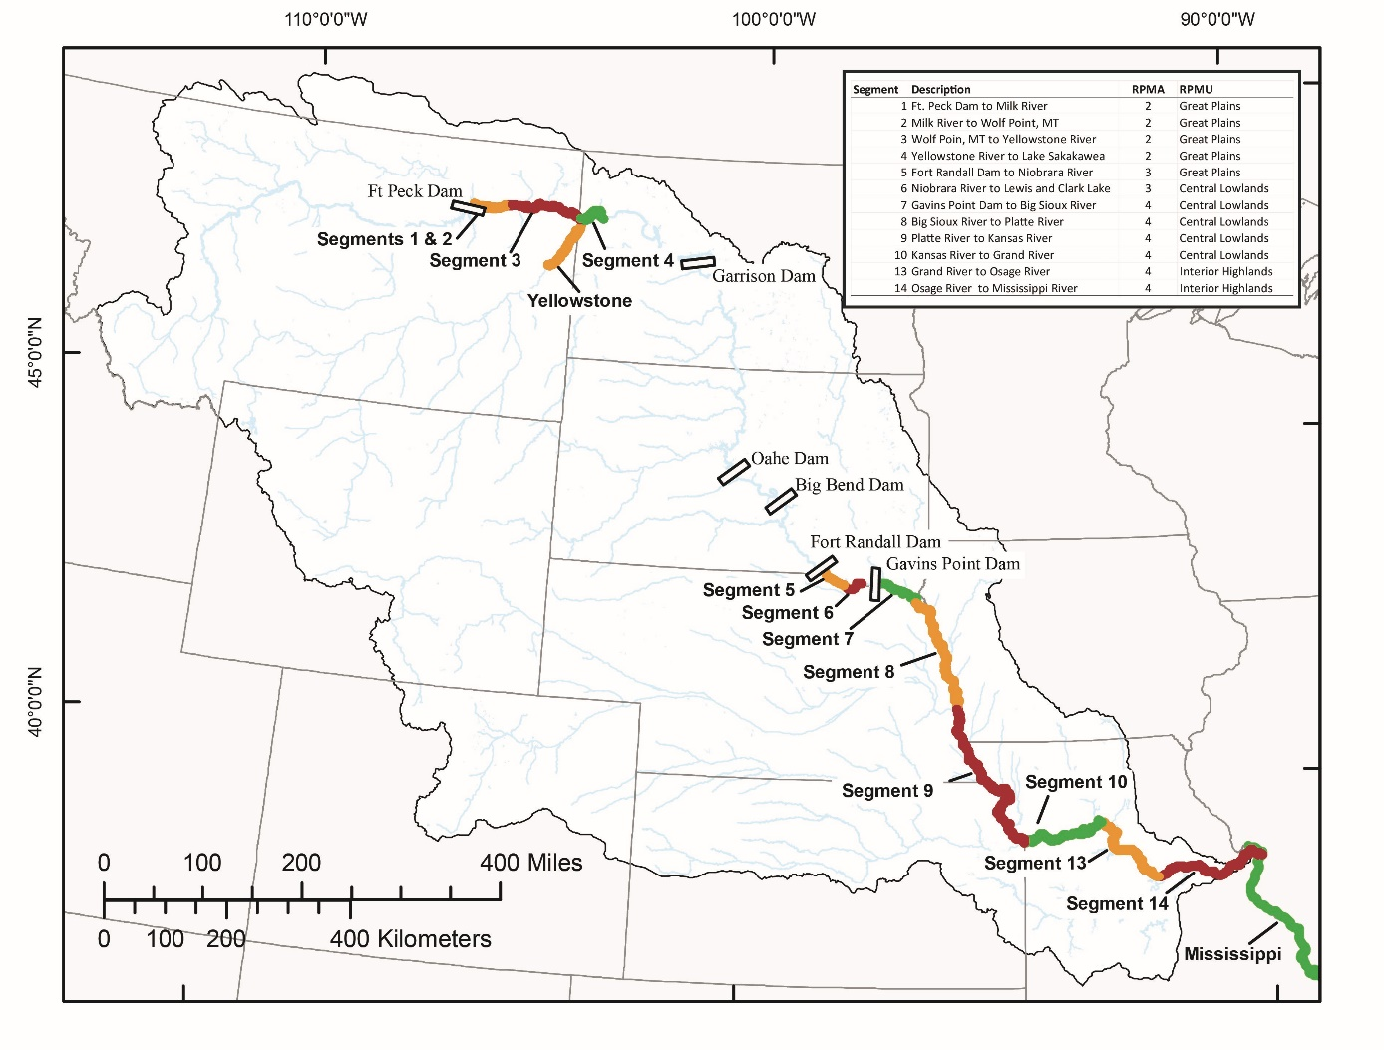

Figure 1. Map of the Missouri River highlighting segments of the upper and lower basins, as well as relevant sections of the Yellowstone and Mississippi Rivers. Relationships between segments, RPMA’s, and RPMU’s are indicated in the upper right. Simulations included sampling bends within segments 2-4 of the upper basin and segments 7-10, 13, and 14 of the lower basin under various monitoring designs.

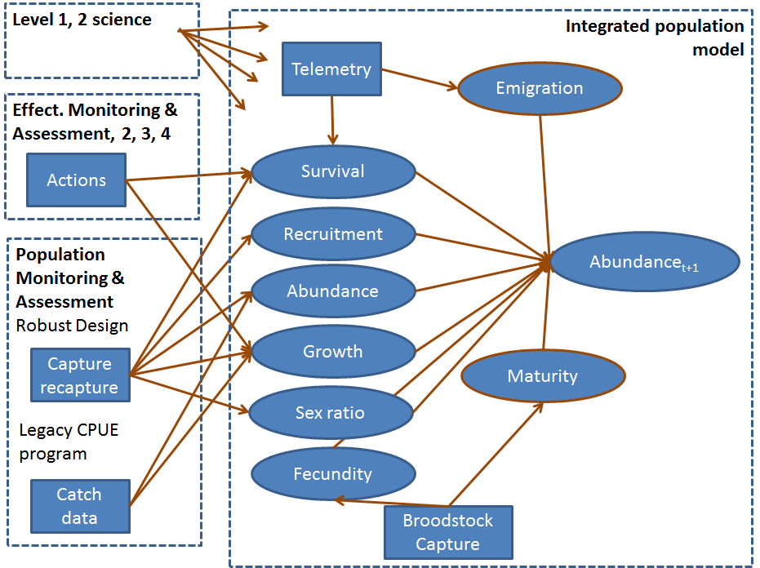

Figure 2. Information monitoring framework illustrating the integration of the 4 information components.

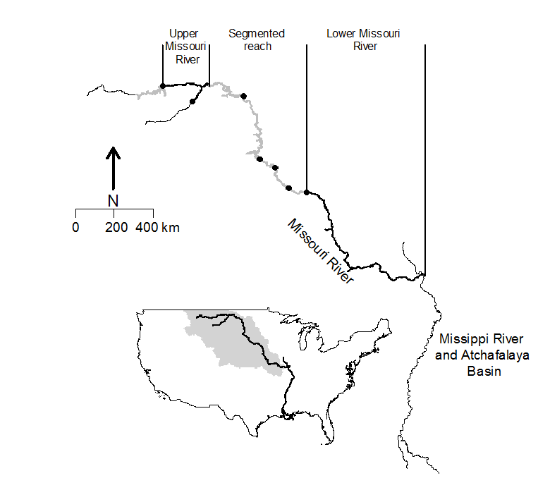

Figure 1. Missouri River drainage (denoted by grey area) and Mississippi River Pallid Sturgeon recovery areas described in this study. Black circles denote dams without fish passage. Black lines denote Missouri River segments used to delineate Pallid Sturgeon populations. ADD RPMAs, do at 600 dpi

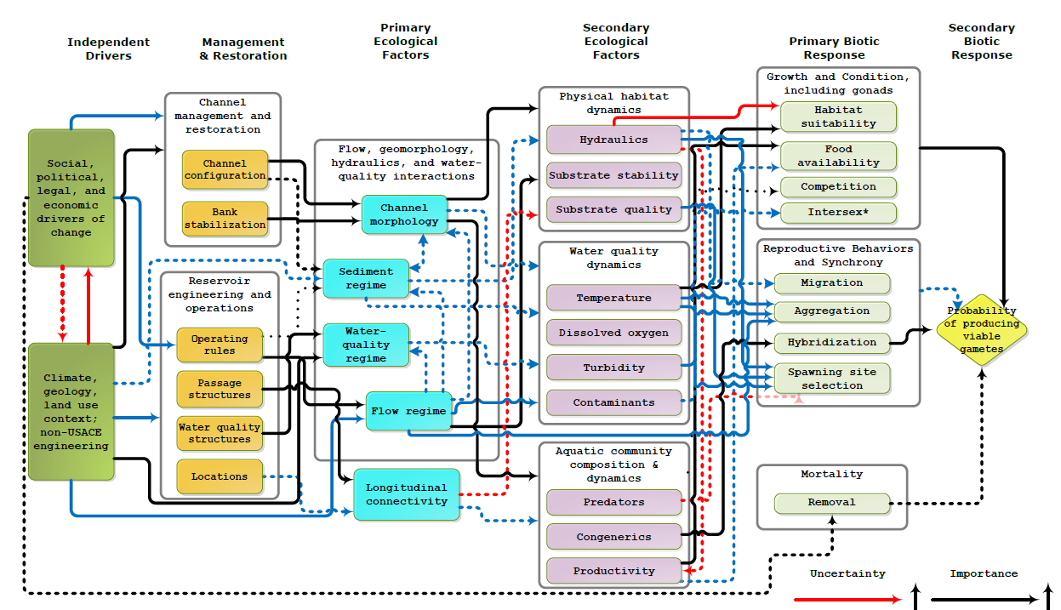

Figure 2. Conceptual model of life history stages represented in the population dynamics model. Transitions denoted with an a and b were have corresponding conceptual ecological models predicting the effect of management actions on survival rates.

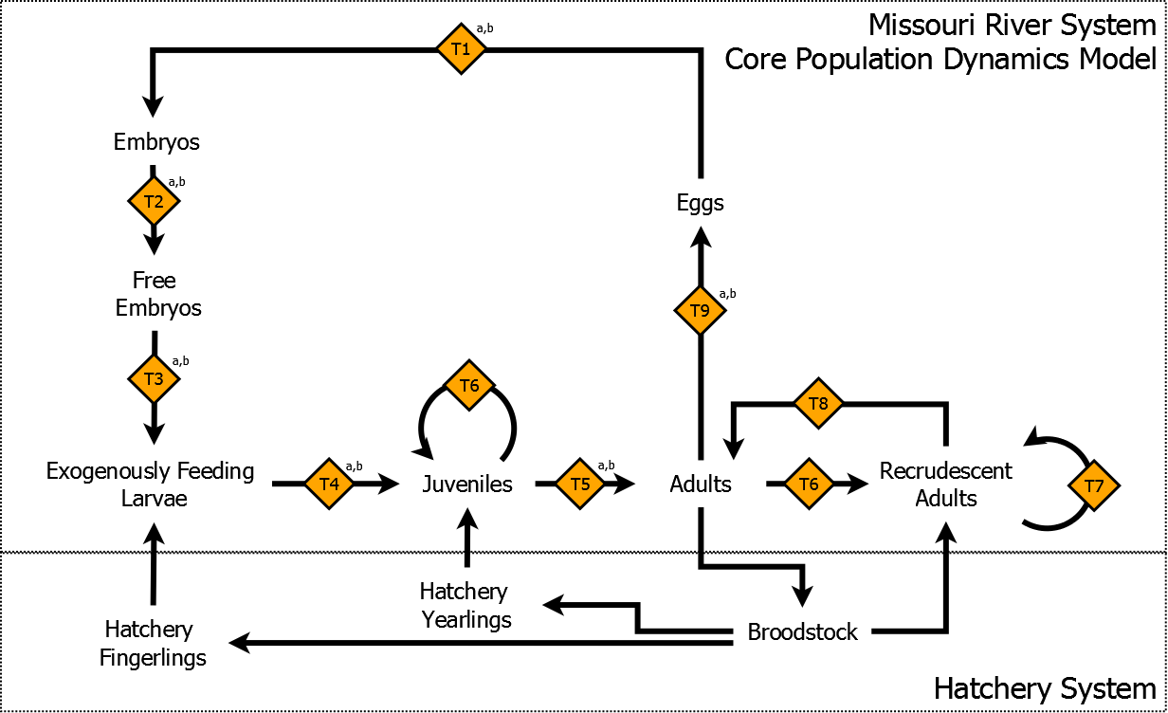

**\*Fix fingerlings and yearlings to match table 1, drop adults and juveniles for age-1+, specify cohort and individual based portions of the model, and have 3 for no recruitment, recruitment, and spatially explicit\***