Print your name at the top of each page (1 point deduction of you do not). Answer each question clearly and concisely. If you need additional space, please use the back of the exam. Make sure that your answers are clearly marked. You have a maximum of 50 minutes to complete the exam. This exam is worth a total of 125 points.

Remember to abide by the Mississippi State University Honor Code at all times.

1) Circle the most correct answer below. What is part of the conceptual process of fisheries management? (2 point)

a) Internet marketing

b) Fishing license sales

c) Decision making

d) Fish sampling

2) Circle the most correct answer below. What is a necessary component of fisheries management? (2 point)

a) Fishing

b) Trophy fish

c) Total angler satisfaction

d) Allocation of resources

3) Is monitoring fish fishery management? (2 point)

4) Fill in the boxes with names and arrows representing the conceptual model of fisheries. (4 points)



5) Circle the most correct answer below. How much is the seafood industry worth? (2 point)

a) 37 dollars

b) 37 thousand dollars

c) 37 million dollars

d) 37 billion dollars

6) Fill in the blank: Fisheries management goals are to produce **_______________** biological, social, and economic benefits from renewable aquatic resources. (2 point)

7) Circle the most correct answer below. The economic impact of sportfishing in Mississippi is valued at: (2 point)

a) 1.2 thousand

b) 1.2 million

c) 1.2 billion

d) 1.2 trillion

8) Why is it important to use models (conceptual, mathematical) in fisheries management (provide at least 2 reasons)? (5 points)

9) How were human impacts on North American fisheries describe Pre-European Settlement and why? (3 point)

10) How are the lengths for stock, quality, preferred, memorable and trophy sized fish defined? (4 points)

11) What is PSD-M? (2 point)

12) What is PSD-P-M? (2 point)

13) How many decimal places should be reported when reporting incremental PSD values? (2 point)

14) Assign the following terms as T for a traditional PSD or I for an incremental (8 points)  
 PSD-Q-P: __________   
 PSD-S-Q __________   
 PSD-T __________   
 PSD-Q __________

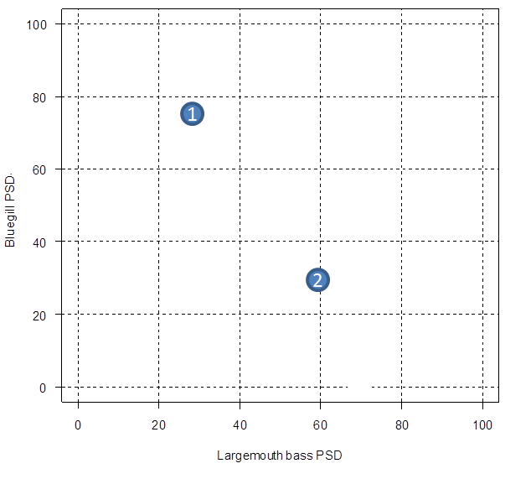

15) Given the plot to the right and for PSD values for Bluegill and Largemouth bass and the table below, determine what type of fishery would best describe these 2 systems and given the PSD values for largemouth bass (*x-*axis) and PSD values for bluegill (*y*-axis). (6 points)  
  
**System 1 (circle 1):**a) Panfish  
b) Balanced  
c) Big Bass  
  
**System 2 (circle 1):**a) Panfish  
b) Balanced  
c) Big Bass

|  |  |  |  |  |  |
| --- | --- | --- | --- | --- | --- |
|  | Largemouth Bass | | | Bluegill | |
| Fishery type | PSD | PSD-P | PSD-M | PSD | PSD-P |
| Panfish | 20-40 | 0-10 | 0 | 50-80 | 10-30 |
| Balanced | 40-70 | 10-40 | 0-10 | 20-60 | 5-20 |
| Big bass | 50-80 | 30-60 | 10-25 | 10-50 | 0-10 |

16) A population of Largemouth Bass was sampled to evaluate size structure of 2 populations. The PSD-Q for the sample of the first population was 40 and the PSD-Q was 60 for the sample of the second population. Which population has more fish in it? (2 points)  
  
  
  
17) Select the two items below that are contained in the MDWFP mission statement. (2 points)

a) Monitor

b) Enhance

c) Conserve

d) Restrict

18) Provide an example of why is it important to understand the history of fisheries management. (2 points)

19) Provide one reason why cultured fish were used in early fisheries management. (2 points)

20) What preceded trucks as the method for moving and distributing fish among North American waters in the early 1900s? (2 points)

21) Circle the most correct answer. ____________ attempts to integrate a broad range of goals not just fishery yield (biodiversity, function). (2 points)

a) Minimum sustained yield

b) Optimal sustained yield

c) Mean sustained yield

d) Yield per recruit

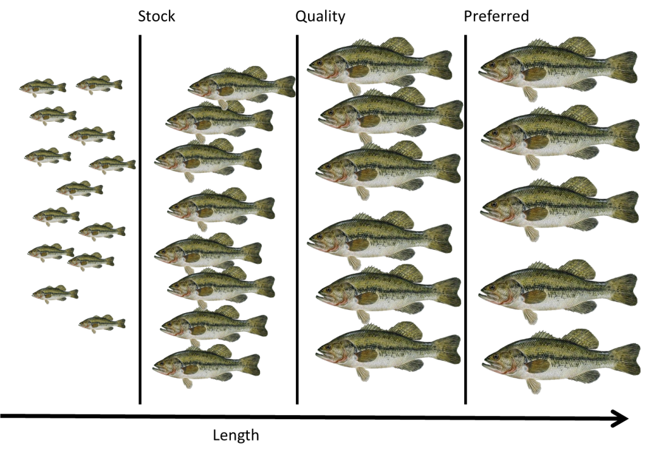22) Given the picture below, how many fish would be considered quality sized (4 points)?

23) What is a finite mortality rate? (3 points)

24) What is the descending limb of a catch curve? (2 points)

25) Fill in the blanks with the appropriate letters: *Z=*________+ ________ (1 point)

26. Fill in the blank. The effects of fishing can __________ size structure. However this may be difficult to detect. (2 points)  
  
27) What are the 3 types of fisheries? (3 points)  
 1)   
 2)   
 3)

28) Define the term ‘sustainability.’ (2 points)

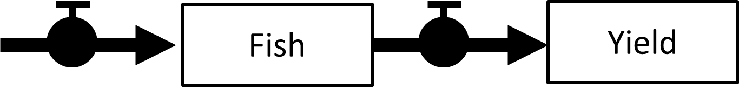29) The boxes (fish and yield) in the figure to the right are called: (1 point)  
 a) processes  
 b) equations  
 c) state variables  
 d) instantaneous rates

30) What is the difference between a population that is in equilibrium and one that is in non-equilibrium? (2 points)  
  
  
  
31) Which of the below is a biomass dynamics model? (1 point)

a) Fox

b) Hare

c) Graham Cracker

d) Graham-Chauffeur

32) Bluegill can spawn at approximately 28 day intervals during the summer. Suppose the spawning season lasted 84 days (3 x 28 day interval) in 2015 and spawning occurred in each interval. How many age-classes are present in 2015? How many cohorts? (2 points)

Age-classes: ________________

Cohorts: ___________________

33) One of the challenges to fisheries management is the values of the different types of fisheries. Identify 3 types of fisheries and what they value? (6 points)

34) Why is it important to use multiple models to forecast or predict the effects of management actions? (3 points)

35) Populations can be organized in at least 3 ways, what is 1 way a fishery manager could organize a population? (2 points)

36) Given the system below identify 1 variable that a fishery manager could control to meet the objective of minimizing predation of Chinook salmon by Largemouth Bass? Explain why the managing the variable will help meet the objective. (3 points)

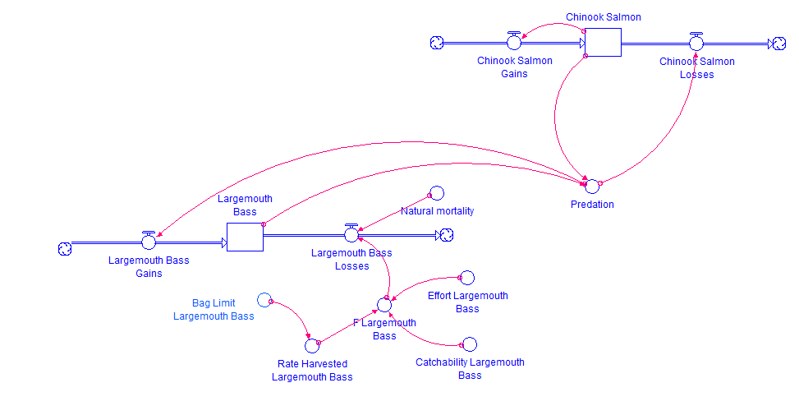

37) Using the figure for question 36, specify 1 component of the model that can be classified as a state, process, or mechanism. (3 points)

States:

Processes:

Mechanisms:

38) Is the following considered bycatch? Why? (3 points)

*“A commercial fisherman sets traps to catch channel catfish for sales in a local fish market.   
 The fisherman also occasionally catches a flathead catfish, which he returns to the water”*

39) Circle all that apply: A stable age distribution assumes the following (1 point)

1. Constant recruitment
2. Constant mortality
3. Constant variability
4. Constant climate

40) What does a growth model predict? (1 point)

41) Why is the term  necessary in the von Bertalanffy growth model? (2 points)

42) Provide x and y-axis labels for the graphic below. (2 points)

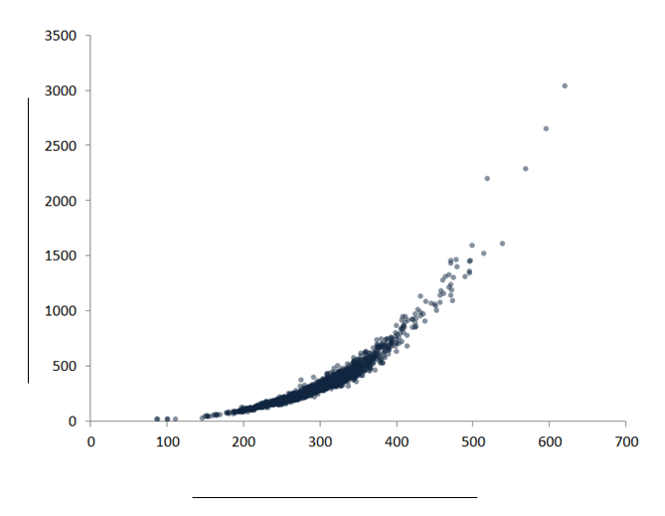

43) The harvest of an age structured fish population is a tradeoff of what two mechanisms that govern the losses and gains in biomass of the population? (4 points)

44) Circle 2 components from below that are needed to simulate the fishery yield of a cohort (i.e., yield per recruit)? (2 points)

a) a function predicting length at age

b) a function predicting cohorts and age classes

c) a function predicting the square root of pi

d) a function predicting gonad weight

e) a function predicting weight at length

45) What does a slot limit apply to? (2 points)

46) What does a minimum length limit apply to? (2 points)

47) What happens to instantaneous and finite rates as they approach 0? (1 point)

48) What type of rate that is applied over very small times steps (i.e., approaching 0)? (1 point)

49) Suppose you had 8000 fish in a population and 6000 of those fish die leaving 2000 fish the following year. What type of rate is calculated where mortality is 6000/8000 = 0.75? (1 point)

50) What fisheries application do instantaneous rates make good biological sense? (1 point)

51) What is ‘balance’ is it relates to proportional stock density (PSD) values? (2 points)