**Print your name at the top of each page (1 point deduction of you do not).** Answer each question clearly and concisely. If you need additional space, please use the back of the exam. Make sure that your answers are clearly marked. You have a maximum of 50 minutes to complete the exam. This exam is worth a total of 125 points. Abide by the Mississippi State University Honor Code at all times.

[1] Name 2 types of fisheries? *4 Point(s)*

1) Recreational, commercial, subsistence

2)  
  
[2] What is the ‘magic number’ for preventing recruitment overfishing, in terms of spawning potential ratio (SPR) 2 *Point(s)*  
  
  
  
  
[3] Provide biologically reasonable x and y-axis labels for the graphic below, in the context of fisheries management. *4 Point(s)*  
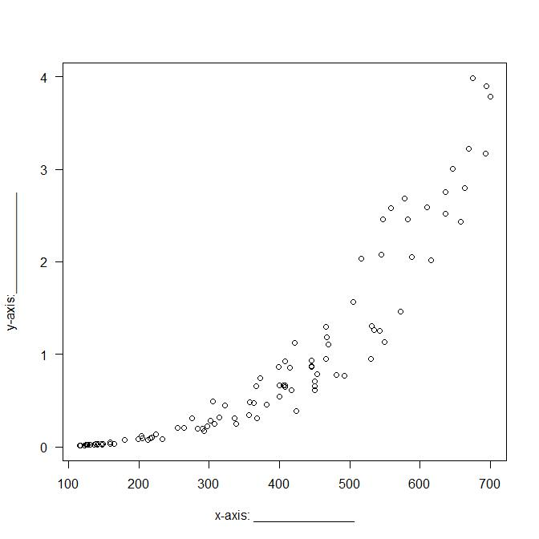  
[4] What does channelization do to a river? *1 Point(s)*

[5] Label the appropriate reservoir zones in the 3 gray boxes in the graphic below. *6 Point(s)*  
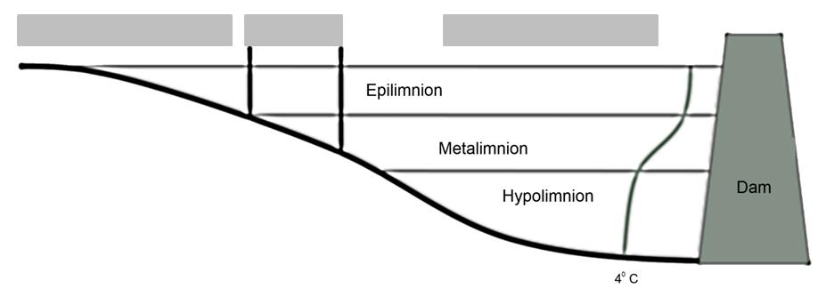  
[6] What is one way to minimize the likelihood of fish kills in a lake or reservoir? *2 Point(s)*  
  
  
  
  
[7] Circle the most correct answer below. This item is required to evaluate recruitment overfishing. *2 Point(s)*  
a) Catch and release mortality  
b) Sex ratio  
c) Fin erosion  
d) Hatchery releases  
  
[8] Name one threat to freshwater stream biodiversity. *1 Point(s)*  
  
  
[9] What are the 3 dimensions of stream interaction? *3 Point(s)*

1)

2)

3)  
  
[10] Circle the most correct answer below. Length at maturity is:_________. *1 Point(s)*  
a) Mean length at which male fish of a given population develop ripe gonads for the first time.  
b) Mean age at which male fish of a given population develop ripe gonads for the first time.  
c) Mean age at which fish of a given population develop ripe gonads for the first time.  
d) Mean length at which fish of a given population develop ripe gonads for the first time.  
  
[11] What is one way to manage sediment loading to a lake or reservoir? *2 Point(s)*  
  
[12] Circle the most correct answer below. Mississippi’s most abundant lake type is:________ *1 Point(s)*  
a) Glacial  
b) Cirque  
c) Oxbow  
d) Terminal

[13] Given the picture below, how many fish would be considered stock _______, quality________, preferred_______, and memorable ______ sized for traditional PSDs? *8 Point(s)*  
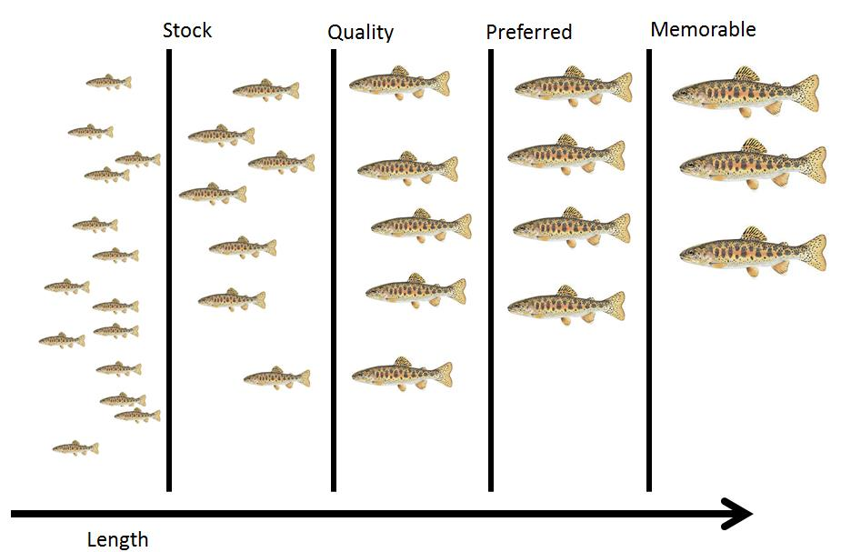  
  
[14] Populations can be organized in at least 3 ways, what is 1 way a fishery manager could organize a population? *2 Point(s)*  
  
  
  
  
  
  
[15] Circle the most correct answer below. What is a necessary component of fisheries management? *1 Point(s)*  
a) Catching fish  
b) Allocation of resources  
c) Monitoring  
d) Catch quotas  
  
[16] Circle the most correct answer below. What has emerged as a rule of thumb for managing fisheries instead of MSY? *1 Point(s)*  
a) F0.001  
b) F0.01  
c) F0.1  
d) F1

[17] Using the graph below illustrating yield per recruit for a cohort of fish evaluated for minimum length limits of 6, 8, 10, and 12 inches. Label each curve, using the numbered blanks provided with GO if growth overfishing is occurring or NO if growth overfishing is not occurring **and** the minimum length limit. (8 points) *8 Point(s)*  
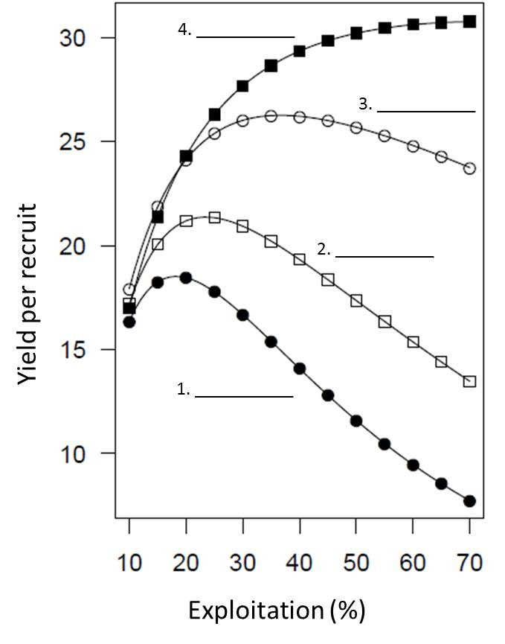  
  
[18] What is the difference between lotic and lentic habitats? *2 Point(s)*  
  
  
  
  
  
  
[19] A management objective identified by MDWFP is to maintain size structure for the lake system. What value could you monitor to see if the objective is achieved? *2 Point(s)*  
  
  
  
  
  
  
[20] What is a small snake-like fish found in Panther Creek? *1 Point(s)*

[21] Circle the most correct answer. What is a problem with the traditional biomass models?

*2 Point(s)*  
1) They are overused  
2) They assume harvest is continuous  
3) The models do not guide stock management

[22] Name two species that are typically co-managed as a single species. *2 Point(s)*  
  
  
  
  
  
  
[23] Specify 3 river zones? 3 *Point(s)*

1)

2)

3)  
  
[24] What is PSD? *1 Point(s)*

[25] Is monitoring fish fisheries management? why or why not? *3 Point(s)*

[26] Fill in the blank: Habitat means: any area _________, or periodically or occasionally __________, by fish or marine vegetation (or both), and includes any biotic (living) or abiotic (non-living) component. 2 *Point(s)*  
  
  
[27] Given the graph below, at what approximate age, does harvest occur for this cohort of fish? Circle on the line where harvest occurs and report the approximate corresponding age. *6 Point(s)*  
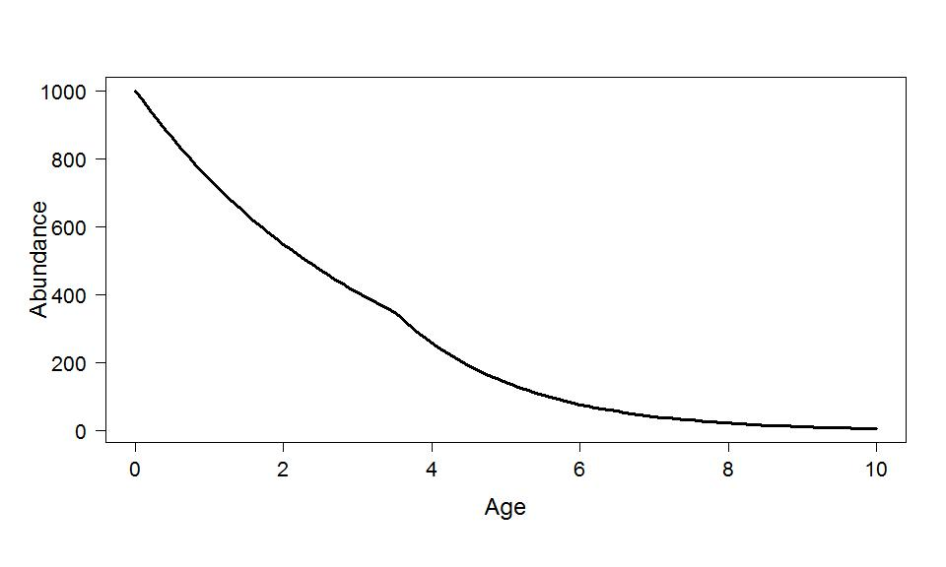

[28] The graphic below illustrates the spawning potential ratios for minimum length limits of 6, 8, 10, and 12 inches. Specify what minimum length limit corresponds to each curve using the numbered blanks. *8 Point(s)*  
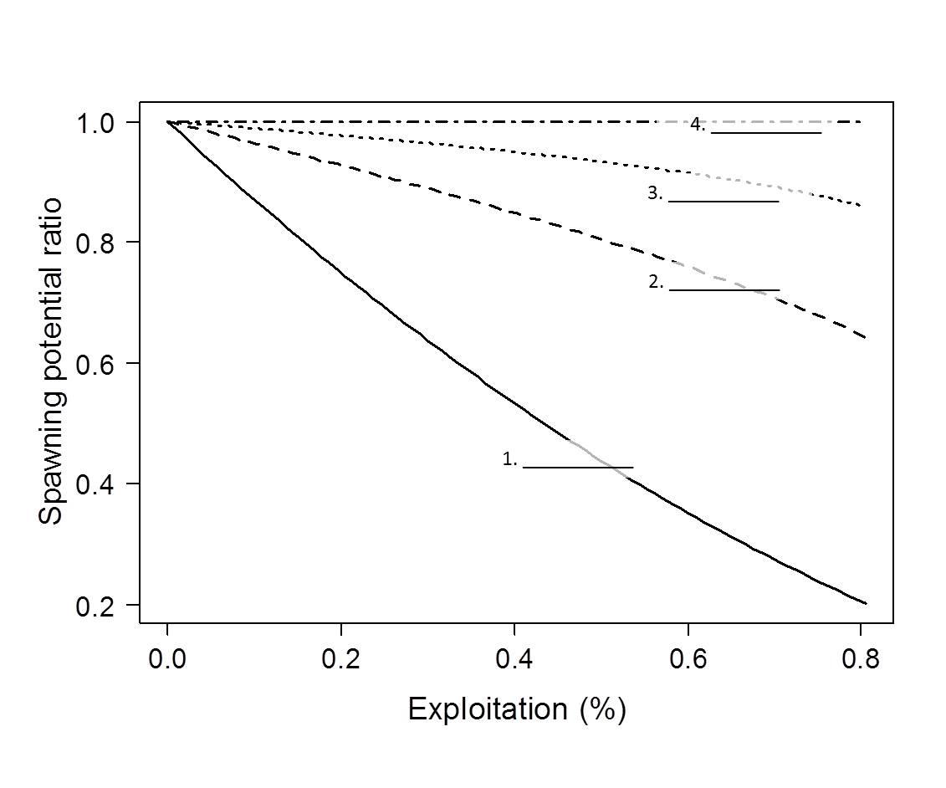  
  
[29] What is 1 element of a fishery management plan used by MDWFP? *1 Point(s)*  
  
  
[30] How many decimal places should be reported when reporting incremental PSD values? *2 Point(s)*  
  
  
  
  
  
  
[31] Describe an outcome in the context of fisheries management. *4 Point(s)*

[32] What is one issue with issuing licenses for a limited access fishery? *4 Point(s)*

[33] Name the 3 elements of aquatic habitat *management* *3 Point(s)*

1)

2)

3)  
  
[34] Circle the best answer. _______ is a river ecosystem concept. *2 Point(s)*

a) Fish zones concept

b) Chasing waterfalls concept

c) Reservoir concept

d) Navigation concept  
  
[35] Circle the most correct answer below. What is one trade off of harvesting an age structured population? (1 point) *1 Point(s)*  
a) Harvesting the entire population  
b) Harvesting lots of smaller fish  
c) Harvesting young of year fish  
d) Harvesting predators  
  
[36] Name 2 of the elements of aquatic *habitat* *4 Point(s)*

1)

2)  
  
[37] Provide 1 reason why using maximum sustained yield (MSY) is a poor idea for fisheries management? *2 Point(s)*  
  
  
  
  
  
  
[38] Choose the best acronym that describes how objectives should be made. *2 Point(s)*  
a) S.M.A.R.T

b) D.U.M.B

c) B.A.S.S

d) T.L.C  
  
  
[39] Develop 2 objectives you think might be representative of recreational or tournament largemouth bass anglers’ objectives. *6 Point(s)*  
1)

2)  
  
  
[40] Fill in the blank. __________ can be considered the most permanent form of pollution. *2 Point(s)*  
  
  
[41] True or false. A young of the year fish is considered a recruit. _____________ *1 Point(s)*  
  
  
[42] Circle the most correct answer below. ________ is a stressor to lake and reservoir habitat *1 Point(s)*  
a) Solar radiation  
b) Shoreline non-development  
c) Water quality  
d) Epilimnion  
  
[43] What are 2 ways to potentially control fishery effort? *4 Point(s)*

1)

2)  
  
[44] Define fecundity, as it relates to fish. *2 Point(s)*

[45] Circle the most correct answer below. What do most fishery harvest models assume? *1 Point(s)*  
a) Variable rates  
b) Non-equilibrium yield  
c) Constant rates  
d) Proportional stock density  
  
[46] Why is it important to use models (conceptual, mathematical) and multiple models in fisheries management (provide at least 2 reasons)? *4 Point(s)*  
  
  
  
  
  
  
[47] True or False. Objectives should be vague. *1 Point(s)*  
  
  
[48] Name one way streams may be classified. *2 Point(s)*

[49] Define a recruit and specify one criterion that may be used to define a recruit? *2 Point(s)*  
  
  
  
  
  
  
[50] Label the appropriate lake zones in the 2 gray boxes in the graphic below. *4 Point(s)*  
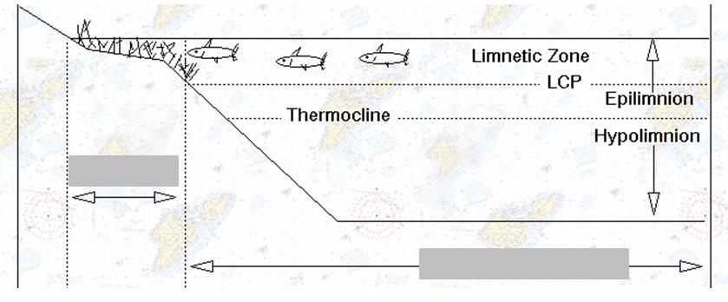  
  
[51] Define recruitment overfishing and specify a consequence of recruitment overfishing. *4 Point(s)*