Print your name at the top of each page (1 point deduction of you do not). Answer each question clearly and concisely. If you need additional space, please use the back of the exam. Make sure that your answers are clearly marked. You have a maximum of 180 minutes to complete the exam. This exam is worth a total of 200 points. Abide by the Mississippi State University Honor Code at all times.

[1] Circle the most correct answer below. What do most fishery harvest models assume? *1 Point(s)*

a) Variable rates  
b) Non-equilibrium yield  
c) Constant rates  
d) Proportional stock density   
  
[2] Circle the most correct answer below. What is a necessary component of fisheries management? *1 Point(s)*

a) Catching fish  
b) Allocation of resources  
c) Monitoring  
d) Catch quotas  
  
[3] Is monitoring fish fishery management, why or why not? *3 Point(s)*  
  
  
  
  
[4] Why is it important to use models (conceptual, mathematical) and multiple models in fisheries management (provide at least 2 reasons)? *4 Point(s)*

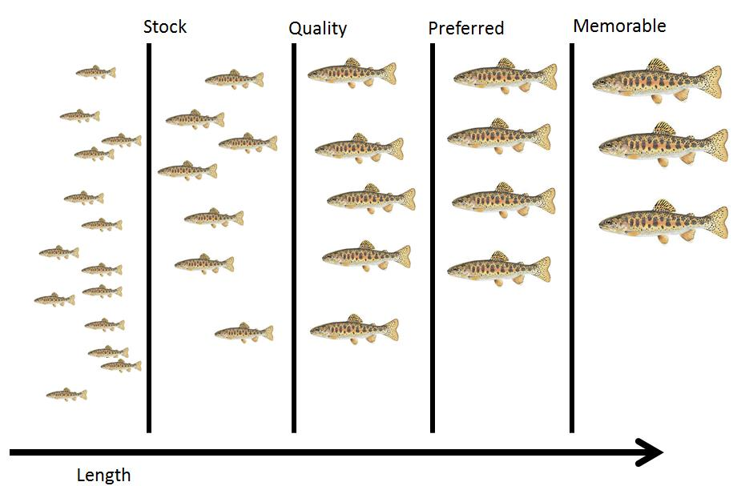  
  
[5] How many decimal places should be reported when reporting incremental PSD values? *2 Point(s)*  
  
  
[6] Given the picture to the right, how many fish would be considered quality sized? *7 Point(s)*

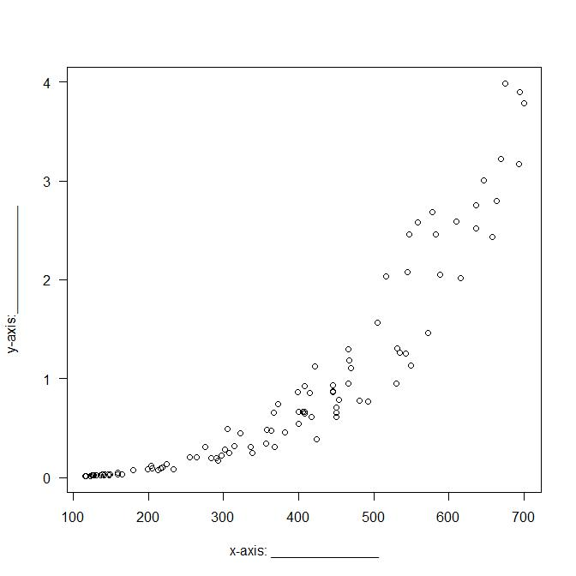[7] Populations can be organized in at least 3 ways, what is 1 way a fishery manager could organize a population? *2 Point(s)*  
  
  
  
  
  
  
[8] Provide biologically reasonable *x* and *y*-axis labels for the graphic to the right, in the context of fisheries management. *2 Point(s)*

[9] Provide 1 reason why using maximum sustained yield (MSY) is a poor idea for fisheries management? *2 Point(s)*  
  
  
  
  
  
  
[10] Circle the most correct answer below. What has emerged as a rule of thumb for managing fisheries instead of MSY? *1 Point(s)*

a) F0.001  
b) F0.01  
c) F0.1  
d) F1  
  
[11] What are age-structured populations managed for? HINT populations are managed to minimize what? *2 Point(s)*  
  
  
  
  
  
  
[12] Circle the most correct answer below. What is one trade off of harvesting an age structured population? *1 Point(s)*

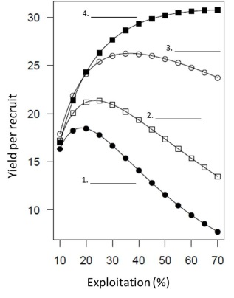  
a) Harvesting the entire population  
b) Harvesting lots of smaller fish  
c) Harvesting young of year fish  
d) Harvesting predators  
  
[13] Using the graph to the right for yield per recruit for a cohort of fish evaluated for minimum length limits of 6, 8, 10, and 12 inches. Using the numbered blanks provided: 1) Label each curve with the corresponding minimum length limit. 2) Label each curve as GO if growth overfishing is occurring or NO if growth overfishing is not occurring. (8 points) *8 Point(s)*  
  
  
[14] Given the graph below, at what age, approximately, does harvest occur for this cohort of fish? Circle on the line where harvest occurs and report the approximate corresponding age. *4 Point(s)*  
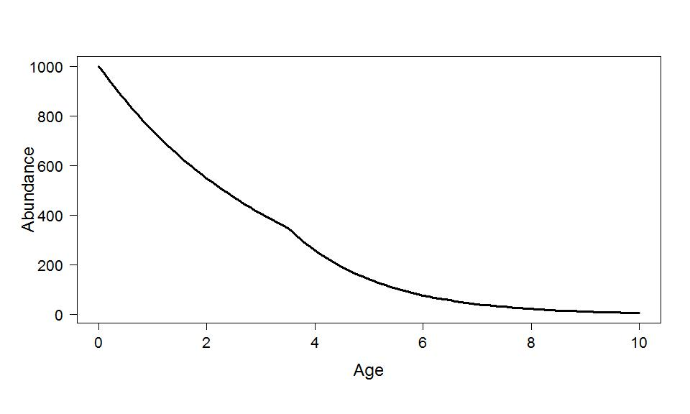  
  
[15] Define a recruit and specify one criterion that may be used to define a recruit? *2 Point(s)*

[16] True or false. A young of the year fish is considered a recruit. _____________ *1 Point(s)*  
  
  
[17] Define recruitment overfishing. *2 Point(s)*  
  
  
  
  
  
  
[18] Name two species that are typically co-managed as a single species. *2 Point(s)*  
  
  
  
  
  
  
[19] Circle the most correct answer below. This item is required to evaluate recruitment overfishing. *2 Point(s)*

a) Catch and release mortality  
b) Sex ratio  
c) Fin erosion  
d) Hatchery releases  
  
[20] Define fecundity in terms of fish. *2 Point(s)*  
  
  
  
  
  
  
[21] Circle the most correct answer below. Length at maturity is:_________. *1 Point(s)*

a) Mean length at which male fish of a given population develop ripe gonads for the first time.  
b) Mean age at which male fish of a given population develop ripe gonads for the first time.  
c) Mean age at which fish of a given population develop ripe gonads for the first time.  
d) Mean length at which fish of a given population develop ripe gonads for the first time.

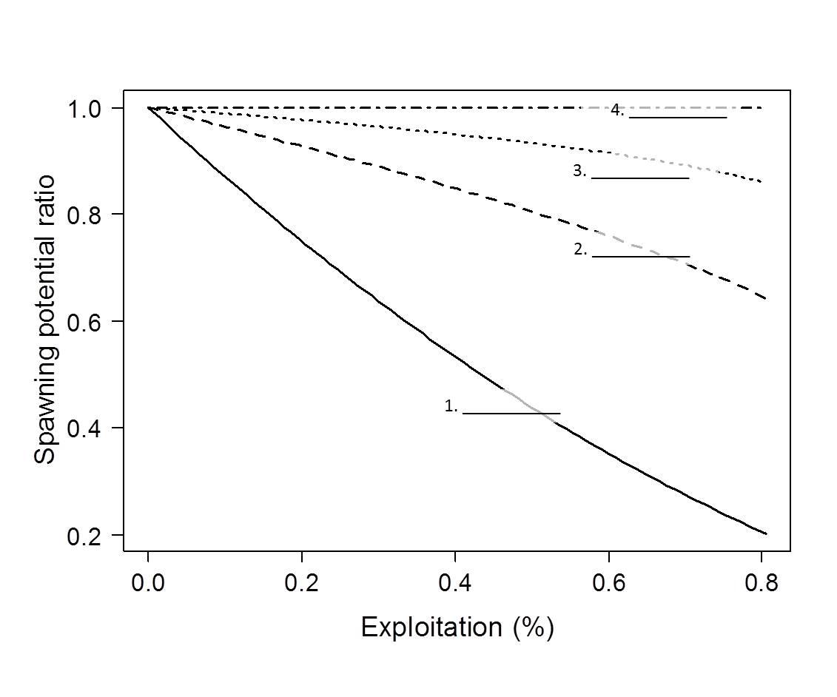[22] The graphic to the right illustrates the spawning potential ratios for minimum length limits of 6, 8, 10, and 12 inches. Specify what minimum length limit corresponds to each curve using the numbered blanks. *4 Point(s)*

[23] What is the ‘magic number’ for preventing recruitment overfishing, in terms of spawning potential ratio (SPR) *1 Point(s)*  
  
  
  
[24] Fill in the blank: Habitat means: any area __________________, or periodically or occasionally ___________________, by fish or marine vegetation (or both), and includes any biotic (living) or abiotic (non-living) component. *1 Point(s)*  
  
[25] What does channelization do to a river? *1 Point(s)*  
  
  
  
  
  
[26] Name 2 of the elements of *aquatic* *habitat.* *2 Point(s)*

1)

2)  
  
[27] Name the 3 elements of *aquatic habitat* *management.* *3 Point(s)*

1)

2)

3)  
  
[28] What is lotic habitat? *1 Point(s)*

[29] Circle the most correct answer below. Mississippi’s most abundant lake type is: *1 Point(s)*

a) Glacial  
b) Cirque  
c) Oxbow  
d) Terminal  
  
[30] Label the appropriate lake zones in the 2 gray boxes in the graphic below. *4 Point(s)*  
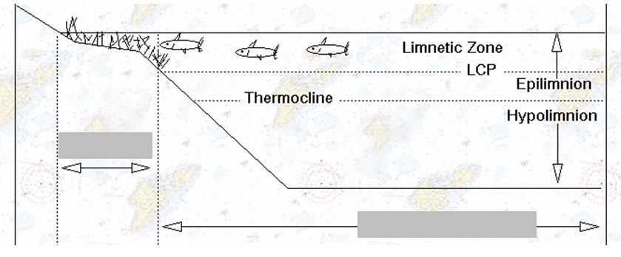  
[31] Circle the most correct answer below. ________ is a stressor to lake and reservoir habitat. *1 Point(s)*  
a) Solar radiation  
b) Shoreline development  
c) Profundal zone  
d) Epilimnion  
  
[32] What is one way to manage sediment loading to a lake or reservoir? *2 Point(s)*  
  
  
  
  
[33] What is one way to minimize the risk of fish kills in a lake or reservoir? *2 Point(s)*

[34] What mollusk species has been estimated to cause 10-30 millions in remediation? *2 Point(s)*  
[35] Specify 2 vectors of introduction for non-native aquatic species? *2 Point(s)*

1)

2)  
  
[36] Label the appropriate reservoir zones in the 3 gray boxes in the graphic beneath. *6 Point(s)*  
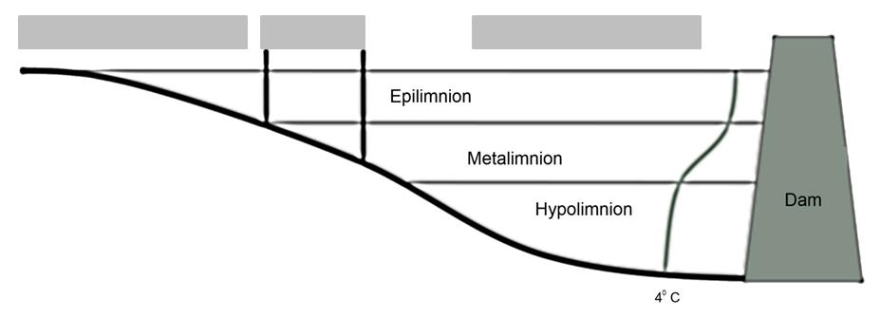[37] What are the 3 management strategies for invasive and introduced aquatic species? *6 Point(s)*

1)

2)

3)  
  
[38] Eradication of invasive species is rarely successful, but there are instances where it is successful. Provide 1 element that would contribute to the likelihood of a successful eradication. *2 Point(s)*  
  
  
  
  
[39] When dealing with restoration and introductions of aquatic species what is the most important first step? *2 Point(s)*  
  
  
  
  
  
[40] Identify one type or example of biological control of invasive or introduced aquatic species. *2 Point(s)*  
  
  
[41] A(n) _________________ fishery is undeveloped or new fishery. Believed to have a significant potential for expansion in total production. *1 Point(s)*  
  
  
[42] A(n) ________________________ fishery is operating at or close to an optimal yield level, with no expected room for further expansion. *1 Point(s)*  
  
  
[43] What are 2 ways to control fishery *effort*? *4 Point(s)*

1)

2)  
  
[44] What are the 2 types *commercial fisheries*? *4 Point(s)*

1)

2)  
  
[45] Identify 1 problem with open access commercial fisheries. *2 Point(s)*  
  
  
  
  
  
  
[46] Which part of the total allowable catch for a fishery is missing below? *1 Point(s)*

1) Commercial harvest  
2) Recreational harvest  
3) ________________   
  
[47] What 2 items do you need to know when determining how many licenses to issue in a limited access fishery? *4 Point(s)*

1)

2)  
  
[48] What is one issue with issuing licenses for a limited access fishery? *4 Point(s)*  
  
  
  
  
  
[49] What does an individual transferable quota system give each fisherman? *2 Point(s)*  
  
  
[50] True or False. Transferable quotas can be leased from another fisherman? *1 Point(s)*  
  
[51] Circle the most correct answer. What is a problem with the Traditional Biomass models? *2 Point(s)*

1) They are overused  
2) They assume harvest is continuous  
3) The models do not guide stock management   
  
[52] What is the difference between lotic and lentic habitats? *2 Point(s)*  
  
  
  
  
[53] Climate change influences what 2 aspects of water? *2 Point(s)*

1)

2)  
  
[54] What are the 2 different recruitment camps? *4 Point(s)*

1)

2)  
  
[55] Circle the most correct answer. Which of the following is a management action to minimize catch and release mortality during periods of high temperature? *1 Point(s)*

a) Woodsy Closures  
b) Hoot Owl Closures  
c) Night Owl Closures  
d) Owl Pellet Closures  
  
[56] What happens if harvest mortality is compensatory in a population? Why is knowing whether this is occurring or not important in terms of harvest management? *6 Point(s)*  
  
  
  
  
  
  
[57] What type of management incorporates learning from monitoring? *2 Point(s)*

[58] Why is a major difference between fisheries and wildlife management? *4 Point(s)*

[59] How does fishery induced selection occur in fisheries with a minimum length limit or gear size restriction? *6 Point(s)*  
  
  
  
  
  
  
[60] Why is it difficult to tease apart the effects of fishing and the fishery induced selection on a population? *6 Point(s)*  
  
  
  
  
[61] Circle the most correct answer below. What is part of the conceptual process of fisheries management? *1 Point(s)*

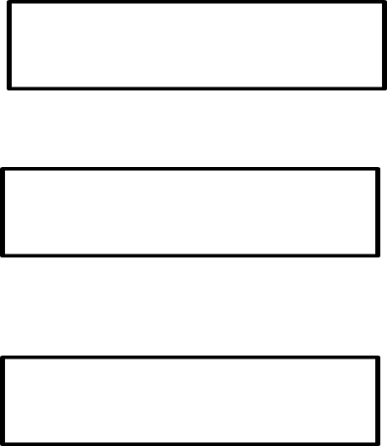  
a) Internet marketing  
b) Fishing license sales  
c) Decision making  
d) Fish sampling  
  
[62] In the figure to the right. Fill in the boxes with names and arrows (there should be 3 names and 3 arrows) representing the conceptual model of fisheries. *3 Point(s)*  
  
[63] Circle the most correct answer below. How much is the seafood industry worth? *1 Point(s)*

a) 37 dollars  
b) 37 thousand dollars  
c) 37 million dollars  
d) 37 billion dollars  
  
[64] Circle the most correct answer below. The economic impact of sportfishing in Mississippi is valued at:___________. *1 Point(s)*

a) 1.2 thousand  
b) 1.2 million  
c) 1.2 billion   
d) 1.2 trillion

[65] How are the lengths for stock, quality, preferred, memorable and trophy sized fish defined? *3 Point(s)*  
  
  
  
[66] Given the table of incremental PSD values for a bluegill population below, identify 1 thing that is incorrect. *4 Point(s)*

|  |  |
| --- | --- |
| Size class | Value |
| PSD-S-Q | 50.00 |
| PSD-Q-P | 40.00 |
| PSD-P-M | 10.00 |
| PSD-M-T | 5.00 |
| PSD-T | 2.00 |

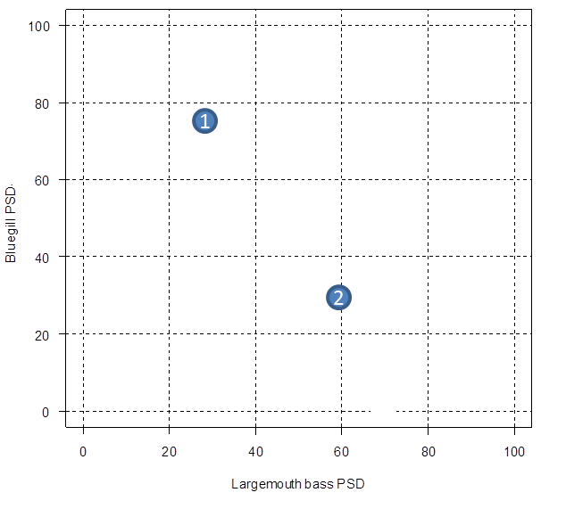  
[67] Given the plot to the right and for PSD values for Bluegill and Largemouth bass and the table below, determine what type of fishery would best describe these 2 systems and given the PSD values for largemouth bass (*x*-axis) and PSD values for bluegill (*y*-axis). *4 Point(s)*  
System 1 (circle 1):  
a) Panfish  
b) Balanced  
c) Big Bass

System 2 (circle 1):  
a) Panfish  
b) Balanced  
c) Big Bass

|  |  |  |  |  |  |
| --- | --- | --- | --- | --- | --- |
|  | Largemouth bass | | | Bluegill | |
| Fishery type | PSD | PSD-P | PSD-M | PSD | PSD-P |
| Panfish | 20-40 | 0-10 | 0 | 50-80 | 10-30 |
| Balanced | 40-70 | 10-40 | 0-10 | 20-60 | 5-20 |
| Big bass | 50-80 | 30-60 | 10-25 | 10-50 | 0-10 |

[68] A population of Largemouth Bass was sampled to evaluate size structure of 2 populations. The PSD-T for the sample of the first population was 40 and the PSD-T was 60 for the sample of the second population. Which population has more fish in it? *1 Point(s)*  
  
  
  
  
[69] ) Circle the most correct answer. ____________ attempts to integrate a broad range of goals not just fishery yield (biodiversity, function). *1 Point(s)*

a) Minimum sustained yield  
b) Optimal sustained yield  
c) Mean sustained yield  
d) Yield per recruit  
[70] What is a finite mortality rate? *3 Point(s)*  
  
  
  
  
  
  
[71] What is the descending limb of a catch curve? *3 Point(s)*  
  
  
  
  
  
  
[72] Fill in the blanks with the appropriate letters: Z=________ + ________. *1 Point(s)*  
  
  
[73] The boxes (fish and yield) in the figure below are called __________. *1 Point(s)*

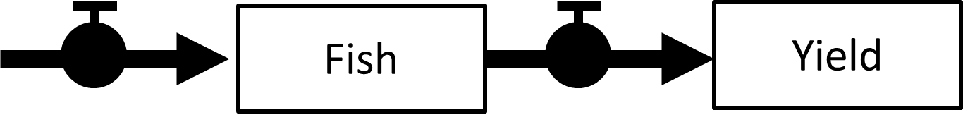  
a) processes  
b) equations  
c) state variables  
d) instantaneous rates   
  
[74] Bluegill can spawn at approximately 28 day intervals during the summer. Suppose the spawning season lasted 84 days (3 x 28 day interval) in 2017 and spawning occurred in each interval. How many age-classes are present in 2017? How many cohorts? *2 Point(s)*

Age-classes: ________________   
  
Cohorts: ___________________   
  
  
[75] One of the challenges to fisheries management is the values of the different types of fisheries. What are 2 of those types and what do they value? *6 Point(s)*

1)

2)