Service Note xxx

**Title:** SPU3 Ethernet Auto Configuration Tool

**Date:** May 30, 2018

**File:** xxx.doc

**P/N:** 099G100000-xxx, Rev A

**EO:**

SPU3 Ethernet Auto Configuration Tool

This document describes the SPU3 Ethernet Auto Configuration Tool and its features.

## System Block Diagram

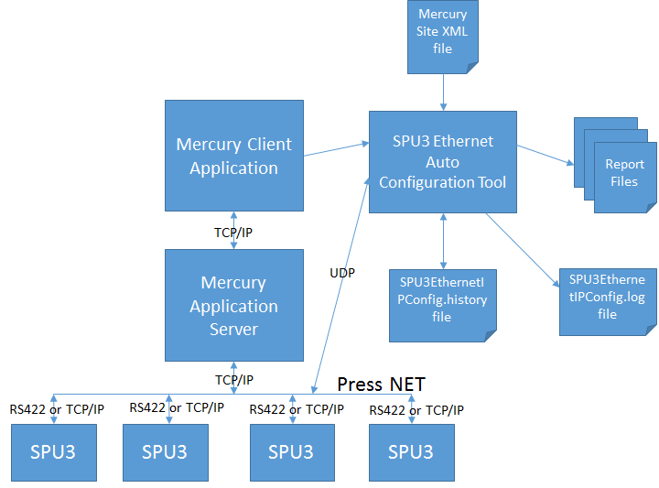

Figure 1, System Block Diagram

## Overview of Subsystems/Applications

SPU3 Ethernet Auto Configuration Tool will display all of its Graphic User Interface controls in English only. However, this Tool can be run from a non-English OS.

Also, this Tool can be launched from both versions of Mercury Client Application, i.e. ANSI version and Unicode version.

The following OS Versions will be supported by this Tool:

* Windows XP Pro, 32 bit
* Windows XP Embedded, 32 bit
* Windows 7, 32 bit and 64 bit
* Windows 7 Embedded, 32 bit and 64 bit
* Windows 10 Iot, 64 bit (not yet tested)

The following sections describes the changes incorporated in each subsystem/application to support the implementation of SPU3 Ethernet Auto Configuration Tool.

### Mercury Client Application

* Added support to launch the SPU3 Ethernet Auto Configuration Tool from Mercury Client Application. For more details refer to the **Appendix** section of this document.

### SPU3 (Servo Power Unit)

* The SPU3 FW will implement the UDP interface and application protocol messages defined in this document.

**Internal Note:** SPU3 Simulator Application can be used to verify the UDP communication interface. However, testing with the SPU3 Simulator should be limited to the LAB environment, when real SPU3 Devices are NOT available.

### SPU3 Ethernet Auto Configuration Tool

The following section describes the purpose of each input/output Files:

**Mercury System XML file:**

* + It is an *optional* input file. In other words, the SPU3 Ethernet Auto Configuration Tool can be used without an input System XML file.
  + The SPU3 IP Addresses from the System XML file will be used to select & change the IP Address of a SPU3 Device found on the Network.
  + The SPU3 IP Addresses from the System XML file will be used to compare with each SPU3 Device found on the Network (LAN). This process will determine the SPU3 Devices that are NOT in sync with the System XML configuration.
  + No changes to the System XML file will be allowed form the SPU3 Ethernet Auto Configuration Tool.

**SPU3EthernetIPConfig.history file:**

* + The history file plays an important role in identifying new SPU3 devices.
  + The history file stores the MAC Address and IP Address of each SPU3 Device found on the Network. The MAC Addresses from the history file will be used to compare with each SPU3 Device found on the Network. If the MAC Address of a SPU3 Device is NOT found in the history file, then it is identified as a *new* SPU3 device.
  + Ideally, the history file will be created when all of the SPU3 Devices are configured as per the System XML configuration.
  + The history file will be saved to the LOGPATH specified as part of the Application command line.
  + The history file will be saved to the Application executable folder, if LOGPATH is not specified.
  + If the history file does NOT exists, a message prompt will be displayed to create the history file, when exiting the SPU3 Ethernet Auto Configuration Tool, as shown below:

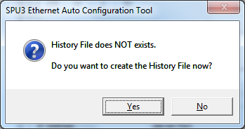

**SPU3EthernetIPConfig.log file:**

* + The log file will be saved to the LOGPATH specified as part of the Application command line.
  + The log file will be saved to the Application executable folder, if LOGPATH is not specified.
  + During the startup of the Application, the log file will be created, if it does NOT exists already.
  + The log file header will include the Application version, Application build date and Application command line arguments.
  + Each log message will include Date and Time info, as shown below:

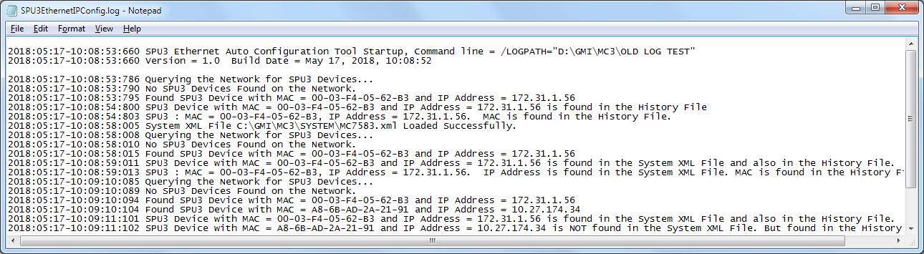

**Report files:**

* + Default report file path is set to the LOGPATH specified as part of the Application command line.
  + Also, the Report File Path is configurable from the **All Devices** View. For more details refer to the **Appendix** section of this document.
  + A typical Report file will include the following data
    - Report creation date
    - Application version and build date
    - Press Name
    - Site Name
    - Site Number
    - For each SPU3 Device found on the Network
      * Device configuration settings
        + MAC Address
        + IP Address
        + Subnet mask
      * Application configuration settings
        + FW Version
        + Communication Type
        + Port orientation
        + Mercury Server IP Address
        + Server Port
  + Report File name convention:
    - SPU3EthernetIPConfigReport_[Year]_[Month]_[Day]_[Hour]_[Minute]_[Second]_[Milli seconds].txt
  + A report file will include the Device configuration settings and Application configuration settings for each SPU3 Device found on the Network.
  + Sample of a Report file is shown below:

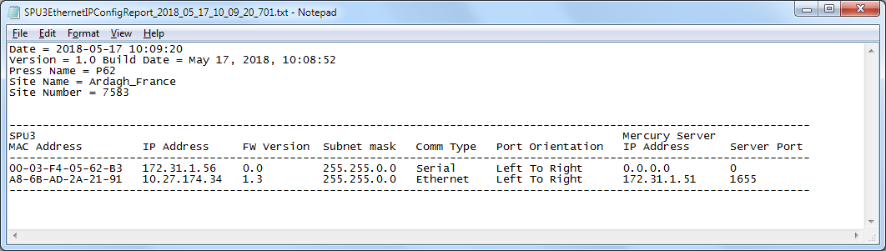

## Assumptions

* Every SPU3 Device would have a valid IP Address assigned, regardless of the communication type (serial / Ethernet)
* SPU3 Ethernet Auto Configuration Tool would run as a standalone application
* SPU3 Ethernet Auto Configuration Tool would be a single instance application
* SPU3 Ethernet Auto Configuration Tool and SPU3 Device would communicate via UDP messages
* SPU3 Ethernet Auto Configuration Tool would be launched from Mercury Client application
* SPU3 Ethernet Auto Configuration Tool would allow user to change SPU3 Device settings and Application settings

# Appendix

The following screen captures illustrate the user interface controls and views of SPU3 Ethernet Auto Configuration Tool.

## Mercury Client 🡺 System 🡺 Utilities 🡺 SPU3 Ethernet Auto Configuration Tool button

A new button  will be added to the Utilities group of the System View, as shown below:

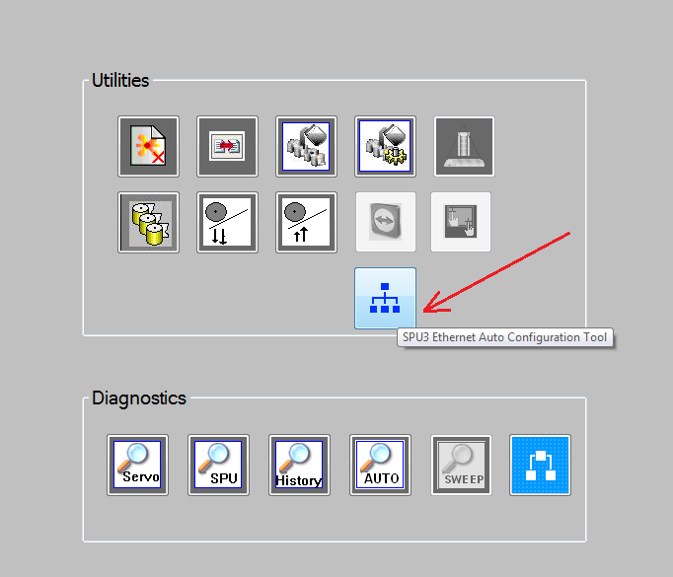

This button will be displayed only when at least one SPU3 is configured in the System XML file. A SPU with a valid IP Address is considered as a SPU3 Device, regardless of its communication type defined in the System XML file.

User pushes this button to launch the SPU3 Ethernet Auto Configuration Tool.

## SPU3 Ethernet Auto Configuration Tool

The following picture describes some of the user interface elements of the SPU3 Ethernet Auto Configuration Tool.

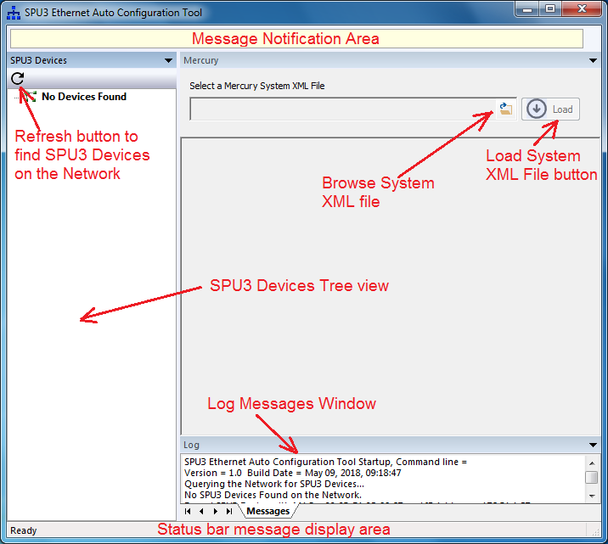

## SPU3 Ethernet Auto Configuration Tool 🡺 No Devices Found View

The following picture illustrates the ‘No Devices Found’ view when no SPU3 devices are found on the Network (LAN).

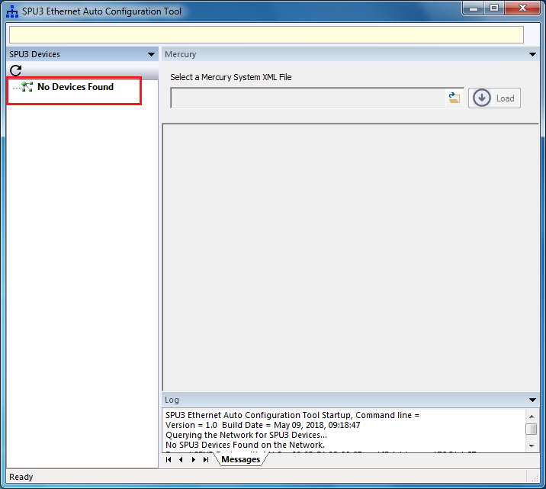

## SPU3 Ethernet Auto Configuration Tool 🡺 SPU3 Device Configuration View

The following picture illustrates the SPU3 Device Configuration View, when at least one SPU3 is found on the Network. From SPU3 Devices view, user selects a SPU3 Device node to view its Device configuration settings and Application Configuration settings. The status bar displays the MAC Address and IP Address of the SPU3 Device selected, as shown below:

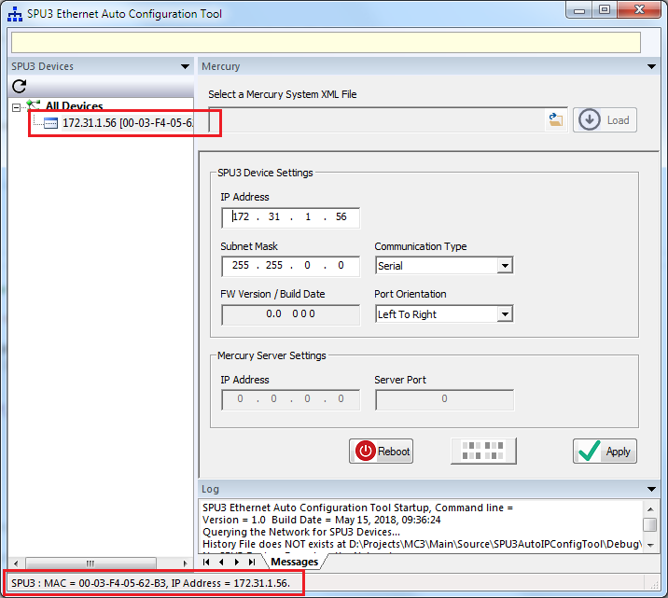

## SPU3 Ethernet Auto Configuration Tool 🡺 SPU3 Device Configuration View 🡺 System XML File browse dialog

To select a Mercury System XML file, user pushes the Browse button. The following Browse dialog gets displayed.

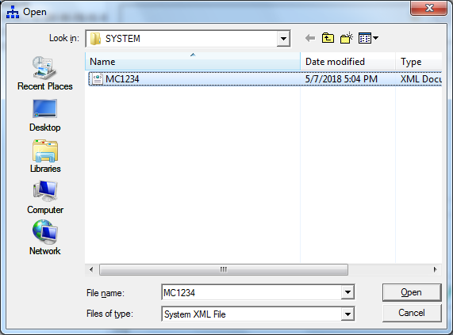

## SPU3 Ethernet Auto Configuration Tool 🡺 Load a System XML file

After selecting a Mercury System XML file, user pushes the Load button to load the System XML file. The following picture depicts the message notification after loading a System XML file.

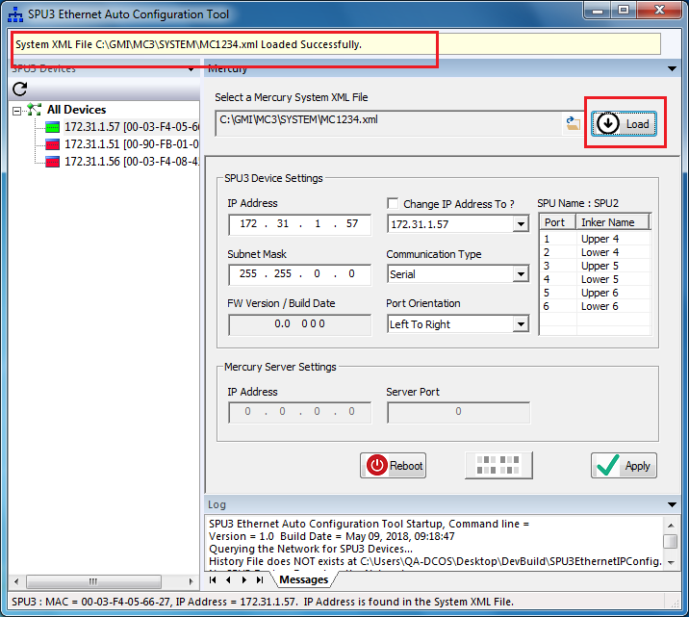

## SPU3 Ethernet Auto Configuration Tool 🡺 Load a System XML File 🡺 Populate SPU3 IP Addresses from the System XML file

The following picture shows the SPU3 IP Addresses retrieved from the System XML file. Also, the picture shows the SPU Name, Port# and Inker Names of the selected SPU3.

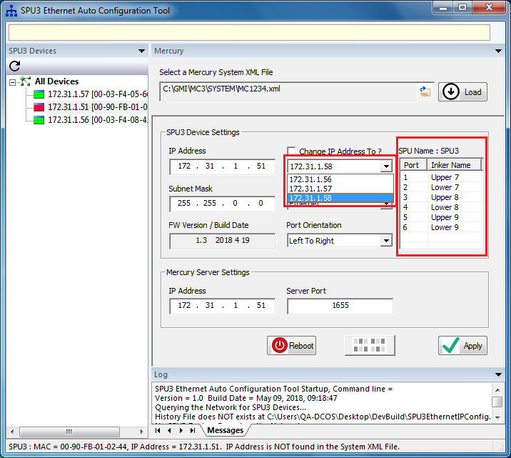

## SPU3 Ethernet Auto Configuration Tool 🡺 SPU3 Device Configuration View 🡺 Apply changes

From SPU3 Device Configuration view, user can make changes to the device settings and application settings. User pushes the **Apply** button tosave the changes made. The following picture illustrates the message notification while applying the changes.

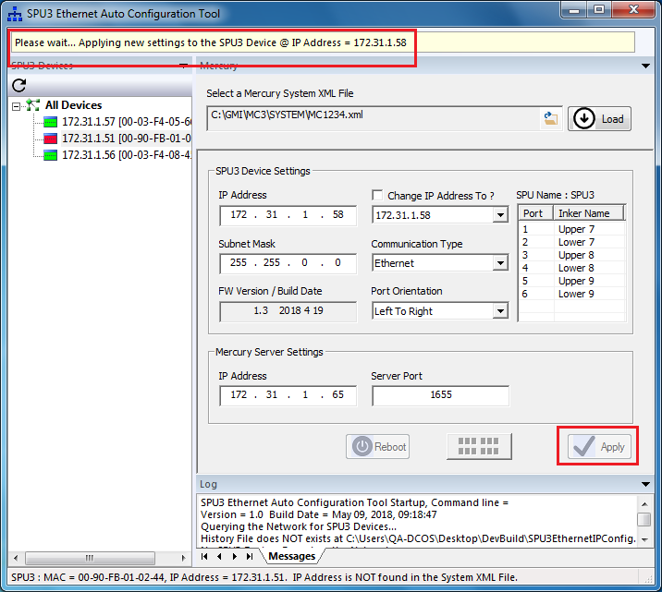

## SPU3 Ethernet Auto Configuration Tool 🡺 SPU3 Device Configuration View 🡺 Reboot a SPU3 Device

From SPU3 Device Configuration view, user can reboot a SPU3 Device. User pushes the **Reboot** button to reboot the selected SPU3 Device. The following picture illustrates the message notification while rebooting the SPU3 Device.

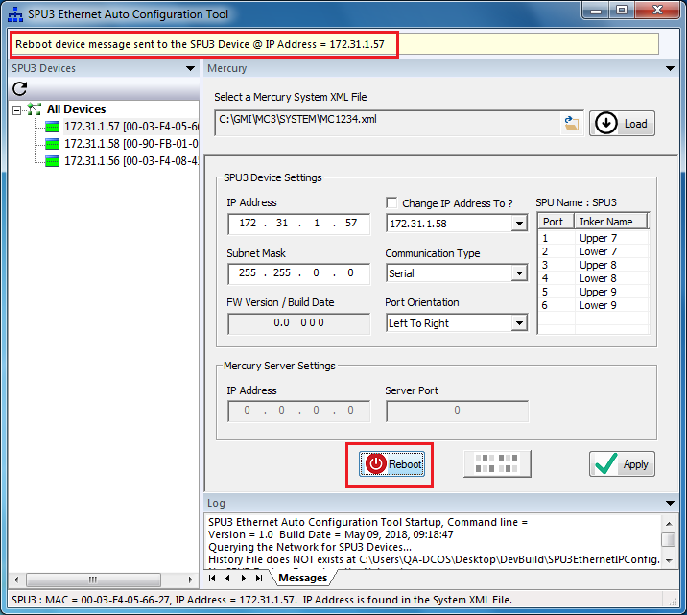

## SPU3 Ethernet Auto Configuration Tool 🡺 SPU3 Device Configuration View 🡺 Blink LEDs

User pushes the **Blink LEDs** button to start/stop blinking the activity/overcurrent LEDs of a SPU3 Device. The Blink LEDs button is a toggle button. The following picture illustrates the message notification while start/stop blinking of the activity/overcurrent LEDs.

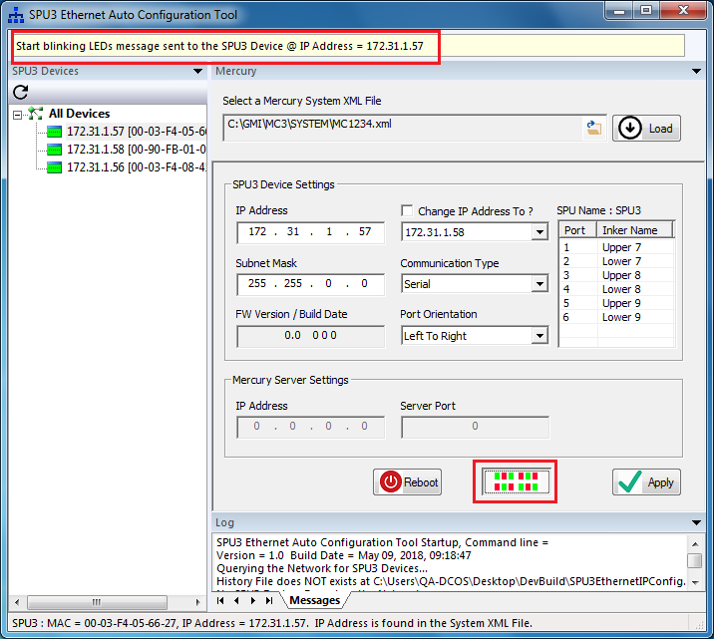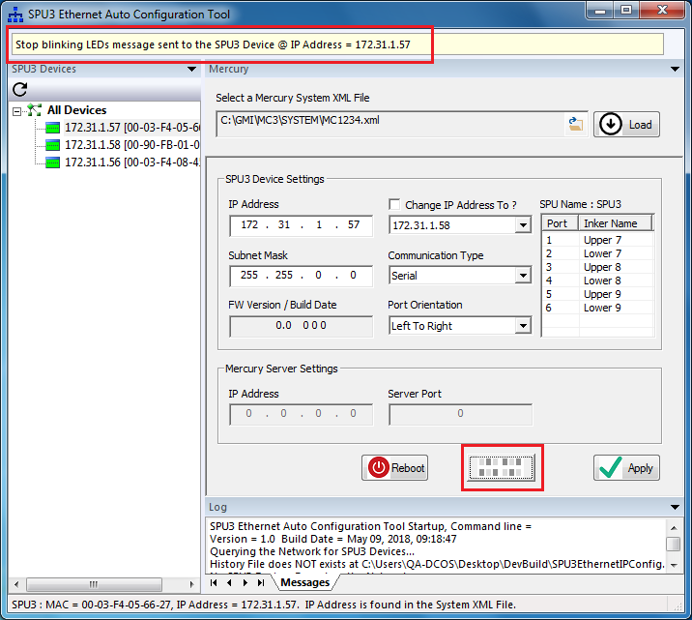

## SPU3 Ethernet Auto Configuration Tool 🡺 SPU3 Device Configuration View 🡺 Communication Type

The Mercury Server settings will be enabled only when the Communication Type is Ethernet.

The following picture depicts the Mercury Server Settings when the Communication Type = Serial.

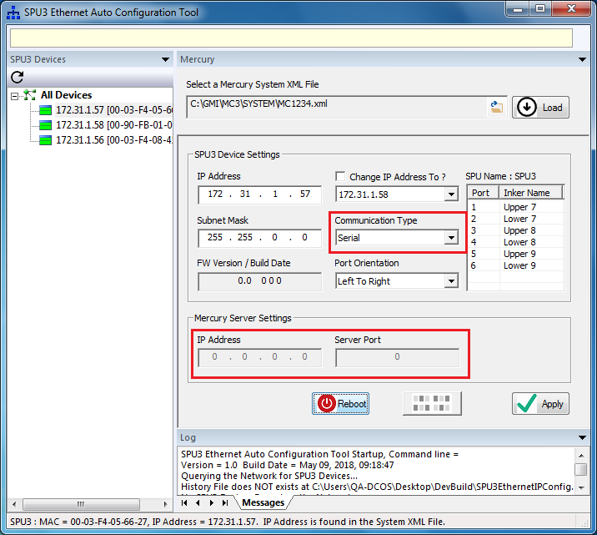

The following picture depicts the Mercury Server Settings when the Communication Type = Ethernet.

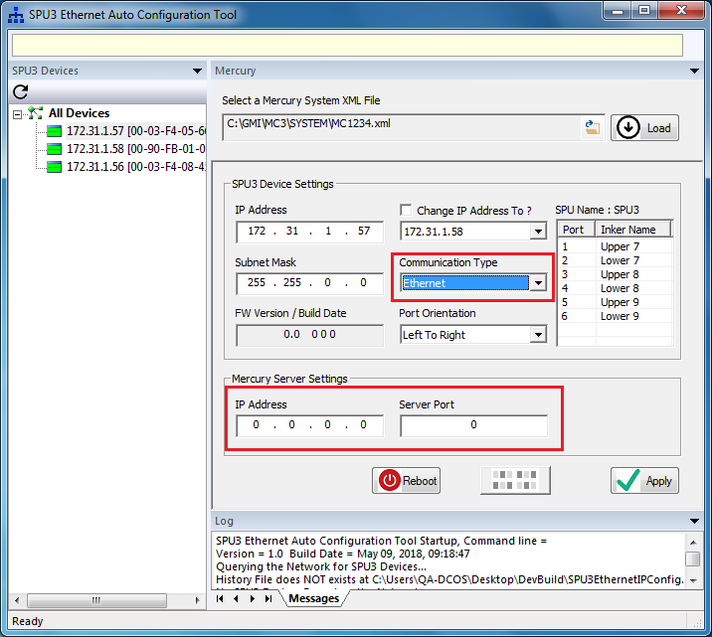

## SPU3 Ethernet Auto Configuration Tool 🡺 Status bar message display

The following picture depicts the functionality of displaying the additional info about the SPU3 Device selected. In this case, the IP Address of the SPU3 Device is NOT found in the System XML file loaded.

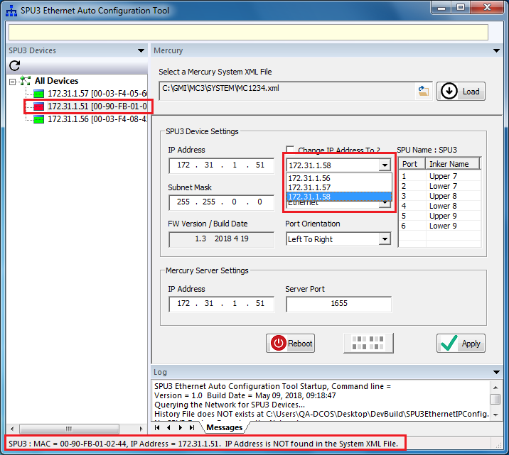

In this case, the IP Address of the SPU3 Device is found in the System XML file. But the MAC address is NOT found in the History File.

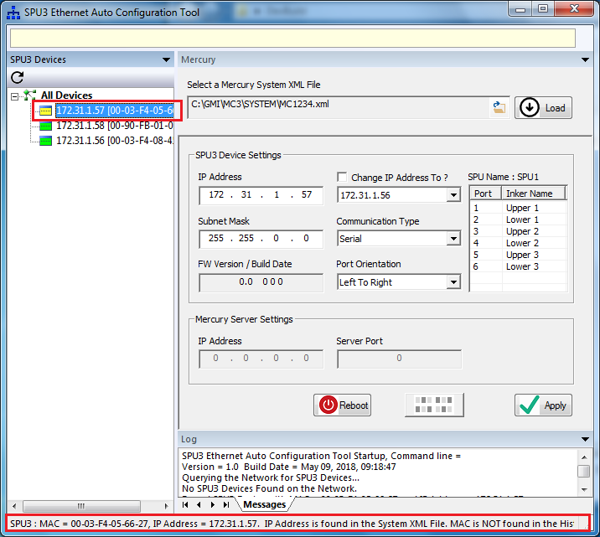

## SPU3 Ethernet Auto Configuration Tool 🡺 All Devices View

The following picture depicts the All Devices View. This view displays the Device settings and Application settings for all of the SPU3 Devices found on the Network. This data is presented in a grid layout. Also, this view has got controls to generate a summary Report and to create the History file.

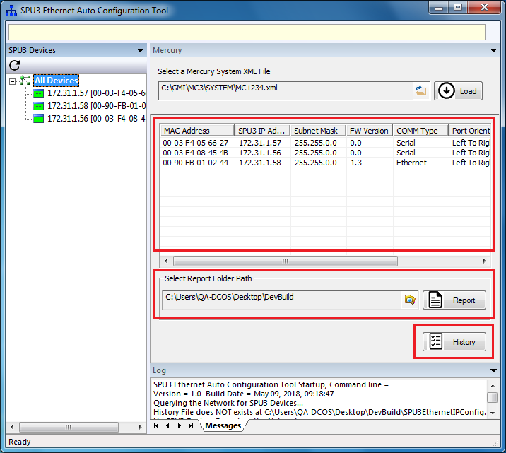

## SPU3 Ethernet Auto Configuration Tool 🡺 All Devices View 🡺 Browse for Report Folder Path

The following picture illustrates the **Browse for Folder** dialog for configuring the Report Folder Path.

The Report Folder Path will be used to save the Report files.

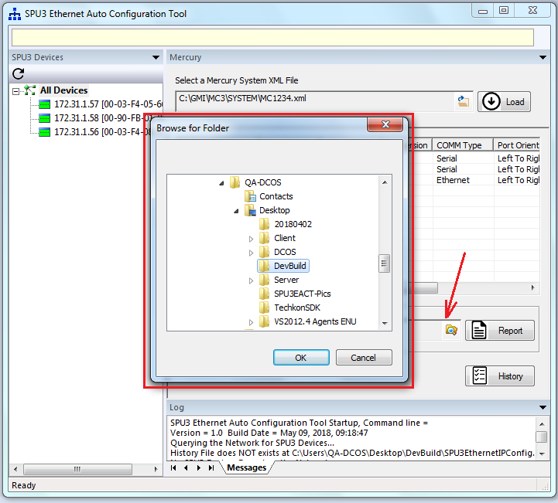

## SPU3 Ethernet Auto Configuration Tool 🡺 All Devices View 🡺 Generate a Report File

User pushes the Report button to generate a report file. Upon generating a report file, a message box will be displayed to notify the report file path and file name, as shown below:

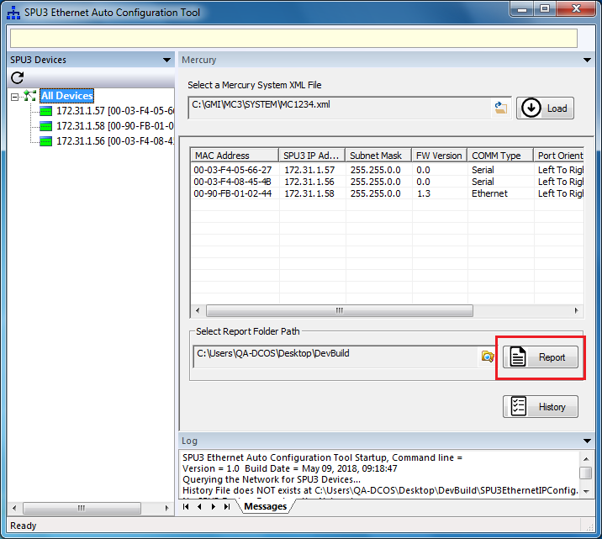

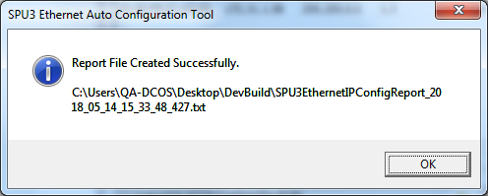

## SPU3 Ethernet Auto Configuration Tool 🡺 All Devices View 🡺 Create the History File

User pushes the History button to create the History file. Upon creating the History file, a message box will be displayed to notify the history file path and file name, as shown below:

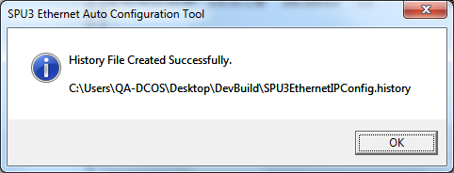

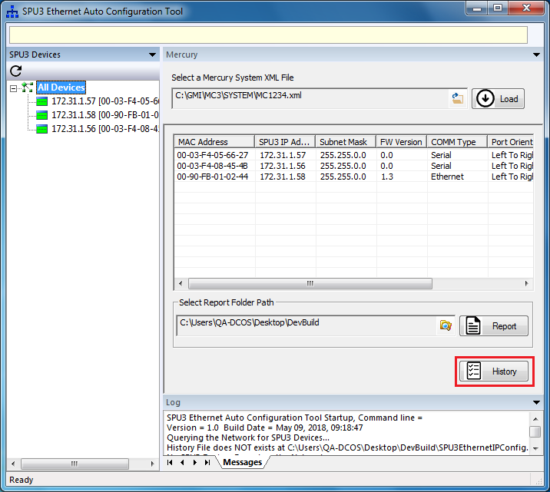

## SPU3 Ethernet Auto Configuration Tool 🡺 About box

The following picture shows the ‘**About’** menu item in the System menu of the SPU3 Ethernet Auto Configuration Tool.

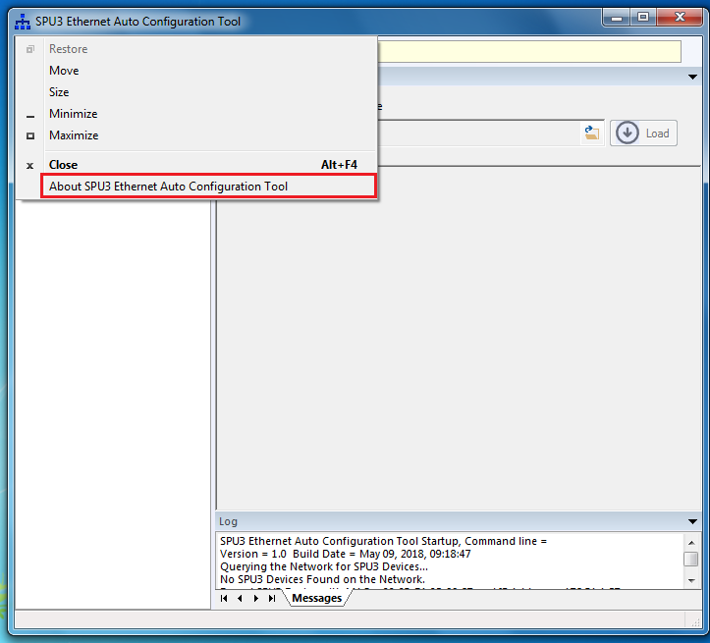

The following About box dialog will be displayed when user selects the ‘About SPU3 Ethernet Auto Configuration Tool’ menu item:

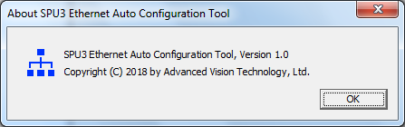

**Revision History**

|  |  |  |  |  |
| --- | --- | --- | --- | --- |
| Revision Date | Revised By | Version | Section/Page Numbers | Revision Description |
| 5/30/18 | MAC | A |  | Initial |
|  |  |  |  |  |
|  |  |  |  |  |