Software Design Specification
For

SPU3 Ethernet Auto Configuration Tool
(WI 158953)

Version 1.2

Document Revision History
Version | Change Description | Document Name | Author | Date
1.0 | Initial draft | SDS+SPU3EthernetAutoConfigurationTool+Ver1.0.doc | Surendra Babu DV | May 9, 2018
1.1 | Added notes about compatible OS details.  Added notes about testing the SPU3 Ethernet Auto Configuration Tool using a SPU3 Simulator Application. Added notes about launching this Tool from Mercury Client Unicode and non-Unicode versions. | SDS+SPU3EthernetAutoConfigurationTool+Ver1.1.doc | Surendra Babu DV | May 18, 2018
1.2 | Added additional feature data to SPU3 Application record in section 4.5.2.2.2, Control for display/change of Performance Mode option in section 5.6 | SDS+SPU3EthernetAutoConfigurationTool+Ver1.2.doc | Mark Colvin | May 10, 2019

Detailed Explanation of Changes & Documents Affected
Version | Section | Description

1 List of Figures 5
2 List of Tables 5
3 Introduction 6
3.1 Purpose 6
3.2 Scope 6
3.3 Acronyms and Abbreviations 6
3.4 Tool(s) Used 7
3.5 References 7
4 System Architecture Description 8
4.1 System Block Diagram 8
4.2 Overview of Subsystems/Applications 8
4.2.1 Mercury Client Application 9
4.2.2 SPU3 (Servo Power Unit) 9
4.2.3 SPU3 Ethernet Auto Configuration Tool 9
4.3 Assumptions 12
4.4 Communications 12
4.5 Messages 13
4.5.1 Data Types 13
4.5.2 Messaging Categories 13
4.5.2.1 Command messages from SPU3 Ethernet Auto Configuration Tool to SPU3 Device 13
4.5.2.1.1 Read SPU3 Device Configuration (0x52) 16
4.5.2.1.2 Write SPU3 Device Configuration (0x57) 17
4.5.2.1.3 Read SPU3 Application Configuration (0x43) 17
4.5.2.1.4 Write SPU3 Application Configuration (0x53) 17
4.5.2.1.5 Blink SPU3 Device LEDs (0x4C) 18
4.5.2.1.6 Reboot SPU3 Device (0x42) 19
4.5.2.2 Response messages from SPU3 Device to SPU3 Ethernet Auto Configuration Tool 20
4.5.2.2.1 Send SPU3 Device Configuration (0x52) 20
4.5.2.2.2 Send SPU3 Application Configuration (0x43) 22
5 Appendix 24
5.1 Mercury Client ➔ System ➔ Utilities ➔ SPU3 Ethernet Auto Configuration Tool button 24
5.2 SPU3 Ethernet Auto Configuration Tool 26
5.3 SPU3 Ethernet Auto Configuration Tool ➔ No Devices Found View 27
5.4 SPU3 Ethernet Auto Configuration Tool ➔ SPU3 Device Configuration View 28
5.5 SPU3 Ethernet Auto Configuration Tool ➔ SPU3 Device Configuration View ➔ System XML File browse dialog 29
5.6 SPU3 Ethernet Auto Configuration Tool ➔ Load a System XML file 29
5.7 SPU3 Ethernet Auto Configuration Tool ➔ Load a System XML File ➔ Populate SPU3 IP Addresses from the System XML file 30
5.8 SPU3 Ethernet Auto Configuration Tool ➔ SPU3 Device Configuration View ➔ Apply changes 31
5.9 SPU3 Ethernet Auto Configuration Tool ➔ SPU3 Device Configuration View ➔ Reboot a SPU3 Device 33
5.10 SPU3 Ethernet Auto Configuration Tool ➔ SPU3 Device Configuration View ➔ Blink LEDs 34
5.11 SPU3 Ethernet Auto Configuration Tool ➔ SPU3 Device Configuration View ➔ Communication Type 35
5.12 SPU3 Ethernet Auto Configuration Tool ➔ Status bar message display 38
5.13 SPU3 Ethernet Auto Configuration Tool ➔ All Devices View 40
5.14 SPU3 Ethernet Auto Configuration Tool ➔ All Devices View ➔ Browse for Report Folder Path 41
5.15 SPU3 Ethernet Auto Configuration Tool ➔ All Devices View ➔ Generate a Report File 42
5.16 SPU3 Ethernet Auto Configuration Tool ➔ All Devices View ➔ Create the History File 43
5.17 SPU3 Ethernet Auto Configuration Tool ➔ About box 44

List of Figures
Figure 1, System Block Diagram 8

List of Tables
No table of figures entries found.

Introduction

Purpose
The main purpose of this document is to present the software design details for developing the SPU3 Ethernet Auto Configuration Tool.

Scope
The scope of this document covers the software design details required to implement the SPU3 Ethernet Auto Configuration Tool. Also, this document focuses on the UDP messages that will be used to communicate with SPU3 Devices to read/write Device settings and Application settings.
This document covers only the UDP messages and its structures that should be implemented by SPU3 FW / SPU3 Simulator Application.
This document does NOT provide comprehensive details about the changes required in SPU3 FW / SPU3 Simulator Application.

Acronyms and Abbreviations
Term/Acronym | Explanation
AVT | Advanced Vision Technology  www.avt-inc.com
UDP | User Datagram Protocol
NetBurner | https://www.netburner.com/
SPU3 | Servo Power Unit
SPU3 FW | SPU3 Application Firmware
SPU3 Simulator Application | A windows .NET Application to simulate the SPU3 FW functionality
TCP/IP | Transmission Control Protocol / Internet Protocol

Tool(s) Used
The following tool(s) are used in producing the details of this document:
- Visual Studio 2015 – Architecture Tools
- Microsoft Office Professional Plus 2016

References
- The Configuration Record Packet.doc
  - Available at: \\usfs1\ENGINEERING\CMG_R&D\Inspections\158953\Docs
- Refer to the following TFS Work Item for latest updates:
  - WI 158953 - MC3 - SPU3 Ethernet Auto Configuration Tool

System Architecture Description

System Block Diagram
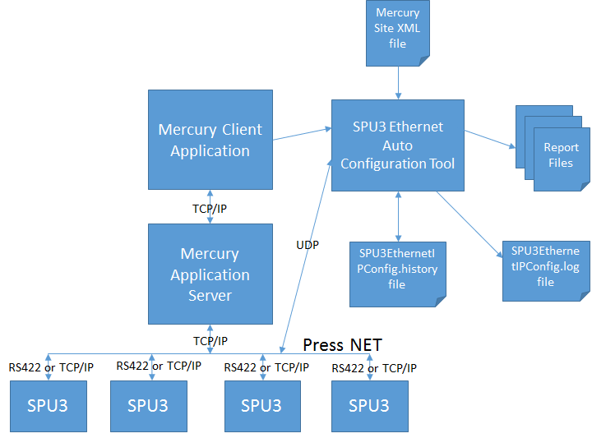
Figure 1, System Block Diagram

Overview of Subsystems/Applications
SPU3 Ethernet Auto Configuration Tool will display all of its Graphic User Interface controls in English only. However, this Tool can be run from a non-English OS.
Also, this Tool can be launched from both versions of Mercury Client Application, i.e. ANSI version and Unicode version.
The following OS Versions will be supported by this Tool:
- Windows XP Pro, 32 bit
- Windows XP Embedded, 32 bit
- Windows 7, 32 bit and 64 bit
- Windows 7 Embedded, 32 bit and 64 bit

The following sections describes the changes incorporated in each subsystem/application to support the implementation of SPU3 Ethernet Auto Configuration Tool.

Mercury Client Application
- Added support to launch the SPU3 Ethernet Auto Configuration Tool from Mercury Client Application. For more details refer to the Appendix section of this document.

SPU3 (Servo Power Unit)
- The SPU3 FW will implement the UDP interface and application protocol messages defined in this document.
Note: SPU3 Simulator Application can be used to verify the UDP communication interface. However, testing with the SPU3 Simulator should be limited to the LAB environment, when real SPU3 Devices are NOT available.

SPU3 Ethernet Auto Configuration Tool
The following section describes the purpose of each input/output Files:
Mercury System XML file:
  - It is an optional input file. In other words, the SPU3 Ethernet Auto Configuration Tool can be used without an input System XML file.
  - The SPU3 IP Addresses from the System XML file will be used to select & change the IP Address of a SPU3 Device found on the Network.
  - The SPU3 IP Addresses from the System XML file will be used to compare with each SPU3 Device found on the Network (LAN). This process will determine the SPU3 Devices that are NOT in sync with the System XML configuration.
  - No changes to the System XML file will be allowed form the SPU3 Ethernet Auto Configuration Tool.
SPU3EthernetIPConfig.history file:
  - The history file plays an important role in identifying new SPU3 devices.
  - The history file stores the MAC Address and IP Address of each SPU3 Device found on the Network. The MAC Addresses from the history file will be used to compare with each SPU3 Device found on the Network. If the MAC Address of a SPU3 Device is NOT found in the history file, then it is identified as a new SPU3 device.
  - Ideally, the history file will be created when all of the SPU3 Devices are configured as per the System XML configuration.
  - The history file will be saved to the LOGPATH specified as part of the Application command line.
  - The history file will be saved to the Application executable folder, if LOGPATH is not specified.
  - If the history file does NOT exists, a message prompt will be displayed to create the history file, when exiting the SPU3 Ethernet Auto Configuration Tool, as shown below:
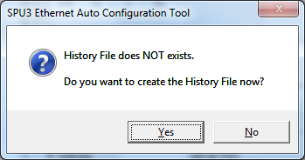
SPU3EthernetIPConfig.log file:
  - The log file will be saved to the LOGPATH specified as part of the Application command line.
  - The log file will be saved to the Application executable folder, if LOGPATH is not specified.
  - During the startup of the Application, the log file will be created, if it does NOT exists already.
  - The log file header will include the Application version, Application build date and Application command line arguments.
  - Each log message will include Date and Time info, as shown below:
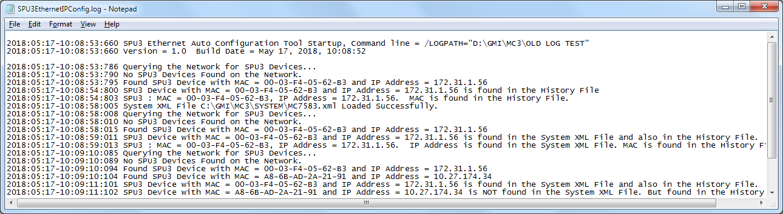
Report files:
  - Default report file path is set to the LOGPATH specified as part of the Application command line.
  - Also, the Report File Path is configurable from the All Devices View. For more details refer to the Appendix section of this document.
  - A typical Report file will include the following data
    - Report creation date
    - Application version and build date
    - Press Name
    - Site Name
    - Site Number
    - For each SPU3 Device found on the Network
      - Device configuration settings
        - MAC Address
        - IP Address
        - Subnet mask
      - Application configuration settings
        - FW Version
        - Communication Type
        - Port orientation
        - Mercury Server IP Address
        - Server Port
  - Report File name convention:
    - SPU3EthernetIPConfigReport_[Year]_[Month]_[Day]_[Hour]_[Minute]_[Second]_[Milli seconds].txt
  - A report file will include the Device configuration settings and Application configuration settings for each SPU3 Device found on the Network.
  - Sample of a Report file is shown below:
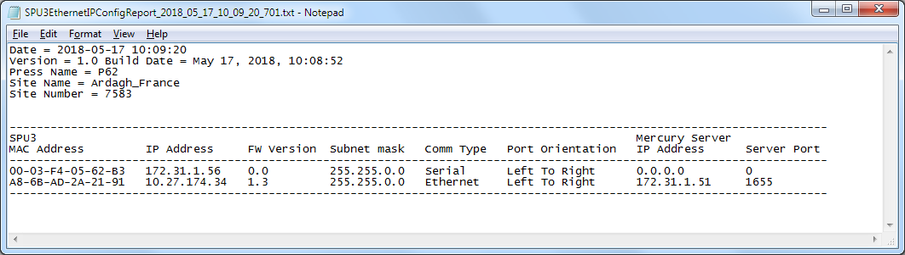

Assumptions
- Every SPU3 Device would have a valid IP Address assigned, regardless of the communication type (serial / Ethernet)
- SPU3 Ethernet Auto Configuration Tool would run as a standalone application
- SPU3 Ethernet Auto Configuration Tool would be a single instance application
- SPU3 Ethernet Auto Configuration Tool and SPU3 Device would communicate via UDP messages
- SPU3 Ethernet Auto Configuration Tool would be launched from Mercury Client application
- SPU3 Ethernet Auto Configuration Tool would allow user to change SPU3 Device settings and Application settings

Communications
The SPU3 Ethernet Auto Configuration Tool and the SPU3 will communicate via UDP using an asynchronous communications model. One side sends a message and, whether it is a notification message or a request message, forgets that it sent it. The sender should not require a reply in order to function properly. Instead, it will handle an incoming message as if it were sent without being requested.
The SPU3 Ethernet Auto Configuration Tool would use the following details while communicating with SPU3.
Port Number: 20034 (0x4E42)
Socket Type: Datagram Socket
Byte order: Different computers use different conventions for ordering the bytes within multi-byte integer values. Some computers put the most significant byte first (known as big-endian order) and others put the least-significant byte first (known as little-endian order). To work with computers that use different byte ordering, all integer values that are sent over the network are sent in network byte order which has the most significant byte first.

Messages

Data Types
This section is to help understand the data types used in the messages, and the format used in the document to describe the messages.
The following table contains the data types used in the message definitions.
Type | Notes
Byte | Single byte unsigned value.
Int16 | Two byte signed value.
UInt16 | Two byte unsigned value.
Int32 | Four byte signed value.
UInt32 | Four byte unsigned value.

Messaging Categories
All communications between the SPU3 Ethernet Auto Configuration Tool and the SPU3 Device will fall into 2 categories:
- Command messages from SPU3 Ethernet Auto Configuration Tool to SPU3 Device
- Response messages from SPU3 Device to SPU3 Ethernet Auto Configuration Tool

All numerical values are assumed to be hexadecimal.

Command messages from SPU3 Ethernet Auto Configuration Tool to SPU3 Device

Message ID | Message Name | Type | Description
0x52 (‘R’) | Read SPU3 Device Configuration | Runtime | Broadcast the message (0x52) to all of the SPU3 devices on the Network to request the device configuration details.
0x57 (‘W’) | Write SPU3 Device Configuration | Runtime | Broadcast the message (0x57) to write the device configuration details of a specific SPU3 Device.
0x43 (‘C’) | Read SPU3 Application Configuration | Runtime | Broadcast the message (0x43) to all of the SPU3 devices on the Network to request the Application configuration details.
0x53 (‘S’) | Write SPU3 Application Configuration | Runtime | Broadcast the message (0x53) to write the Application configuration details of a specific SPU3 Device.
0x4C (‘L’) | Blink SPU3 Device LEDs | Runtime | Broadcast the message (0x4C) to start/stop blinking the activity/overcurrent LEDs of a specific SPU3 device.
0x42 (‘B’) | Reboot SPU3 Device | Runtime | Broadcast the message (0x42) to reboot a specific SPU3 Device.

Note: The Request Command Packet is identical for all of the request messages, except the member Action is changed according to the type of operation being requested.
Action | Description
R | Read SPU3 Device Configuration
W | Write SPU3 Device Configuration
C | Read SPU3 Application Configuration
S | Write SPU3 Application Configuration
L | Blink SPU3 Device LEDs
B | Boot SPU3 Device

Request Command Packet:
Name | Type In Buffer | Notes
Key Value / Verify Code | UInt32 | The verify code value will be set to 0x4255524E (BURN) for all request and response messages.
Action | Byte | The Action indicates the type of operation being requested.
Record Length | UInt32 | Length of the message
IP Address | Byte[4] | IP Address of the SPU3 Device
Subnet mask | Byte[4] | Subnet mask
Gateway IP Address | Byte[4] | Gateway IP Address
TFTP Server IP | Byte[4] | TFTP Server IP Address  The address of the TFTP server to load data from for debugging
Baud rate | UInt32 | The initial system Baud rate
Boot Delay | Byte | The number of seconds to wait before booting
Boot To Application | Byte | True if we boot to the application, not the monitor  0 – Boot to Application  1 – Boot to Monitor
Exception Action | Byte | What should we do when we have an exception?  0 – Reboot  1 – Halt  2 – Reboot Quietly
TFTP File Name | Byte[80] | The file name of the TFTP file to load  Null Terminated
Ethernet MAC Address | Byte[6]
Monitor Port | Byte | UART used by Monitor I/O
DNS Server IP | Byte[4]
Parent MAC Address | Byte[6] | Used to identify boards with multiple MAC Addresses. (Ex WIFI)
Interface | Byte | 0 – Standard  1 – Wi-Fi  2 – Second Ethernet
Direct TX | Byte
IP Used | Byte[4]
Mask Used | UInt32
Gate Used | UInt32
DNS Used | UInt32
Unused | Byte[3]
Boot Quietly | Byte | 0 – Normal Boot  1 – Quiet Boot
Checksum | UInt16 | Checksum is NOT used.  Since we don’t have any idea about the technique being used to calculate the checksum by the NetBurner device.

Read SPU3 Device Configuration (0x52)
This message (0x52) will be broadcasted to all of the SPU3 Devices on the Network, to request the device configuration details. In response to this message, each SPU3 Device will send the device configuration details.

Listed below is the standard message sequence:
SPU3 Ethernet Auto Configuration Tool | SPU3 Device
Read SPU3 Device Configuration (0x52) ➔
Request Command Packet with Action = ‘R’
⬅ Send SPU3 Device Configuration (0x52)
Device Configuration Record Packet with Action = ‘R’.
The response message will include additional details like Plat Form Name and Application Name.

Write SPU3 Device Configuration (0x57)
This message (0x57) will be broadcasted to write the updated configuration details of a specific SPU3 Device.
An updated Request Command Packet will set the member Action to ‘W’ to indicate that a write operation being requested. Upon receiving this message, the SPU3 Device will update its configuration and reboots automatically.

Listed below is the standard message sequence:
SPU3 Ethernet Auto Configuration Tool | SPU3 Device
Write SPU3 Device Configuration (0x57) ➔
Request Command Packet with Action = ‘W’
 | Upon receiving this message, the SPU3 Device will update its device configuration and reboots automatically.

Read SPU3 Application Configuration (0x43)
This message (0x43) will be broadcasted to all of the SPU3 Devices on the Network, to request the application configuration details. In response to this message, each SPU3 Device will send the application configuration details.

Listed below is the standard message sequence:
SPU3 Ethernet Auto Configuration Tool | SPU3 Device
Read SPU3 Application Configuration (0x43) ➔
Request Command Packet with Action = ‘C’
⬅ Send SPU3 Application Configuration (0x43)
Application Configuration Record Packet with Action = ‘C’

Write SPU3 Application Configuration (0x53)
This message (0x53) will be broadcasted to write the updated application configuration details of a specific SPU3 Device. An updated Application Request Command Packet will set the member Action to ‘S’ to indicate that a write operation being requested. Upon receiving this message, the SPU3 Device will update its application configuration and reboots automatically.

Listed below is the standard message sequence:
SPU3 Ethernet Auto Configuration Tool | SPU3 Device
Write SPU3 Application Configuration (0x53) ➔
Application Configuration Record Packet with Action = ‘S’
 | Upon receiving this message, the SPU3 Device will update its application configuration and reboots automatically.

Blink SPU3 Device LEDs (0x4C)
This message (0x4C) will be broadcasted to all of the SPU3 Devices on the Network, to start/stop blinking the activity/overcurrent LEDs of a specific SPU3 device. Upon receiving this message, the SPU3 Device will either start or stop blinking the activity/overcurrent LEDs based on the operation being requested.

Device Operation Record Packet:
Name | Type In Buffer | Notes
Key Value / Verify Code | UInt32 | The verify code value will be set to 0x4255524E (BURN) for all request and response messages.
Action | Byte | Action = ‘L’ (blink LEDs)
Record Length | UInt32 | Length of the message
MAC Address | Byte[6] | SPU3 MAC Address
Operation Data | Byte | 1 = Start blinking LEDs  0 = Stop blinking LEDs

Listed below is the standard message sequence:

To start blinking the SPU3 LEDs:
SPU3 Ethernet Auto Configuration Tool | SPU3 Device
Blink SPU3 Device LEDs (0x4C) ➔
Device Operation Record Packet
Action = ‘L’
Operation Data = 1 (start blinking LEDs)
 | Upon receiving this message, the SPU3 Device will start blinking the activity/overcurrent LEDs.

To stop blinking the SPU3 LEDs:
SPU3 Ethernet Auto Configuration Tool | SPU3 Device
Blink SPU3 Device LEDs (0x4C) ➔
Device Operation Record Packet
Action = ‘L’
Operation Data = 0 (stop blinking LEDs)
 | Upon receiving this message, the SPU3 Device will stop blinking the activity/overcurrent LEDs.

Reboot SPU3 Device (0x42)
This message (0x42) will be broadcasted to all of the SPU3 Devices on the Network, to reboot a specific SPU3 device. Upon receiving this message, the SPU3 Device will reboot automatically.

Device Operation Record Packet:
Name | Type In Buffer | Notes
Key Value / Verify Code | UInt32 | The verify code value will be set to 0x4255524E (BURN) for all request and response messages.
Action | Byte | Action = ‘B’  (reboot SPU3 Device)
Record Length | UInt32 | Length of the message
MAC Address | Byte[6] | SPU3 MAC Address
Operation Data | Byte | 1 = Reboot SPU3 Device

Listed below is the standard message sequence:
SPU3 Ethernet Auto Configuration Tool | SPU3 Device
Reboot SPU3 Device (0x42) ➔
Device Operation Record Packet
Action = ‘B’
Operation Data = 1 (reboot SPU3 Device)
 | Upon receiving this message, the SPU3 Device will reboot automatically.

Response messages from SPU3 Device to SPU3 Ethernet Auto Configuration Tool
Message ID | Message Name | Type | Description
0x52 (‘R’) | Send SPU3 Device Configuration | Runtime | The same message ID (0x52) is used by both sender and receiver to request and send response messages.  However, the response message includes additional details like Plat Form Name and Application Name.  Refer to the Device Configuration Record Packet.
0x43 (‘C’) | Send SPU3 Application Configuration | Runtime | The same message ID (0x43) is used by both sender and receiver to request and send response messages.  The response message includes details about the SPU3 Application configuration details.  Refer to the Application Configuration Record Packet.

Send SPU3 Device Configuration (0x52)
Listed below is the standard message sequence:
SPU3 Ethernet Auto Configuration Tool | SPU3 Device
Read SPU3 Device Configuration (0x52) ➔
Request Command Packet with Action = ‘R’
⬅ Send SPU3 Device Configuration (0x52)
Device Configuration Record Packet with Action = ‘R’.
The response message will include additional details like Plat Form Name and Application Name.

Device Configuration Record Packet:
Name | Type In Buffer | Notes
Key Value / Verify Code | UInt32 | The verify code value will be set to 0x4255524E (BURN) for all request and response messages.
Action | Byte | The Action indicates the type of operation being requested.
Record Length | UInt32 | Length of the message
IP Address | Byte[4] | IP Address of the SPU3 Device
Subnet mask | Byte[4] | Subnet mask
Gateway IP Address | Byte[4] | Gateway IP Address
TFTP Server IP | Byte[4] | TFTP Server IP Address  The address of the TFTP server to load data from for debugging
Baud rate | UInt32 | The initial system Baud rate
Boot Delay | Byte | The number of seconds to wait before booting
Boot To Application | Byte | True if we boot to the application, not the monitor  0 – Boot to Application  1 – Boot to Monitor
Exception Action | Byte | What should we do when we have an exception?  0 – Reboot  1 – Halt  2 – Reboot Quietly
TFTP File Name | Byte[80] | The file name of the TFTP file to load  Null Terminated
Ethernet MAC Address | Byte[6]
Monitor Port | Byte | UART used by Monitor I/O
DNS Server IP | Byte[4]
Parent MAC Address | Byte[6] | Used to identify boards with multiple MAC Addresses. (Ex WIFI)
Interface | Byte | 0 – Standard  1 – Wi-Fi  2 – Second Ethernet
Direct TX | Byte
IP Used | Byte[4]
Mask Used | UInt32
Gate Used | UInt32
DNS Used | UInt32
Unused | Byte[3]
Boot Quietly | Byte | 0 – Normal Boot  1 – Quiet Boot
Checksum | UInt16 | Checksum is NOT used.  Since we don’t have any idea about the technique being used to calculate the checksum by the NetBurner device.
Platform Name | Byte[16] | Up to 16 Bytes  Null Terminated
Application Name | Byte[64] | Up to 64 Bytes  Null Terminated

Send SPU3 Application Configuration (0x43)
Listed below is the standard message sequence:
SPU3 Ethernet Auto Configuration Tool | SPU3 Device
Read SPU3 Application Configuration (0x43) ➔
Request Command Packet with Action = ‘C’
⬅ Send SPU3 Application Configuration (0x43)
Application Configuration Record Packet with Action = ‘C’

Application Configuration Record Packet:
Name | Type In Buffer | Notes
Key Value / Verify Code | UInt32 | The verify code value will be set to 0x4255524E (BURN) for all request and response messages.
Action | Byte | ‘C’ = Read SPU3 Application Configuration
Record Length | UInt32 | Length of the message
MAC Address | Byte[6] | SPU3 Device MAC Address
Communication Type | Byte | Communication Interface Type  0 = Serial, 1 = Ethernet
Port Orientation | Byte | SPU3 Port Orientation  0 = Left to Right  1 = Right to Left
FW Major Version | Byte | SPU3 FW Major Version
FW Minor Version | Byte | SPU3 FW Minor Version
FW Build Year | Byte | SPU3 FW Build Year
FW Build Month | Byte | SPU3 FW Build Month
FW Build Day | Byte | SPU3 FW Build Day
Server IP Address | Byte[4] | Mercury Server IP Address
Server Socket Port | UInt32 | Mercury Server socket port
FW Option Performance Mode | Byte | SPU3 Performance option,  0=Disabled, 1=Enabled
FW Options - available | Byte[19] | Not used at this time
Checksum | UInt16 | Checksum is NOT used.

Appendix
The following screen captures illustrate the user interface controls and views of SPU3 Ethernet Auto Configuration Tool.

Mercury Client ➔ System ➔ Utilities ➔ SPU3 Ethernet Auto Configuration Tool button
A new button  will be added to the Utilities group of the System View, as shown below:
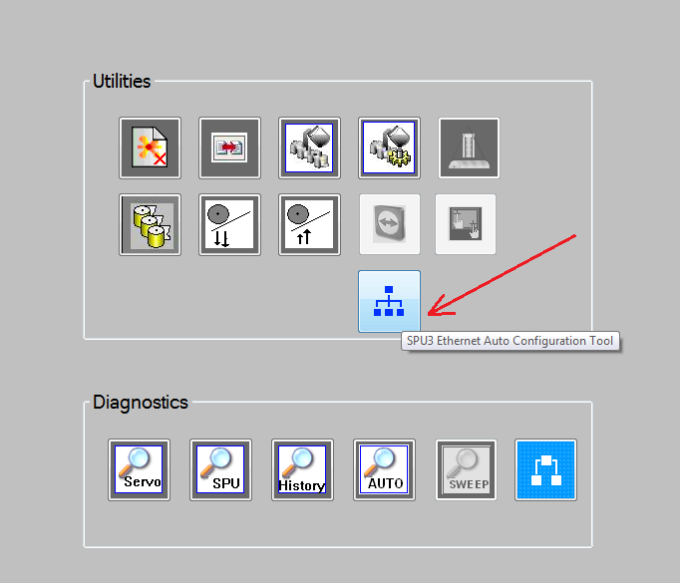

This button will be displayed only when at least one SPU3 is configured in the System XML file. A SPU with a valid IP Address is considered as a SPU3 Device, regardless of its communication type defined in the System XML file.
User pushes this button to launch the SPU3 Ethernet Auto Configuration Tool.

SPU3 Ethernet Auto Configuration Tool
The following picture describes some of the user interface elements of the SPU3 Ethernet Auto Configuration Tool.
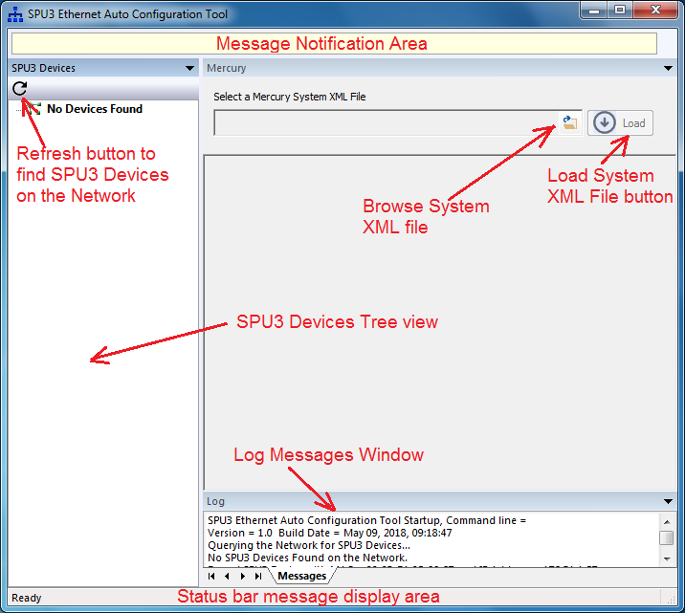

SPU3 Ethernet Auto Configuration Tool ➔ No Devices Found View
The following picture illustrates the ‘No Devices Found’ view when no SPU3 devices are found on the Network (LAN).
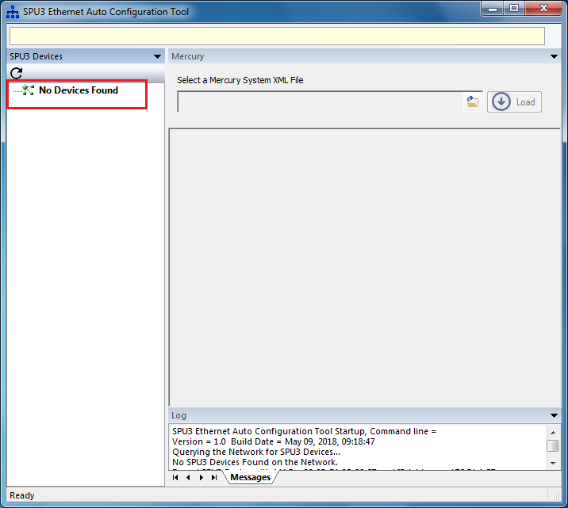

SPU3 Ethernet Auto Configuration Tool ➔ SPU3 Device Configuration View
The following picture illustrates the SPU3 Device Configuration View, when at least one SPU3 is found on the Network. From SPU3 Devices view, user selects a SPU3 Device node to view its Device configuration settings and Application Configuration settings. The status bar displays the MAC Address and IP Address of the SPU3 Device selected, as shown below:
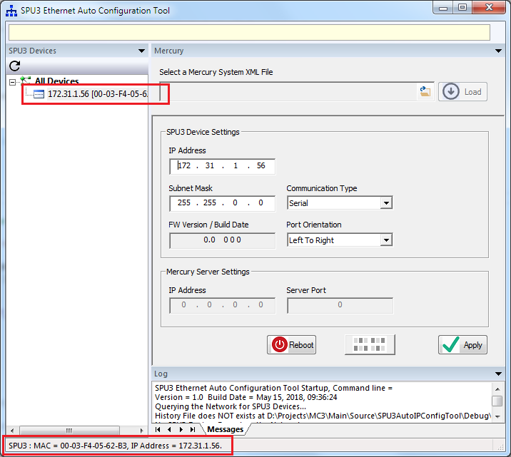

SPU3 Ethernet Auto Configuration Tool ➔ SPU3 Device Configuration View ➔ System XML File browse dialog
To select a Mercury System XML file, user pushes the Browse button. The following Browse dialog gets displayed.
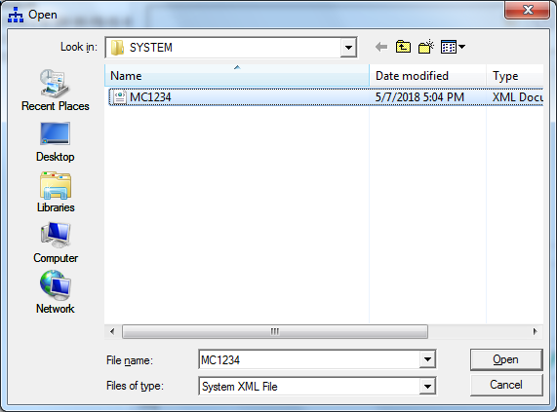

SPU3 Ethernet Auto Configuration Tool ➔ Load a System XML file
After selecting a Mercury System XML file, user pushes the Load button to load the System XML file. The following picture depicts the message notification after loading a System XML file.
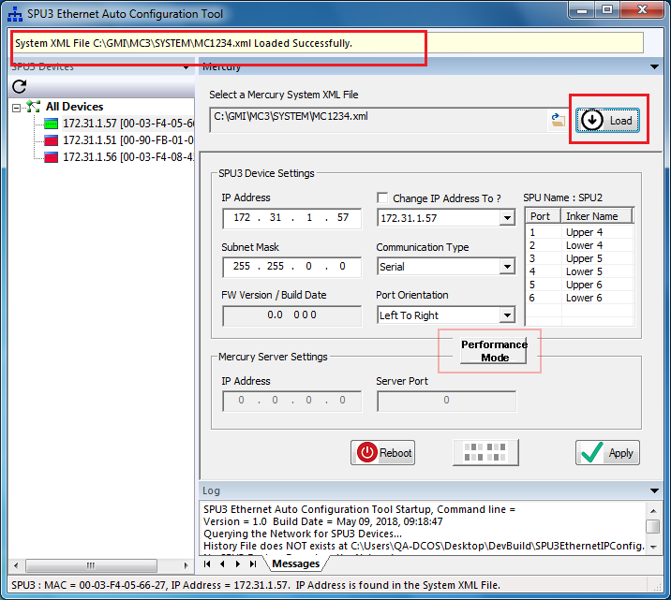

SPU3 Ethernet Auto Configuration Tool ➔ Load a System XML File ➔ Populate SPU3 IP Addresses from the System XML file
The following picture shows the SPU3 IP Addresses retrieved from the System XML file. Also, the picture shows the SPU Name, Port# and Inker Names of the selected SPU3.
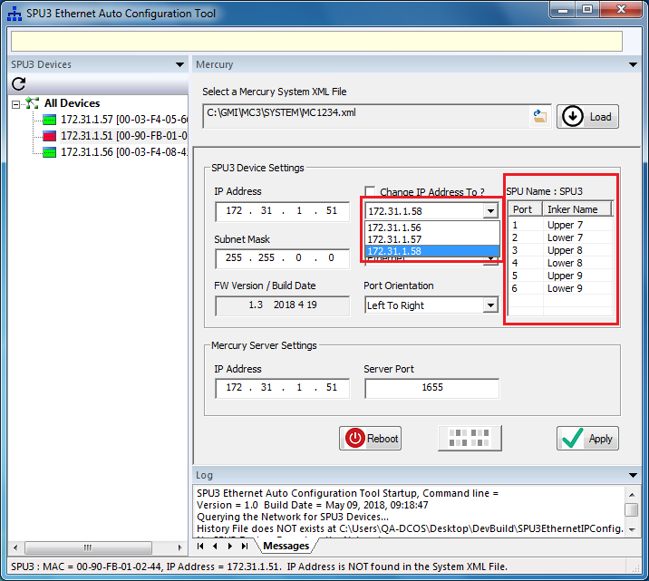

SPU3 Ethernet Auto Configuration Tool ➔ SPU3 Device Configuration View ➔ Apply changes
From SPU3 Device Configuration view, user can make changes to the device settings and application settings. User pushes the Apply button to save the changes made. The following picture illustrates the message notification while applying the changes.

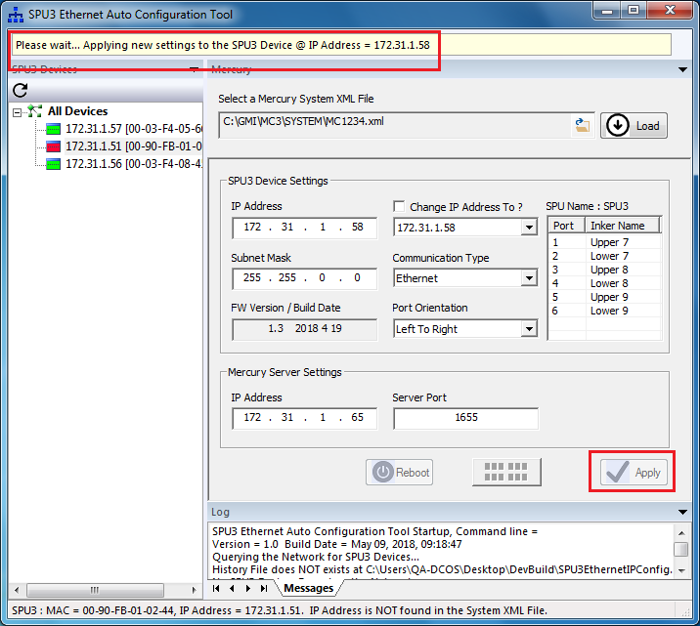

SPU3 Ethernet Auto Configuration Tool ➔ SPU3 Device Configuration View ➔ Reboot a SPU3 Device
From SPU3 Device Configuration view, user can reboot a SPU3 Device. User pushes the Reboot button to reboot the selected SPU3 Device. The following picture illustrates the message notification while rebooting the SPU3 Device.
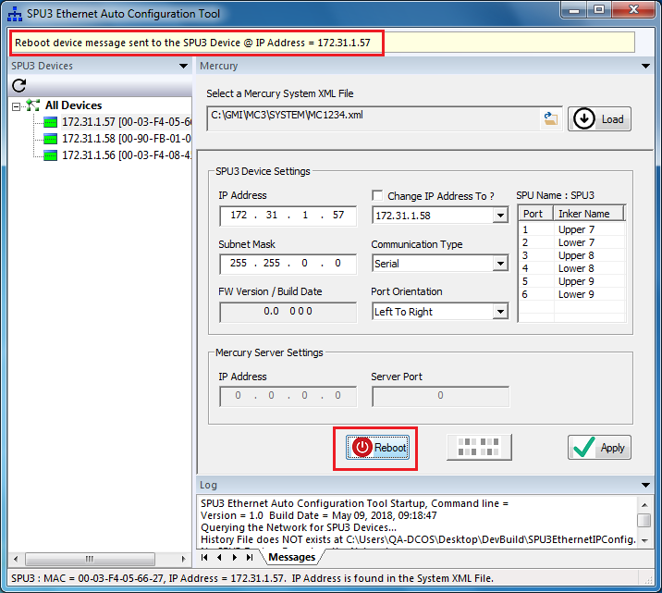

SPU3 Ethernet Auto Configuration Tool ➔ SPU3 Device Configuration View ➔ Blink LEDs
User pushes the Blink LEDs button to start/stop blinking the activity/overcurrent LEDs of a SPU3 Device. The Blink LEDs button is a toggle button. The following picture illustrates the message notification while start/stop blinking of the activity/overcurrent LEDs.
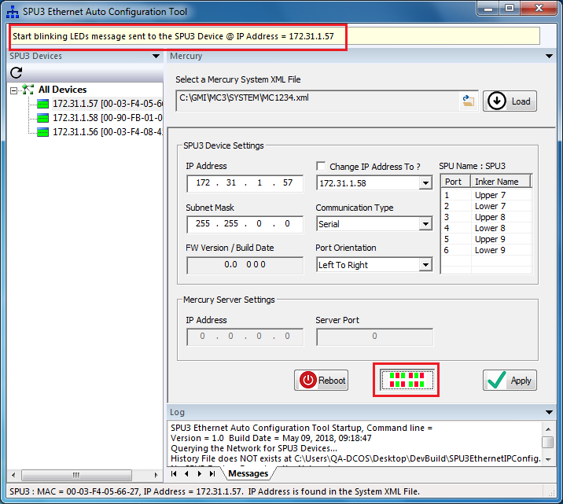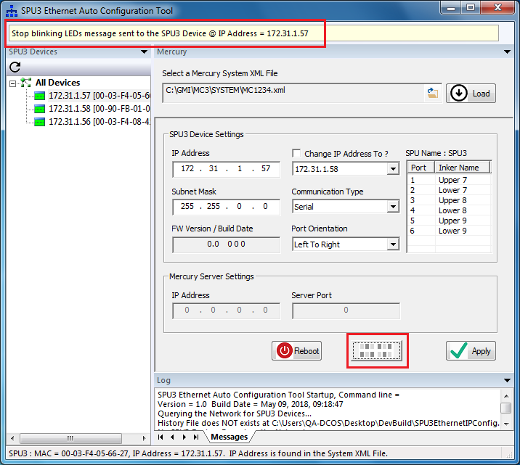

SPU3 Ethernet Auto Configuration Tool ➔ SPU3 Device Configuration View ➔ Communication Type
The Mercury Server settings will be enabled only when the Communication Type is Ethernet.
The following picture depicts the Mercury Server Settings when the Communication Type = Serial.
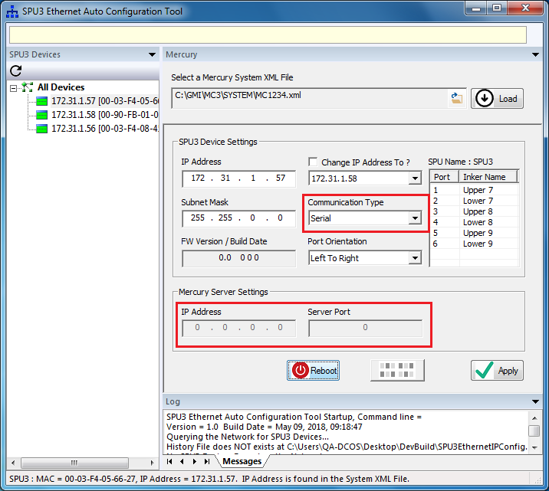

The following picture depicts the Mercury Server Settings when the Communication Type = Ethernet.
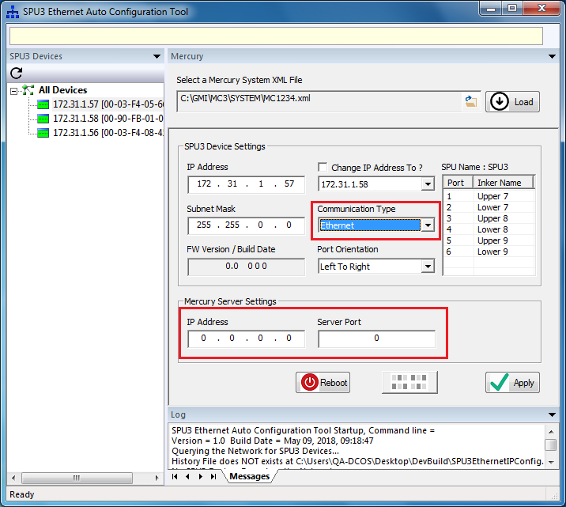

SPU3 Ethernet Auto Configuration Tool ➔ Status bar message display
The following picture depicts the functionality of displaying the additional info about the SPU3 Device selected. In this case, the IP Address of the SPU3 Device is NOT found in the System XML file loaded.
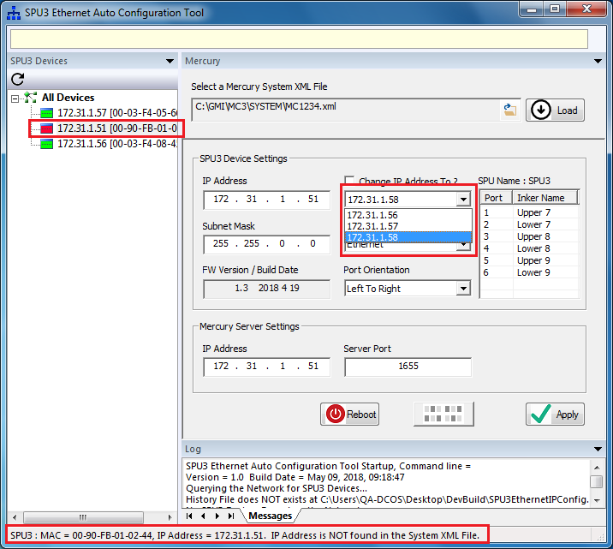

In this case, the IP Address of the SPU3 Device is found in the System XML file. But the MAC address is NOT found in the History File.
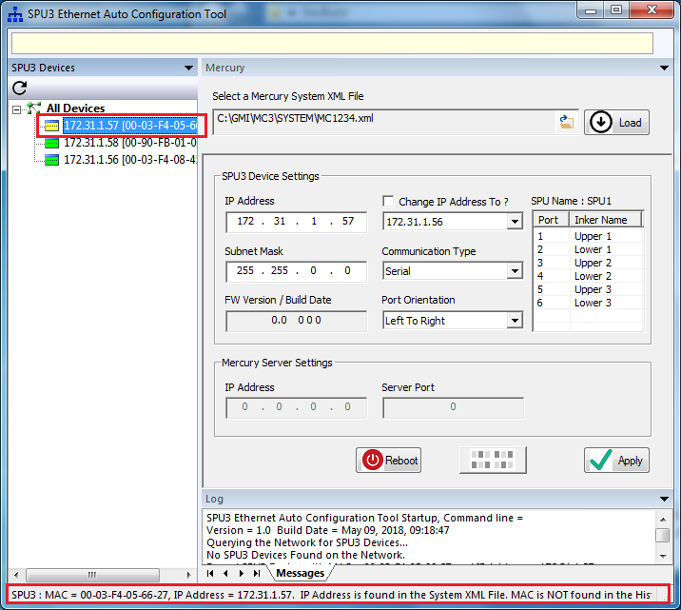

SPU3 Ethernet Auto Configuration Tool ➔ All Devices View
The following picture depicts the All Devices View. This view displays the Device settings and Application settings for all of the SPU3 Devices found on the Network. This data is presented in a grid layout. Also, this view has got controls to generate a summary Report and to create the History file.
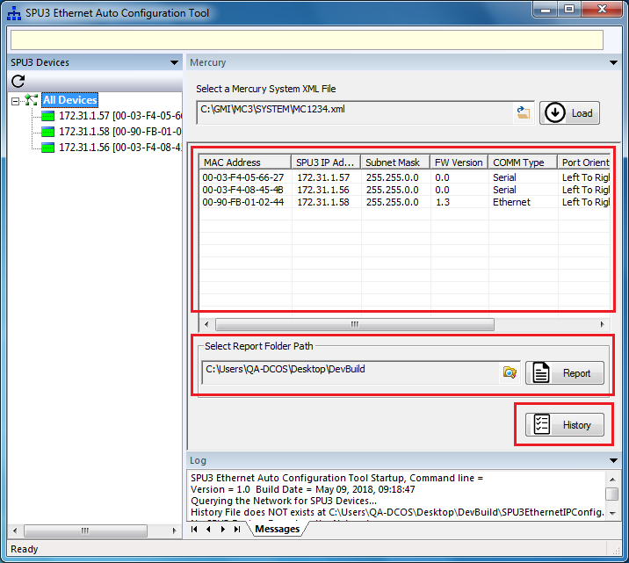

SPU3 Ethernet Auto Configuration Tool ➔ All Devices View ➔ Browse for Report Folder Path
The following picture illustrates the Browse for Folder dialog for configuring the Report Folder Path.
The Report Folder Path will be used to save the Report files.
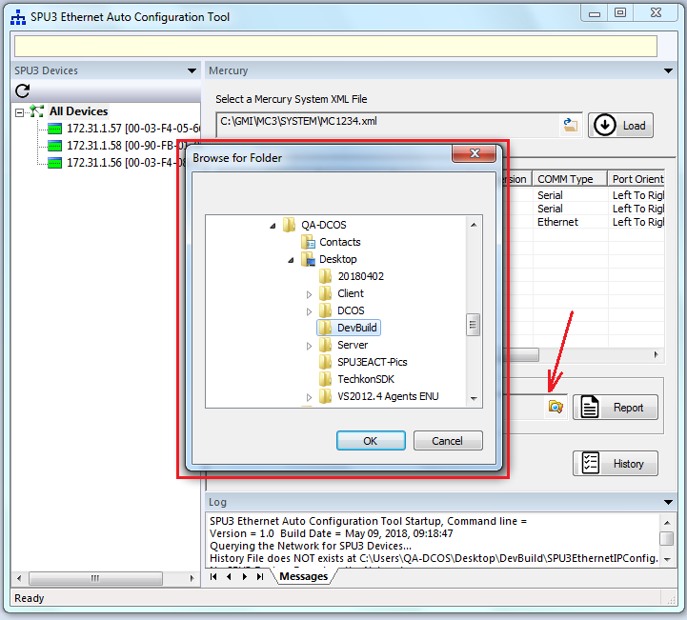

SPU3 Ethernet Auto Configuration Tool ➔ All Devices View ➔ Generate a Report File
User pushes the Report button to generate a report file. Upon generating a report file, a message box will be displayed to notify the report file path and file name, as shown below:
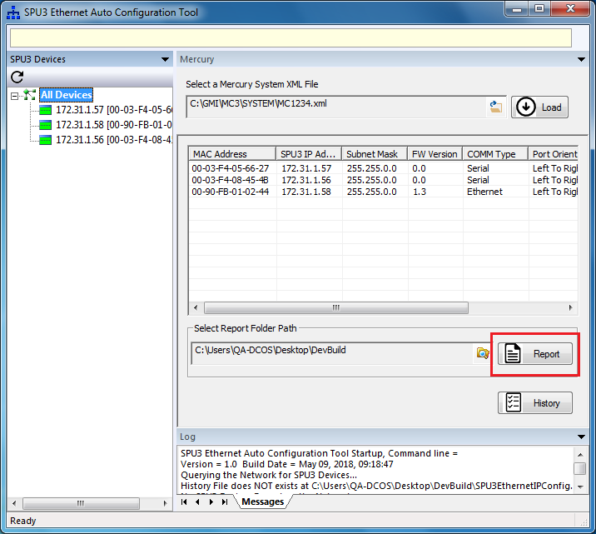

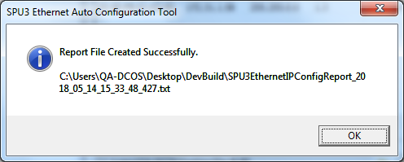

SPU3 Ethernet Auto Configuration Tool ➔ All Devices View ➔ Create the History File
User pushes the History button to create the History file. Upon creating the History file, a message box will be displayed to notify the history file path and file name, as shown below:
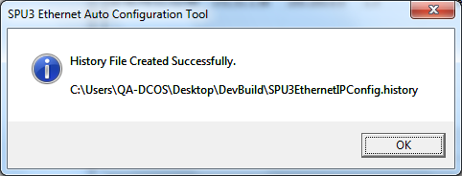
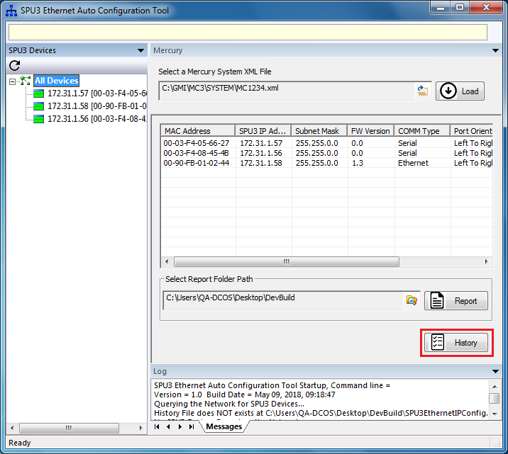

SPU3 Ethernet Auto Configuration Tool ➔ About box
The following picture shows the ‘About’ menu item in the System menu of the SPU3 Ethernet Auto Configuration Tool.

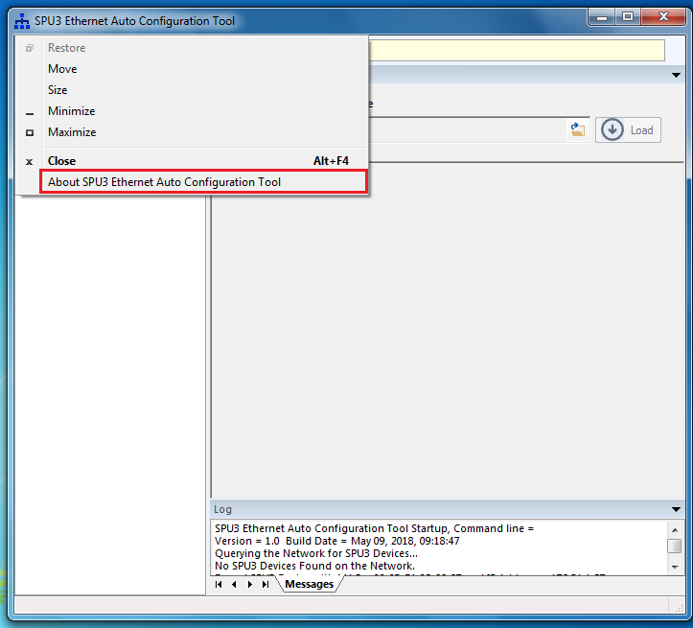
The following About box dialog will be displayed when user selects the ‘About SPU3 Ethernet Auto Configuration Tool’ menu item:
