Comexi Press Simulator – Oct 2018

Here is the components and relationships:



Test computer contains:

Development software for PLC and Convertor configuration…

Hilscher SysCON.net software to configure the Profibus DP to Serial convertor.

Beckhoff TwinCat 3 software to program/debug the Beckhoff PLC Bridge.

AVT constructed Press Sim Client software to handle data to/from Mercury App server, apply console changes to on-press data (same as Press) and change on-press data for press-side adjustments.

Hilscher Convertor configuration:

Profibus DP Master – connect to AVT Comexi sweep controller interface with Beckhoff CX8190 PLC and EL6731-0010 Profibus Slave

Ethernet – MODBUS client connects to test computer with AVT Press Simulator acting as a MODBUS Master with GUI display and data transfer logic from input array to output arrays.

RED – critical components

BLUE – test components

Test process:

1. App Server computer modifies console data on PLC Bridge PLC via MODBUS
2. Data is applied to Profibus data registers (input array) then to the convertor Profibus interface
3. Data is passed to the MODBUS client in the convertor and then to test computer running AVT Press Simulator software acting as MODBUS master.
4. Any changes in the console settings (input array) are processed to the on-press settings (output array).
5. Data changes to the output array are passed to the MODBUS client, then to the PLC Bridge via Profibus
6. PLC Bridge sends data to App Server computer via MODBUS and viewed on Mercury client.

Assumptions:

Profibus DP master is station 1 – Actual printing press is Profibus Master DP circuit with same arrays.

Profibus PLC slave is station 8

Short cable with termination ends between Profibus Master and Slave circuits.

Array of 8 16bit integer inputs stored in PLC – 8 fountains are controlled with 0 to 99% from Mercury client (console settings)

Array of 8 16bit integer outputs stored in PLC – 8 fountains are monitored and sent to Mercury client (on-press settings)

These arrays are attached to PLC Profibus circuit to be cyclic data exchange.

The Profibus to MODBUS convertor only exchanges data with the PLC and the Press Simulator software.

MODBUS simulator software interface:

Based on the Mod_RSsim2 simulator software utility, acting as a MODBUS server, act as the Comexi press data display and GUI controls for changing the Comexi sweep setting independently from the Mercury sweep interface.

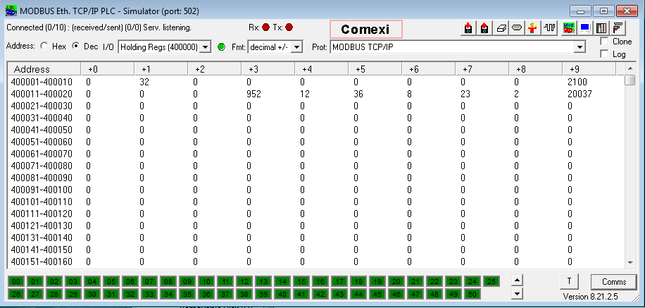

Add a new control for the Comexi press on the toolbar. See above.

Registers 40001 to 40008 will be targets (input) from the Mercury Profibus interface.

Registers 40009 to 4016 will be on-press (output) to the Mercury Profibus interface.

Both set of register values will be displayed in two columns, for each fountain sweep value.

When a new value appears at any target registers, there will be a timed update to the corresponding on-press register, ending with the on-press register matching the target register. Any change to the target register will be locked out until the on-press value has been reached.

A separate input field for each fountain will appear in another column to act as external press control of the Comexi sweep roller speed. Any value 0 to 99 can be entered.

A column of SET buttons will appear next to the press control input fields. Clicking on the button will take the input field value and change the target register for the corresponding fountain. This will act as an external change to the sweep interface to the Mercury system.

NOTE: the press control target value change will NOT be seen by the Mercury system, as those registers are only outputs to the Mercury Profibus interface. The on-press values will start to change and then stop when the on-press value is same as target value.

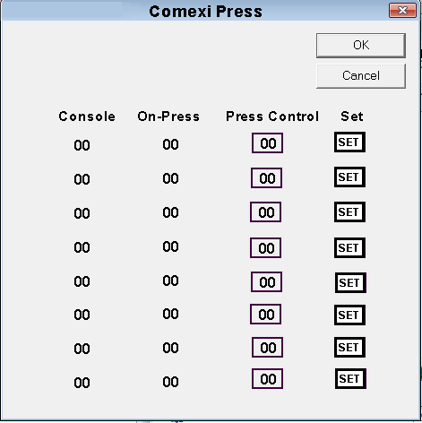

Mockup of the Comexi press dialog is above.