|  |  |  |
| --- | --- | --- |
| SSI #: 177002 177003 177005 -181982 181929 182050 | Rev. | Task ID / Description |
| A | MC3 AVT PLC - Implement Comexi Sweep Control - Profibus Bridge  MC3 AVT PLC - Comexi Sweep Control - Profibus Bridge - Press Simulator  MC3 - SiteGen - Add Comexi Sweep Control to AVT PLC types  MC3 - App Server - Add Comexi Sweep Control to AVT PLC types  MC3 - App Server - AVT PLC swp/wtr - updates to on-press values should update the console value  MC3 - SiteGen - AVT PLC swp/wtr - updates to on-press values should update the console value |

|  |  |  |  |  |  |  |  |  |  |
| --- | --- | --- | --- | --- | --- | --- | --- | --- | --- |
| Type (Select 1) | Requirements Spec Status | | | Design Spec Status | | | Code Inspection Status | | |
| Enhancement | For Review  Accepted  Rejected | | | For Review  Accepted  Rejected | | | For Review  Accepted  Rejected | | |
| New Feature | Process | Name | Date | Process | Name | Date | Process | Name | Date |
| Bug Fix | Originator |  |  | Originator |  |  | Originator | Mark Colvin | 10-30-18 |
|  | Reviewed |  |  | Reviewed |  |  | Reviewed |  |  |

|  |  |  |  |  |
| --- | --- | --- | --- | --- |
| Impact | Check-In | | Carry back/over | |
| High Risk  Medium Risk  Low Risk | Checked into PVCS  Baseline: 1.69b | Date | Carry back  Carry over  Branch:       Branch: | Date |

|  |  |  |  |  |
| --- | --- | --- | --- | --- |
| Systems Affected (Select all that apply) | | | | |
| Host/Console | Subsystems | Peripherals | OEM (must also select Host) | *OEM Type |
| Autosmart | CCU– PQ Camera Ctrl Unit | Autosmart Cmgr | ABB | Standard |
| Clarios | Clarios/CQD On-Press | CIP– CIP Interpreter | CANbus | Master |
| Microcolor II | Client | CN2 – Colornet II | Goss Colortrol | Slave |
| Mercury | Configuration | CQCM – CQ Cmgr | Goss Nantes |  |
| PressAnalysis | CQFG – CQ Frame Grabber | PS – PlateServer | Goss OV3 * |  |
| PrintQuick | L&A – Lights & Alarms | PDE – Press Data Export | Goss PCQ II PLC |  |
| RibbonQuick | NGOP (NGPH) | PQCM – PQ Cmgr | Goss TCS PCQ |  |
| Simulators | OCU3 |  | Goss TCS/O2 * |  |
| Internal Tools (      ) | PCU |  | HWS CPC |  |
|  | PHCM |  | KBA Colortronic * |  |
|  | PQCAM – PQ Camera |  | KBA Densitronic |  |
|  | RCU – Ribbon Control Unit |  | KBA Colortronic SCL | Documentation |
|  | RPLC – RIO PLC | PLC | Komori PQC-IV | Manual(s) |
|  | RQCAM – RQ Camera | Chambon | MAN Pecom04 | Service Note(s) |
|  | Server | Goss | MAN Pecom95 | Release Notes(s) |
| Other Systems | Servo2+ | Hantscho | MAN Pecom90 | Install Docs |
| Jupiter | SVO – Servo | Mitsubishi | MLP API | Theory of Operation |
|  | SpectralLab SMU | Toshiba | Mitsu II * | (Other) |
|  | SPU | RIO/Rabbit |  |  |
|  | SPU3 | AVT PLC – CX8190 | (Other) |  |
|  | TCM – CQ Timing Control |  |  |  |
|  | TCMR–PQ Timing Control |  |  |  |
|  | (Other) |  |  |  |

Requirement Specification Details: (If separate document) See SDS

# General Description of the Task and its Desired End Result / Description of the Problem Found (Bug Fix)

# Interface Requirements (Specify type of interface such as User, Communication, etc.)

WI 177002 - MC3 AVT PLC - Implement Comexi Sweep Control - Profibus Bridge

Mercury Sweep controls for Comexi CIC press type.

Profibus network interface for Comexi Sweep Interface.

Assume Comexi Sweep interface is Profibus DP Master at station address 1.

Assume AVT interface must be available at station 8.

Profibus data configuration is:

**8 x 16bit Inputs to Comexi Sweep controller** – values 0 to 99 allowed. These registers will be used by Mercury Sweep interface to change the fountain roller speeds.

**8 x 16bit Outputs from Comexi Sweep controller** – values 0 to 99 allowed. These registers will be used to indicate the current fountain roller speeds. This information will be used by the Mercury system to show ON-PRESS data on the Mercury client.

No other controls or status from Comexi Sweep Controller.

Comexi Sweep controller sets the baud rate of Profibus network. AVT sweep interface should detect the baud rate from master.

# Functional Requirements

Mercury software should control sweep settings of each fountain, up to 8.

Mercury software should indicate sweep status for each fountain.

Sweep values of 0 to 99 are allowed.

# Performance Requirements

Detect connection faults.

Unknown speed or timing requirements.

# Other Requirements

Replacing another vendor’s implementation:

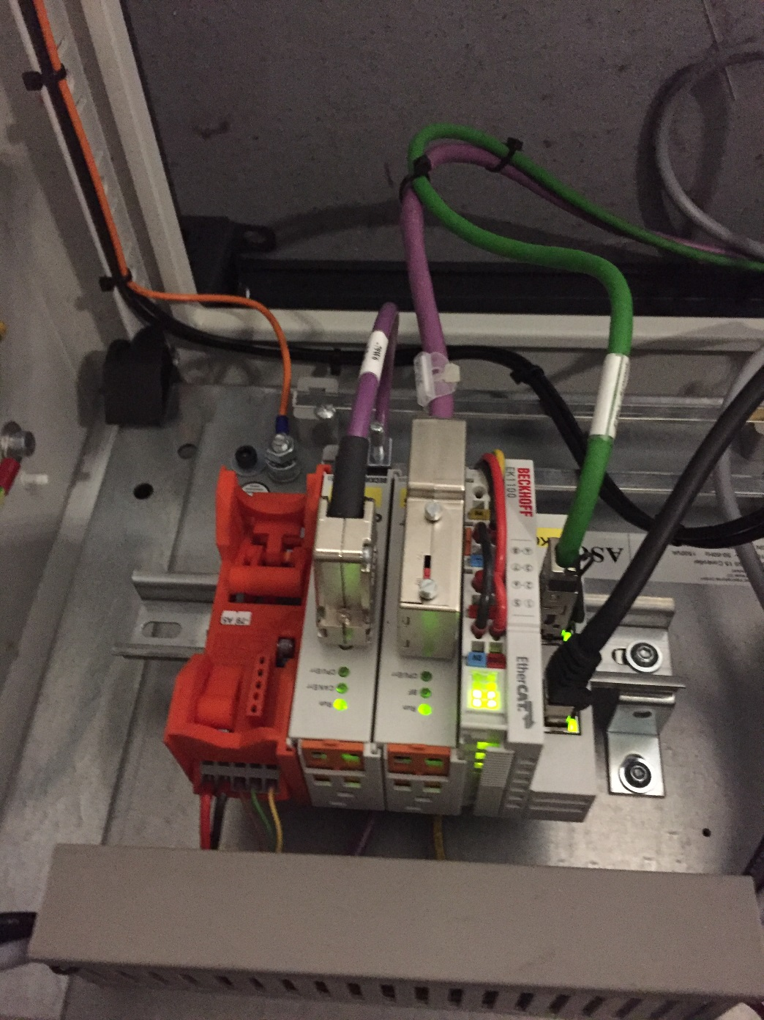

Design Specification Details: (If separate document) See SDS:

# Root Cause Analysis: (Bug fix)

# Theory of Operation: (Describe all algorithms and sequence of events within the task)

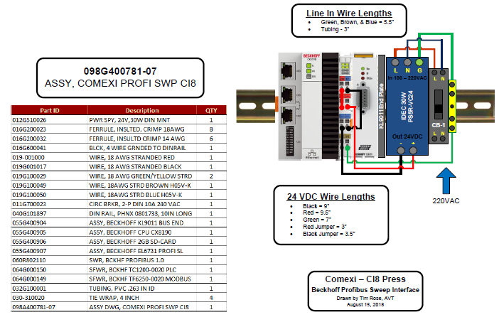

Connection to PRESS NET network as 172.31.1.91 at Ethernet port X001

MODBUS registers used per fountain: (highlighted)

|  |  |  |  |  |  |  |  |  |  |  |  |  |  |
| --- | --- | --- | --- | --- | --- | --- | --- | --- | --- | --- | --- | --- | --- |
| **FOUNTAIN 1 Index 0** | | |  |  |  |  |  |  |  |  |  |  | **MB array** |
| Cancel Inker positioner | | |  | Boolean |  |  | Turn off inker positioner outputs (from slave) | | | | | 32840 | 71 |
| Cancel water positioner | | |  | Boolean |  |  | Turn off water positioner outputs (from slave) | | | | | 32841 |  |
| Inker_OFF | |  |  | Boolean |  |  | True to indicate ink sweep FUNCTION is tmp OFF (from slave) | | | | | 32842 |  |
| Water_OFF | |  |  | Boolean |  |  | True to indicate water ctrl FUNCTION is tmp OFF (from slave) | | | | | 32843 |  |
| Error from last request_Ink | | |  | Boolean |  |  | True if error/cancel from last request of inker control (to slave) | | | | | 32844 | 75 |
| cancel ink surge | |  |  | Boolean |  |  | Turn off ink surge, force timer to zero (from slave) | | | | | 32845 |  |
| Inker_RUN | |  |  | Boolean |  |  | True to force RUN ink positioner to curr trgt (from slave) | | | | | 32846 |  |
| Water_RUN | |  |  | Boolean |  |  | True to force RUN water positioner to curr trgt (from slave) | | | | | 32847 |  |
| Error from last request_Water | | | | Boolean |  |  | True if error/cancel from last request of water control (to slave) | | | | | 32848 |  |
| Reserve |  |  |  | Boolean |  |  | available - was flood increase | | | |  | 32849 |  |
| Cancel water flood | |  |  | Boolean |  |  | Turn off water flood, force timer to zero (from slave) | | | | | 32850 | 81 |
| Ink Wash Up | |  |  | Boolean |  |  | Ink Washup on/off (from slave), 30 minute max on | | | | | 32851 |  |
| Reserve |  |  |  | Boolean |  |  | available |  |  |  |  | 32852 |  |
| Inker_RUNNING | |  |  | Boolean |  |  | True if INKER_IS_RUNNING state (to slave) | | | | | 32853 |  |
| Water_RUNNING | |  |  | Boolean |  |  | True if WATER_IS_RUNNING state (to slave) | | | | | 32854 | 85 |
| Sweep trim target value | | |  | Word | Percent |  | Min, Max is configured | | |  |  | 32830 | 61 |
| Water trim target value | | |  | Word | Percent |  | Min, Max is configured | | |  |  | 32831 |  |
| Ink Surge Time Set | |  |  | Word | Seconds |  | Interval, Max is configured | | |  |  | 32832 |  |
| Water Flood Time Set | | |  | Word | Seconds |  | Interval, Max is configured | | |  |  | 32833 |  |
| Ink Function Setting value | | |  | Word | Setting1to2 | | 1=Manual, 2=Auto | |  |  |  | 32834 | 65 |
| Water Function Setting value | | | | Word | Setting1to2 | | 1=Manual, 2=Auto | |  |  |  | 32835 |  |
| Ink Ductor Value | |  |  | Word | Setting0to3 | | Digital outputs, displayed values configured. | | | | | 32836 |  |
| Ink Surge Countdown | | |  | Word | Seconds |  | 0 | max surge time | | non zero activated | | 32837 |  |
| Water Flood Countdown | | |  | Word | Seconds |  | 0 | max flood time | | non zero activated | | 32838 |  |
| Ink Voltage Min | |  |  | Word | Voltage times 1000 | | (min must be lower than max) | | | |  | 32839 | 70 |
| Ink Voltage Max | |  |  | Word | Voltage times 1000 | | |  |  |  |  | 32840 |  |
| Water Voltage Min | |  |  | Word | Voltage times 1000 | | (min must be lower than max) | | | |  | 32841 |  |
| Water Voltage Max | | |  | Word | Voltage times 1000 | | |  |  |  |  | 32842 |  |
| Sweep trim on-press value | | |  | Word | Percent |  | Actual runtime position vs target | | | |  | 32843 |  |
| Water trim on-press value | | |  | Word | Percent |  | Actual runtime position vs target | | | |  | 32844 | 75 |

# User Interface Related Changes/Additions: (Describe all UI additions and changes expected)

WI 177005 - MC3 - App Server - Add Comexi Sweep Control to AVT PLC types

New type of Beckhoff PLC type needed for AVT PLC Sweep control. This sweep control is a PLC based Bridge - from MODBUS to Profibus Sweep controller on Comexi CI8 press. Use same MODBUS addresses for Sweep Runtime Data as PCU, Ramping PLC type.

SiteGen configuration is IP address and port number only. No PLC configuration required. These will be hardware coded. up to 10 fountains.

No other sweep/water features needed. Console value and onpress values handled, as 0 to 99% given to PLC via MODBUS.

Not sure about error handling and data range other than 0 to 99% - connection detect only.

I see from Tim’s photos that there are separate registers for input and output to Comexi sweep controller. I see there is Comexi PLC logic to equalize these registers for each fountain. Comexi input registers will come from our client console values, when these values change the new value is written to Comexi input registers and we will read Comexi output registers as our on-press data for the same fountain. At some point these values will be equal and the same will occur at the Mercury console.

Press Aux. controls (not Mercury) are present to change sweep roller speed. PLC and App Server must respect settings from these controls. These are simulated in Press Simulator software. Press PLC logic transfers the console settings from Mercury to roller speed. This is also simulated by Press Simulator.

WI 181929 - MC3 - App Server - AVT PLC swp/wtr - updates to on-press values should update the console value

AVT PLC sweep and water supports a console and onpress value per fountain.

Normally, Mercury Client adjusts the console, this is passed to app server, passed to the PLC. PLC adjust the wsp/wtr settings and on-press value is updated, passed to the app server, passed to the Client.

Preference is now that HMI changes to the PLC on-press values should change the Mercury Client console value.

Also the Comexi Sweep controller has an external method of changing the sweep on-press value without the Mercury Client.

A change is needed in the Mercury App Server to detect changes in the on-press value and update the console value for any fountain.

If a sweep/water interface is running, do not detect console value change until stopped running.

If an error occurs in last sweep/water request, do no update console value.

Additional to this feature would be need for the sweep/water console settings to require the RUN control to be used during any change at the Mercury client. This feature characteristic DOES NOT include any OTHER sweep/water related feature, such as wash up, surge, flood, ductor settings.

This feature will be an installer enabled in Mercury XML system file, associated only with any AVT PLC sweep/water control.

WI177003 - MC3 - SiteGen - Add Comexi Sweep Control to AVT PLC types

WI 182050 - MC3 - SiteGen - AVT PLC swp/wtr - updates to on-press values should update the console value

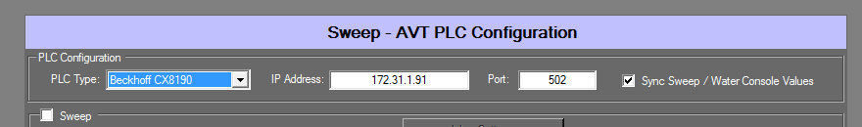

WI 181982 - MC3 AVT PLC - Comexi Sweep Control - Profibus Bridge - Press Simulator

See other documents:

Comexi_Simulator_20181023.docx – Overview of Press Simulation Hardware and Simulation software

Setup_Comexi_Simulator.docx – Hardware setup instructions

# Internal System Related Changes/Additions: (Describe all additions and changes expected)

## Purpose

## Inputs

## Processing

## Outputs

## Change/Addition title

# Global Structure (Class) Requirements: (List all global structure changes and additions expected)

|  |  |  |  |
| --- | --- | --- | --- |
| NEW / REV | CLASS / STRUCTURE NAME | TYPE (Size) | DESCRIPTION |
|  |  |  |  |

# Global Variable Requirements: (List all global variable changes and additions expected)

|  |  |  |
| --- | --- | --- |
| NEW / REV | TYPE (Size) | DESCRIPTION |
|  |  |  |

# Network Message Requirements: (List all network message changes and additions expected)

|  |  |  |  |  |
| --- | --- | --- | --- | --- |
| NEW / REV | SYSTEM | | PROTOCOL  (Ethernet, Serial) | DESCRIPTION |
| FROM | TO |
|  |  |  |  |  |

# Resource String Changes/Additions

|  |  |  |  |  |
| --- | --- | --- | --- | --- |
| NEW/ REV | MESSAGE ID | TEXT | MAX LTH | TRANSLATE  (Y/N) |
|  |  |  |  |  |

Implementation Details: (If separate document) See SDS:

# Changes Made to Implement the Task: (Describe changes made)

Mercury 1.69b+ client to be used.

SiteGen and App Server available here: \\usfs1\ENGINEERING\CMG_R&D\Inspections\181929\DevBuild\20181030

# Function Changes / Additions: (List all functions affected by the change)

|  |  |  |  |
| --- | --- | --- | --- |
| NEW / REV | FILENAME | ARCHIVE REVISION | FUNCTION NAMES |
|  |  |  |  |

# Global Structure (Class) Changes / Additions: (List all global structures changed or added)

|  |  |  |  |  |
| --- | --- | --- | --- | --- |
| NEW / REV | CLASS / STRUCTURE NAME | CLASS / STRUCTURE MEMBERS | | DESCRIPTION |
| TYPE (Size) | VARIABLE NAME |
|  |  |  |  |  |

# Global Variable Changes / Additions: (List all global variables changed or added)

|  |  |  |  |
| --- | --- | --- | --- |
| NEW / REV | TYPE (Size) | VARIABLE NAME | DESCRIPTION |
|  |  |  |  |

# Network Message Changes / Additions: (List all messages changed or added)

|  |  |  |  |  |  |  |
| --- | --- | --- | --- | --- | --- | --- |
| NEW / REV | MSG #  (0x0100) | SYSTEM | | PROTOCOL  (Ethernet, Serial) | MESSAGE FORMAT (Data Content) | DESCRIPTION |
| FROM | TO |
|  |  |  |  |  |  |  |

# Resource String Changes/Additions: (List all messages changed or added)

|  |  |  |  |  |
| --- | --- | --- | --- | --- |
| NEW/ REV | MESSAGE ID | TEXT | MAX LTH | TRANSLATE  (Y/N) |
|  |  |  |  |  |

Test Plan Details: (If separate document) See STP:

# Steps to reproduce the problem: (Bug Fix)

## Test Setup

|  |  |
| --- | --- |
| Load used to produce problem | Mercury 1.69b client, Mercury 1.69b+ SiteGen and App Server |
| Lab testable (YES/NO) | YES |
| Spin fixture needed(YES/NO) | NO |
| OEM, configuration and setup required | Hilscher NetTAP50 Profibus to Serial Gateway |
| Supporting Software | Comexi Press Simulator (AVT) |
| Other (Specify) |  |

## Test Steps

# Test Summary

|  |  |  |  |
| --- | --- | --- | --- |
| NAME/NUMBER | DESCRIPTION (PURPOSE) | ALPHA OR BETA TEST | REQUIREMENT |
| 1 | Mercury setup of Comexi Sweep Interface |  |  |
| 2 | Press Simulation setup of press |  |  |
| 3 | Change Mercury Client sweep settings |  |  |
| 4 | Change Press Aux sweep settings |  |  |
| 5 | Disconnect Beckhoff PLC connection to Mercury |  |  |
| 6 | Disconnect Profibus connection to PLC |  |  |
|  |  |  |  |

# Test Procedures

## Alpha Tests

### Test Name/Number 1

Sweep controls added.

AVT PLC selected

Configure the CX8190 PLC type

Use appropriate IP address (usually 172.31.1.51) and Port 502

Select the Sync Sweep/Water console values – normally done for Comexi press.

Complete the remaining XML file for test configuration

**Test 2** - Connect the PLC hardware and Press Simulation. (Connect the press simulation hardware to test computer, 172.31.1.250 is IP address of Press Simulation hardware)

Start the Press Simulator on Windows computer with NIC at IP address of 172.31.1.251 to control press simulation hardware.

Click the Comexi button on software.

Load each fountain with sweep value and then click SET button next to setting.

Start the Mercury App Server. Check that MODBUS data is being exchanged.

Start Mercury Client. Go to Sweep All view. Check to be sure that Client sweep settings match the Press Simulator.

Do not click OK or Cancel or ENTER on test computer or the Comexi GUI will close. If the Press Simulator software is closed, the RED lite on the Press Simulation hardware (serial) will appear and the sweep data will go to zero for all fountains.

**Test 3 - Change Mercury Client sweep settings**

Vary the Mercury sweep settings, confirm match on the Press Simulator.

**Test 4 - Change Press Aux sweep settings**

Vary the Press Aux sweep settings on Comexi GUI on the Press Simulator, be sure the Mercury client follows these changes. On press data will update first, then the console setting.

**Test 5 - Disconnect Beckhoff PLC connection to Mercury**

Disconnect the CAT5 cable from Beckhoff PLC connector X001. Wait for the Mercury Client CONNECTION symbol to go from GREEN to RED.

Reconnect cable and the symbol will change back to green.

**Test 6 – Disconnect the Profibus cable from Press Simulation hardware or Beckhoff PLC**

Disconnect the Profibus cable from Beckhoff PLC connector X1. Wait for the Mercury Client sweep status indicator to show STALLED at each fountain.

Reconnect cable and make a 1% change at each fountain, the STALLED symbols will be replaced by EQUAL icon.

Inspection Details: (If separate document):

# General Information

|  |  |  |  |  |
| --- | --- | --- | --- | --- |
| # | DATE | MEETING LENGTH | INSPECTION TYPE | DESCRIPTION |
|  |  |  |  |  |

# Attendees

|  |  |  |  |  |  |  |  |  |
| --- | --- | --- | --- | --- | --- | --- | --- | --- |
| # | MODERATOR | PREP TIME | READER | PREP TIME | TESTER | PREP TIME | AUTHOR | GUEST |
|  |  |  |  |  |  |  |  |  |

# Code Inspected

|  |  |  |
| --- | --- | --- |
| MODULE NAME | LINES OF CODE INSPECTED | COMMENTS |
|  |  |  |

# Defects

|  |  |  |  |  |  |
| --- | --- | --- | --- | --- | --- |
| # | DEFECT  TYPE | SEVERITY | MODULE | LINES | DESCRIPTION |
|  |  |  |  |  |  |

The following table lists the types of standard defects:

| **Number** | **Name** | **Description** |
| --- | --- | --- |
| COM | Comments | Code, documentation, messages & manuals |
| SYN | Syntax | General syntax problems |
| TYP | Typos | Spelling and punctuation |
| IF | Instruction Format | General format problems |
| BE | Begin-end | Improper operation delimiters |
| BU | Build | Package change management, library, version control, system build |
| ASN | Assignment | General assignment problems |
| NC | Naming convention | Naming declaration, duplicate names |
| SVR | Scope of Variables |  |
| IC | Initialize and close | Variables, objects, etc. |
| RVL | Range variable limits | Array range |
| IF | Interface | General interface problems |
| IN | Internal | Procedure calls and references |
| IO | Input/Output | File, display, printer, communication |
| UF | User formats | Contents |
| CEM | Checking error messages | Inadequate checks |
| DSC | Data Structure | Content |
| DSS | Data Structure | Scope |
| FUN | Function | General logic |
| PTR | Pointers | Pointers, strings |
| LP | Loops | Off-by-one, incrementing, recursion, etc. |
| AG | Algorithmic | Application computations |
| SC | System Configuration | Timing, memory, etc. |
| ENV | Environment | Design, compile, test, other support system problems |
| REQ | Requirement | Missed, incomplete or incorrect requirement |
| STD | Standards | Non-conformance to the coding standard |
| MIS | Missing | Overlooked, left out |
| X | Extra | Not needed |
| PF | Performance | Impacts the performance of the code |
| OI | Open Item | Unresolved item assigned as an action item |

Documentation Details:

# Manuals:

# Service Notes:

# Release Notes:

# Install Docs:

# Theory of Operation:

# Other (Specify):