Steps to setup and configure a NetTAP50 project – Profibus to MODBUS – Oct 2018

**Important information:**

* IP address for Hilscher data convertor Press Sim side – 172.31.1.250
* IP address for test computer for Comexi press simulation – 172.31.1.251
* Profibus DP Master (Comexi press sweep interface)– station 1
* Profibus Baud Rate – 1500 Kbits/s
* Profibus Slave (AVT PLC Profibus interface) – station 8

**Connection of Press Simulator to Comexi PLC:**

1. Attach the Hilscher Data Convertor to DIN rail.
2. Attach the Profibus cable to both DB9 connectors of Beckhoff EL6731-0010 and the data convertor. Either end of cable is Okay to use, both ends are terminated for Profibus.
3. Attach power cable from data convertor to PLC 24V DIN rail P/S.
4. Attach data convertor Y cable to RJ45 connector of data convertor.
5. Attach CAT5 cable to Y cable and RJ45 cable of test computer.
6. Attach CAT5 cable to Beckhoff PLC X001 connector to Mercury PRESS NET network.

**Steps to configure data convertor: (only needed if data convertor has lost configuration, otherwise skip to end of this document)**

Install SyCON software. This includes the convertor setup design software and the ODMV3 software (Online Data Manager)

Start the SyCON software.

Select New Project.

Go to Interface windows on the right side, select the Field Bus tab.

Select the Profibus DPV1 -> Gateway -> NT50 XX-XX item… don’t click on this selection.

Drag this item to the center section, on top of the grey network line at the top.

Right click this icon(NT50), that now shows attached to the grey network line, select the Configuration -> Gateway.

In the settings tab, Primary network is Profibus DP Master, Secondary network is Open MODBUS/TCP.

In the NetX Driver tab, Disable RS232 and enable TCP/IP, IP address s/b **172.31.1.250,** Network Mask s/b 255.255.255.0. Save this configuration. This is the IP address of the data convertor, part of the Y cable attached to the RJ45 connector on the convertor.

Device Assignment tab, select ALL and then Scan. Select the NT50 DP-RS, Path is … ch2

Click OK.

Go to the Interface window again, select the Vendor tab.

Find the Beckhoff devices, Slave list, Select the device EL6731-0010.

Note: if Beckhoff list is not present in the Vendor list, import the GSD file from the

Beckhoff EL6731-0010 files @ this folder:

C:\twincat\3.1\config\IO\Profibus\EL31095F.gs*

Drag the EL6731 device to the magenta network line in the center section, next to the other icon.

Right click, go to Configuration:

Modules: APPEND eight times the entry 1 WORD Slave Out/Master In. These will appear in the configured modules list. These are the INPUT ARRAY for the Profibus interface (8 x 16bit)

APPEND eight times the entry 1 WORD Slave In/Master Out. These will appear in the configured modules list. These are the OUTPUT ARRAY for the Profibus interface (8 x 16bit)

Click OK.

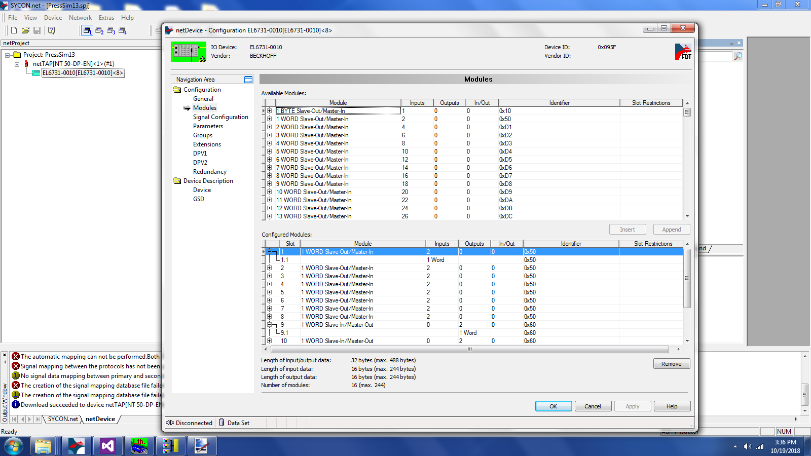

Right click the NT50 icon.

Configure the Open MODBUS/TCP

Configuration tab: Protocol mode is CLIENT.

Data Swap is YES.

Map FC1/FC3 is enabled

Uncheck the DHCP option.

Enter the IP address of 173.31.1.250 and network mask of 255.255.255.0

Click OK.

Right Click the NT50 icon.

Configure Gateway, Signal Mapping:

Shown s/b: Port X2 – Profibus DP Addr1 Port X3 – Open MODBUS/TCP – 172.31.1.250

EL6731-0010 Addr2

Check if Auto Mapping X2 to X3 is available. If so, Click Appy and check for the below list of entries.

IMPORTANT

Mapped Signals shows now links to Profibus to MODBUS

Port X2 Port X3

EL6731 Addr2 1 WORD Slave Out/Master In Input 1 -> 1 WORD Out Input 1

| |

Input 8 -> Input 8

EL6731 Addr2 1 WORD Slave In/Master Out Output 1 <- 1 WORD In Output 1

| |

Output 8 <- Output 8

Click OK

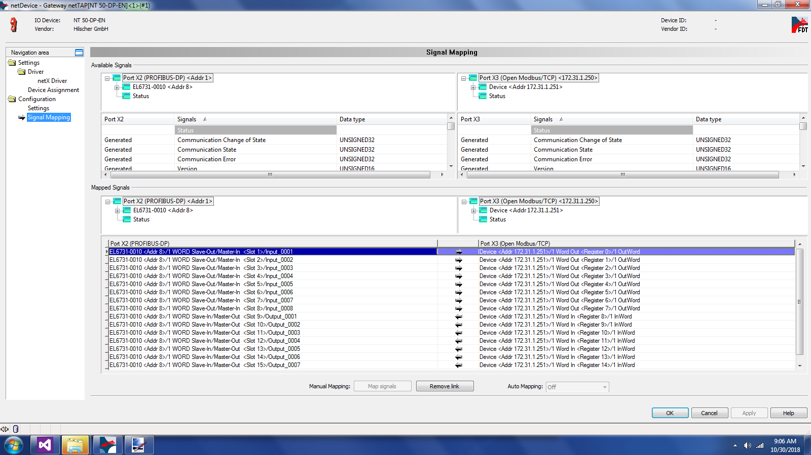

NOTE: If Auto mapping is not available, then manual mapping must be done:

Drag the field Input 000x directly right to the 1 Out Word field, do this eight times.

Drag the 1 In Word field directly left to the Output 000x field, do this eight times.

Click OK.

Right Click NT50 icon.

Configure Profibus DP Master

On Station Table tab, click the Station A entry and change to 8.

On Bus Parameters tab, change the Station Address to 1, Baud Rate is set to 1500.

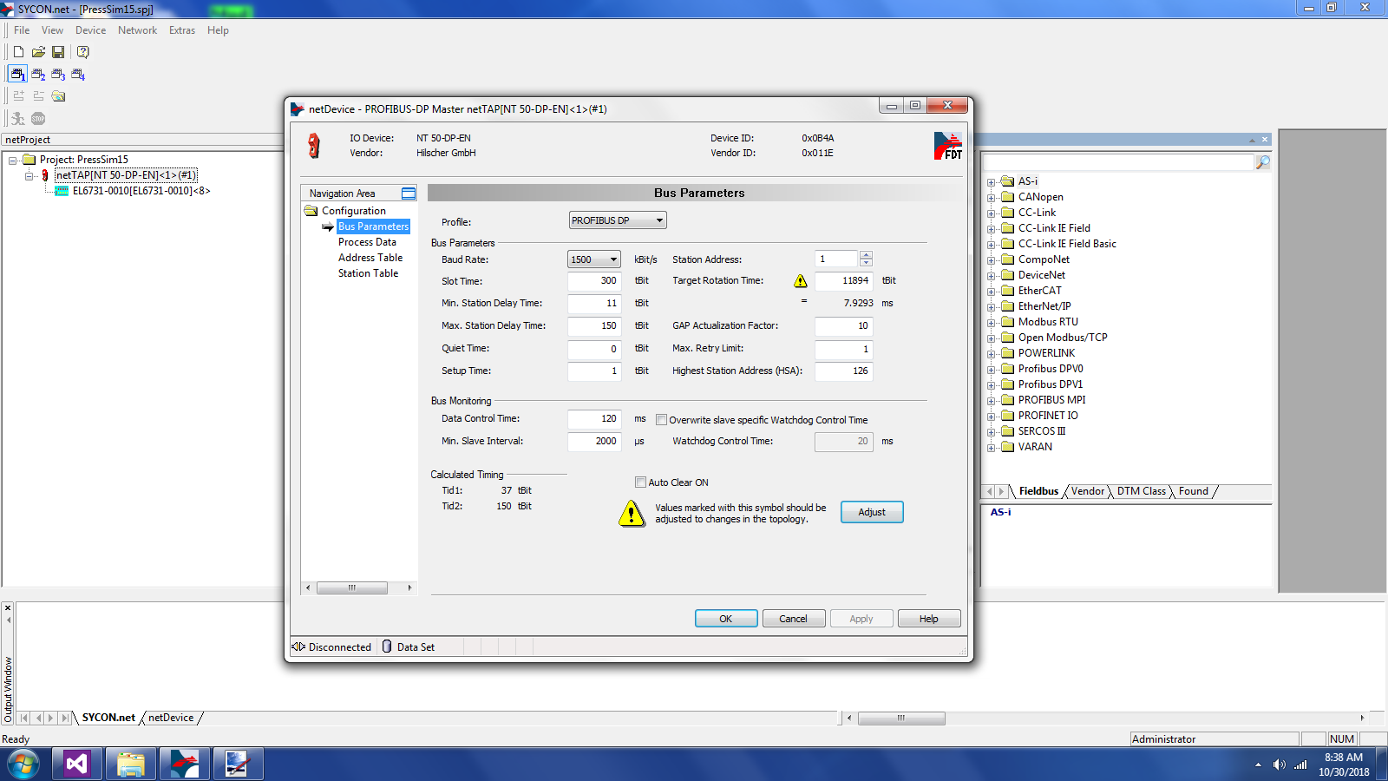

Click OK.

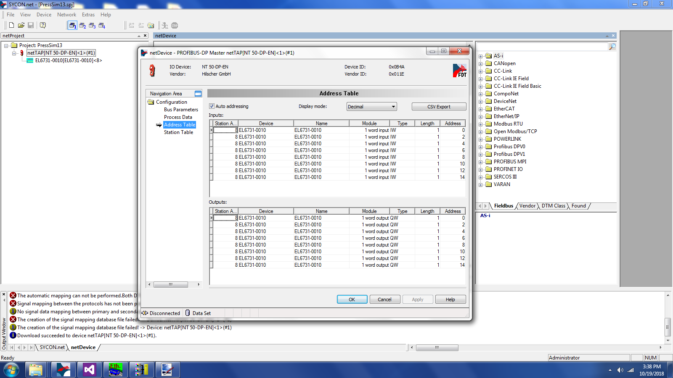

Right Click NT50, configure Open MODBUS/TCP, Command Table:

Set Delay to 20ms.

Click **Add** command to table:

IP address is 172.31.1.251 (MODBUS Master IP address)

Unit ID is 1 for all (MODBUS station #1 for the MODBUS master)

Function Code for **first eight commands** is Preset Single Register, Address starts with 1, 1 register each.

**Next eight commands**, function code is Read Holding Register, Address starts with 9, 1 register each.

Click OK.

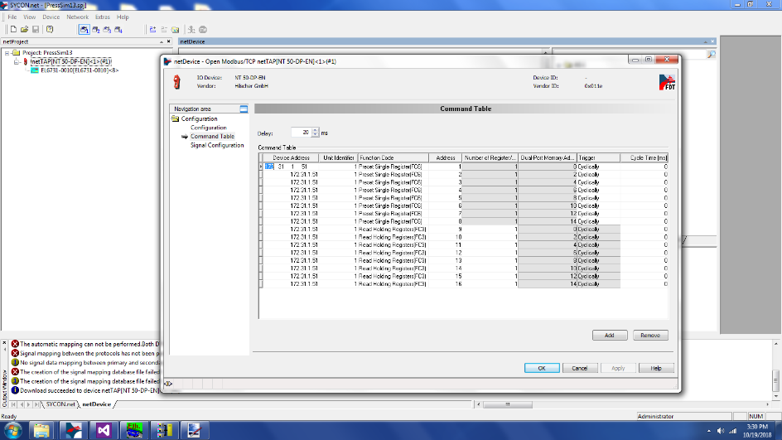

Important – SAVE PROJECT. (in the toolbar)

Right Click NT50 icon Download.

If asked to download while connected, click YES.

**If Hilscher Sycon project is available to load from backup**:

Select Sycon project from folder (*.SPJ)

Right click the NT50 icon – Download.

Now the data convertor is ready to exchange data.

Red SERIAL light will be lit until the Comexi Press Simulator is started.

Here is a working setup of the data convertor connected to the CX8190 PLC:

Note the power connections to data convertor shared by the PLC.

Note the FOUR GREEN LEDs on the data convertor.

MODBUS master application missing will turn on the RED Serial LED.

Profibus GREEN LED will be RED if the Profibus cable is disconnected at either end. Also the BF LED on the Beckhoff EL6731-0010 will flash if Profibus cable is disconnected.

