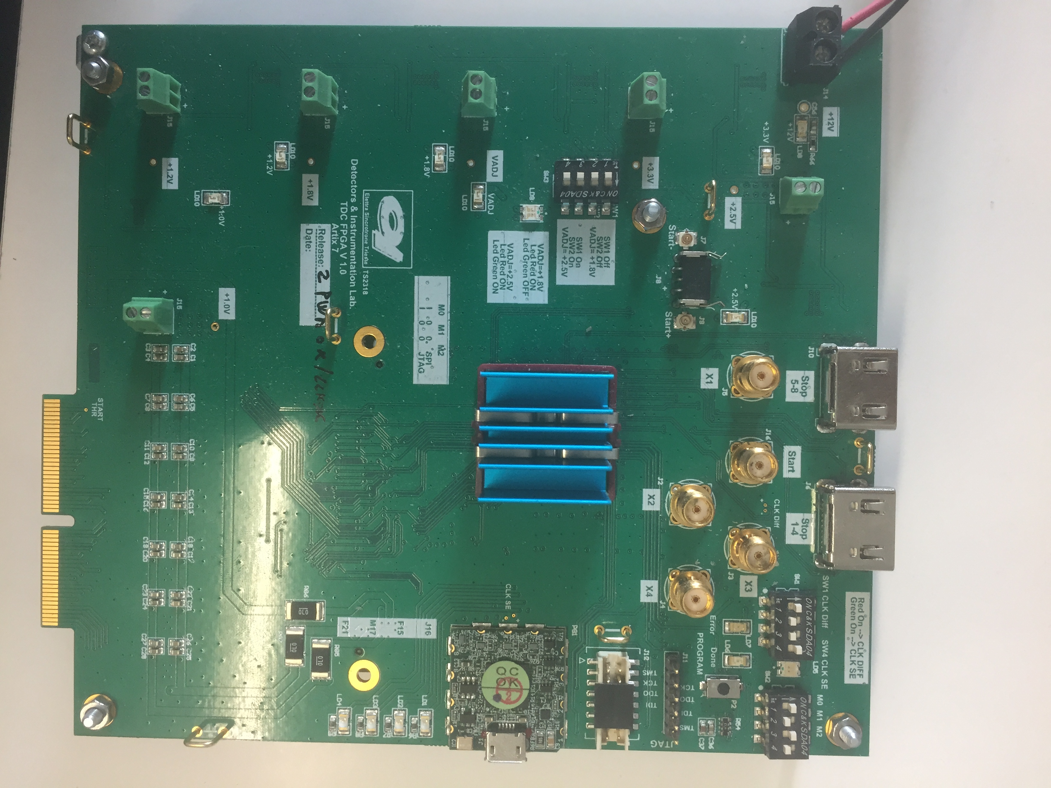

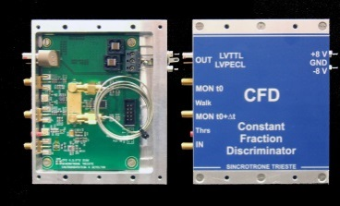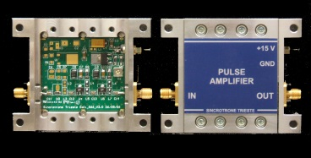

Cross Delay Lines

detector

RF pulse amplifier

Constant Fraction

Discriminator

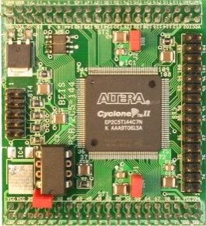

FPGA based

TDL-TDC

Data elaboration

and communication

FPGA

CDL Pulse

Amplified

Pulse

Digital

Signal