Your data was exported in pipe-delimited format (.txt) instead of Excel (.xslx) due to the limitations of Excel with large data sets. To open the files in Excel, follow the steps below:

1. Select Delimited from the original file type, and select the “My data has headers” option button. Click Next to continue.

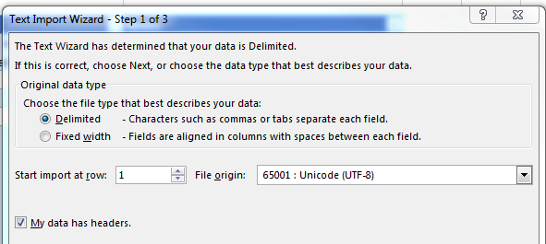

1. Select the “Tab” and “Other” option buttons, and type the pipe (|) in the text area next to “Other”. (Pipe is the shift character above the Enter key.) Click Next to continue.

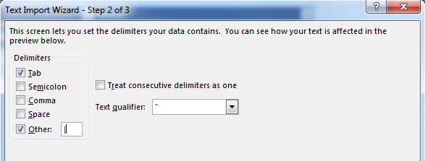

1. You can preview your data by clicking the Finish button.