Fundamental view
The file system in MOS reflects the fact that the system is a data base system with the best concern to storing information, handling information and securing information.
The file system is based on the fact that every column is in fact one file and the search path(directories)

are infact the data base, the table and the column(a column can also be look at as a module/run able program).
In the system there is a special data base (called system) this is where information about the system lies.
The information is secured by access matrix which restricts users on column level, but there are some special features.

Structure
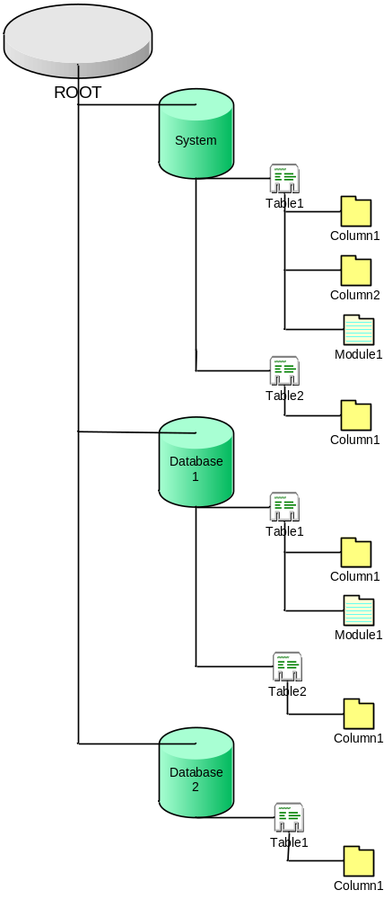

Security

Editing
When information in the file system changes, the information, about all changes that will happen, is stored before anything happens. When the log of the changes, that is to be made, is created the changes are made and if everything works correct a flag, that indicates that the changes were preformed without complications, is set. If the changes are dropped or there is something wrong, the system sees this and corrects the information.

Access

The access to information is determined by the execution state a process is executing in. There are three states; user state, system function state and kernel state. The user and system function state has none access while the kernel state has full access. Only the system function state processes can call the file system functions.
The access of the information is also controlled by the DB engine and the security module.

User access
User level
User process

System functions level
SQL interpreter

SQL engine

Kernel level

User security
Mem
Manager
Process
Manager
FS
Manager

HAL

Network
Mem
Conio
Discs

TCP/IP(ethernet) etc
Keyboard
Monitor etc
Data flow

If a user wants to extract information from any memory device, the user process must call the kernel functions which are responsible for retrieving that kind of information. The kernel function first identifies the user (or system function) and if the user have rights to access the requested information, the kernel function gets the information and puts it in the user memory area.

