Fundamental view
The system is a server with the capability to store information. The information stored is secured so that only authorised user can access the information. The management of information is fast and the security around the information is high.
The system runs on one computer where it has full control. All external accesses (over network i.e.) with the system is unforgeable and information is unreadable by unauthorised users.
The system’s main purpose is to be used in organisations where the demand for fast and reliable storage systems is considered high..
The system is an open source system and it is free for any person to use, but has a license cost for economic organisations such as profitable organization. For client programs that will be communication with the system the costs are as previously described.

Structure

System (internal system structure)
User level
User process

System functions level
SQL interpreter
SQL engine

User security
Host
Monitor

Kernel level

FS
Manager
Memory
Manager
Process
Manager

HAL

Discs
Conio
Network
Memory

Memory
Data flow
Keyboard
Monitor etc.
ethernet etc.
Keyboard
Monitor etc
TCP/IP (ethernet) etc

Network
MOS system
Client X
User A
User B
User C
Client Y
Network (TCP/IP) or other
Encrypted channel where transferes can be made without being mopdifiedmodified or fabricated

Distribution of data bases over many servers
When data base in a SQL-request can’t be found on a local machine the request sent to the system will return a address to an other system which the local system has as forward address if no such address is specified in the system the SQL-request can’t be handled. This means that SQL-requests that require information on two different Server can’t be carried out.
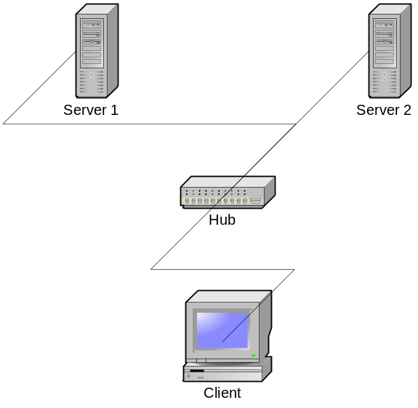
3.

2. 4.
Communication:
SQL-request (request data from a data base)
Answer: Data base not found try Server 2
SQL-request (request data from a data base)
Answer: As before or the data requested

Security
The authorisation by the system can only happen when a correct password is entered. The password and all transfers are sent encrypted.

Information flow
The information flows in the network are:
- Start up information flow
- Authorisation where a password is supplied from the user and the response is ok/not ok
- Query where a query in SQL format(or other format) is sent and the response is ok/not ok +information
- Disconnect the information flow

Development
The development is issued on sourceforge where all progress and source are available for anyone interested.

Distribution
The distribution will be issued over internet or by retails.

Other
The system is a good complement to a big network where important and sensitive information can be stored. The cost for the system is low and the open source idea means that faults in the code can be found by various people and this makes the system more secure.

Appendixes:
SQL interpreter
SQL engine
File system
Users and files

