# **Kiwi Buzzer Connection with .NOW**

## .NOW

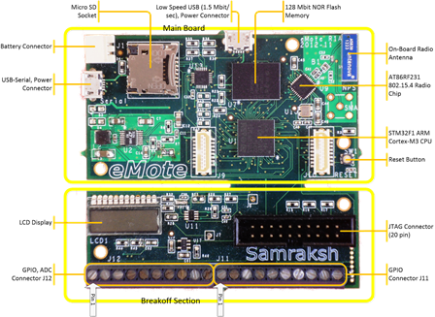

Kiwi Multi-Sensor Board

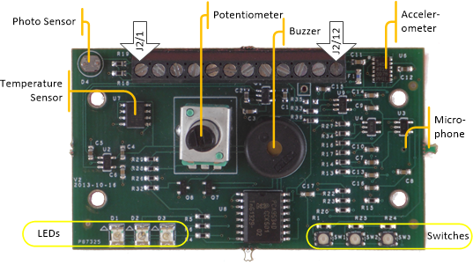

Hold the Kiwi such that the screw terminals are on the top of the board, component side up. This means the silk should be naturally legible (not upside down), the pot (knob) on the left, and buzzer on the right.

From this perspective, pin 1 is the left screw terminal and pin 12 is on the right.

.NOW-Kiwi Buzzer Connection

The Kiwi must be connected to the .NOW as follows:

J11-1 to Kiwi pin 12 (power)

J11-2 to Kiwi pin 9 (buzzer power enable)

J11-4 to Kiwi pin 1 (buzzer pwm)

J12-10 to Kiwi pin 11 (ground)

Please see below figure for an example connection:

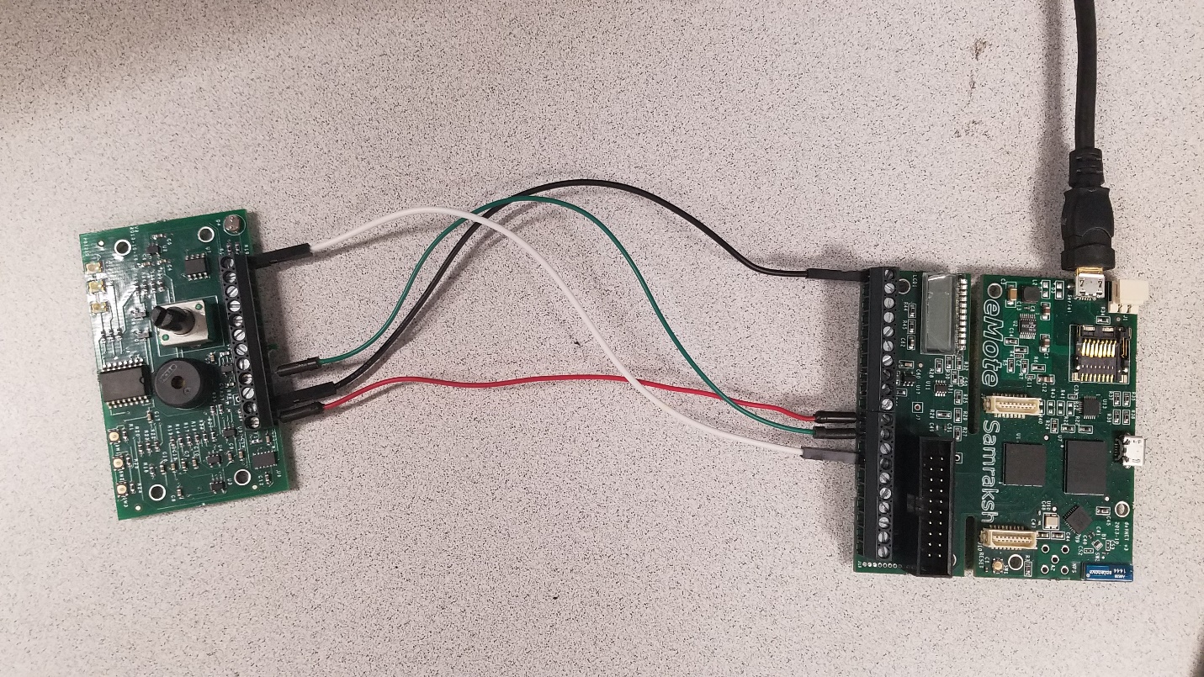

References

1. <https://samraksh.com/index.php/support/layouts-pinouts-interconnects/kiwi-multi-sensor>
2. <https://samraksh.com/index.php/support/layouts-pinouts-interconnects/dot-now>