Prototype Report: Reading Text in a Foreign Language and the Collapsing Ladder Window

Matthieu Cormier
Dalhousie Computer Science
6050 University Avenue
Halifax, NS, CANADA
1-902-494-2093
mcormier@cs.dal.ca

ABSTRACT
Computers can be an effective tool to aid in learning and using reference material. When reading in a foreign language we are limited by our vocabulary in that language. This paper discusses a prototype that allows a user to quickly look up dictionary reference material while minimizing the interruption time to the user. It introduces a new interface widget that has been named the collapsing ladder window. The collapsing ladder window enables the user to browse through definitions and use reference material in context without cluttering the screen with information that she is not currently concerned with.

KEYWORDS: Language acquisition, collapsing ladder window, context sensitive help

INTRODUCTION
Reading in a second language can be tedious because our vocabulary in that language is generally more limited than in our first language. When you encounter an unknown vocabulary word you generally look it up in a dictionary, unless you can guess the meaning from its context. The word can either be looked up in a language-to-language dictionary (i.e. French-English) or using a dictionary of the language being read. This can be tedious for someone who wishes to read in a foreign language since you can potentially be flipping in between four sources:

- What you are reading, (i.e. A book in French)
- Second Language Dictionary (i.e. French)
- Language-to-language dictionary
(i.e. French-English)
- First Language Dictionary (i.e. English)

Intended user
The application is designed for someone who already has a solid base of understanding in a second language. It is not meant as a tool to teach a new language, but as a tool to aid in expanding someone’s comprehension in a second language.

The Tablet
The tedium of reading in a second language may be eliminated if we could eliminate the need to flip through different books. In this paper I propose reading the material on a tablet computer with a touch screen (or pen-based) interface. I envision the tablet screen size to have a minimum dimension of 11cm x 18 cm (4" x 7") the size of a paperback, and a maximum size of 22cm x 28cm(8.5" x 11") the size of a piece of paper. The tablet would not be rectangular like a PDA, or the screen from a laptop. The bottom of it would be roughly triangular in shape, with contours and handholds that simulate the feel of a book when it is open.

The Design Process
As a design exercise two interfaces were created. First, an interface for a PDA with a resolution of 240 x 320 was designed, and then an interface for a hypothetical tablet with a resolution of 480 x 640 was designed.

The PDA Design
The PDA design was a throwaway, it was intended as a design exercise only. Creating a PDA design helped to identify all the required tasks for the tablet. It will not be presented in detail in this paper. It was hoped that by first designing for a low-resolution the higher resolution design would be improved. The PDA interface works similarly to a web browser with left and right back arrows. The main disadvantage of a low-resolution display is that the book text and definition text cannot be displayed at the same time. This forces the user to flip back and forth to understand the word in context.

The Tablet Design
After all the required tasks and functionality had been mapped out by doing a PDA design, a tablet interface was designed. A tablet offers us more screen real estate than a small PDA. More screen real estate enables a user to view the book he is currently reading and a definition at the same time.

THE TABLET INTERFACE
To look up a word the user holds and clicks on that word. Therefore all reference material is context sensitive. When the user clicks on a word, that word is highlighted in the text and the sentence that the word belongs to is highlighted the same color as the word but lighter. This provides emphasis on the word that the user is looking up and allows the user to easily reread the sentence from the beginning after reading and understanding the definition. Definitions slide down smoothly from the top of the screen like a hidden URL bar in Macintosh Internet explorer. (I surf the web without any tool bars and use command-L to show the URL bar when I’m inputting an address by hand).

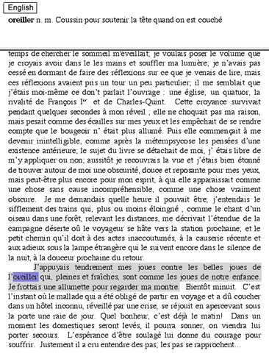
Figure 1: Definitions are displayed in a window that slides down from the top of the screen. In this example the user is reading text in French and has clicked on the noun “oreiller”. Notice that the word is highlighted in the main text along with the sentence that it is contained in.

Every word in the text can be used to retrieve a definition, and every word in a definition can also be used to retrieve another definition. Online dictionaries provide only one word definition at a time, but our goal is to provide context to the user as to why she has looked up the word.

When a definition word is clicked a window slides down (from the top of the screen) to provide the definition for that word (Fig 1). This process is recursive; the user may have to view definitions of words inside the definition, or get a translation of a definition (Fig 2).

Although we want the user to be able to view many definitions quickly we also want to remind the user that main focus is reading the book. One, two, and maybe three definition windows could be displayed along with the main text, but more than three windows and our screen will begin to be cluttered (depending on the size of the definitions), and more confusing. To remedy this problem the collapsing ladder window was designed.

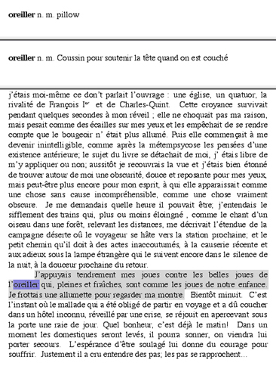
Figure 2: The French definition has not been sufficient for our user so an English definition has been retrieved. Since there are only two definitions no definitions are minimized.

Collapsing Ladder Window
Reading definitions is a process of comparing a definition with some previous material. Although a user may need to look at several definitions to understand the text, he only needs to compare a definition with the main text, or a definition with a previous definition.

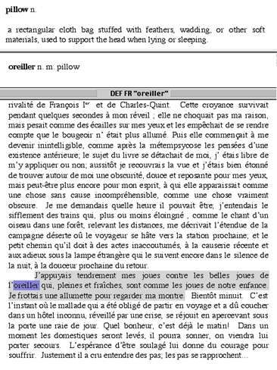Figure 3: Our user does not understand the English word pillow so he clicks on it and gets the English definition for pillow. The French definition minimizes to a bar. The user can now focus on what a pillow is and what the French translation for pillow is.

The collapsing ladder window is designed to minimize the amount of information on the screen while allowing the user to view the main text. It takes the process of comparing two items at once into consideration and minimizes previous definitions when more than 2 definitions have been traversed (Fig 3). Previous definitions can be viewed by viewed by clicking on the minimized bar (Fig 4). By clicking on top or bottom bars a user can metaphorically climb up or down a ladder of definitions that she has constructed.

Two Known Issues
I suggested in my video prototype that if a word is a compound word then the user could select part of the word and click to retrieve a definition for part of the word. In my software prototype no examples of compound words were handled. After reflection on the prototype I think that some type of tree display of the word could be shown; or the user could be notified in some way that she is looking at a compound word and that he has options to view either root word definition.

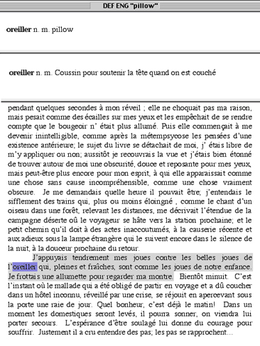
Figure 4: Now that the user understands what a pillow is she chooses to view the French definition for “oreiller” by clicking on the bar in Figure 3. The French definition for “oreiller” expands and the top English definition for “pillow” minimizes. The user can move up and down a list of definitions like this, viewing two definitions at a time.

Verb tenses are also a subtle issue. For example: the verb “taire” in French when conjugated to the past participle is written “tu”. Tu is also the pronoun for second person singular. Although this particular example is well known, and it is easy to distinguish between a pronoun and a verb from the context of the sentence, it does highlight the subtle nuances of language. An example of this is in the software prototype (cru). In the software prototype I chose to put all possible definitions of cru in the definition window (the definition of croire was listed but no explanation on how cru is can be a past form of croire).

SUCCESS OR FAILURE OF PROTOTYPE?
I was very satisfied with the prototype, and after completing it wished that such software existed.

Looking up the definitions using the collapsing ladder is a form of online help, and much research has been done in that field. Quality of text [1], and concise answers [2] are very important to the success of online help. Fortunately, document writers are not required, because dictionaries already provide us with concise quality text. This fact greatly contributes to the success of the application.

Using context sensitivity instead of some other input method works well when reading in foreign languages. It avoids the issue of requiring the user to input non English characters. I realized how cumbersome this can be when I typed in the text for the prototype. I had to continually switch keyboards for the special French and Norwegian characters. Eventually I just made a list of the characters in my word processor and used copy and paste.

POSSIBLE FUTURE DEVELOPMENT
Usability testing needs to be done on the collapsing ladder window interface. Although it seems logical and intuitive to me, I did design it. User feedback could help to improve the tool or even tell us that it does not work very well.

The main goal of the tablet is to improve vocabulary, not to be able to lookup words more quickly. Research needs to be done on how to integrate memorization techniques into the application. If users don’t improve their vocabulary then the application is a failure.

One common memorization technique when reading text is taking notes. It could be possible to incorporate Schilt’s work [3] on free form digital annotations into the application. I don’t believe that someone that is reading for leisure would want to take notes, but reading on a tablet computer is not the same as reading a paperback. Users may enjoy writing jot notes when they are reading a piece of fiction since it does not destroy the original text.

ACKNOWLEDGEMENTS
To Karen Parker for her suggestion to consider annotated text.

REFERENCES
- Borenstein, S. 1986. Help Texts vs. Help Mechanisms: A New Mandate for Documentation Writers. Proceedings of the 4th annual International Conference on Systems Documentation. First line of conclusion.
- Goodall, S. Online Help: A Part of Documentation. SigDoc 92. Third sentence of conclusion.
- Schilit B. Beyond Paper: Supporting Active Reading with Free Form Digital Ink Annotations. CHI 98. Entire document.

