Michael Cowan

Computational Physics

Problem Set 6

1. In this problem, we calculate the energy eigenvalues for a perturbed quantum particle in a box using the variational method. The perturbation is of size 0.2 and occupies the rightmost ¼ of the box. We are instructed to calculate the energy levels using the lowest 8 base states of the unperturbed Hamiltonian ($ψ_{n}=\sqrt{2/L} sin⁡(nπx/L)$).

All of the multiplication of basis states and integral functions were given to us, so the only code I actually had to write was to construct the perturbed Hamiltonian matrix and then calculate its eigenvalues.

Code:

1. clear all;
2. %set the parameters
3. global hbar=1 m=1 L=1;
4. global perturbation=0.2;
5. %construct the Hamiltonian matrix
6. for i=1:8
7. for j=1:8
8. M(i,j)=H0(i,j)+V(i,j);
9. end
10. end
11. disp('The Hamiltonian matrix is:');
12. disp(M);
13. disp('The energy eigenvalues are:');
14. disp(sort(eig(M)));

Results:

The Hamiltonian matrix is:

4.9530e+00 -3.0011e-02 3.1831e-02 -2.4008e-02 1.0610e-02 2.5723e-03 -1.0610e-02 1.1433e-02

-3.0011e-02 1.9789e+01 -5.4019e-02 4.2441e-02 -2.1436e-02 1.1546e-14 1.4005e-02 -1.6977e-02

3.1831e-02 -5.4019e-02 4.4474e+01 -5.1447e-02 3.1831e-02 -1.0004e-02 -6.3662e-03 1.3096e-02

-2.4008e-02 4.2441e-02 -5.1447e-02 7.9007e+01 -4.0014e-02 2.5465e-02 -1.0913e-02 3.5183e-15

1.0610e-02 -2.1436e-02 3.1831e-02 -4.0014e-02 1.2341e+02 -4.0923e-02 3.1831e-02 -1.8468e-02

2.5723e-03 2.8857e-15 -1.0004e-02 2.5465e-02 -4.0923e-02 1.7770e+02 -4.8479e-02 3.6378e-02

-1.0610e-02 1.4005e-02 -6.3662e-03 -1.0913e-02 3.1831e-02 -4.8479e-02 2.4186e+02 -4.8017e-02

1.1433e-02 -1.6977e-02 1.3096e-02 -7.2670e-17 -1.8468e-02 3.6378e-02 -4.8017e-02 3.1588e+02

The energy eigenvalues are:

4.9529

19.7891

44.4739

79.0069

123.4137

177.7029

241.8599

315.8774

To check that the program worked correctly, I also calculated the energy eigenvalues for the unperturbed system by setting the perturbation to 0.

The Hamiltonian matrix is:

4.93480 0.00000 -0.00000 -0.00000 -0.00000 0.00000 -0.00000 -0.00000

0.00000 19.73921 0.00000 0.00000 0.00000 0.00000 0.00000 -0.00000

0.00000 -0.00000 44.41322 0.00000 0.00000 -0.00000 0.00000 -0.00000

-0.00000 0.00000 0.00000 78.95684 0.00000 0.00000 0.00000 0.00000

-0.00000 0.00000 0.00000 0.00000 123.37006 -0.00000 -0.00000 -0.00000

0.00000 0.00000 -0.00000 0.00000 -0.00000 177.65288 0.00000 0.00000

0.00000 0.00000 0.00000 0.00000 0.00000 0.00000 241.80531 -0.00000

-0.00000 -0.00000 -0.00000 -0.00000 -0.00000 0.00000 -0.00000 315.82734

The energy eigenvalues are:

4.9348

19.7392

44.4132

78.9568

123.3701

177.6529

241.8053

315.8273

These values exactly match the expected values for the unperturbed Hamiltonian, which are given by $E_{n}=(n^{2}π^{2}ℏ^{2})/(2mL^{2})$.

Extra section:

Because I had some time, I also calculated the weighting coefficients of the individual wave functions. I then graphed the individual wave functions with their weighting coefficients as well as the total wave function found by summing the individual wave functions.

Additional code:

1. disp('The basis state coefficients are:');
2. c=sort(eig(M-eye(8,8).*sort(eig(M))));
3. disp(c);
4. for n=1:8
5. for k=0:100
6. psin(n,k+1)=c(n).*u(n,k/100);
7. end
8. end
9. psi=psin(1,:);
10. for p=2:8
11. psi=psi.+psin(p,:);
12. end
13. figure(1); clf;
14. plot(0:0.01:1,psin);
15. xlabel('Position');
16. ylabel('Amplitude');
17. title('Individual States c_{n}\psi _{n}');
18. pause(0.5);
19. figure(2); clf;
20. plot(0:0.01:1,psi);
21. xlabel('Position');
22. ylabel('Amplitude');
23. title('Total Wavefunction \Psi');

Result:

The basis state coefficients are:

warning: product: automatic broadcasting operation applied

-0.056835

-0.052907

-0.049982

-0.046414

-0.036866

-0.020002

0.112761

0.150245

The warning arises from multiplying the identity matrix elements by the energy eigenvalues, since the matrices are not the same size. In theory I should have written a for loop to do the multiplication, but Matlab didn’t seem too hung up on the issue so I decided to just go with it.

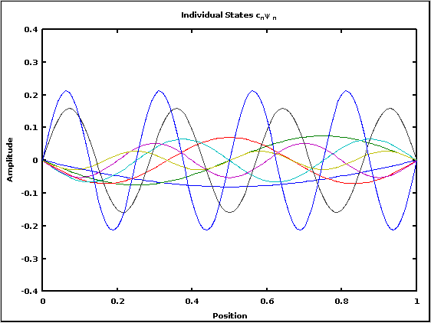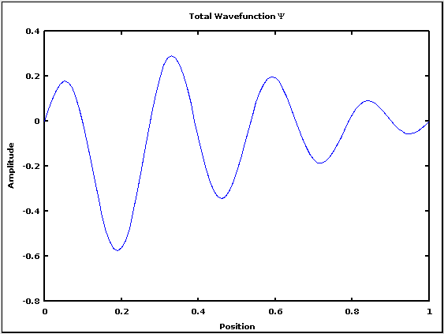

Figures 1: the Individual States with their weighting coefficients cnψn and the Total Wavefunction Ψ

Notice that the amplitude of the total wavefunction decreases greatly in the area of the perturbation, as some of the wavefunction will be reflected by the potential barrier at x=0.75.