Cloud and Cluster Database Management Project
Project 1
Jonathan Jensen, Timothy Jensen, Nicholas Hoover, Matthew Pate

1 Tasks
- Map the given data to the key/value model, document model, or column family model.
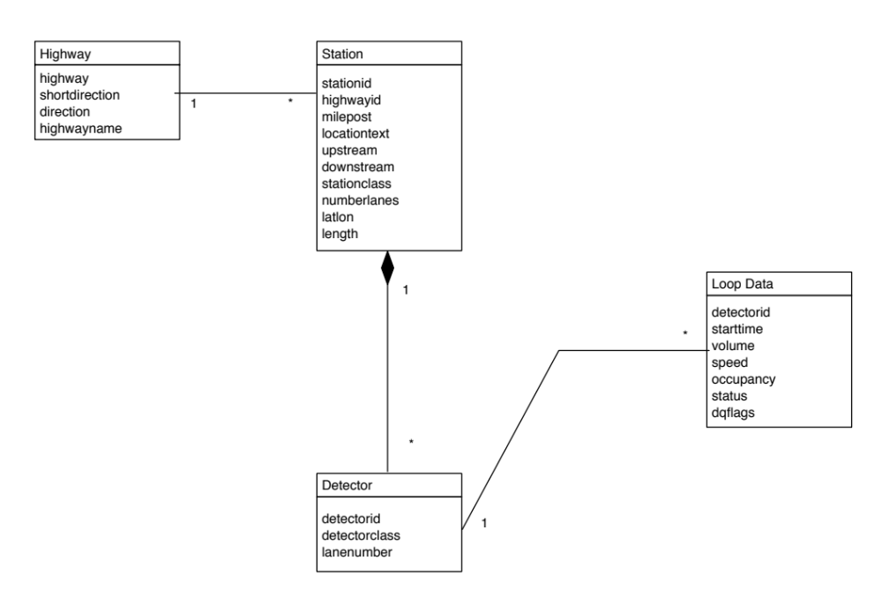
Figure 1: UML Diagram of NoSQL Aggregates for Document Model

Example Aggregates for Document Model:
// -----------  // Freeway Stations  // -----------  {  "stationid" : ,  "highwayid" : ,  "milepost" : ,  "locationtext" : ,  "upstream" : ,  "downstream" : ,  "stationclass" : ,  "numberlanes" : ,  "lat" : ,  "lon" : ,  "length" :  "freeway_detectors" : [  {  "detectorid" : ,  "detectorclass" : ,  "lanenumber" :  },  {  /.../  }  ]  } | // ---------------  // Freeway Loop Data  // ---------------  {  "detectorid" : ,  "starttime" : ,  "volume" : ,  "speed" : ,  "occupancy" : ,  "status" : ,  "dqflags" :  }  // ------------  // Highway  // ------------  {  “highway” : ,  “shortdirection” : ,  “direction” : ,  “highwayname” :  }

- Describe in words or pseudo-code how you could answer the queries below.
  - Count high speeds: Find the number of speeds > 100 in the data set.

In the FREEWAY_LOOPDATA table,
for all rows{
if SPEED > 100
increment counter
return counter
}

  - Volume: Find the total volume for the station Foster NB for Sept 21, 2011.

In the FREEWAY_STATIONS table,
scan LOCATION_TEXT column for "Foster NB"
FS_ID = Station_ID
In the FREEWAY_DETECTORS table,
for all rows where STATION_ID == FS_ID{
FD_ID = DETECTOR_ID
In the FREEWAY_LOOPDATA table:
for all rows where DETECTOR_ID = FD_ID{
if STARTTIME includes 9/21/2011
TOTAL_VOLUME = TOTAL_VOLUME + VOLUME
}
}

  - Peak Period Travel Times: Find the average travel time for 7-9AM and 4-6PM on September 22, 2011 for station Foster NB. Report travel time in seconds. You should have one average travel time for 7-9AM and one average travel time for 4-6pm.

In the FREEWAY_STATIONS table,
scan LOCATION_TEXT for "Foster NB"
STATION_ID_KEY = FREEWAY_STATIONS.STATION_ID
LENGTH = FREEWAY_STATIONS.LENGTH

  - Route Finding: Find a route from Johnson Creek to Columbia Blvd on I-205 NB using the upstream and downstream fields.

In the FREEWAY_STATIONS table,
next_station_id = downstream where locationtext == "Johnson Cr NB"
while (locationtext != "Columbia to I-205 NB" where stationid ==
next_station_id){
next_station_id = downstream
}

  - Update: Update stationid 1140 to have a length of 2.3.

In the FREEWAY_STATIONS table
set (1140, 2.3)

