260-2017-04-24-speed-lab

PSYCH 260.003

2017-04-24 09:52:34

## Today's topic

* Measuring the speed of nervous system conduction
* And, a tiny lesson in open, transparent, reproducible data science

## Question

* How fast does the nervous system conduct information?
* [Prior evidence](https://psu-psychology.github.io/psych-260-spring-2017/lecture-notes/260-2017-03-29-somatosensation.html#15)
  + Proprioception vs. touch
* Why do we care?

## Prediction

We predict that the speed of conduction will be ...

## Scheme

* Speed = Distance/Time
* Chain of participants to make distance larger
  + If typical person ~ 1.5 m, then
  + at s=30 m/s, t = d/s -> 1.5/30 = 0.05 secs.

## Condition 1 (ankle)

* Squeeze ankle
* ankle_shoulder + shoulder_brain + brain_decide + brain_shoulder + shoulder_hand

## Condition 2 (shoulder)

* Squeeze shoulder
* shoulder_brain + brain_decide + brain_shoulder + shoulder_hand
* Condition 1 - Condition 2
* ankle_shoulder + ~~shoulder_brain~~ + ~~brain_decide~~ + ~~brain_shoulder~~ + ~~shoulder_hand~~

## Measure

* sum(ankle_shoulder) for all participants -> Distance
* mean(time(Condition 1)) - mean(time(Condition 2)) -> Time
* Speed = Distance/Time

## Materials

* Stop watch
* Tape measure

## Decisions

* Same hand or dominant?
* Alternate ankle/shoulder or one condition before the other?
* How many trials?
  + Fixed number?
  + When reach asymptote?

## Data files

* Data file with [body measurements](https://docs.google.com/spreadsheets/d/1NFGu-M4AGf_4IHf-o4y3sCHUZ3Ao-CpBUpXqCsQrAIg/edit#gid=0)
  + participant, ankleshoulder (cm)
* Data file with [reaction times](https://docs.google.com/spreadsheets/d/1NFGu-M4AGf_4IHf-o4y3sCHUZ3Ao-CpBUpXqCsQrAIg/edit#gid=1626241513)
  + trial {1...n}, condition {ankle, shoulder}, time (s)

# Load R packages  
library("googlesheets")  
suppressPackageStartupMessages(library("dplyr"))  
suppressPackageStartupMessages(library("ggplot2"))

## Measuring distance

psych260 <- gs_title("psych-260-spring-2017")

## Sheet successfully identified: "psych-260-spring-2017"

psych260 %>%   
 gs_read(ws = "distance") ->  
 distance

## Accessing worksheet titled 'distance'.

##   
Downloading: 130 B   
Downloading: 130 B   
Downloading: 130 B   
Downloading: 130 B

## No encoding supplied: defaulting to UTF-8.

dist.hist <- ggplot(data = distance, aes(x=ankleshoulder)) +  
 geom_histogram(bins = 5)

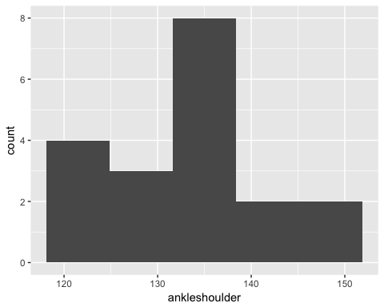

## Sum distance

with(distance, summary(ankleshoulder))

## Min. 1st Qu. Median Mean 3rd Qu. Max.   
## 122.0 125.5 132.0 133.2 137.5 149.0

# Calculate sum  
dist.sum = with(distance, sum(ankleshoulder))

The total distance is 2531 cm.

## Measuring time

psych260 %>%   
 gs_read(ws = "time") ->  
 time

## Accessing worksheet titled 'time'.

##   
Downloading: 110 B   
Downloading: 110 B   
Downloading: 120 B   
Downloading: 120 B   
Downloading: 120 B   
Downloading: 120 B

## No encoding supplied: defaulting to UTF-8.

# Plot data  
time.plot = ggplot(data = time, aes(x=trial, y=time, color=condition)) +  
 geom_point() +   
 geom_line()

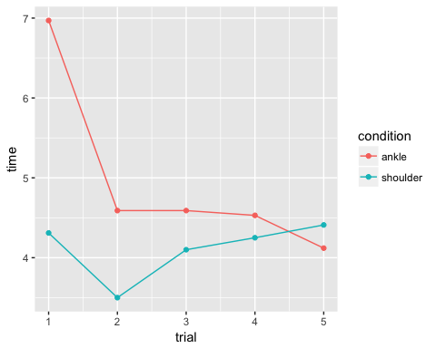

## Calculate time difference

time %>%   
 filter(condition == "ankle") ->   
 ankle.times  
  
time %>%   
 filter(condition == "shoulder") ->   
 shoulder.times  
  
time.diff <- data_frame(trial=unique(time$trial),  
 time=ankle.times$time - shoulder.times$time)  
  
time.diff.plot = ggplot(data = time.diff, aes(x=trial, y=time)) +  
 geom_point() +   
 geom_line()

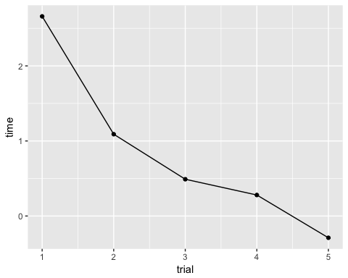

## Calculating speed

time.diff$speed <- (dist.sum)*.01/time.diff$time  
  
speed.hist <- ggplot(data = time.diff, aes(x=speed)) +  
 geom_histogram(bins = 5)

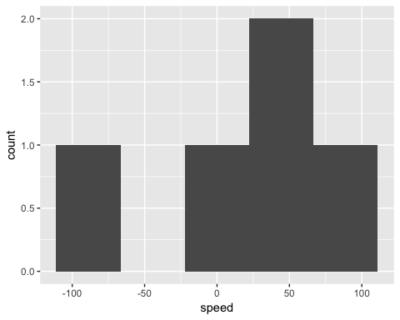

## Plot time series of speeds

speed.plot <- ggplot(data = time.diff, aes(x=trial, y=speed)) +  
 geom_point() +  
 geom_line()

speed.plot

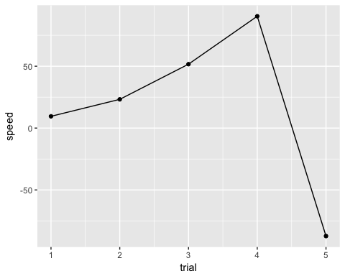

## Summarizing findings

* We tested the mean speed of neural propagation in a sample of n=19 college-age adults.
* The mean speed of neural propagation over 5 trials was 17.5 m/s with a range of [-87.28, 90.39] m/s.
* These findings are/are not generally in accord with values we would expect from the literature.

## Limitations

## How to replicate/extend

## Contributors

## Resources

This document was prepared in RStudio 1.0.36 on 2017-04-24 09:52:39.

sessionInfo()

## R version 3.3.2 (2016-10-31)  
## Platform: x86_64-apple-darwin13.4.0 (64-bit)  
## Running under: OS X El Capitan 10.11.6  
##   
## locale:  
## [1] en_US.UTF-8/en_US.UTF-8/en_US.UTF-8/C/en_US.UTF-8/en_US.UTF-8  
##   
## attached base packages:  
## [1] stats graphics grDevices utils datasets methods base   
##   
## other attached packages:  
## [1] ggplot2_2.2.1 dplyr_0.5.0 googlesheets_0.2.1  
##   
## loaded via a namespace (and not attached):  
## [1] Rcpp_0.12.10 xml2_1.1.1 knitr_1.15.1 magrittr_1.5   
## [5] hms_0.3 munsell_0.4.3 colorspace_1.3-2 R6_2.2.0   
## [9] httr_1.2.1 stringr_1.2.0 plyr_1.8.4 tools_3.3.2   
## [13] grid_3.3.2 gtable_0.2.0 DBI_0.6-1 htmltools_0.3.5   
## [17] openssl_0.9.6 yaml_2.1.14 lazyeval_0.2.0 assertthat_0.2.0  
## [21] rprojroot_1.2 digest_0.6.12 tibble_1.3.0 readr_1.1.0   
## [25] purrr_0.2.2 rsconnect_0.7 curl_2.5 evaluate_0.10   
## [29] rmarkdown_1.4 labeling_0.3 stringi_1.1.5 cellranger_1.1.0  
## [33] scales_0.4.1 backports_1.0.5 jsonlite_1.4