# Supplemental Figure 1

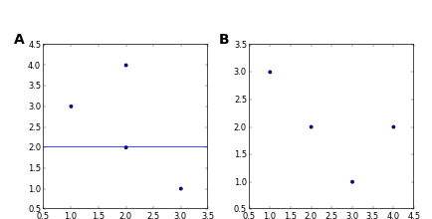

**SuppFig1Test. A.** This is a test figure 2. **B.** This is a test figure 1.

# Supplemental Figure 2

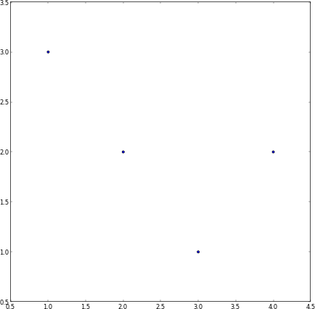

**SuppFig2Test.** This is a test figure 1.

# Supplemental Table 1

|  |  |
| --- | --- |
| X | Y |
| 1 | 4 |
| 2 | 3 |
| 3 | 2 |
| 4 | 1 |

**Testing tables.**