**Notes:**

A div used to message between code and user (i.e. div id="message")

Generate data on start instead of keeping it all stored in single variable when possible

*Shuffle Array function*

function shuffleArray(array) {

for(var i = array.length-1; i > 0; i--) {

var holder = Math.floor(Math.random() * (i+1));

var temp = array[i];

array[i] = array[holder];

array[holder] = temp;

}

return array;

}

- Using objects in an array is useful for more detail in data

Event Listeners in javascript

- document.getElementById('ID').addEventListener("change", function() {}

- can do different things if theres a change in the element

**Web Design Notes**

Web Design includes

Wireframing - wireframing is the rough draft design of a website. Placing pieces of the website for the client to view and approve.

UX/UI - User Interface(UI) is used for display of webpage and stuff for point and interaction. User Experience(UX) is how a person feels when they use a product.

Layout & Spacing

Navigation

Colors

Fonts

Icons

Imagery

Typography is the design and layout of text displayed on a webpage. Tool for typography measurements https://pearsonified.com/typography/.

5 Principles of Typography

1) Font(Serif and Sans Serif)

2) Size (14-16px)

3) Line Height (150% of text size)

4) Alignment

5) Readability

CSS Box Model design

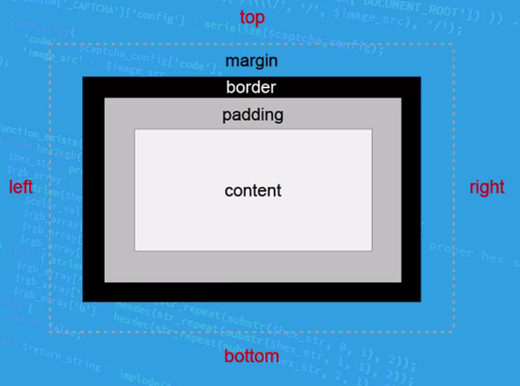

Every single element has these 4 elements around it

content - all the information goes inside the content.

**Bootstrap:**

Bootstrap is setup in 3 categories, containers, rows, columns where they're stored in each other in that order.