**Appendix_A**

**Transcript (First meeting – March 2016)(Interview)**

Me: Good morning Mr. X. First of all, I want to say thank you for letting me help you with this issue.

Mr. X: Your help is appreciated, I’m unsure of your programming skills but I will explain it all and then you can tell me how you fell about it.

Me: Alright, so what is the problem that needs solving?

Mr. X: I want to make it easier for students to record data, which would also make it easier to keep track of the data.

Me: And have you thought about how the data would be collected: on a computer or phone or..?

Mr. X: An app on the phone would be the most ideal for the students to use and for ease of collection.

Me: What kind of app?

Mr. X: Preferably an android app

Me: What would the app contain exactly?

Mr. X: the app would need to be split into 4 main parts, as you will see when you go on the trip in May this year. You will have to find a way to record the number of pedestrians and traffic.

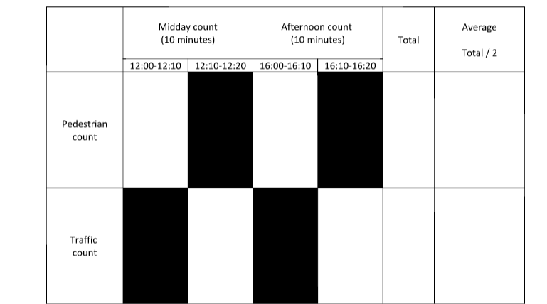

The different types of land use according to a certain area on a map (each student will be assigned a different area of the map). The students will also have to rate certain buildings in their area of the map according to certain criteria and give them a score from 0-5.

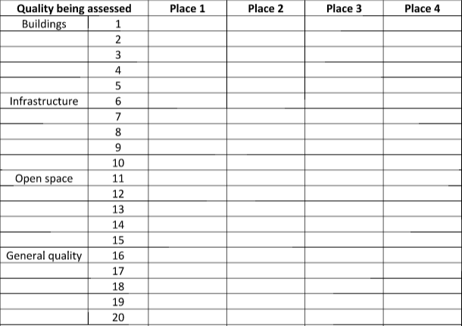

And the last part would have to be rating the environment according to criteria and give a score from -2 to 2.

Me: Alright, that sounds like a lot of work.

Mr. X: Well, maybe, but I will later give you the paper in geography class which explains all about the data collection process.

*Gives paper*

Me: *Looks through paper*

I will look at it in more detail over the coming weeks, I think we should meet again then, this time with my advisor and discuss this idea further, how does that sound?

Mr. X: That sounds great, see you then!

Me: Goodbye.

Mr. X: Goodbye.