**Criterion B: Design**

**Basic Structure of the Android application**

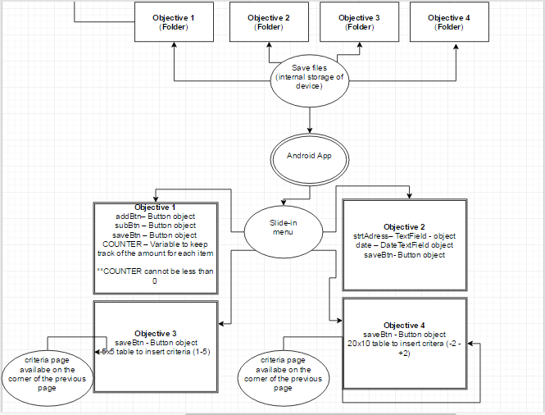

*Figure 1 : Flowchart of*

**The application**

The programming language is of course java, but there is also a visual aspect to it. XML is used to place objects such as buttons, text fields or tables relative to each other and the device (type of device has to be specified before starting the application).

This is what the hierarchy looks like for this application

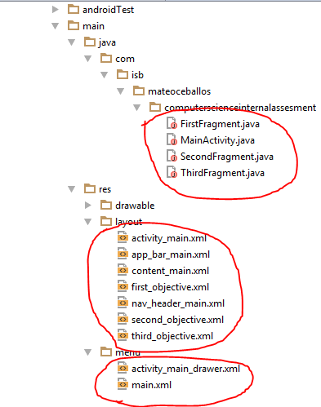

*Figure 2 : Xxxk hjlkgjlkdjgdlf*

Each java class is associated to one XML file, known as the layout, because it shows the layout for that class. Then there are a few other layout files which are combined together to create the slide-in menu. The MainActivity.java is the main class of the entire application, in that class; the menu is created and is told what layout file it should display based on which option is pressed in the slide-in menu.

**Interface (Menu)**

The menu will consist of the following:

|  |  |  |  |
| --- | --- | --- | --- |
| Objective 1 | Objective 2 | Objective 3 | Objective 4 |

OBJECTIVE 1

|  |  |  |
| --- | --- | --- |
| **NAME** | **TYPE** | **DESCRIPTION** |
| addBtn | Button object | Increase the value of COUNTER by 1, COUNTER cannot be less than 0 |
| subBtn | Button object | decrease the value of COUNTER by 1, COUNTER cannot be less than 0 |
| saveBtn | Button object | Save values of COUNTER to internal storage as txt file |
| COUNTER1 | Integer | Keep track of number of pedestrians count |
| COUNTER2 | Integer | Keep track of number of traffic count |

OBJECTIVE 2

|  |  |  |
| --- | --- | --- |
| **NAME** | **TYPE** | **DESCRIPTION** |
| strtAdress | TextField object | The address of the street at which the student is at |
| saveBtn | Button object | Saves data as 2d array into text file located in the internal storage |
| DATE | DateTextField object | Write down the date of recording |

OBJECTIVE 3

|  |  |  |
| --- | --- | --- |
| **NAME** | **TYPE** | **DESCRIPTION** |
| saveBtn | Button object | Saves data as 3d array into text file located in the internal storage // the type of building, the value (1-5) and which out of 5 of that building type |
| TABLE | TableView Object | 6x5 length |

OBJECTIVE 4

|  |  |  |
| --- | --- | --- |
| **NAME** | **TYPE** | **DESCRIPTION** |
| saveBtn | Button object | Saves data as 2d array into text file located in the internal storage // the type of building, the value (1-5) and which out of 5 of that building type // creates file if there isn’t one already |
| TABLE | TableView Object | 20x10 length, each element is an integer from -2 to +2 |

**Internal Storage (invisible to the user)**

When I first came across having to decide among different types of storage, I immediately thought of using the internal storage of the device rather than SQL for example because of the amount of data overall.

When an application is installed on a device, a folder is automatically created in the storage containing everything about that application. That would be the ideal place to store text files with data.

|  |  |  |  |
| --- | --- | --- | --- |
| MAIN APPLICATION FOLDER | | | |
| Objective 1  FOLDER | Objective 2  FOLDER | Objective 3  FOLDER | Objective 4  FOLDER |

The files would be organized with a date and time like

OBJ[X]_YYYYMMDD_HHMMSS

e.g.

OBJ1_20170219_134257

This is to keep track of when data was recorded