Intermediate Report
DARPA Contract F30602-96-2-00227

Evaluation of the MultiGraph Kernel
on an IBM SP2 Scalable Workstation Cluster

Hubertus Franke, Ph.D.
IBM T.J.Watson Research Center
PO-Box 218
Yorktown Heights, NY 10598
frankeh@watson.ibm.com

The overall task of this contract was twofold. First, the existing Multigraph Toolset (consisting of graphical model-builder, object oriented database and the domain specification compiler) have been ported to the IBM SP2 scalable workstation cluster and are currently reviewed for application to various software diagnosis problems).
Second, and focus of this report, is the evaluation and the port of the next generation Multigraph Kernel, a software implementation of a macro-dataflow computational model for single processor and distributed memory multiprocessor architectures, to the IBM SP2. Following the description of the computational model, the paper discusses some of the implementational details of the Kernel. The results of a performance evaluation conducted on IBM’s SP2 scalable parallel workstation cluster are reviewed and suggestions for possible performance improvements derived from this analysis are provided.
1. Introduction

Complex computer integrated systems for large-scale applications such as industrial plant control or aerospace systems tightly couple the software system with their physical environment, creating complex component interactions. Hence, it is imperative that software be constructed in close association with the physical system, so they can evolve together.

The Multigraph Architecture (MGA) is a framework that utilizes model integrated program synthesis techniques to build such systems [2]. Domain specific models are created using a multi-view graphical model editor and store in model databases. These models are then used as input to a set of domain model interpreters that synthesize the applications. This approach is shown in Figure 1.


Figure 1: Infrastructure of the MultiGraph Architecture (MGA)

This technology has matured in major applications developed for the Government and private industry, including fault detection, isolation and recovery systems for aerospace applications, on-line problem solving environments for the chemical manufacturing industry, high-performance parallel instrumentation systems, embedded simulators for turbine and rocket engine testing, and medical instrumentation.

To facilitate portability, the interpreters typically synthesize the application on top of a parallel virtual machine that is expressed as a Macro Dataflow Computational Model [1]. In this model, active objects communicate via ports with each other, thus triggering an object’s execution. The model is inherently parallel. In the context of the MGA, the Multigraph Kernel (MGK) implements this dataflow model as the runtime system. The MGK is implemented as an overlay above operating and communication systems and is supported on many standard platforms (UNIX, WINDOWS-NT, WINDOWS-95, etc. operating systems and TCP/IP, MPI communication systems).

This report evaluates the overhead, performance and scalability of the MGK when run on a commercial supercomputer, the IBM SP2. In particular, it examines the overhead introduced by the MGK for basic activities such as scheduling and communication on single as well as multi processor versions.

2. Multigraph Kernel Essentials

The Multigraph Kernel implements a Macro Dataflow Computational Model [1]. In this model, a computation is comprised of a graph of active objects, called actors, communicating with each other through ports thus triggering their individual execution. In MGK, an actor consists of the following components:

- number of input ports through which messages are received (max 256),
- number of output ports through which messages are sent (max 256),
- context defining the state of the actor which persists through the lifetime of the actor,
- set of trigger mechanisms specifying when an actor should be executed. These include either arrival of data on any input port (IF_ANY), on all input ports (IF_ALL) or specific combinations of input ports (IF_MASK),
- script (i.e. a function) to be executed upon activation of the actor.

A typical script code fragment looks as follows:
First, data is received on active input ports, then computation is performed possibly changing the actor’s state and finally results are propagated through various output ports. The MGK provides the ability to propagate all basic data types (e.g. integer, double), arbitrary sized arrays of basic data types, and buffers of raw data.
actor_script()
{
T *state = mgk_node_context();
forall active InPorts pin
mgk_receive(pin,&datain);

do_computation /* modify the state */

forall relevant OutPorts pout
mgk_propagate(pout,dataout);
}

The MGK execution engine implements the following general algorithm:
Mgk_Execution_Engine()
{
forever
RunActor ();
RunCommunication ();
}
During RunActor the first actor of a priority based ActorReadyQueue is fetched and its script is executed. An actor’s priority is determined by adding a fixed priority defined at actor creation time to a dynamic runtime priority defined by the number of scheduling cycles a ready actor was not granted execution. This scheme ensures that every ready actor will eventually execute.
The details of data propagation and RunCommunication depend on the system:
In a single node system, the MGK enqueues the data associated with a mgk_propagate request at the time of the request at the input ports of actors connected to the output port and checks whether the triggering condition of the destination actor is satisfied. If so, the destination actor is entered into the ready queue. Hence, RunCommunication in a single node system is a NOOP.
In distributed multi-processors systems, RunCommunication is responsible for exchanging requests between the participating MGK kernels using the system’s underlying communication medium (e.g. TCP/IP, MPI, SHMEM). Data, actor and port information associated with a non-local mgk_propagate is stored into a remote propagation queue associated with the remote MGK hosting the destination actor. No messages are sent at this point. After the actor’s execution all non-empty remote propagation queues are processed and all pending requests are sent using lower level protocols. Consequently, the RunCommunication has to check for incoming communication requests from remote kernels, decode the requests and store data to the appropriate input ports of the designated actors and check for triggering conditions of involved actors.

The MGK provides a builder programming API that enables the application at runtime to build a distributed actor graph or to reconfigure an existing actor graph while it is running. This provides high flexibility in terms of software code generation as required by the applications targeted by the Multigraph Architecture, where the computational graph often has to be manipulated at runtime to match changing operational requirements.

3. System Configuration

All evaluation experiments were performed on an IBM SP2 Scalable Workstation cluster. The IBM SP2 at hand was configured as a 32-node processor cluster connected via a TB3 high performance switch. The individual POWER-2 processors of this particular configuration (called thin-nodes due to their limited memory bandwidth and floating point performance) have the following characteristics:

L1 Inst Cache Size | 32 KB
L1 Data Cache Size | 64 KB
Integer Performance | 134 Mips
Floating Point | 67 Mflops (dependent fma’s)
Floating Point | 269 Mflops (independent fma’s)

The following inter-processor communication performance using the MPI message passing interface [3] was measured.


Figure 2: SP2/TB3 inter-processor MPI Latency
Figure 3: SP2/TB3 inter-processor MPI Bandwidth

The latency and bandwidth for the SP2 was measured using a simple ping-pong program.
Figure 2 shows the basic linearity of the latency curve for small messages (512bytes). Figure 3 shows the bandwidth achievable on this SP2 configuration. At 4Kbytes the curve experiences a small dip which is due to the fact that the MPI implementation on the SP2 switches from an eager protocol to a synchronous protocol, thus incurring an extra message roundtrip. At 32Kbytes the curve accelerates due to the fact that the MPI implementation omits extra copies into the CSS based on assumptions related to the internal token-flow/retry mechanisms.

Two versions of the MGK were available for evaluation:

- Stand-Alone MGK (MGK^{SA}) only runs on a single node and can not communicate with other kernels.
- Distributed MGK (MGK^{MPI}) runs on distributed multiprocessor systems using the system’s native MPI message passing facilities to communicate among kernels.

4. Basic Overhead Evaluation

In order to measure the basic overhead in employing MGK we constructed the simple actor graph shown in Figure 4. Two actors A1 and A2 are connected by a number of N ports. Both actor’s script functionality is to receive and propagate data hence activating each other. At every activation, A1 propagates a double floating point number over each output port to the associated input port of A2. A2’s trigger condition is set to start execution when data is available on all input ports. Upon receiving the data, A2 sends a data token to A1 to reiterate this loop. The experiment is warmed for 2000 iterations to account for typical system related activities such as cache/page warm-up or shared library linkage. The execution time is measured for the following 10000 iterations.

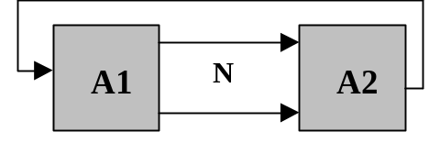
Figure 4: Simple 2-Actor Graph to measure

4.1. Connection Scalability

Figure 5 shows how MGK^{SA} scales with the number of connections when executed on a single SP2 processor. The graph reveals a non-linear component which can be attributed to the fact that MGK checks on each propagation request whether any of the target actor’s triggering conditions are fulfilled in order to activate the actor. Since checking a trigger condition in the IF_ALL case is based on a bit-masking algorithm this check is of complexity O(N) and hence for the given test case introduces a small but visible O(N²) component. This non-linear component could be removed by placing actors onto a new CheckQueue at propagation or message reception time, given they are not already in that queue, and then check the trigger conditions only once at the end of RunCommunication.


Figure 5: Single Processor Overhead per Iteration for MGK^{SA} and MGK^{MPI}
As explained above, the results for this experiment follow the general overhead function OH as a function of number of ports:
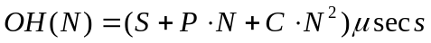
where:
- S is the Scheduling Overhead
- P is the Propagation Overhead of one port with one double floating number
- C is the Overhead for checking a triggering condition.

For the 1-processor MGK^{SA} this resulted in the following function (based on curve fitting):

.

Figure 5 also shows that using MGK^{MPI} over the MGK^{SA} version on a 1-processor setup does not introduce any significant overhead. The curve fitting for MGK^{MPI} resulted in the following relationship.

.

The extra 14μsecs can be broken down into MPI related activities and MGK related activities. Using low level SP2 tracing tools [4] we measured that 8μsecs are related to an MPI_IProbe instruction which checks for incoming messages from other MGK kernels (although not existent), the remaining 6μsecs are executed in the MGK communication code checking various propagation queues. The output of this tracing tool is shown in Figure 6.

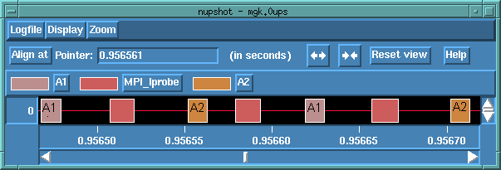
Figure 6: SP2 Tracing Plot for 1-Processor MGK^{MPI} execution

Executing the same experiment on a 2-Processor MGK^{MPI} configuration yields the results shown in Figure 7. Given the connectivity between A1 and A2, we are ensured that although A1 and A2 are located on different processors, there will be no overlap in actor execution. The execution time is now dominated by the inter-processor communication.

Analyzing the numbers shown in Figure 7, we obtain the following overhead function (through curve fitting) for cross processor propagation and activation.

.


Figure 7: Overhead with MGK^{MPI} on a 2 Processor System

The overhead of 149μsecs per port in the inter-processor case seems relatively high as compared to 4.6μsecs in the intra-processor propagation. However, this number should be compared to the SP2 basic inter-processor communication, i.e. MPI performance. The implementation requires that HDR message of 7 words be sent to identify the next message. This is necessary for the receiving host to be able to allocate the proper data structures to receive the data content in, as well as to use the proper type to receive the data (note, for heterogeneity and portability reasons, all messages in MPI are typed (e.g. array of integers)).
In principle the next message can be any of the following:
- Scalar data propagation message: This message includes remote actor and port information and the data itself.
- Array or buffer data propagation message: Similar to the scalar type but it contains an array of data.
- Remote builder command: allows any host to issue requests to different hosts to create actor nodes and to connect actor nodes together. Actors are globally accessible from all nodes.
- MGK^{MPI} token flow message: In order to monitor progress and ensure proper ordering requirements, MGK^{MPI} maintains and limits the number of unacknowledged. Token-flow information is “piggybacked” on the previous messages where possible.

In the general case, data can be sent/received with MPI within 60μsecs in a ping pong case and within 30μecs in a pipelined manner. Taking these lower bounds into account, the remaining unaccounted μsecs still amount for a rather large protocol overhead. To understand the existing overhead better, we generated an execution trace for the 2 port case, and using the SP2 tracing tool we reconstructed the various operations that took place during the experiment. The events during the propagation along 2 ports from A1 to A2 are shown in Figure 8, where host-0’s execution trace is presented in the upper row and host-1’s trace is shown in the lower row.

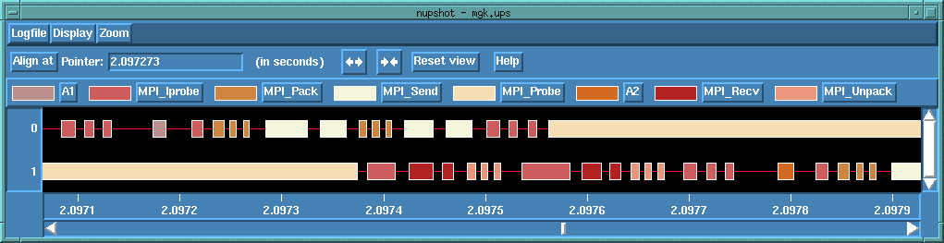
Figure 8: Event Traces for MGK^{MPI} on a 2 Processor System

The execution trace reveals that various opportunities for improvements:

One shortcoming we observed, was that after all data has been propagated, three consecutive MPI_Iprobe operations are issued to check for incoming messages before execution continues. This is due to the organization of RunCommunication and its interaction with the MGK scheduler to determine whether to block for incoming messages (i.e. no further actors can run) or to keep polling. Polling for remote requests is performed using MPI_Iprobe, followed by a MPI_Recv until no messages are available. Furthermore, an MPI_Probe is used for waiting for a communication event and since the result is not cached, it is always followed by a MPI_Iprobe to recheck the condition.

Another observation was that the overhead for packing the HDR and the DATA message for each propagation request (3 MPI_Pack requests and 2 MPI messages) consumes a rather large portion of the overhead. Though sending two messages allows for message pipelining, the MPI message startup costs on the SP2 are 20μsecs and trying to combine messages could have an improving effect on the total overhead. In particular all HDRs to a particular host could be packed to describe all the data, again packed into one message that is expected with the next message. Reducing the number of MPI messages to one message (or sequence of larger messages) can decrease the overhead. On the other hand, the pipelining effect of sending messages (as seen in Figure 8) will be lost. In addition, due to the mixed nature of the protocol (propagation, builder, token-flow-control), this could increase the protocol complexity significantly, which at this point we decided against.
Nevertheless, assumptions are made about the potential depth of the communication subsystem, that in case of underestimating the buffering depth of the system could result in not fully utilizing system resources and exchanging unnecessary control messages (although tokens are “piggybacked” on normal messages) or in the case of overestimation could introduce additional synchronization points since the remote hosts might do not drain message at the required time due to actor execution phase. For instance, the IBM SP2 MPI implementation uses a synchronous send protocol for message sizes larger than 4Kbytes.

There are various other ways to potentially reduce the overhead. For instance, non-blocking communication can be used to post a set of asynchronous sends and receives. This allows to simultaneously receive requests from several remote hosts as well as to overlap communication and actor execution. In general, doing so, allows to exploit the concurrency that exists in the communication subsystem, rather than to sequentialize the host to host communication.

Though various shortcomings were identified, one has to keep in mind that MGK^{MPI} was designed as a portable kernel running on top of native MPI implementations (or even different communication systems) which themselves can have very different system characteristics. Those shortcomings might or might not be present on in different platforms.

4.2. Data Scalability

The next experiment measures how well MGK scales with the number of data item propagated over each connection for the same A1→A2 setup using arrays of double floating point numbers. The source of propagation is a static array. The destination actor receives a mgk_buffer containing the data, which has to be explicitly de-allocated. Hence this experiment measure the overhead of allocating one buffer, propagating it and deallocatoing it. Figure 9 shows the execution time for one connection with increasing buffer size in bytes. The overhead increases linearly with buffersize for messages with less then 16Kbytes of data and follows the following cost function per x bytes sent in an mgk_buffer:
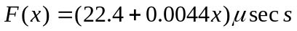 .
The fixed overhead includes the buffer management for allocation and deallocation. The byte dependent overhead of 4.4nsecs is approximately the expected cache performance. For buffers exceeding the cache size or in the more general case when data to be copied is not in cache, the byte dependent factor of the cost function is approximately 30nsec, which reflects the raw memory performance.

Figure 10 shows a 3D contour graph that plots execution time over number of connections and buffersize. The graph indicates a small “step” visible at a combined datasize of 32Kbytes (Connections * Buffersize) which is, as discussed above, related to the cache size. Other than this step, the graph indicates linearity in both dimensions. Figure 11 shows the 3D profile of the execution time for 1-64 connections reiterating the linearity observation. All three graphs demonstrate good scalability with respect to buffer size on a single processor.


Figure 9: MGK^{SA} Scalability of MGK-Buffers over 1 Connection

Figure 10: MGK^{SA} Scalability of MGK-Buffers over 1-8 Connections


Figure 11: MGK^{SA} Scalability of MGK-Buffers over 1-64 Connections

We now execute the same experiment on a two processor configuration to identify the overhead associated with propagating mgk_buffers over processor boundaries.
Figure 12 shows the cost of sending a buffer over a single connection. The curve reflects the protocol that is used for larger buffers. For buffers, smaller than a cut-off point cop=2KBytes, data is packed right onto the DATA message of a remote propagation request. For buffers larger than cop a rendezvous protocol is used to require the receiver to allocate the proper buffers first before data is sent. This initial roundtrip accounts for the large step at 2KBytes. Each additional step is explained by the protocol sending a MPI message for each 2Kbytes portion of the buffer.
In this manner MPI is really used as a low level packet layer. This by itself allows the portable and modular implementation of the communication layer in MGK, yet increases the overhead. In order to limit the overhead, it would be beneficial to only send one DATA message per buffer rather than the various packet messages. This also allows take advantage of the increased bandwidth normally exhibited in message passing systems for larger messages sizes.

Figure 12: MGK^{MPI} Scalability of MGK-Buffers over 1 Connection
Figure 13: MGK^{MPI} Scalability of MGK-Buffers over 1-8 Connections

Examining the 3D profiles of execution time over number of connections and buffer size shown in Figure 13 and Figure 14, the same linear relationship (not withstanding the initial step function) is observed as in the single processor case.


Figure 14: MGK^{MPI} Scalability of MGK-Buffers over 1-64 Connections

To summarize the basic overhead section, although MGK^{MPI} under utilizes the MPI capabilities in various cases, both MGK^{MPI} and MGK^{SA} both scale very well, namely linearly, with the number of connections and with data size.

5. Multiprocessor Scalability

The following experiments examine MGK^{MPI} with respect to its scalability on multi-processor configurations. For this we have chosen an actor graph with fixed regular layout and modified various parameters with respect to this “graph” in order to study various dependencies. The particular graph chosen throughout the following experiments was an 8x8 matrix of actors similar to the 4x4 shown in Figure 15, where each actor can be connected to any actors in the next column propagating one double floating point number per connection. The final column of actors propagates a data token to a final actor, which upon reception on all input ports retriggers the first column of actors. It is guaranteed that each actor has at least one input and one output port. In order to keep all actors ready for execution the final node initially triggers the actors in the first column #column times. Each experiment was run such that the graph was first warmed up, i.e. the first set of pipelined data has reached the final actor and from there on 150*8 cycles (i.e. number of final node execution) were executed.

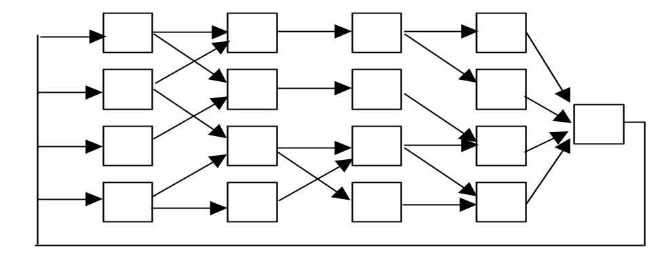
Figure 15: Experimental 4x4 Actor Graph to measure Multi-Processor Scalability

The parameters that we anticipate to have an impact on the performance of the graph’s execution are :
- Actor Runtime
- Graph Interconnectivity
- Actor Placement

These parameters where changed according to the following rules

Actor Runtime

We assume that the runtime of the actors are normally distributed with a mean value of μ= 5msecs and a standard deviation σ [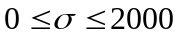]. σ is changed in step of 200 yielding possible actor runtimes in the range of 0-10msecs. The density function of the normal distribution is: 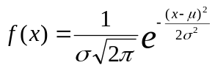.

The Random Number Generator is based on the Box-Mullen Transformation
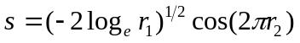,
where r1 and r2 are two uniform random numbers in the range (0,1), and s is the desired sample from the standardized normal distribution. A sample x from any normal distribution with specified μ and σ is obtained from s with 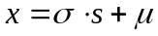. In order to be able to compare the various scenarios of changing and hence actor runtime, we ensured that the mean of all 64 actors remained at μ=5msecs by compensating for possible discrepancies.

Graph Connectivity

Using the above random number generator we change the probability P that a connection exists between any two actors of consecutive columns. Hence with P=1.0 an actor is connected to all the actors in the next column and with P=0.0 it is connected to no actor. As mentioned previously, in the case that an actor has no output connection, we force a connection to the actor in the same row and the next column. Similarly, in the case that there exists no input connection, we force a connection to the actor same row and in the previous column.

Actor Placements

The placement of actors to specific nodes can be critical to the overall performance of the generated system. Since the development of actor placement policy (app) was not part of this task, we assumed very simple placement policies to demonstrate the sensitivity to placement. The results do not imply that these algorithms yield any optimal performance. In particular, none of these algorithms takes communication time into account. The following app’s were considered:

- Horizontal Placement: all actors in a row are allocated towards one processor.
- Vertical Placement: all actors in a column are allocated towards one processor.
- Greedy Placement: although in practical applications it can be difficult or even impossible to estimate the runtime of the various actors, this placement algorithm uses an actor’s runtime to simulate a priori an activation sequence and allocates the ready actor with the largest runtime to the next free processor assuming infinite processor numbers. This algorithm does not take into account that the actor graph is traversed several times.

We measured the efficiency of running the matrix experiment with all 3 placement policies for 1,2,4,8 and 16 processor for various combinations of standard deviations σ and connectivity C. Efficiency ε is defined as 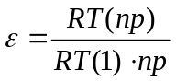, where np is the number of processors and RT(np) is the observed runtime for running the experiment on np processors using MGK^{MPI}.
The efficiency results are shown in Figure 16 through Figure 19. In these figures we do not identify which placement policy yielded which result as these can heavily depend on the setup and the initial seed value chosen. Instead we try to show the general scalability characteristics that exists. The figures show, that MGK^{MPI} is highly scalable for lightly connected setups (C=0%) with low standard deviation (σ=0). The linear degradation is due to the linearly increasing number of inter-processor communication, nevertheless, an efficiency of always greater than 90% is an excellent result. With medium parameterization ([C=30%, σ=1000] and [C=70%, σ=1000]) the efficiency curves vary, hence it demonstrates that knowledge about connectivity and actor runtime knowledge allows one to pick the “right” placement policy. Assuming the best combination of np and app, MGK^{MPI} again demonstrates good scalability as efficiency does not drop below 80%. Even for a fully connected actor matrix (C=100%) with high standard deviation (σ=2000) efficiency does not drop below 68% for best combinations of np and app.

Figure 16: Efficiency over # Procs for C=0%, σ=0
Figure 17: Efficiency over # Procs for C=30%, σ=1000
Figure 18: Efficiency over # Procs for C=70%, σ=1000
Figure 19: Efficiency over # Procs for C=100%, σ=2000

5. Conclusions

This report discusses the evaluation of the MGK Multigraph Kernel, a portable distributed macro dataflow computational engine, on top of a commercial distributed scalable workstation cluster, the IBM SP2. We first showed that single processor overhead introduced by the MGK is small and hence good scalability in terms of computation graph connectivity and data propagation size exists. For small problems, the multiprocessor version exhibited various overheads that origin from both (a) the underlying system message passing performance and (b) the overhead introduced by the MGK remote kernel overhead. Using the low level tracing routines, we were able to identify various shortcomings and identify improvements to the MGK to enhance performance in future versions. These include in particular a better utilization of the MPI functionality, rather than using it only as a “packet” layer.

For multiprocessor configurations, we have shown that although MGK demonstrates good scalability, the actual efficiency can depend on various graph parameters, namely actor runtime and placement, connectivity and communication bandwidth per port. Ultimately, the need for a placement algorithm that can take satisfy load-balancing requirements taking all these parameters into account would be highly desirable.

Nevertheless, in realistic problems (where not only scalars are propagated) the results of the connection scalability and data scalability should be interpreted together. For a mix of scalar and larger sized propagated data items the current MGK protocol overhead (extra probe-s, etc.) will be less significant. In particular, the ratio of data rates between a custom MPI application (written with the a priori knowledge of what the program actually has to do) and an MGK implementation of the same will get more favorable as the data sizes grow.

Ultimately, it is our experience that the ease of using MGK, especially in connection with automated program synthesis, as in the context of the MultiGraph Architecture, justifies the overhead encountered.

- Agha, G.A.: “ACTORS: A Model of Concurrent Computation in Distributed Systems”, The MIT Press, Cambridge, MA, 1986.
- Abbott,B., Biegl, C., Karsai, G., Sztipanovits, J.: “Model-Based Software Synthesis”, IEEE Software, pp. 44-53, May 1993.
- MPI Forum: “Document for a standard Message Passing Interface”, Technical Report CS-93-214, University of Tennessee.
- Wu, C.E., Franke, H. Yew-Huey Liu: “A Unified Trace Environment for the IBM SP Systems”, IEEE Journal on Parallel and Distributed Technology, Summer 1996.

