**Part 3** – Eduardo Moura Cirilo Rocha, [mouracirilor@wisc.edu](mailto:mouracirilor@wisc.edu)

Parameters used:

* Learning rate = 0.01
* Max_epoch = 50
* # hidden units = 20

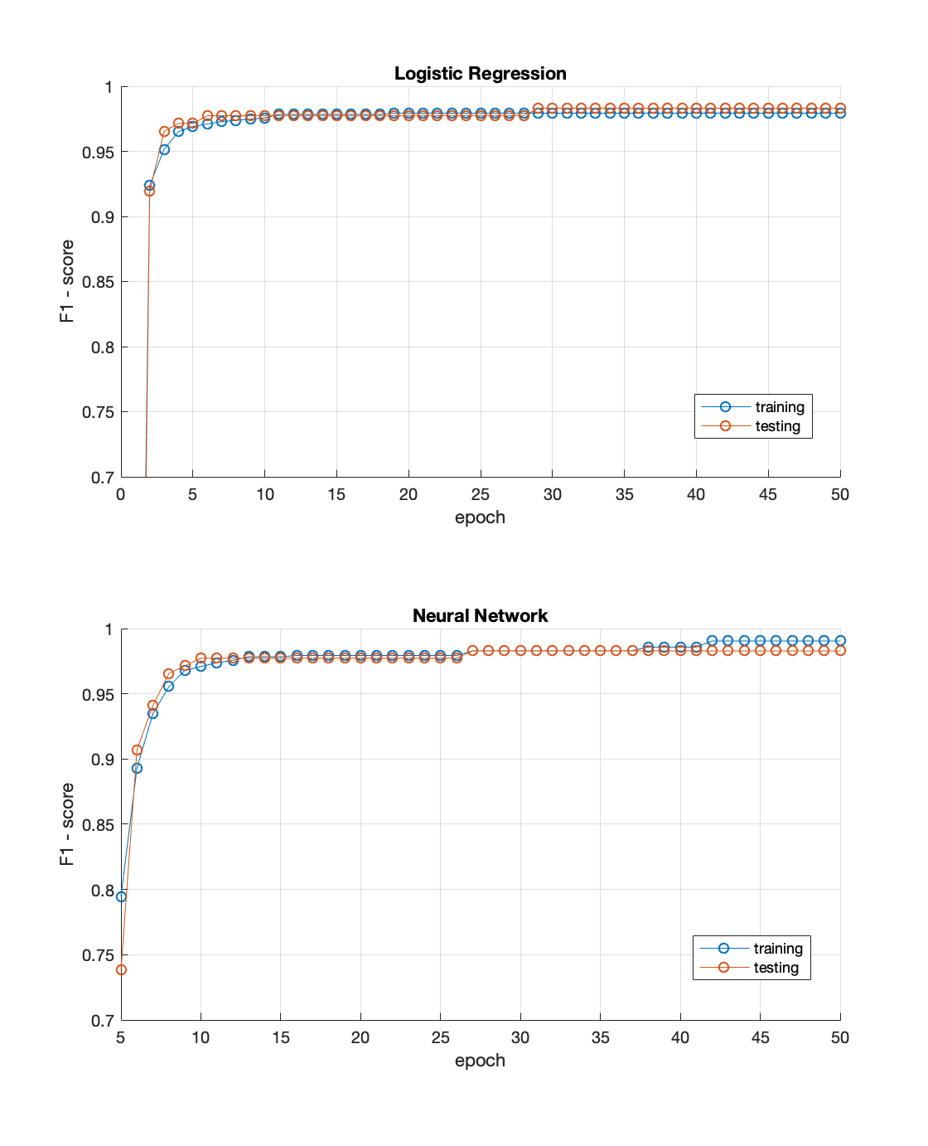

The F1-score increases as the training occur (as the number of epochs increases).

Final score is very similar between the two methods. This is not surprising since the data set is quite small. That is, Logistic regression appears to be enough for this problem.

In fact, the separation between the training and testing curves for the NN indicates some overfitting. This overfitting can be explained by the bigger amount of parameters to be tuned. Decreasing the number of hidden units might help reducing this overfitting.