Welcome to the Node Express Postgres challenge!

In this challenge you will be creating an application for a talent placement company. They are looking for the ability to add Talent (aka, clients) to their database. Each talent needs to have at least a first name, last name, phone number, and a high range and low range for salary expectations.

In addition each talent should also list their skills. A skill just has a name, such as “JavaScript” or “Public Speaking”.

The client wants the homepage to display a listing of all talent, and what skills they have. They also would like a button that hides and shows a form for adding new talent to the database. When adding new talent, skills are chosen from a list of skills pulled from a second table in the database (see the diagram below).

The client also needs a button to hide and show both a list of all existing skills and a form for adding new skills to the database.

This is a visual representation of what your tables will look like:

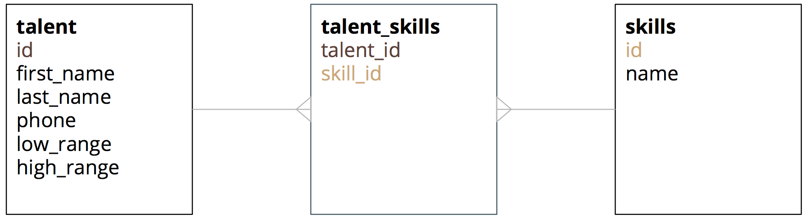

Be sure to use the Postgres documentation as needed: http://www.postgresql.org/docs/current/static/index.html

Perform the following tasks:

- Start postgres.
- Create the tables in a new database, make sure the ids are auto incrementing using SERIAL, and that the ids in the talent_skills table use REFERENCES, and should have a composite key using PRIMARY KEY.
- Create a new Node.js application, and install Express, and pg. pg is the driver we will use to send SQL commands to the database.
- Add your homepage and pull in all JavaScript and CSS you need. You can use either jQuery or Angular (if using Angular with Checkboxes, I recommend using checklist-model http://vitalets.github.io/checklist-model/)
- Start small, just add the form for creating new skills first, and get the data to save to the database. You can check if the data saves in PgAdmin or by directly querying your database. Note that you can use the SQL type text as a shortcut for “string of any length” (http://www.postgresql.org/docs/current/static/datatype-character.html)
- Next get your list of skills to display on the page.
- Now that you have that working, you’ll need to add the form for creating talent. This is where things get tricky, because you will have to create not only a new entry in the talent table, but also add entries into the talent_skills table as well.
- Next, get your list of talent to display on the page.
- Finally, get the talent’s skills to display on the page as well.
- Use Bootstrap or any custom CSS you like to make things look nice!

Hard Mode

Add the ability to delete talent and skills from the homepage.

Pro Mode

Add the ability to update talent and skills from the homepage.

Extreme Mode

Inside of pg.connect’s callback, add a query that create the tables if they do not already exist. You can see in the Postgres Documentation (http://www.postgresql.org/docs/current/static/sql-createtable.html) that you can use IF NOT EXISTS.

