# Required Setup

Testing for Omnisource to Butler

1. CustomerPO (BINumber) - BI22892

2. 206598 - (Omnisource Sales Order)

3. Line No - 01

4. Customer = STEE90, SupplierNo = OMNI00

5. Branch - 38

6. Remove Branch 38 from Otm_Interface_Branches Table

a. SELECT * FROM dl4trainosc.OTM_Interface_Branches;

b. DELETE FROM dl4trainosc.OTM_Interface_Branches WHERE Branch = '38'

7. Deploy to 172.16.251.98 as ShimApi

8. Install and configure TRK1

a. Install directory on scrpadb - /sairoot/dl4testcres/saitx

b. Winscp truckscale basic source to /tmp on scrpadb

c. Use loadsave to make executable

d. Move executable to /sairoot/dl4testcres/saitx

e. Change Permissions and Ownership to 644 and saitx:users

9.

Omnisource to SDI-Butler Test Description

Ticket (TSFQOI) was created in TRK1 and will be picked up in the Shim when received at Butler. The Validation will be performed by SAI as this ticket was created and managed by SAI

Omnisource TicketNo: TRZKLH

Omnisource ShipmentNo: 1NU933

Omnisource - Sales_Tkt_Hdr Table

POST Logic

Validation Performed at Butler:



1NU933 Validated. Log shows that shipment 1NU933 was routed from the Shim API to SAI Web Services.

# RIMAS Omnisource to SDI-Butler Test Description

Material Shipper

Validation Performed at SDI-Butler

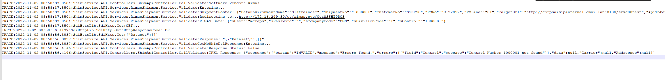

POST made to RIMAS, and Control Number not found.

Attempt 2

SuppShipNo was deleted from table and may be re-used.

Attempt 3 Use Control # Multiple Time

TJFVCQ Placed InYard

Validate Same Control #

Same behavior as truckscale has today when validating SAI SuppShipNo