Proceedings of ME 701 (Development of Computer Applications in Mechanical Engineering)
ME 701
December 19, 2014, Manhattan, KS

Review and Enhancement of Monte Carlo Foam simulation using Object oriented Programing, and Message-Passing Interface (MPI)

Michael Reichenberger
Kansas State University
Manhattan, KS, United States of America

Abstract
Foam materials saturated with neutron sensitive compounds are of interest as a viable replacement for 3He-based neutron detectors. Previous studies have shown the feasibility of 6LiF-saturated foam detectors as a valid replacement both experimentally and theoretically. However, the random geometry of foam material has previously limited the effective theoretical considerations for such materials to generalized approximations of detector efficiency based on the effective amount of neutron-sensitive material and effective charged-particle ranges. Neutron transport and subsequent charged particle energy deposition have been previously simulated using novel Monte Carlo methods in order to develop reaction-product pulse-height spectra, to determine intrinsic thermal-neutron detection efficiency, and to optimize material properties for open-cell foam neutron detectors. The present work re-assessed the physical accuracy of the former simulations, improves the flexibility of the simulation package by incorporating object oriented programing practices, and improves computation efficiency by utilizing message-passing interface. The new version of the foam simulation addresses flaws in charged particle tracking and is more easily adapted to other types of foams. Finally, the use of a message-passing interface reduces the computation time by utilizing additional processing cores.

Motivation
Porous materials are under investigation as viable replacements for 3He-based neutron detectors [1]. Foam-based materials are of particular interest due to their extremely low cost and mass-producibility [2]. Previous research investigated the effectiveness of various configurations of 6LiF-saturated foam gas-filled neutron detectors experimentally and analytically [1]. However, the random nature of open-cell foam geometries limits the effectiveness of such analytical methods to generalized cases. Theoretical investigation of the intrinsic thermal-neutron detection efficiency of open-cell foam devices of various shapes and sizes, as well as predicting the resulting pulse-height spectra (PHS) for such devices, requires the development of novel Monte Carlo simulation techniques which can be used to emulate the heterogeneous and random geometry of the foam structure.
Monte Carlo simulation has long been used as a method to predict the solution to complex particle transport problems [3]. Developing appropriate probability distributions and accounting for all necessary physical phenomena presented in the problem are critical to accurate simulations. Properly modeling neutron and charged particle transport in porous foam materials necessitates the consideration of the struts and pores of the foam structure.
Objective
The present work was undertaken in order to verify the validity of previous work, and to improve the simulation usability. First, the previous simulation was profiled in order to discover which portions of the simulation required the most computation. After analyzing the profiling data in Table I, the simulation process was re-assessed from the ground up with object oriented programming practices in mind.

The classes in Table II were developed in increase the flexibility of the simulation, and are described in greater detail under the enhancement discussion.

Using the classes and methods of Table II, a simulation script was written to execute the Monte Carlo simulation amongst numerous nodes using message-passing interface (MPI). MPI execution was only made possible by re-designing the simulation.
Previous Version
Former development roughly approximated the geometric characteristics of foam. Several physical parameters of the foam were characterized using a scanning electron microscope and are summarized in Table III. Additionally, the strut material composition was acquired from the foam manufacturer and appropriate thermal-neutron absorption cross sections were calculated based on the ⁶Li content and neutron absorption cross sections [4]. Finally the simulation lower-level discriminator (LLD) was set to 300 keV, conforming with previous research [1, 2].
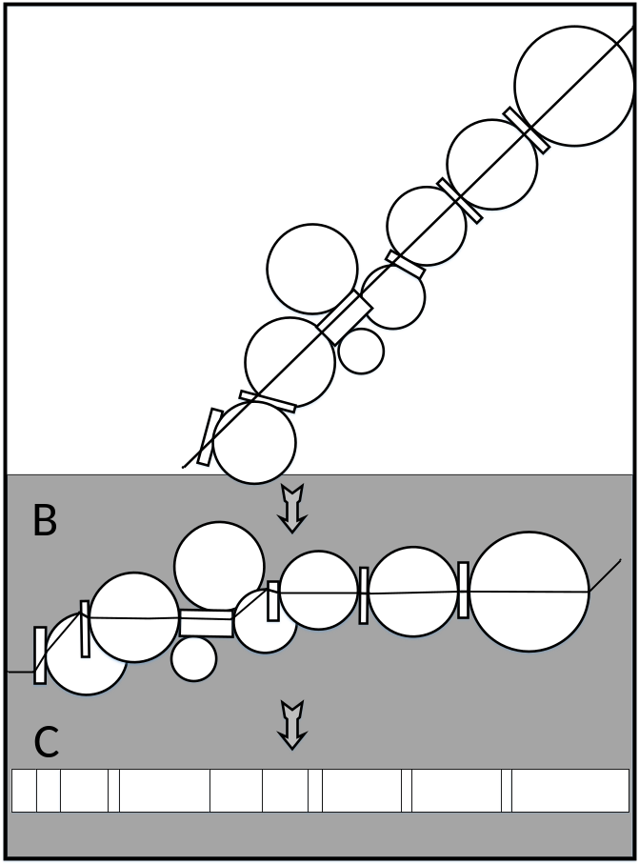
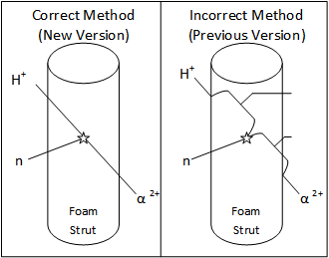
Table III: Foam parameters used for Monte Carlo simulation with the DPG method.
Fig. 1. Evolution of the particle path model used for dynamic path generation. (A) Illustrates the physical path of a particle through the foam with struts and pores modeled as cylinders and spheres. (B) Demonstrates how the same path can be represented by a particle incident on the same struts and pores with different trajectories. (C) Shows the interpretation of the particle path length through each medium which was used for the Monte Carlo simulation.

Fig. 2. Comparison of the correct and incorrect reaction product tracking used in the present and prior work respectively.
Observed Parameter | Minimum |  | Maximum
Strut Thickness | 30 μm | 50 μm
Strut Length | 200 μm | 600 μm
Pore Diameter | 400 μm | 600 μm
One challenge in simulating a foam material is developing the random geometry. Monte Carlo techniques were used in previous work to model charged particle transport through multi-layered, thin-film-coated devices composed of regular repeating structures [5]. However, the random geometry of the foam structure reduces the capability of the former methods to homogenized, simplified versions of the detector medium. A novel Monte Carlo technique called the “Dynamic Path Generation” (DPG) method was developed to reduce the complex, 3-dimensional, heterogeneous, and random structure of porous materials to a simple 1-dimensional particle path. Rather than using a static geometry (common for Monte Carlo particle transport simulations [3]), a dynamic path was generated for each particle history to emulate the foam features inside a defined space, as described in Fig. 1. By using a dynamic path to imitate the random structure of open-cell foam struts and pores, Monte Carlo simulations have been developed which are capable of accounting for these foam heterogeneities. Neutron and reaction product paths were both modeled using the DPG method. After a neutron interaction was simulated, charged particle transport was conducted using the residual energy method [6]. The primary concern when analyzing the previous simulation was if the first charged particle path-length was accurately calculated. Prior work attempted to estimate length of travel for each reaction product through the strut in which a neutron interacts by calculating the distance to the edge of the strut using a complicated geometric calculation. Additionally, it was discovered, that the original work did not accurately account for the energy lost by reaction products traversing the first strut before entering the ionizing gas.
Enhancements
Simulation enhancements include three categories: bug fixes (improving accuracy), object-oriented design (enhancing flexibility), and MPI capabilities (increasing execution speed).
Accuracy Improvements
Simulation accuracy critically important for any scientific computation. The objective of the foam Monte Carlo simulation is to predict the intrinsic thermal-neutron detection efficiency for various types of neutron sensitive foams. Using the predictions from the simulation, experiments can more quickly focus on developing the most effective radiation detectors rather than spending time characterizing various foams. During the analysis of the prior work, errors in charged particle tracking were discovered, which suggested that the results may have over-estimated intrinsic thermal-neutron detection efficiency. The previous simulation was not accurately reducing charged particle energy to account for the energy loss through the first strut, instead birthing all reaction products at the surface of a strut. This error greatly increased the average ionization energy for each neutron interaction. The situation is further depicted in figure 2.
Additionally, the prior work attempted to use geometry to find the reaction product path-length. Current work uses vector tracking to determine reaction product path-length in the three-dimensional strut rather than settling for a less-accurate two-dimensional approximation.
By using vector tracking for the reaction product path-length calculation, in addition to correctly adjusting reaction product energies, the current work represents a more accurate simulation of the physical phenomena of concern.
Flexibility Enhancements
Asd
Execution Speed Increases
Asd
Results
Fixed physics
Compared to previous simulation
Compared to experiment
Compared to homogenized solution
Easy to change foam parameters
Lithium content
Strut dimension
Optimization implications
Speed increase
1 node vs 4 node vs 32 node
Future Improvements
Better characterization of the foam
Expansion to other types of foam
Experimental verification
References
- Kyle A. Nelson, James L. Neihart, Todd A. Riedel, Aaron J. Schmidt, Douglas S. McGregor, "A novel method for detecting neutrons using low density high porosity aerogel and saturated foam," Nuclear Instruments and Methods in Physics Researsh A, vol. 686, pp. 100-105, 2012.
- Kyle A. Nelson, Steven L. Bellinger, Benjamin W. Montag, James L. Neihart, Todd A. Riedel, Aaron J. Schmidt, Douglas S. McGregor, "Investigation of Aerogel, Saurated Foam, and Foil for Thermal Neutron Detection," in IEEE Nuclear Science Symposium, Valencia, Spain, 2011.
- William L. Dunn, J. Keneth Shultis, Exploring Monte Carlo Methods, Academic Press, 2012.
- National Nuclear Data Center, "Evaluated Nuclear Data File (ENDF)," Brookhaven National Laboratory, 2014.
- D.S. McGregor, M.D. Hammig, Y.H. Yang, H.K. Gersch, R.T. Klann, "Design considerations for thin film coated semiconductor thermal neutron detectors - I: basics regarding alpha particle emitting neutron reactive films," Nuclear Instruments and Methods in Physics Research Section A, vol. 500, no. 1-3, pp. 272-308, 2003.
- J.K. Shultis, D.S. McGregor, "Calculation of ion Energy-Deposition Spectra in Silicon, Lithium-Fluoride, Boron, and Boron Carbide," College of Engineering, Kansas State University, Manhattan, KS, 2007.

