|  |
| --- |
| **77⁰ 04.1’N 159⁰ 50.2’W. 2130µ (1164 fms) D.I. stn α II Charlie N⁰2** |
| **77⁰ 41.5’N 164⁰ 21.5’W. 275 fms D.I. stn α II Charlie 44** |
| **Grade 1, sample 2, +500 µ** |
| **Grade 2, sample 2, 250 - 500 µ** |
| **Grade 2, 44, 250-500** |
| **Grade 3, sample 2, 180 - 250 µ** |
| **Grade 3, 44, 180 - 250 µ** |
| **Grade 3, 44, 180 - 250 µ** |
| **Grade 4, 44, 152 - 180 µ** |
| **Grade 4, sample 2 , 152 - 180 µ** |
| **Grade 5, 44, 124 - 152 µ** |
| **Grade 5, sample 2, 124 - 150 µ** |
| **Grade 6, 44, 104 - 124 µ** |
| **Grade 6, sample 2, 104 - 124 µ** |
| **Grade 7, 44, 63 - 104 µ** |
| **Grade 7, sample 2, 63-104 µ** |
| **Grade 8 Sample 2 - 63 µ** |
| **Grade 8, 44, 63µ,** |

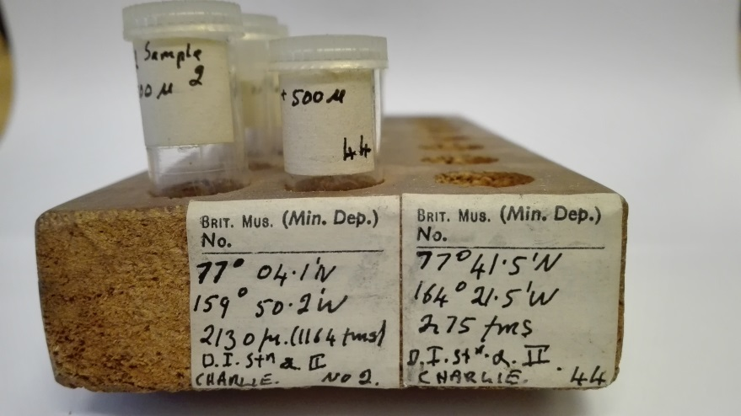

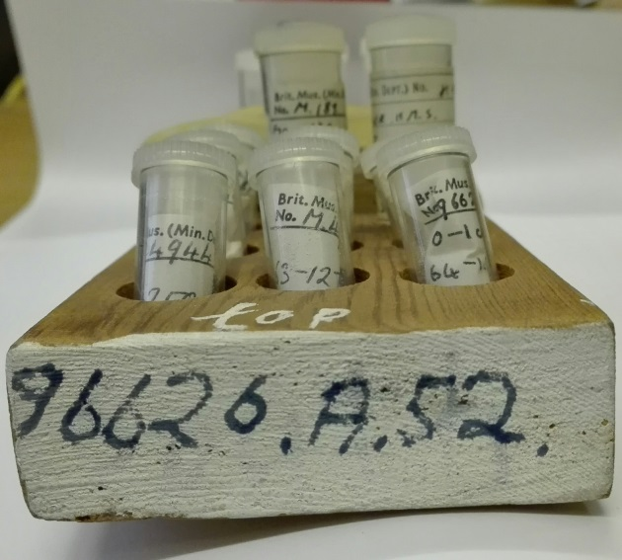

|  |
| --- |
| **96626. A. 52.** |
| **No 1966.0.57** |
| **J.3. Ex 52' +250µ M. Miocene** |
| **No M.170, +250µ** |
| **No M.170, 127-250µ** |
| **Challenger HMS No 157** |
| **Lat 53⁰ 55' S, Long 108⁰35' E, Depth 1950 fms?** |
| **S. Indian Ocean, see slide 38** |
| **No M.248, +250µ** |
| **Cb stn.191.A 30.4.68** |
| **No M.189 from the Coarse particles Foraminifera** |
| **No 96626(A48) +250µ** |
| **No 96626.A34, 0-1 cms 127-250µ Foraminifera** |
| **No 96626.A34, 0-1 cms +250µ Foraminifera** |
| **No 96626.A48, 64-127µ** |
| **No 96626.A34, 0-1 cms, 64-127µ Foraminifera** |
| **No M.4944, 63-127µ** |
| **No M.4944, 127-250 µ** |

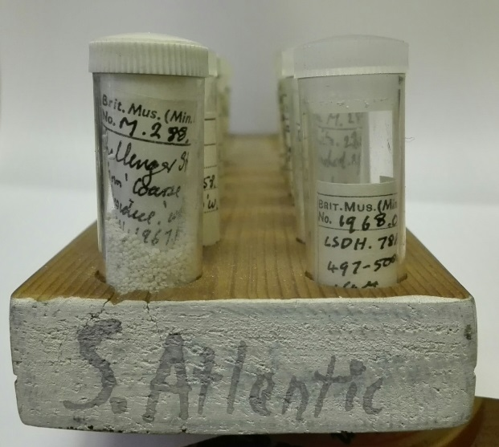

|  |
| --- |
| **South Atlantic** |
| **No M.288, Challenger Stn 5** |
| **from coarse residue washed 20.11.1967 3HB.** |
| **No1968.0.397, LSDH.788, 497-500 cms, +64µ, 2 tubes** |
| **DWB 5.121, 10-14cms, 3.2.1958** |
| **Lat 27⁰09' S. Long 109⁰50' W, Depth 3320 m.** |
| **Foraminifera separated. April 1964 KAB** |
| **No M.288, Challenger Stn 224, washed 29.4.68** |
| **Loc. from G. aequilateral B?.** |
| **HMS Challenger Stn No 417** |
| **Lat 2⁰42' S. Long 14⁰41' W, Depth 2350 fms.** |
| **Foraminifera separated poor separtin?** |
| **No M.288, from Washing cleaned 1967 KAB** |
| **M 408 from original bottom sample, st no 338** |
| **21.3.1876 Lat 21⁰ 15' S, Long 14⁰ 2' N, Depth1990 fms** |
| **Scob. Ooye separated 1963-250µ** |
| **No M 408 HMS Challenger Stn No 338,** |
| **Lat 21⁰ 15' S, Long 14⁰2' W, Depth 1990 fms** |
| **Scob. Ooye separated 1963 + 250µ** |
| **No 1962.371. HMS Owen, No C.52 . No 69 C52** |
| **Lat 38⁰ 12' S, Long 29⁰ 00' W, Depth 1868 fms** |
| **from mass piece of 14" core.** |
| **No 1962.372. HMS Owen, St.No 70 C53, 3.1.1961** |
| **Lat 37⁰ 52' S Long 17⁰ 36' W, Depth 1400 fms, on Mid. Atlantic Ridge** |
| **Challenger sounding 42, St No 5, 21/2/1873** |
| **Lat 24⁰20' N Long. 24⁰28' W, Depth 2740fms,** |
| **Giade + .125 - .25mm** |
| **No 039.28 R.R.S. Discovery, st No 212, 16.4.1927,** |
| **Lat 61⁰15' S, Long 64⁰ 42' 50" W, Depth 3350M.** |
| **Foraminifera from separated material.** |
| **Drifting 9 ce station Alpha II, St No 2** |
| **Lat 22⁰ 04.1' N Long 159⁰ 50.2' W** |

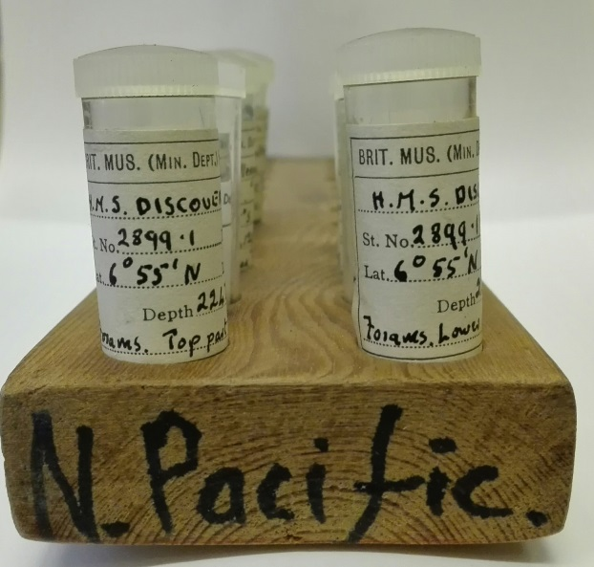

|  |
| --- |
| **North Pacific** |
| **No 1954.35 H.N.S. Discovery, St No 2899.1, 4.11.1951** |
| **Lat 6⁰ 55' N Long 66⁰ 56' E, Depth 2247.9 fms** |
| **Foraminifera top part of part 1** |
| **No 1954.35 H.N.S. Discovery, St No 2899.1, 4.11.1951** |
| **Lat 6⁰ 55' N Long 66⁰ 56' E, Depth 2247.9 fms** |
| **Foraminifera lower part of part 1** |
| **Provi dence ? Rearf.? 28.3.1 1961 KAB?** |
| **No M.249 H.M.S. challenger, St. No 192.a 26.8.1874** |
| **Lat 5⁰ 49' 15" S Long 132⁰ 14' 15" E, Depth 129 fms** |
| **From Jan mavhed "from Traval?" washed by H.A.W? 1963** |
| **No96626 A52, 109.5 -111cms, cuttings** |
| **No 1954.41.(17) H.M.S. Challenger II, 14.Aug.1953, Depth 500 fms** |
| **Forams and sediment** |
| **No 1937.127.(19) pourqoui Pas St No 504, 6.6.1924** |
| **Lat 49⁰ 48' N Long 7 35 W (4), Depth 132 m, Coarse sievings** |
| **H.M.S. challenger, st No 192a, 26.8.1874** |
| **Lat 5⁰ 49' 15" S Long 132⁰ 14' 15" E, Depth 129 fms** |
| **From tube marked " washings"** |
| **No1961.54, 0-2 cms, +64µ, Irish sea** |

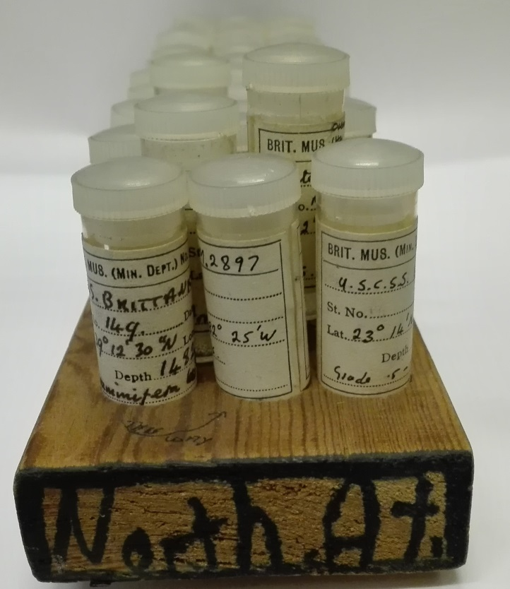

|  |
| --- |
| **North Atlantic** |
| **No M 1291 S.S. Brittanica, St No 149, 10.6.1899** |
| **Lat 39⁰ 12' 30 N Long 70⁰ 14' 30" W, Depth 1482 fms** |
| **Foraminifera wash thru 1/8 mm.d** |
| **No M.2897, H.S.C.S.S. Blake.** |
| **Lat 23⁰ 14' N Long 82⁰ 25' W, Depth 785 fms grade + 5mm** |
| **No M.2897, H.S.C.S.S. Blake.** |
| **Lat 60⁰ 30' N Long 16⁰ 11' W, Depth 1388 fms** |
| **No 0.43.29, H.M.S. Rose Mary, St. No 147** |
| **Lat 60⁰ 30' N Long 16⁰ 11'W, Depth 1388 fms** |
| **Foraminifera 1/4-1/8 mm diam.** |
| **No 1962.211 presented by 01.D.B. Errson?, core. No Rq-6 July 31.1951** |
| **Lat 62⁰ 21' N Long 27⁰ 37 W, Depth 1289 meters** |
| **U.S. S. REHBOTH. Top -3 cms.** |
| **No D.43-29 HMS Rosemary St. No. 147 , Lat. 60⁰ 30' N Long 16⁰ 11' W,** |
| **Depth 1388 fms, Foraminifera +1/2 mm diam.** |
| **No 1961.69.1011, R.V.Sarsia St No 19/6, 17 May 1958** |
| **Lat 47⁰ 50' N Long 08⁰ 08' W. Depth 670 - 710 fms V. Coarse sievings.** |
| **No 1962.210, presented by Dr. D B. Dickson? Core no v16 - 227, 26..4..1960** |
| **Lat 60⁰ 02' N Long 50⁰ 50' W, Depth 3,305 meters Top-2 cms R.V.VEMA.** |
| **No 1957.323(58) HMS VIDAL St No 58 Lat 66⁰31.5'N Long 03⁰28' E , Depth 789 fms** |
| **Grade less than .25µm** |
| **No 1957.329(55) H.M.S. VIDAL St No55 Lat. 70⁰22'N Long 01⁰06'E** |
| **Depth 1728fms Grade less than .25µm** |
| **No 1957.328(58) HMS VIDAL St No 58 Lat. 66⁰31.5'N Long 03⁰28' E** |
| **Depth 789 fms, Grade +.25 mm** |
| **No 0.4P .20, Lat 53⁰32.2'N Long 19⁰11' W deth 1370 fms, Rosemary HV? 68** |
| **No 8657 U.S.S. TUSCARORA St No 75 16.7.1874 Lat. 52⁰14'N Long 173⁰14'E** |
| **Deth 947 fms Foraminifera separated 11.1962** |
| **Drifting ICE Station ALPHA II St No 14 Lat77⁰37.0'N Long 163⁰13.8' W** |
| **Depth 460m foraminifera 63µ sieve.** |
| **No 1937.127.(19) Pourqoui Pas, St No 504 6.6.1924** |
| **Lat 49⁰48'N long 7⁰35' W (4?) depth 132m, fine sievings** |
| **No 0.43.29 H.M.S. ROSEMARY St No 147 Lat. 60⁰30' N Long 16⁰11' W** |
| **depth 1388 fms, Foraminifera 1/2 - 1/4 mm diam.** |
| **Blake Plateau, "indetermined? List" fine washings.** |
| **No M1291 S.S. BRITTANICA. St No 149, 10.6.1899, Lat 39⁰ 12'30N, Long 70⁰14' 30 W** |
| **Depth 1482 fms Foraminifera =1/2 mm diameter.** |
| **No M. 2897 U.S.C.S.S. Blake Lat 23⁰14'N Long 82⁰25' W, 785 fms grade .25 -.125mm** |
| **No 1959.440.b(3), Vᴓringen N??? N. Atalntic, Toped? St No 33, 1876-78** |
| **Lat 77⁰ 58' N, Long 05⁰ 10' E, depth 1333 fms** |
| **M 1291 S.S. BRITTANICA St No 149, 10.6.1899, Lat 39⁰12'30"N Long 70⁰14'30" N** |
| **Depth 1482 fms Foraminifera 1/4 - 1/8 mm diam.** |
| **No M 9174 Norvegian North Atlantic laped? St 1876-78** |
| **St No 349 , Lat 76⁰ 30' N Long 02⁰57' E, Depth 1487 fms, Biloculina Clay.** |
| **No 1961.69.1011, R.V.Sarsia St No 19/6, 17 May 1958, Lat 47⁰50'N, Long 8⁰08' W** |
| **Depth 670-710 fms, coarse whashing.** |
| **No 1961.69.1011, R.V.Sarsia St No 19/6, 17 May 1958, Lat 47⁰50'N, Long 8⁰08' W** |
| **Depth 670-710 fms, fine Seavings.** |
| **No 1961.69.1011, R.V.Sarsia St No 19/6, 17 May 1958, Lat 47⁰50'N, Long 8⁰08' W** |
| **Depth 670-710 fms, Foraminifera sieved.** |
| **No M1291 S.S. BRITTANICA. St No 149, 10.6.1899, Lat 39⁰ 12'30N, Long 70⁰14' 30 W** |
| **Deth 1482 fms Foraminifera 1/2 - 1/4 mm dia.** |
| **No M. 2897 U.S.C.S.S. Blake Lat 23⁰14'N Long 82⁰25' W, 7** |
| **Depth 85 fms grade less than .125mm** |
| **No 1955.280(12) H.M.S. VIDAL, St No 26, Lat 62⁰29'N, Long 2⁰53'E, Depth 1400fms,** |
| **Top of core foraminifera** |
| **No 1954.41.(12) H.M.S.Challenger II, 10.Sept.1953** |
| **Lat.56⁰41'N Long 18⁰46.5' W, Depth 716 fms. Forams.** |
| **Challenger souding 42 St No 5, 21/2/1813 Lat 24⁰20'N, long 24⁰28' W,** |
| **Depth 2740fms, Grade +.25mm** |
| **No 1957.328.(55) H.M.S. VIDAL St No 55, Lat 70⁰22'N long 01⁰06' E** |
| **Depth 1728 fms, grade +.25mm** |
| **No M 9173 Norvegian North Atlantic lapedation? St 299, 1876 -78** |
| **Lat 73⁰ 10' N Long 02⁰ 14' W, Depth 1366 fms "Bilorubina clay"** |
| **Drifting ICE Station ALPHA II St No 66 Lat77⁰24.8'N Long 164⁰37.3' W** |
| **Depth 305m, Foraminifera 63µ sieve.** |
| **No 1962.162 Type loc for slides of same reg. No contains G. Incompta .** |
| **Lat 23⁰ 10' N Long 82⁰ 20' W, Depth 204 fms grade** |
| **Material from Dr. Cipelli 17.12.1962** |